IEEE P802.15
Wireless Specialty Networks

Project | IEEE P802.15 Working Group for Wireless Specialty Networks (WSNs) – 802.15.6ma
Title | Proposed text for 6ma MAC – Beacon Access Phase
Date Submitted | July 4, 2023
Source | Seong-Soon Joo (KPST) | E-mail: [ssjoo@etri.sci.kr]
Re: | Contribution to IEEE 802.15.6ma
Abstract | This document provides a text draft of 6ma MAC for introducing new beacon access phase in clause 6.3.
Purpose | Support development of technical content for the draft
Notice | This document has been prepared to assist the IEEE P802.15. It is offered as a basis for discussion and is not binding on the contributing individual(s) or organization(s). The material in this document is subject to change in form and content after further study. The contributor(s) reserve(s) the right to add, amend or withdraw material contained herein.
Release | The contributor acknowledges and accepts that this contribution becomes the property of IEEE and may be made publicly available by P802.15.

Revise the sub-clause 6.3 as follows:

6.3 Access classification and division
To provide or support time referenced allocations in its BAN, a hub shall establish a time base as specified in 4.4, which divides the time axis into beacon periods (superframes) regardless of whether it is to transmit beacons. In such cases, the hub shall transmit a beacon in each beacon period (superframe), except in inactive superframes, or shall not transmit a beacon in any superframe (beacon period). The hub may shift (rotate) its beacon transmission time, as specified in 6.13.1, from one offset from the start of current beacon period (superframe) to another offset from the start of next beacon period (superframe), thereby shifting the time reference for all scheduled allocations, to prevent large-scale repeated transmission collisions between its BAN and neighbor BANs.
In cases where a hub is not to provide or support time referenced allocations in its BAN, it may operate without a time base or superframes and hence without transmitting beacons at all.
Equivalently, a hub shall operate in beacon mode transmitting a beacon in every beacon period other than in inactive superframes to enable time referenced allocations; or shall operate in non-beacon mode transmitting no beacons, with superframes and allocation slots established if access to the medium in its BAN involves time referencing, or without superframes or allocation slots if access to the medium in its BAN involves no time referencing.
In summary, a hub shall operate in one of the following three access modes:
⎯ Beacon mode with beacon periods (superframes);
⎯ Non-beacon mode with superframes;
⎯ Non-beacon mode without superframes.
6.3.1 Beacon mode with beacon periods (superframes)
In this mode, a hub shall organize applicable access phases in each active beacon period (superframe) as illustrated in Figure 64, where B stands for beacon (B). The hub may maintain I inactive superframes (beacon periods) after each active superframe (beacon period), if there are no allocation intervals scheduled in the inactive superframes, where I is a positive integer chosen by the hub. In an active superframe (beacon period), a hub shall transmit a beacon and may provide access phases. In an inactive superframe (beacon period), a hub shall not transmit any beacon and shall not provide any access phases.
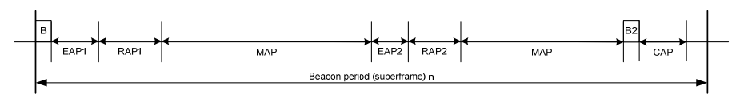
Figure 64 —Layout of access phases in a beacon period (superframe) for beacon mode

The hub shall place the access phases—exclusive access phase 1 (EAP1), random access phase 1 (RAP1), managed access phase (MAP), exclusive access phase 2 (EAP2), random access phase 2 (RAP2), another managed access phase (MAP), and contention access phase (CAP)—in the order stated and shown above. The hub may set to zero the length of any of these access phases, but shall not have RAP1 end before the guaranteed earliest time as communicated in Connection Assignment frames sent to nodes that are still connected with it. To provide a non-zero length CAP, the hub shall transmit a preceding B2 frame. The hub shall not transmit a B2 frame if the CAP that follows has a zero length, unless it needs to announce B2- aided time-sharing information and/or provide group acknowledgment.
A node may obtain, and initiate frame transactions, in contended allocations in EAP1, RAP1, EAP2, RAP2, and CAP in any active superframe using CSMA/CA or slotted Aloha based random access as specified in 6.5.
Only in a MAP, as shown in Figure 65, may the hub
⎯ arrange scheduled uplink allocation intervals, scheduled downlink allocation intervals, and scheduled bilink allocation intervals;
⎯ provide unscheduled bilink allocation intervals; and
⎯ improvise type-I, but not type-II, immediate polled allocation intervals and posted allocation intervals starting in this MAP.
In an EAP, RAP, or CAP, or MAP, as shown in Figure 64, the hub may also improvise future polls or posts starting and ending in a MAP as shown in Figure 65 (through Poll, T-Poll, I-Ack+Poll, and B-Ack+Poll frames as specified in Table 21).
These allocation intervals along with the corresponding access methods whereby they are obtained are illustrated in Figure 65.
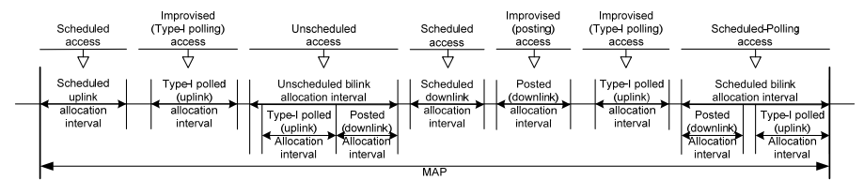
Figure 65 —Allocation intervals and access methods permitted in a managed access phase
A hub of the dependable BAN shall organize applicable access phases in each active beacon period as illustrated in Figure 66, where Beacon Access Phase (BAP) is allocated for transmitting beacons without colliding among coexisting dependable BANs. The first beacon slot of a BAP is allocated to the coordinator hub of the dependable BAN group and the last beacon slot of a BAP is reserved for a BAN of the IEEE 802.15.6-2012. For a leaf hub of a dependable BAN group, a beacon slot in BAP is assigned by the coordinator hub of the dependable BAN group. A coordinator hub maintains the start time of BAP and leaf hubs synchronize to BAP of the coordinator hub as described in 6.4.4.
For mitigating the interference among coexisting dependable BANs, a hub of a dependable BAN may defer the start of access phases by setting the access offset, within which let not to exceed the length of beacon period, as described in 6.4.4.
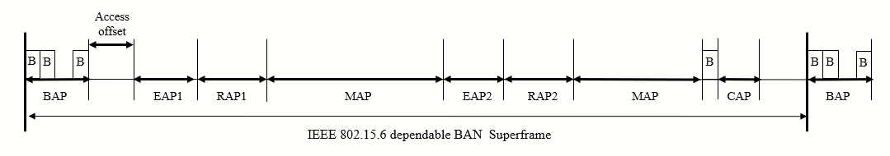
Figure 66 —Layout of access phases in a beacon period (superframe) for beacon mode of the dependable BAN

