IEEE P802.15

Wireless Specialty Networks

Project | IEEE P802.15 Working Group for Wireless Specialty Networks (WSNs)
Title | Timeline TG6ma
Date Submitted | May 18th, 2023
Source | Marco Hernandez^{1,2}, Ryuji Kohno^{1,3}, Takumi Kobayashi^{1,3}, Minsoo Kim¹, Daisuke Anzai⁴ | ¹YRP-IAI, Japan, ²CWC Oulu Univ. Finland, ³YNU, Japan, ⁴Nagoya I.T., Japan
Abstract | Agenda joint 4ab and 6ma meeting.
Purpose | Material for discussion.
Notice | This document has been prepared to assist the IEEE P802.15.6ma. It is offered as a basis for discussion and is not binding on the contributing individual(s) or organization(s). The material in this document is subject to change in form and content after further study. The contributor(s) reserve(s) the right to add, amend or withdraw material contained herein.
Release | The contributor acknowledges and accepts that this contribution becomes the property of IEEE and may be made publicly available by P802.15.6ma.

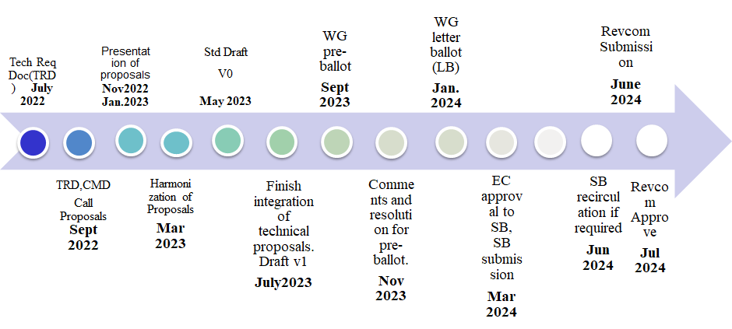

Topic | Deadline | Notes
Technical Requirements Document (TRD). Channel Model Document (CMD). Call for Proposals. | Sept. 2022 | TRD describes the technical requirements baseline for the evaluation of proposals. The CMD contains the channel models for different use cases targeted by the Std.  Announcement of call for proposals.
Due day for proposals | March 10th, 2023
Presentation of proposals | Nov. 2022, January, March 2023 | Start of discussions for harmonization of proposals.
Harmonization of Proposals | March 2023 | Agreements on key technologies.
Std Draft v.0 | May 2023 | Mostly editorial revisions and start integrating text of agreed proposals.
Std Draft v. 1 | July 2023 | Plan to finish integration of technical proposals.
Std Draft v. 1 recirculation | August 2023 | TG approval
WG pre-ballot | September 2023 | WG pre-ballot submission.
Comments and resolution for pre-ballot. | November 2023 | Finish resolutions to pre-ballot comments and recirculation.
WG letter ballot (LB) | January 2024 | LB submission
LB recirculation | January 2024 | Comment-resolutions to LB recirculation
Conditional approval for Sponsor Ballot (SB) | January 2024 | Seek conditional approval
Final LB recirculation. EC approval | March 2024 | Just before the March meeting.
EC approval to SB | March 2024
SB submission | March 2024
SB recirculation | May 2024 | Resolutions to SB.
Conditional/unconditional approval to RevCom | May 2024 | Submission to SASB agenda
SB recirculation if required | June 2024
RevCom submission | June 2024 | RevCom approval

