IEEE P802.15
Wireless Specialty Networks

Project | IEEE P802.15 Working Group for Wireless Specialty Networks (WSNs) – 802.15.4ab
Title | Proposed Text for 4ab MAC - Scheduling IE update for Hyper Block scheduling
Date Submitted | May 2023
Source | Hongwon Lee, Insun Jang, Jinsoo Choi, Hangyu Cho(LG Electronics)  Kangjin Yoon(Meta) | E-mail: [hongwon.lee@lge.com]  E-mail: [kyoon@meta.com]
Re: | Contribution to IEEE 802.15.4ab
Abstract | This document provides details of MAC features for 4ab especially related to Scheduling IE for hyper block scheduling
Purpose | Support development of technical content for the draft
Notice | This document has been prepared to assist the IEEE P802.15. It is offered as a basis for discussion and is not binding on the contributing individual(s) or organization(s). The material in this document is subject to change in form and content after further study. The contributor(s) reserve(s) the right to add, amend or withdraw material contained herein.
Release | The contributor acknowledges and accepts that this contribution becomes the property of IEEE and may be made publicly available by P802.15.

6.9.7.3.5 Hyper block-based mode
A hyper block is a group of ranging blocks. Hyper block-based mode uses the time structure that is periodic. Figure 6-XXX shows an example timing diagram of hyper block-based mode.
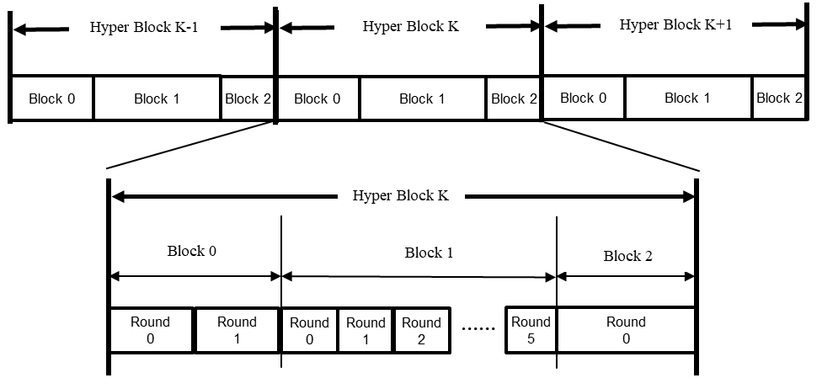
Figure 6-XXX – Example of timing diagram of hyper block-based mode

Each hyper block consists of a whole number of blocks. In the hyper block-based mode, it is allowed for the different blocks within a hyper block to have different configuration for block duration, round duration, and slot duration. On the other hand, the different hyper blocks have the same configuration.
The configuration for the hyper block structure can be repeatedly transmitted in every RCM by the controller. Hyper Block Structure IE (HBS IE), as defined in 7.4.4.56, can be used to signal the durations of each block in a hyper block. The HBS IE specifies the index of the corresponding block and includes a list of the block durations of all the blocks within the hyper block. Optionally, round duration and slot duration can also be delivered in HBS IE. On reception of the HBS IE with the RCM, a controlee can assume that hyper block structure is followed. Each block structure can be setup by specifying the Ranging Block Duration field, the Ranging Round Duration field, and the Ranging Slot Duration field in HBS IE and/or the ARC IE within the RCM. Alternatively, the hyper block structure may be setup and/or fixed by the next higher layer.
The hyper block-based mode is optional.

Revise the sub-clause 7.4.4.X Scheduling IE in 15-23-0062-03-04ab-text-for-scheduling-ie as follows:

7.4.4.X Scheduling IE
The Scheduling IE is used by the controller to schedule blocks or slots to be used by intended device. The Content field of the Scheduling IE shall be formatted as shown in Figure 7-X.
Bits: 0–3 | 4–6 | 7 | 8 | 9–15 | Octets: variable
Scheduling List Length | Scheduling List Type | Address Size | Receiver Address Present | Reserved | Scheduling List

Figure 7-X – Scheduling IE Content field format

The Scheduling List Length field indicates the number of elements in the Scheduling List field, each of which is formatted as per Figure 7-XX or Figure 7-XXX depending on the value of the Scheduling List Type field.
The Scheduling List Type field specifies how each element of the Scheduling List field is formatted. The Scheduling List Type field shall have one of the values specified in Table 7-Y.
Table 7-Y – Values of the Scheduling List Type field in the Scheduling IE
Scheduling List Type field value | The type of Scheduling List field
0 | Per-slot scheduling
1 | Consecutive slot scheduling
2 | Bitmap-based slot scheduling
3 | Periodic scheduling
4 | RSF scheduling
5 | Bitmap-based block scheduling
6–7 | Reserved

When the per-slot scheduling is used, each Scheduling List element schedules one slot to a device.
When the consecutive slot scheduling is used, each Scheduling List element schedules one slot to a device. Since there is no Slot Index field in the Scheduling List element, slots are scheduled in a sequential order. For example, the slot following the slot in which the Control Message is sent shall be scheduled for the device specified in the first Scheduling List element. There shall be no empty slot between scheduled slots.
When the bitmap-based slot scheduling is used, multiple slots may be scheduled to a device by using one Scheduling List element. A bitmap in each Scheduling List element represents the pattern of scheduled slots to a single device.
When the periodic scheduling is used, multiple slots may be scheduled to a device by using one Scheduling List element. A pattern of scheduled slots shall be represented by the size of scheduling step and the number of scheduling repetitions.
When the RSF scheduling is used, multiple slots may be scheduled to a device by using one Scheduling List element. At a slot, devices shall transmit RSF (defined in x.x.x) according to the Scheduling List element, and the composition of RSF is determined by the Scheduling List element.
When the Bitmap-based block scheduling is used, multiple blocks may be scheduled to a device by using one Scheduling List element. A bitmap in each Scheduling List element represents the pattern of scheduled blocks to a single device. For example, Scheduling IE with Scheduling List Type 5 may be transmitted with same cycle of HBS IE defined in 7.4.4.56 for hyper block-based mode scheduling and the bitmap in each Scheduling List element represents scheduled blocks to a single device in a hyper block.

The Address Size field specifies the size of the Sender Address field and the Receiver Address field. If the Address Size field is zero, short address shall be used for the Sender Address field and the Receiver Address field. If the Address Size field is one, extended address shall be used for the Sender Address field and the Receiver Address field.
The Receiver Address Present field when one indicates the presence of the Receiver Address field, or not present when zero.

The format of the Scheduling List field depends on the value of the Scheduling List Type field.
When the Scheduling List Type field is set to 0, Scheduling List elements shall be formatted as per Figure 7-Y.
Octets: 1 | 2/8
Slot Index | Sender Address
Figure 7-Y – Scheduling List element format when Scheduling List Type is 0
The Slot Index field is used to assign a slot index to the device identified by the Sender Address field.
The Sender Address field identifies each participating device.

When the Scheduling List Type field is set to 1, Scheduling List elements shall be formatted as per Figure 7-YY.
Octets: 2/8
Sender Address
Figure 7-YY – Scheduling List element format when Scheduling List Type is 1
The Sender Address field identifies each participating device.

When the Scheduling List Type field is set to 2, Scheduling List elements shall be formatted as per Figure 7-XX.

Bits: 0–1 | 2 | 3–7 | Octets: Variable | 2/8 | 0/2/8 | 0/1
Scheduling Bitmap Length | Bitmap Offset Present | Reserved | Scheduling Bitmap | Sender Address | Receiver Address | Bitmap Offset
Figure 7-XX – Scheduling List element format when Scheduling List Type is 2

The Scheduling Bitmap Length field specifies the size of the Bitmap field. The Scheduling Bitmap Length field shall have one of the values specified in Table 7-X.
Table 7-X – Values of the Scheduling Bitmap Length field in the Scheduling IE
Scheduling Bitmap Length field value | The size of Scheduling Bitmap field
0 | 8 bits bitmap
1 | 16 bits bitmap
2 | 32 bits bitmap
3 | 64 bits bitmap

The Bitmap Offset Present field when one indicates the presence of the Bitmap Offset field, or not present when zero.
The Scheduling Bitmap field contains a binary bitmap string. Each bit maps to the slots following the slot in which the Scheduling IE is transmitted. For example, if the Scheduling IE is sent in the slot whose index is 0 and the Bitmap Offset Present field is set to 0, the first bit corresponds to the slot whose index is 1. The bit is set to 1 to indicate that the corresponding slot is scheduled, otherwise the bit is set to zero to indicate that the corresponding slot is not scheduled. The first bit in time sent in the field refers to the first time slot and the subsequent bits refer chronologically to the subsequent time slots. When the number of bits sent in the Scheduling Bitmap field is greater than the number of remained slots, the last excess bits sent shall be ignored.
The Sender Address field identifies which device can send frames in scheduled slots.

The Receiver Address field, if present, indicates the device to which frames will be sent in scheduled slots.
The Bitmap Offset field specifies the number of slots between the slot on which the Scheduling IE is sent and the first slot to be scheduled. The first slot to be scheduled corresponds to the first bit in the bitmap. For example, if the Scheduling IE is sent in the slot whose index is 0 and the Bitmap Offset field is set to 5, the first bit corresponds to the slot whose index is 6.

When the Scheduling List Type field is set to 3, Scheduling List elements shall be formatted as per Figure 7-XXX.

Bits: 0–6 | 7–10 | 11–15 | Octets: 2/8 | 0/2/8
Starting Slot Index | Scheduling Step | Scheduling Repetition | Sender Address | Receiver Address
Figure 7-XXX – Scheduling List element format when Scheduling List Type is 3
The Starting Slot Index field indicates the first slot of the periodic scheduling pattern.
The Scheduling Step field specifies the number of slots in the gap between periodic scheduled slots.
The Scheduling Repetition field specifies the number of repetitions of scheduled slots within the periodic scheduling pattern.

The Sender Address field identifies which device can send frames in scheduled slots.
The Receiver Address field, if present, indicates the device to which frames will be sent in scheduled slots.

When the Scheduling List Type field is set to 4, Scheduling List elements shall be formatted as per Figure 7-YYY.

Bits: 0–6 | 7–10 | 11–15 | Octets: 2/8 | 0/2/8 | 1 | 1 | 1
Starting Slot Index | Scheduling Step | Scheduling Repetition | Sender Address | Receiver Address | Sequence Index | Number of Gaps | Sequence Repetition
Figure 7-YYY – Scheduling List element format when Scheduling List Type is 4
The Starting Slot Index field marks the first transmission slot after trigger step of multiple RSF transmission in the recurring periodic transmission pattern in unit of slots.
The Scheduling Step field specifies the number of slots in the gap between scheduled slots.
The Scheduling Repetition field specifies the number of scheduled slots within the periodic scheduling pattern.
The Sender Address field identifies which device can send frames in scheduled slots.

The Receiver Address field, if present, indicates the device to which frames will be sent in scheduled slots.
The Sequence Index field indicates the code index of MMRS that allocated to the device in this Scheduling List element relate to.
If sequence index field indicates the code indices of MMRS based on the length-128 complementary set, Number of Gaps field shall be used to specify the length of zero between two parts of the length-128 complementary set. The value of this field shall be between 0 and 64.
The Sequence Repetition field indicates the number of MMRS repetitions in RSF (i.e., N_MSR), and the value of this field shall be between 32 and 256.
When the Scheduling List Type field is set to 5(Bitmap-based block scheduling), Scheduling List elements is formatted as per Figure 7-Z.
Bits: 0–1 | 2–7 | Octets: 2/8 | 0/2/8
Block scheduling Bitmap Length | Reserved | Block Scheduling Bitmap | Sender Address
Figure 7-Z – Scheduling List element format when Scheduling List Type is 5
The Block scheduling Bitmap Length field specifies the size of the Block Scheduling Bitmap field. The Block Scheduling Bitmap Length field shall have one of the values specified in Table 7-X.
The Block Scheduling Bitmap field contains a binary bitmap string. Each bit maps to the blocks following and including the block in which the Scheduling IE is transmitted. For example, if there are three blocks in a Hyper Block defined in 6.9.7.4.5, the first, second and third bits correspond to the block whose index are 0, 1, and 2 in a Hyper Block respectively. The bit is set to 1 to indicate that the corresponding block is scheduled, otherwise the bit is set to zero to indicate that the corresponding block is not scheduled. When the number of bits sent in the Block Scheduling Bitmap field is greater than the number of remained blocks, the last excess bits sent shall be ignored.
The Sender Address field identifies which device can send frames in scheduled blocks.
If RDM IE defined in 7.4.4.44 and the scheduling IE defined in 7.4.4.x exist in the same control message, then each ERDEV(s) in enhanced HPRF mode shall only be scheduled by the scheduling IE defined in 7.4.4.x.

