IEEE P802.15
Wireless Specialty Networks

Project | IEEE P802.15 Working Group for Wireless Specialty Networks (WSNs) – 802.15.4ab
Title | Proposed Text for 4ab MAC - Hyper Block-based Mode
Date Submitted | 13 March 2023
Source | Youngwan So, Mingyu Lee, Taeyoung Ha, Aniruddh Rao Kabbinale, Clint Chaplin (Samsung Electronics) Jinjing Jiang, Alexander Kreb (Apple), Kuan Wu, Lei Huang, Rojan Chitrakar, Bin Qian, David Xun Yang (Huawei) Kangjin Yoon (Meta), Pooria Pakrooh, Bin Tian, Steve Shellhammer (Qualcomm), David Barras, Boris Danev (3dB Tech.) Zhenzhen Ye (Redpoint Positioning), Huan-Bang Li, Takeshi Matsumura (NICT), Pablo Corbalán Pelegrín and Srivathsa Masthi Parthasarathi (NXP) | E-mail: [youngwan.so@samsung.com]
Re: | Developing technical content for actual specification text.
Abstract | This document provides details of MAC features for 4ab especially for Hyper block-based mode
Purpose | Support development of technical content for the draft
Notice | This document has been prepared to assist the IEEE P802.15. It is offered as a basis for discussion and is not binding on the contributing individual(s) or organization(s). The material in this document is subject to change in form and content after further study. The contributor(s) reserve(s) the right to add, amend or withdraw material contained herein.
Release | The contributor acknowledges and accepts that this contribution becomes the property of IEEE and may be made publicly available by P802.15.

Insert the new sub-clause 6.9.7.3.5 after 6.9.7.3.4 as follows:

6.9.7.3.5 Hyper block-based mode
A hyper block is a group of ranging blocks. Hyper block-based mode uses the time structure that is periodic. Figure 6-XXX shows an example timing diagram of hyper block-based mode.
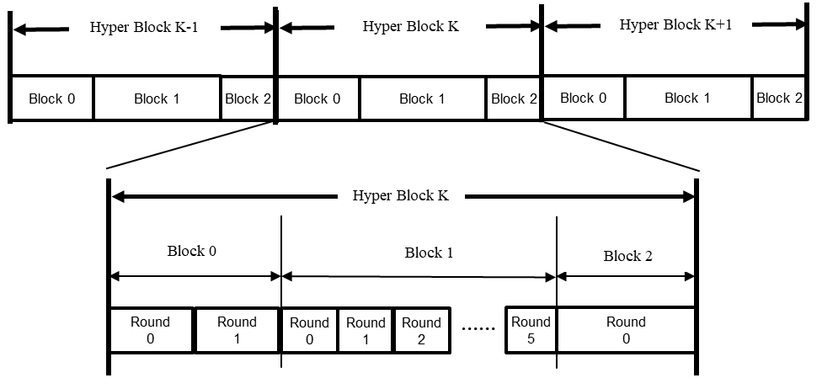
Figure 6-XXX – Example of timing diagram of hyper block-based mode

Each hyper block consists of a whole number of blocks. In the hyper block-based mode, it is allowed for the different blocks within a hyper block to have different configuration for block duration, round duration, and slot duration. On the other hand, the different hyper blocks have the same configuration.
The configuration for the hyper block structure can be repeatedly transmitted in every RCM by the controller. Hyper Block Structure IE (HBS IE), as defined in 7.4.4.56, can be used to signal the durations of each block in a hyper block. The HBS IE specifies the index of the corresponding block and includes a list of the block durations of all the blocks within the hyper block. Optionally, round duration and slot duration can also be delivered in HBS IE. On reception of the HBS IE with the RCM, a controlee can assume that hyper block structure is followed. Each block structure can be setup by specifying the Ranging Block Duration field, the Ranging Round Duration field, and the Ranging Slot Duration field in HBS IE and/or the ARC IE within the RCM. Alternatively, the hyper block structure may be setup and/or fixed by the next higher layer.
The hyper block-based mode is optional.

Insert the new subclause 7.4.4.56 after 7.4.4.55 as follows:
7.4.4.56 Hyper Block Structure IE (HBS IE)
The HBS IE is used by controller to send the hyper block structure configuration to controlees through RCM message. The Content field of HBS IE shall be formatted as illustrated in Figure 6-ZZZ.

Octets:2 | 1 | 1 | Variable
Hyper Block Index | Content Control | Block Description List Length | Block Description List
Figure 6-ZZZ – HBS IE Content field format
The Hyper Block Index field specifies the index of the Hyper block,
The Content Control field is formatted as per Figure 6-LLL, and indicates the presence of duration fields in the Block List, which is structured as per Figure 6-KKK.
Bits: 2 | 1 | 1 | 4
Block Duration Units | Round Duration Presence | Slot Duration Presence | Reserved
Figure 6-LLL – Content Control field format
The Block Duration Units field indicates the size of the Block Duration field as per Table XXX.
Table XXX. Block Duration Units field
Block Duration Units field value | Description
00 | Size of Block Duration field is 1 octets and the unit of Block Duration field is the number of rounds
01 | Size of Block Duration field is 2 octets and the unit of Block Duration field is the number of slots
10 | Size of Block Duration field is 3 octets and the unit of Block Duration field is the number of RSTU
11 | Reserved

The Round Duration Presence indicates the presence of the Round Duration field when it is”1”, and it is not present when it is “0” as per Figure 6-KKK.
The Slot Duration Presence indicates the presence of the Slot Duration field when it is “1”, and it is not present when it is “0” as per Figure 6-KKK.
Block Description List Length specifies the number of Block Description List elements in the Block Description List field. The number of Block Description List Elements shall be set equal to the number of blocks in the hyper block.
Block Description List field contains Block Description List elements each of which is structured as per Figure 6-KKK.

Octets: 1 | 1/2/3 | 0/1 | 0/2
Block Index | Block Duration | Round Duration | Slot  Duration
Figure 6-KKK – Block Description List field format

The Block Index field specifies the index of the block within the hyper block.
The Block Duration field is an unsigned integer that specifies the duration of a block. The size and the unit of the Block Duration field is determined by the Unit of Block Duration field as per Table XXX

The Round Duration field is an unsigned integer that specifies the duration of the round in units of slots, which is the number of slots in the round.

The Slot Duration field is an unsigned integer that specifies the duration of a slot in RSTU.

