IEEE P802.15
Wireless Personal Area Networks

Project | IEEE P802.15 Working Group for Wireless Personal Area Networks (WPANs)
Title | Text for UWB Native Discovery for Ranging Session and Channel Usage Coordination
Date Submitted | March 2023
Sources | Hongwon Lee(LG Electronics), …
Re: | Contribution to IEEE 802.15.4ab
Abstract
Purpose | This submission proposes text to for the IEEE Std 802.15.4ab specification framework document.
Notice | This document does not represent the agreed views of the IEEE 802.15 Working Group or IEEE 802.15.4ab Task Group. It represents only the views of the participants listed in the “Sources” field above. It is offered as a basis for discussion and is not binding on the contributing individuals. The material in this document is subject to change in form and content after further study. The contributors reserve the right to add, amend or withdraw material contained herein.

Insert the new sub-clause 1.2.2.3 after 1.2.2.2 in 15-22-0381-02-04ab-nba-uwb-ranging-text-proposal-for-15-4ab-tfd as follows:

1.2.2.3 Unified Native Discovery for initialization/setup and channel usage coordination
The initiator may send unified advertising poll (ADV-POLL2) packets opportunistically at times and intervals to its discretion as deemed suitable for the higher layer functionality to be supported. Similarly, the responder may opportunistically listen for incoming ADV-POLL2 packets. In the unified advertising poll (ADV-POLL2) packets, there are two kinds of information included. One is related to initialization/setup and the other is related to channel usage coordination. For initialization/setup, the operation is same as in 1.2.2.1. Additionally, unified advertising poll (ADV-POLL2) packets is used to announce scheduling information of the initiator which is already established Ranging Area Network (RAN1) with other responders to another initiator which tries to establish new RAN (RAN2). This scheduling information is used to establish new RAN (RAN2) of another initiator that ranging procedure is not overlapped with scheduled round procedure of RAN1. For this purpose, unified advertising poll (ADV-POLL2) packets includes information related to not only initialization/setup but also channel usage coordination.
The unified advertisement packet (ADV-POLL2) format is described in the following figure:
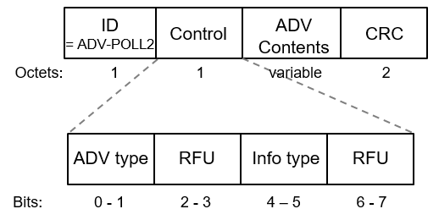
Figure 1.2.2.3.1 – Unified advertisement packet (ADV-POLL2)
The unified advertisement packet format is based on compressed PSDU type (1.5.2).
The ID field is a packet identification of compressed PSDU defined in 1.5.2. The ID field of unified advertisement packet is ‘0x23’ (ADV-POLL2).
The control field includes ADV type subfield and Info type subfield to determine ADV Contents. ADV type (Table 1.2.2.3.1) subfield and Info type (Table 1.2.2.3.2) subfield are defined in the following table:
ADV type | Advertisement packet type
00 | Ranging Session setup only
01 | UWB Per-Session Info only
10 | Ranging Session setup and UWB Per-Session Info
11 | Reserved
Table 1.2.2.3.1 – ADV type in ADV-POLL2
Depending on ADV type, the advertisement packet has different capabilities. The capabilities are described in the below.
- 00: Only for initialization and setup. If a responder finds this type of advertisement packet, it requests only Ranging session setup. In this case, Info type (Table 1.2.2.3.2) shall be set to ‘00’. The unified advertisement packet format can be constructed like in the following figure:

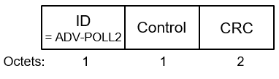
Figure 1.2.2.3.2 – Unified advertisement packet (ADV-POLL2) with ADV type ‘00’
- 01: Only for channel usage coordination. If a responder finds this type of advertisement packet, it obtains UWB Per-Session Info for channel usage coordination. In this case, Info type (Table 1.2.2.3.2) shall be set to ‘01’, ‘10' or ‘11’.
- 10: For both initialization and setup and channel usage coordination. If a responder finds this type of advertisement packet, a responder chooses action whether establishing Ranging session setup or obtaining UWB Per-Session Info for channel usage coordination. In this case, Info type (Table 1.2.2.3.2) shall be set to ‘01’, ‘10' or ‘11’.
Info type | UWB Per-Session Info type
00 | No UWB Per-Session Info field
01 | Minimum info in UWB Per-Session Info field
10 | UWB Per-Session Info field with Active Period
11 | UWB Per-Session Info field with round structure
Table 1.2.2.3.2 – Info type in ADV-POLL2
Depending on Info type, kind of information in UWB Per-Session Info is determined. The kind of information is described in the below:
- 00: The unified advertisement packet has no UWB Per-Session Info field. The packet format is described in the figure 1.2.2.3.2.
- 01: The unified advertisement packet has UWB Per-Session Info field including minimum info like block duration.
- 10: The unified advertisement packet has UWB Per-Session Info field including active period.
- 11: The unified advertisement packet has UWB Per-Session Info field including round structure such as round duration, the number of rounds in a block and active round indices.
In case info type is ‘01’, ‘10’ or ’11’, the unified advertisement packet can be described in the following figure:
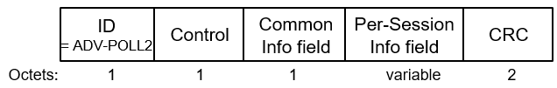
Figure 1.2.2.3.3 – Unified advertisement packet with Per-Session Info (ADV-POLL2)
TODO: Common Info field and Per-Session Info field [11] including UWB AP Info type should be defined in here.
TODO: In case UWB AP Present is ‘1’ in Common Info field, unified advertisement packet including UWB AP Info field [10] should be defined like in the following figure.

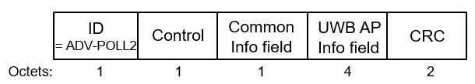
Figure 1.2.2.3.x – Unified advertisement packet with UWB AP Info (ADV-POLL2)
The ADV Contents field depends on ADV type and Info type as mentioned in the above. The unified advertisement packet formats in each ADV type and Info type combination are described in the following table:
 | ADV type = 00 | ADV type = 01 | ADV type = 10
Info type = 00 | Ranging Session Setup only. No Common Info field and no Per-Session Info field | - | -
Info type = 01 | - | Channel Usage Coordination only. Common Info field, and Per-Session Info field(UWB AP Present = 0, minimized info including block duration) or UWB AP Info field(UWB AP Present = 1) | Both Ranging Session setup and channel Usage Coordination. Common Info field, Per-Session Info field(UWB AP Present = 0, minimized info including block duration) or UWB AP Info field(UWB AP Present = 1)
Info type = 10 | - | Channel Usage Coordination only. Common Info field, Per-Session Info field(UWB AP Present = 0, including Active Period info.) or UWB AP Info field(UWB AP Present = 1) | Both Ranging Session setup and channel Usage Coordination. Common Info field, Per-Session Info field(UWB AP Present = 0, including Active Period info.) or UWB AP Info field(UWB AP Present = 1)
Info type = 11 | - | Channel Usage Coordination only. Common Info field, Per-Session Info field(UWB AP Present = 0, including round structure) or UWB AP Info field(UWB AP Present = 1) | Both Ranging Session setup and channel Usage Coordination. Common Info field, Per-Session Info field(UWB AP Present = 0, including round structure) or UWB AP Info field(UWB AP Present = 1)
Table 1.2.2.3.3 – ADV Contents cases
After transmitting ADV-POLL2 with ADV type ‘00’ on the initialization (or discovery) channel, the initiator shall listen for an incoming advertising response packet (ADV-RESP2) with Request mode ‘00’ in the subsequent ranging slot. Once a responder has received ADV-POLL2, it may transmit ADV-RESP2 with Request mode ‘00’ in the subsequent ranging slot. When the responder has transmitted ADV-RESP2 with Request mode ‘00’, it shall listen for a start of ranging (SOR) packet in the ranging slot following the ADV-RESP2 packet. The ADV-RESP2 packet format including Request mode is described in the following figure and table:
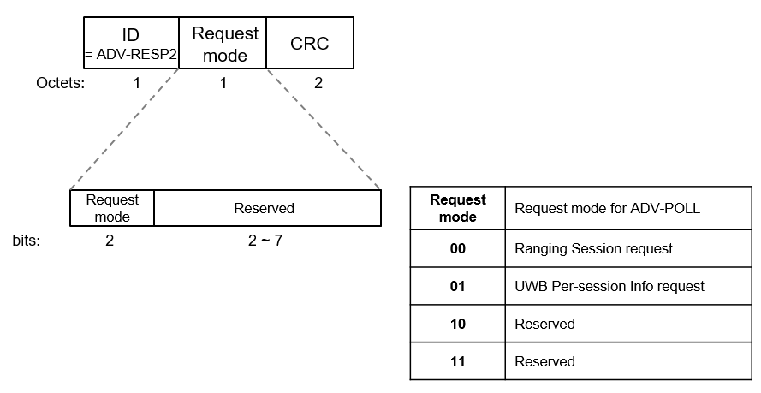
Figure 1.2.2.3.4 – Response packet format with Request mode (ADV-RESP2)
Request mode | Request mode for ADV-POLL2
00 | Ranging Session request
01 | UWB Per-session Info request
10 | Reserved
11 | Reserved
Table 1.2.2.3.3 – Request mode in ADV-RESP2
Request mode shall be set ‘00’ if ADV type in ADV-POLL2 is ‘00’ and Request mode shall be set to ‘01’ if ADV type in ADV-POLL2 is ‘ 01’. If ADV type in ADV-POLL2 is ‘10’, both Request mode can be used.
After transmitting the SOR packet, the initiator shall enter the ranging control phase. After the initiator has confirmed receipt of the RESP from the responder during ranging control phase, and unless initialization of further ERDEVs is required, the initiator shall discontinue ranging initialization and cease transmission of ADV-POLL2 packets. When the responder has transmitted ADV-RESP2 with Request mode ‘00’, it shall listen for a start of ranging (SOR) packet in the ranging slot following the ADV-RESP2 packet. Once the initiator has received an ADV-RESP2 with Request mode ‘00’ packet, it may transmit a SOR packet in the ranging slot following the ADV-RESP2 with Request mode ‘00’ packet.
After transmitting ADV-POLL2 with ADV type ‘01’ on the initialization (or discovery) channel, the initiator shall listen for an incoming advertising response packet (ADV-RESP2) in the subsequent ranging slot. The responder scanning the advertisement packet uses for not initialization and setup but channel usage coordination. In the ADV-POLL2 with ADV type ‘01’, UWB Per-Session Info field may be included in the packet. The responder uses the information directly for channel usage coordination or it may transmit ADV-RESP2 with Request mode ‘01’ in the subsequent ranging slot if it tries to obtain more channel usage information optionally. When the responder has transmitted the ADV-RESP2 with Request mode ‘01’, it shall listen for a channel usage information (CUI) packet in the ranging slot following the ADV-RESP2 packet. Once the initiator has received an ADV-RESP2 packet with Request mode ‘01’, it transmits a CUI packet in the ranging slot following the ADV-RESP2 packet.
After transmitting ADV-POLL2 with ADV type ‘10’ on the initialization (or discovery) channel, the initiator shall listen for an incoming advertising response packet (ADV-RESP2) in the subsequent ranging slot. The responder scanning the advertisement packet uses response packet (ADV-RESP2) for not only initialization and setup but also channel usage coordination. If the responder tries to establish session setup, ADV-RESP2 with Request mode ‘00’ is transmitted by the responder. When the responder has transmitted ADV-RESP2 with Request mode ‘00’, it shall listen for a start of ranging (SOR) packet in the ranging slot following the ADV-RESP2 packet. Once the initiator has received an ADV-RESP2 with Request mode ‘00’ packet, it may transmit a SOR packet in the ranging slot following the ADV-RESP2 with Request mode ‘00’ packet. If the responder tries to perform channel usage coordination, the responder uses the information directly for channel usage coordination in the advertisement packet ADV-POLL2) or the responder requests more channel usage information using Request mode in ADV-RESP2 with Request mode ‘01’ optionally. Once a responder has received ADV-POLL2, it may transmit ADV-RESP2 with Request mode ‘01’ in the subsequent ranging slot if the responder tries to obtain more channel usage information. When the responder has transmitted the ADV-RESP2 with Request mode ‘01’, it shall listen for a channel usage information (CUI) packet in the ranging slot following the ADV-RESP2 packet. Once the initiator has received an ADV-RESP2 packet, it may transmit a CUI packet in the ranging slot following the ADV-RESP2 packet.
The unified advertisement process for ranging session setup and channel usage coordination is exemplified in the following figures:
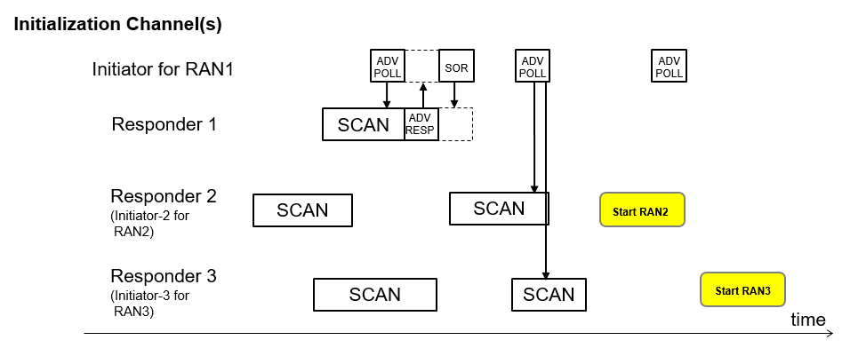
Figure 1.2.2.3.5 - Unified Native Discovery example 1
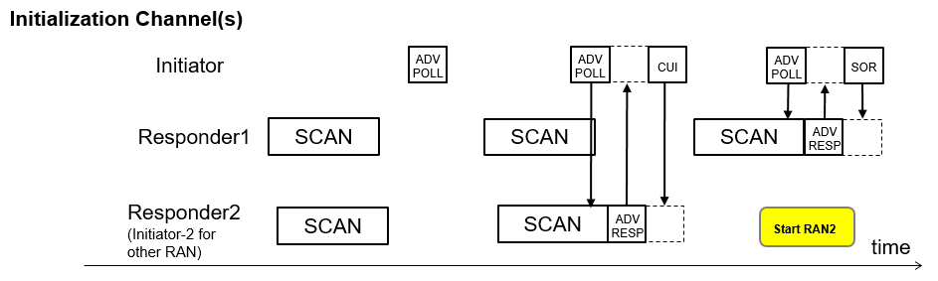
Figure 1.2.2.3.6 - Unified Native Discovery example 2

Revise the sub-clause 1.5.3 in 15-22-0381-02-04ab-nba-uwb-ranging-text-proposal-for-15-4ab-tfd as follows:

1.5.3 Compressed PSDU messages
Phase | Message | Octet 0 (Message ID) | Octets 1-N | Description
Control | POLL | 0x00 | […, CRC16] | A qualifying poll message. More poll messages are tbd.
 | RESP | 0x01 | […, CRC16] | A qualifying response message.
 | POLL2 | 0x?? | […,NbaChannelMap, CRC16] | After receiving NbaChannelMap from the initiator, the responder shall be able to determine the NbaChannelAllowList, and employ this list to assign a NB channels to each ranging with the mechanism defined in 2.2.3.  [8], [9], in session control process tbd.
Measurement Report | RPRT  (from responder) | 0x02 | […, CRC16] | A qualifying report message.
 | RPRT  (from initiator) | 0x03 | […, CRC16] | A qualifying report message.
 | RPRT2 | 0x?? | […,NbaChannelMap, CRC16] | [8], [9], in session control process tbd.
 |  | 0x04-0x1f |  | Reserved for in session control and report phases
 | ADV-POLL | 0x20 | […, CRC16]
 | ADV-RESP | 0x21 | […, CRC16]
 | SOR | 0x22 | […, CRC16]
 | ADV-POLL2 | 0x23 | […, Control, ADV Contents, CRC16] | Unified advertisement packet for initialization/setup and channel usage coordination
 | ADV-RESP2 | 0x24 | […, Request mode, CRC16] | Response packet for ADV-POLL2 to request initialization/setup or channel usage coordination
 | CUI | 0x25 |  | After receiving ADV-RESP2 with Request mode ‘01’, Channel Usage Information(CUI) including UWB Per-Session Info field may be transmitted
 |  | 0x26-0x2f |  | Reserved for out of session
 | Reserved | 0x7f-0xff | Vendor specific | 128x256 PSDUs with 2-byte message ID

Revise the sub-section 1.2 in 15-22-0381-02-04ab-nba-uwb-ranging-text-proposal-for-15-4ab-tfd as follows:

1.2 References
[1] 15-21-0409-01-04ab-narrowband-assisted-multi-millisecond-uwb
[2] 15-21-0605-00-04ab-nba-mms-uwb-mac-considerations
[3] 15-22-0080-00-04ab-nba-mms-uwb-mac-followup
[4] 15-22-0340-01-04ab-narrowband-channel-access-and-interference-mitigation-for-nba-mms-uwb
[5,6] 15-23-0004-01-04ab-nba-uwb-technical-framework-proposal (2023-Jan)
[7] SP 800-38A Recommendation for Block Cipher Modes of Operation: Methods and Techniques”, National Institute of Standards and Technology (NIST), December 2001.
[8] 15-22-0659-01-04ab-further-thoughts-on-the-mac-of-the-nba-mms-uwb
[9]15-23-0037-00-04ab-enhanced-poll-and-report-based-on-compressed-psdu-for-nba-mms-uwb
[10] 15-22-0573-01-04ab-follow-up-on-uwb-channel-usage-coordination
[11] 15-23-0067-00-04ab-updates-on-uwb-channel-usage-coordination

