Annex-x

Slot Configuration Profiles

Introduction
This annex describes the 3 profiles of the slot configuration default, static, and mobile. Based on the a priori deployment scenarios one of them can be selected.

Slot Profiles.
Bin is the basic building block of the slot, which is over a single subchannel, and the number of symbols varies based on the profile. All the profiles are given such that the slot contains the 48 data symbols maintaining the same data capacity, but the number of bins present in a slot varies.

Default Profile.

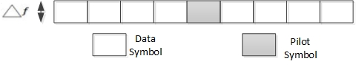
Figure 1 Default Profile Bin Structure

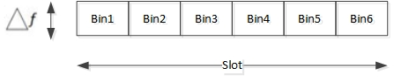
Figure 2 Default Profile Slot Structure

Static Profile.

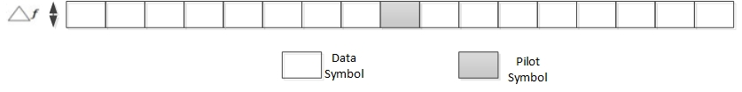
Figure 3 Static Profile Bin Structure

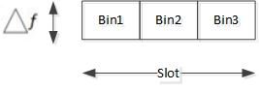
Figure 4 Static Profile Slot Structure

Mobile Profile.

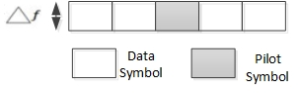
Figure 5 Mobile Profile Bin Structure

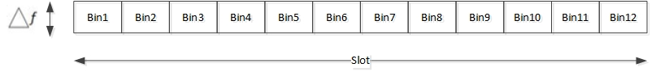
Figure 6 Mobile Profile Slot Structure

