IEEE802.16t Air Interface Protocol – MAC Layer
December 16th, 2022

Contents
2 Objective 3
3 Definition of Terms 3
4 ieee802.16t MAC layer design considerations 4
4.1 Minimizing MAC and PHY layer overhead 4
4.2 Support of low latency applications 4
4.3 Allocation messages reduction 5
4.4 Support of BSC by the BS MAC layer 5
5 Frame Formats 6
5.1 Frame Structure 6
6 Timelines 7
6.1 Super Frame Structure 7
6.2 Interval and Period 8
6.3 Frame duration and Super-frame duration 8
6.4 Synchronization 9
6.4.1 Between BS and Remotes 9
6.4.2 Between BSC and BSs in the control area 9
7 Bandwidth Allocation Services 10
7.1 Unsolicited Grant Service (UGS) 10
7.2 Semi Persistent Service (SPS) 11
7.3 Bulk Allocation Service (BAS) 12
7.4 Instantaneous Allocation Service 13
7.5 Delivery of Allocation Message 13
7.6 BS Scheduler 15
8 Allocation messages 16
8.1 Allocation Message (ALLOC-MSG) format 16
8.1.1 Allocation_IE 17
8.2 Allocation control message (ALLOC-CTRL-MSG) format 18
9 Simplified Network Entry 18
9.1 Simplified Network Entry with Authentication 19
9.2 Network Attach Request Message format 20
9.3 Network Attach Response Message format 21
10 Simplified Reporting Mechanism 21
11 Subchannel group relocation of Remotes 22
11.1 Pre-Network Entry 22
11.1.1 Allocation_IE for Subchannel group Relocation 23
11.2 Post-Network Entry 24

Objective
This document describes the proposed MAC layer modifications for the ieee802.16t air interface protocol.
The modifications are designed to reduce overhead, improve frequency utilization, and reduce latency when operating in narrow channels. In addition, the MAC layer modifications are designed to support resource allocations by a Base Station Controller.

Definition of Terms
BSC – Base Station Controller – A software system which coordinates use of Air Interface Resources for a set Base Stations and associated Remote Stations within a defined Control Area for the purpose of avoiding radio frequency Interference.
BS – Base Station
RS – Remote Station
MS – Mobile Station - a mobile remote radio.
Sector - An area under the control of a Base Station. All the Remote Stations (Fixed & Mobile) within this area communicate with the Base Station controlling the sector. A single base station can support more than one sector.
Control Area - A set of Base Stations under control of a single instance of the Base Station Controller.
AIR - Air Interface Resources - as defined by IEEE 802.16t, an allocation of radio frequencies and time.
PDU – Protocol Data Unit. The data unit transmitted/received over the air.
SDU – Service Data Unit. The packet transmitted/received over an Ethernet or serial interface, e.g., an Ethernet frame.
MCS – Modulation & Coding Scheme
UGS – Unsolicited Grant Service. A scheduling mode with a priori periodic allocation of bandwidth per service flow. UGS parameters are fixed.
SPS – Semi-Persistent allocations Service. A periodic allocation mode characterized by an allocation interval, allocation size, a validity period, an activation condition, and a termination condition. Both interval and validity period are defined in terms of frames.
BAS – Bulk Allocation Service. On demand or unsolicited resource allocation mode not related to a specific service flow.

ieee802.16t MAC layer design considerations

Minimizing MAC and PHY layer overhead
- The ieee802.16 MAC layer was originally designed to support channel bandwidth down to 1.25 MHz. The throughput at this channel size is relatively high. It can sustain highly dynamic, on demand, bandwidth allocation schemes with little impact on end user throughput and latency.
- The ieee802.16s/ieee802.16-2017 includes couple of MAC layer changes to enable support for channel bandwidth down to 100 KHz while maintaining the air interface protocol overhead in check. The original ieee802,16 scheduling modes (BE, NRTPS, RTPS, ERTPS & UGS) are maintained. Also, the DL & UL MAP messages are still transmitted at every frame along with the preamble and FCH which limits the minimal frame duration.
- The ieee802.16t air interface protocol is designed to support much narrower channels. As such, more drastic changes are needed here including the addition of new, less dynamic scheduling modes, the reduction in the volume of allocation messages and the decoupling of allocation messages from the frame.
- A significant overhead component in the air interface protocol is the DL and UL bandwidth allocation messages. This overhead is reduced by the introduction of new less dynamic scheduling modes, e.g., Semi-Persistent Service (SPS) scheduling mode and maintaining bandwidth allocation messages only for bursty applications. The bandwidth allocation messages are not tied to the frame and the allocation can be done into future frames beyond the current or the next frame.
- MAC and PHY layer overhead will be configurable, based on the application requirements. For example, the rate of preamble and the rate of all MAC messages (e.g., closed loop power control, link adaptation etc.) is optimized depending on whether the remotes are mobile or fixed and if mobile, depending on their speed.

Support of low latency applications
  - In a non-congested network, the latency is determined by the frame duration and the scheduling mode.
  - The frame duration is configurable. The frame duration is minimized for low latency applications. The per-frame MAC and PHY overhead is minimized by decoupling the preamble and the bandwidth allocation messages from the frame. Once decoupled, the MAC layer overhead does not depend on frame duration. The frame duration is now configured such that it can carry a full time sensitive SDU. Note that fragmentation can be used to transmit a SDU using frames shorter than the SDU length, but the latency will then be determined by the number of frames required to carry the entire SDU.
  - Latency reduction is also supported by a priori bandwidth allocation scheme, i.e., Unsolicited Grant (UGS), Semi-Persistent Service (SPS) and Bulk Allocation Service (BAS) scheduling modes.
  - Regular MAP messages are not used. Regular DL and UL traffic will employ UGS and SPS scheduling modes. In addition, optional Bulk Allocation Service (BAS) mode can be used to allocate bandwidth to the basic remote service flow in the UL and DL directions, even before the low latency SDU is received. The BS/Remote scheduler will use BAS allocations to serve new SDUs in the DL/UL direction based on their priority. Ad hoc allocation messages will be used for low latency bursty applications whenever bulk allocations are not available.

Allocation messages reduction
  - Reduction of allocation messages overhead for low-rate regular traffic applications and for the use of bulk allocations requires more flexible bandwidth allocation messages compared to the current MAP messages. New allocation messages will have the ability to specify allocations in the future beyond the current or the next frame.

Support of BSC by the BS MAC layer
  - The ieee802.16t BS MAC layer can operate in either stand-alone MAC or secondary scheduler MAC mode.
  - While operating in secondary scheduler MAC mode, the BS will support procedures required to send bandwidth requests and receive allocations from the BSC. These procedures include:
- Send to the BSC instantaneous, semi-persistent and bulk bandwidth requests.
- Bandwidth requests will cover both uplink and downlink direction.
- An instantaneous bandwidth allocation will cover the Time to Live (TTL) of the request. The SPS bandwidth request will specify the periodicity, the size per allocation and the validity of the request.
  - The BSC can also send unsolicited SPS and BAS allocations to the BSs.
  - When the BS operates in secondary scheduler mode, the BSC is responsible for the allocation of bandwidth in a way that avoids self- interference. Separation between interfering sectors may be done in either frequency or time or both. A super-frame structure with a configurable number of frames will be available to support flexible separation in time. The super frame structure will be synchronized between the BSC and all BSs within the control area.

Frame Formats

Frame Structure
- A Frame can start with Preamble or Data burst depending on the allocations.
- The frame duration is configurable. Assuming minimum of 3 slots in DL and 3 slots in UL for non-fragmentable connectivity maintenance, the minimum supported frame duration values as per the channel bandwidth is given in Table 1.

Δf, kHz | Frame Duration, ms | DL+UL slots Per Frame
5 | 100 | 9
6.25 | 62.5 | 7
12.5 | 50 | 11
25 | 20 | 9
50 | 10 | 9
Table 1: Minimum Frame Duration vs Subcarrier spacing.

- The DL:UL ratio is configurable based upon the application requirements.
- Bandwidth allocation will employ allocation messages (ALLOC-MSG) instead of MAPs. The allocation messages are decoupled from frames and are transmitted when needed.
- Given below are three possible frames formats which can occur at different times.
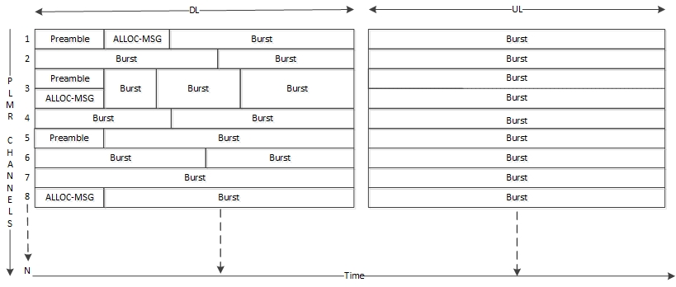
Figure 1 : Example Frame with Preamble, Allocation message and data burst

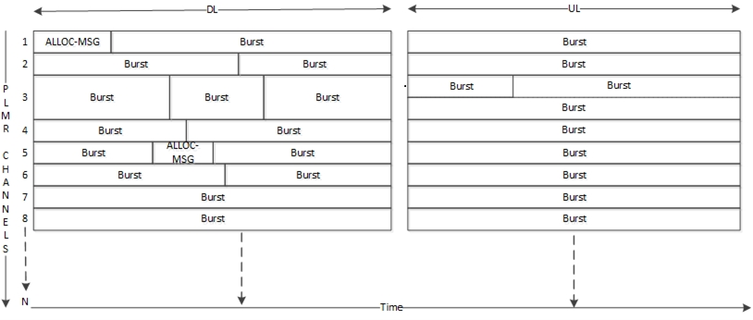
Figure 2 : Example Frame with Allocation message and data burst

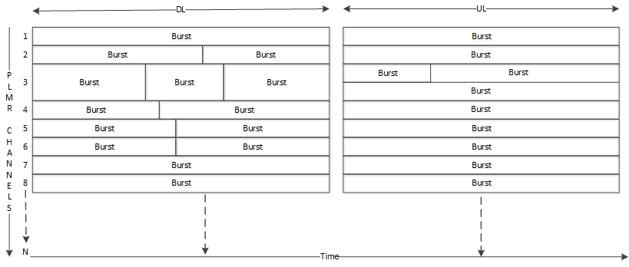
Figure 3 : Example Frame with data bursts

Timelines

Super Frame Structure
  - Time is divided into super-frames which are divided into frames. The number of frames in a super-frame is configurable.
Figure below is an example of a super-frame consisting of 10 frames where the duration of a frame is 100 ms.

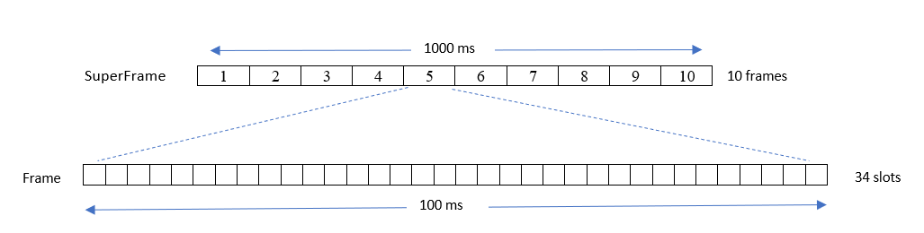
Figure 4 : Example Super frame structure

Interval and Period
- These terms are applicable to SPS allocations which are characterized by fixed size allocations and fixed slot intervals between successive allocations.
- The time duration between two successive allocations is termed an interval. There are fixed size allocations at every interval. The interval is specified in terms of frames.
- Period is the time for which the allocations are valid. A period can be infinite or finite. The finite validity period can be indicated in the number of intervals for which it is valid, i.e., finite period can be defined as an integer multiple of an interval.
- For example, allocation with interval of two frames and validity period of 10 intervals, spans over 20 frames.
- The location of the allocation within the frame, i.e., the slot offset, is considered from the beginning of the frame.

Frame duration and Super-frame duration
- The longer the frame, the longer the latency. Support of low frame duration is needed to support low latency requirement of high priority applications. The frame duration for such an application will be configured such that a complete PDU can be encapsulated in one frame.
- The objective of the super-frame is to provide an additional dimension of separation between sectors for the scheduler.
- With this amendment, the scheduling window may extend many frames into the future.
- The duration of a super-frame will be greater than the maximum interval among all UGS/SPS allocations.

Synchronization

Between BS and Remotes
- All Remotes are synchronized with the BS using Preamble or GPS.
- As per IEEE 802.16-2017, BS indicates the frame number in the allocation messages transmitted to remotes. Remotes use the frame number to synchronize with the frame number of the BS.
- The frame number is specified in 16 bits, and it resets after 64k. Please refer to Figure 5.

Between BSC and BSs in the control area
- All BSs are synchronized using GPS.
- BSC starts the super-frame when it boots up based on frame duration and number of frames per super-frame configuration.
- Frame within the super-frame is referred to as Frame offset, please refer to Figure 5.
- All new BSs shall use the Synchronization (Sync) message information to synchronize with BSC.
- BSC shall send the Sync message indicating the start of the super-frame in any of the upcoming 1PPS signals which aligns with start of super-frame.
- Sync message shall also carry the number of frames per super-frame information.
- Please refer to Figure 5 for super-frame synchronization using Sync message along with 1PPS signal.

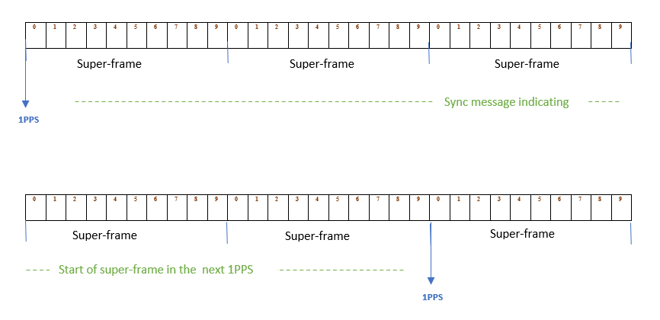
Figure 5 : Super-frame Synchronization

In the above Figure 5,
Frames per Super-frame : 10
Frame offset : 0 to 9 (frame within super-frame)
Frame duration : 20 ms
Super frame duration : 200 ms
Sync message : Sent from BSC to BSs indicating start of super-frame in the next PPS signal

Bandwidth Allocation Services

Unsolicited Grant Service (UGS)
- The scheduler allocates fixed size grants per interval and conveys the allocation through a one-time allocation message.
- The 802.16t UGS implementation is different from its 802.16-2017 implementation. In 802.16-2017 implementation, each fixed size repeated allocation is conveyed in DL-MAP/UL-MAP message which occurs every frame and the placement (location within the frame) of each repeated allocation may vary based on other allocation scheduled in that frame. But in 802.16t the allocation the placement (location within the frame) does not vary, and this is conveyed in one-time allocation message (ALLOC-MSG) during the start of allocation. Since the location is fixed, both BS and remote know the DL or UL repeated allocation in future and accordingly transmit/receive at the fixed location.
- UGS service is started after service flow creation and the allocation is based on QOS parameters of the service flow.
- The validity is infinite.
- The interval of a UGS allocation is defined in terms of frames.
- The following parameters are included in a UGS allocation.
  - The interval between successive allocations.
  - The size of the grant in bytes within each interval.
- The allocation is in slots assuming worst case MCS, i.e., the number of slots per allocation depends on the MCS. In case there is change in MCS the allocation size or grant may change but location of allocation remains fixed.
- If the MCS goes lower than assumed, there can be fragmentation affecting latency.
- Given below are the action taken at MS and BS.
  - If the MCS goes lower, remote shall borrow resource from other low priority service flow allocation if any. BS can provide an additional finite allocation over link adaptation period.
  - If the MCS is higher, the remote shall utilize the remaining allocation for other purposes.
- This scheduling mode is suitable for serving time sensitive applications with regular transmission cycles and fixed length SDU.
- UGS should be supported in both UL and DL.
- An uplink or downlink UGS allocation message is acknowledged by the remote.

Semi Persistent Service (SPS)
- SPS is a variation of UGS. It is dynamically activated and terminated.
- SPS is designed to serve a specific application with known characteristics. The respective SPS parameters are designed to accommodate the periodicity and packet size of the application.
- The service has a validity period which can be finite.
- The following parameters are included in an SPS allocation:
  - The interval between successive allocations.
  - The size of the individual allocation within each interval.
  - The validity period of the SPS allocation.
  - The activation and termination criteria.
- SPS can be established and terminated dynamically during operation. SPS service flow parameters are defined in the SF configuration file.
- The activation condition is the detection of an SDU with one or more classifiers matching the condition. The termination of the SPS service flow is the absence of the SDU matching the condition for a certain period. SPS service flows may be established in both DL and UL.
- Allocation control message (ALLOC-CTRL-MSG) is used to activate or terminate the SPS.
- If the MCS is below the assumed worst case, the remote may use other low priority service flow allocation.
- An uplink or downlink SPS allocation message is acknowledged by the remote.

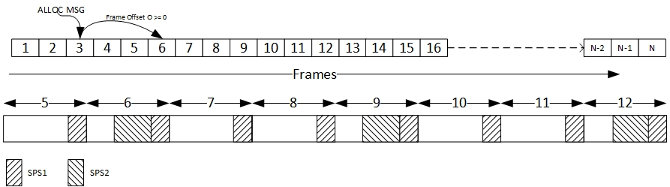
Figure 6 : SPS allocations
The figure above shows:
- First row with frames spanning from 1 to N.
- Allocation message in frame 3 indicating SPS allocation (SPS2) with interval of 3 frames starting from the 6th frame (Frame offset O = 3).
- Second row is the enlarged view of frames with allocations. The allocations can be applied to DL or UL subframes.
- SPS1 is an ongoing SPS allocation with 1 frame interval and SPS2 has started from frame number 6.

Bulk Allocation Service (BAS)

- On demand or unsolicited allocations to all the remotes in uplink.
- The bulk allocation may be either a onetime allocation or a repeated allocation.
- In the repeated allocation case, unlike in the case of SPS, the allocation is not designed to serve a specific application with specific periodicity and packet size. Here are the BAS use case examples:
  - Connectivity maintenance in DL and UL.
  - In advance allocation of bandwidth by the BS equally between all remotes or non-equally, depends on the volume of DL/UL traffic to/from each remote.
  - BAS will be used to allocate bandwidth in both DL and UL.

Instantaneous Allocation Service
This allocation mode is used when the BAS resource allocations are not available to serve the SDU.
- The scheduler will consider on demand bandwidth request.
- In case of secondary scheduler MAC mode, the BS will request bandwidth for each SDU, but the BS may also send a request for multiple SDUs with the same attributes (same direction, same priority, etc.).
- The scheduler will allocate resources to remotes considering priority and maximum latency.
- There can be an upper limit on the resource allocated per remote. This is to avoid starvation of other waiting remotes.

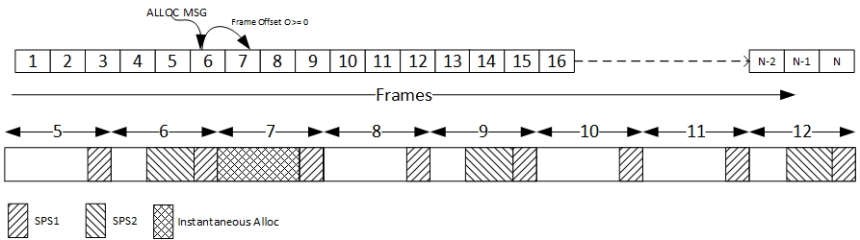
Figure 7 : Instantaneous allocation along with SPS
The figure above shows:
- Allocation message in frame 6 indicating Instantaneous allocation in Frame 7 with an offset of 1 frame (Frame Offset O= 1).
- The allocations can be applied to DL or UL subframes.

Delivery of Allocation Message
In case of UGS and SPS allocations where the allocations are repeated, the BS must ensure the allocation message is delivered to the remote.
There following measures shall be taken to guarantee the delivery of an allocation message.
- The allocation message shall be transmitted in Robust FEC code.
- Remote shall acknowledge the reception of allocation message by sending ACK message (ALLOC-CTRL-MSG, see Table 6 ) with control code set to Acknowledge.
- In case of uplink allocations, BS can start the allocation after sending the allocation message and monitor the status. The remote can start using the allocation after receiving allocation message.
- In case of downlink allocations, BS shall schedule allocation in future frame offset considering the waiting period for ACK message and can start allocation only after receiving ACK message from the remote.
- BS can resend the allocation message,
  - In uplink, if BS does not receive ACK within the timeout period nor transmission in the allocation.
  - In Downlink, if BS does not receive ACK within the timeout period.
The state sequence for uplink allocation message is shown in Figure 7.
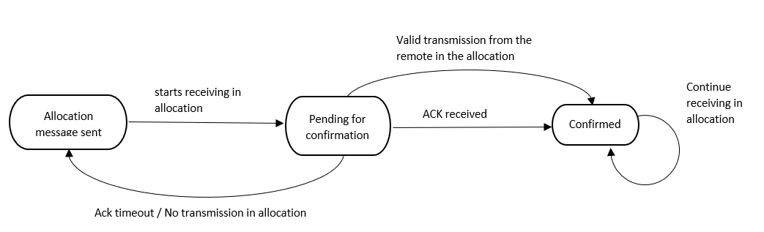
Figure 8 : Uplink UGS/SPS Allocation state machine, BS side

The state sequence for downlink allocation message is shown in Figure 8
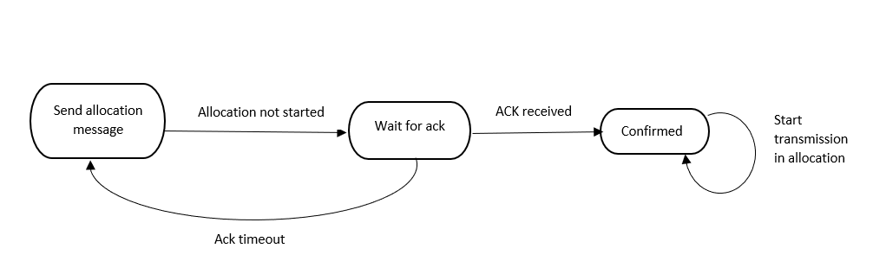
Figure 9 : Downlink UGS/SPS allocation state machine, BS side

BS Scheduler
- The BS scheduler will be scheduling for future frames as follows:
  - Instantaneous allocations within a time spanning one super-frame.
  - UGS/SPS occurring across super-frames within the validity period.
  - Bulk allocations occurring across super-frames can be one-time or repetitive with validity period .
- The scheduler maintains information of scheduled allocations which are valid. When scheduling a request, the scheduler must use this information to determine the resource availability in the future frames and accordingly allocate the resources.
- The scheduler performs scheduling on a “subchannel group” basis.
- The allocations are communicated to the remotes by Allocation messages (ALLOC-MSG). Allocation messages are sent over each self-sufficient subchannel group for allocations to remotes present in that subchannel group.
- In case secondary scheduler MAC mode, the BS scheduler determines the resource allocated on any subchannel group based on the downlink and uplink allocations granted by the BSC for that subchannel group. In this mode, the BS shall have mixed operations, scheduling the available slots as primary and requesting for bandwidth as secondary.
- In case of standalone MAC mode, the BS scheduler calculates the resource available on any subchannel group based on the number of subchannels in the group.

Allocation messages
- Allocation message will be transmitted when needed on robust modulation (configured minimum DL FEC).
- Depending on the traffic needs, an allocation message can have DL allocations only, UL allocations only or both DL and UL allocations.
- Resource allocations will be of three types, instantaneous, semi persistent and bulk
- An allocation message will indicate the future frame number, slot offset within the frame where the allocations starts and the number of slots within the allocations.

Allocation Message (ALLOC-MSG) format
- Allocation message defines instantaneous and semi-persistent allocations in DL and UL.
- Allocation message can have DL allocations only, UL allocations only or both DL and UL allocations.
- Allocation message is divided into two parts, header and allocation information.
- The header is of 6 bytes and will be transmitted on Downlink Robust FEC code of the BS.
- The allocation information is of variable length, and it can be transmitted on the least common downlink FEC code of the remotes being allocated in the message.
- The following parameters are included in the Header.
- The Allocation information length in slots. If the length specified is zero, then there is no allocation information. BS can transmit such allocation message with header for synchronization purpose.
- Frame number.
- FEC code for the allocation information. This can be decided based on the downlink FEC code of the remotes being allocated in this message. The least common DL FEC code will be used to transmit allocation information.

Syntax | Size(bit) | Notes
Allocation_Message () { | --- | ----
Header { |  | 6 bytes header
Header Type | 1 | 1: Allocation message header 0: GMAC header  This field is used to distinguish between GMAC header and Allocation message header.
Message length | 4 | Allocation information length in terms of slots.
Frame Number | 16 | Current frame number, used for Synchronization
FEC Code | 4 | FEC Code of Allocation information (message excluding header)
BS EIRP | 8 | Signed Integer from –128 to 127 in unit of dBm
Reserved | 7
HCS} | 8 | CRC for upper 5 bytes.
Allocation_information { | ---
while (Message length) { |  | while remaining data
Allocation_IE} | 48 | See Allocation_IE format
}
HCS} | 8 | CRC for Allocation_information
Table 2 : Allocation message format

Allocation_IE

Syntax | Size  (Bit) | Notes
Allocation _IE () { | __ | __
Direction | 1 | 0: Downlink 1: Uplink
Allocation ID | 5 | Identifier
DIUC/UIUC | 4 | FEC code
CID | 8 | Basic CID
Slots | 8
Frame offset | 4 | Frame offset indicating future start frame number
Slot offset | 6 | Slot offset within the future frame
Interval | 4 | Number of frames in the interval.  1 to 0xFF: Used in UGS, SPS and Bulk allocations.  0 : Instantaneous
Validity Period | 8 | In terms of intervals. (Number of repeated allocations)  1 to 0xFE: finite  0xFF: infinite  0: Instantaneous
}
Table 3 : Allocation IE format

DIUC
A 4-bit DIUC shall be used to define the data burst and other IEs.
DIUC value | Usage
0-7 | Data IE
8-15 | Reserved
Table 4 : DIUC values

UIUC
A 4-bit UIUC shall be used to define the data burst and other IEs.

UIUC value | Usage
1-8 | Data IE
9 | Power Control IE
10 | Periodic Ranging IE
11 | SubchannelGroup_Relocation_IE
12 | Initial Ranging IE
13 | Safety Zone IE
14 | CDMA Allocation IE
15 | Reserved
Table 5 : UIUC values

Allocation control message (ALLOC-CTRL-MSG) format
Syntax | Size(bit) | Notes
Allocation_Control_Message () { | --- | ----
Management Message Type | 8 | ----
Allocation ID | 4
Control code | 4 | 0 : Cancel  1: Acknowledge  2: Activate  3: Terminate  4 to 15 : Reserved
} | --- | ----
Table 6 : Allocation control message format

Simplified Network Entry
- The 802.16-2017 network entry procedure involves multiple message exchanges between BS and remote after initial ranging phase. In 802.16t implementation the network entry procedure is simplified with minimum message exchanges between BS and MS.
- The multiple network entry states (Ranging, Capability negotiation (SBC), Registration) are replaced with a single state (Network Attach).
- The Network Attach message exchanges will carry only essential parameters required for network entry.
- The figure below describes the Simplified Network entry procedure, starting from the DL acquisition.

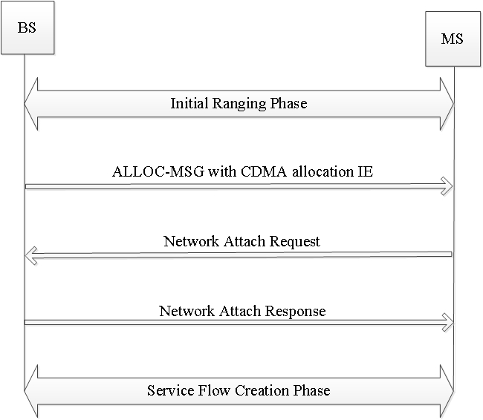
Figure 10 : Simplified network entry

Simplified Network Entry with Authentication
- With Authentication, there is an intermediate message exchange between BS and MS before network entry. The message Pre-Network Attach response message will carry all the necessary parameters needed for remote to proceed to Authentication phase.
- After completing Authentication, the remote will send Post Authentication Network Attach request message and BS will respond with Network Attach Response.

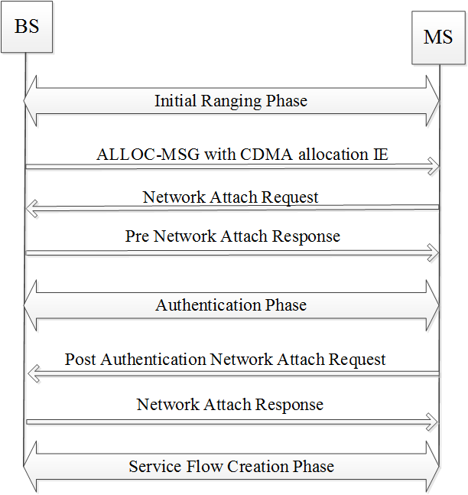
Figure 11 : Simplified Network entry with Authentication

Network Attach Request Message format

Syntax | Size(bit) | Notes
Network_Attach_Request () { | --- | ----
Management Message Type | 8 | ----
MS Mac Address | 48 | MAC Address
MS IP Address | 32 | IPv4 Address
Authentication Type | 3 | 0 : Security disabled  1 : EAP TLS  2 : EAP TTLS_CHAP  3 : EAP TTLS_MS_CHAP  4 : MS_CHAPv2  5 to 7 : Reserved
Encryption Type | 1 | 0 : Security Supports AES 128 Encryption method  1 : Security Supports AES 256 Encryption method
DL FEC Code | 4 | Maximum DL FEC Code
UL FEC Code | 4 | Maximum UL FEC Code
Reserved | 4 | Unused
} | --- | ----
Table 7 : Network Attach Request message format

Network Attach Response Message format

Syntax | Size(bit) | Notes
Network_Attachment_Response () { | --- | ----
Management Message Type | 8 | ----
Response Message | 1 | 0: Accept  1 : Reject
If (Response Message = = Accept) { | --- | ---
MS MAC Address | 24 | The least significant 24 bits of the MS MAC address.
BS MAC Address | 24 | The least significant 24 bits of the Base Station MAC address.
BS IP Address | 32 | IPv4 Address
Basic CID | 8 | Basic CID assigned by BS.
Primary Management CID | 16 | Primary Management CID assigned by BS. Security Support Parameters
Mobility Features Support | 3 | 0: Mobility (HO) support  1: Sleep mode support  2: Idle mode support
Reserved | 4
} | --- | ----
else if (Response Message = =Reject) { | --- | ----
Reason | 7 | 0 : Capabilities Mismatch, Others: Not specified
} | --- | ----
} | --- | ----
Table 8 : Network Attach response message format

Simplified Reporting Mechanism
- Remote will send unsolicited Compressed Report response message to BS at an indicated or configured periodicity.
- This message carries minimum parameters needed for Link adaptation as compared to 802.16e standard Report response message.

Syntax | Size(bit) | Notes
Compressed_Report_Response () { | --- | ----
Management Message Type | 8 | ----
CINR | 8 | Averaged CINR measurement report
RSSI | 16 | Averaged RSSI measurement report
Current Tx power | 8 | Current transmission power of MS
Max DL FEC | 4 | Max FEC code supported by MS
Max UL FEC | 4 | Max FEC code supported by MS
}
Table 9 : Compressed Report Response format

Subchannel group relocation of Remotes
This feature allows BS to relocate the remote from one subchannel group to another subchannel group. Relocation can happen either before network entry (Pre-Network Entry) or after network entry (Post-Network Entry) of the remote. Both the scenarios are described below.

Pre-Network Entry
- BS can relocate the new remote (performing Initial Ranging) to new subchannel group just after successful ranging, before creating remote connections (basic or primary).
- BS will decide upon the new preferred subchannel group and convey the information to remote by sending ALLOC-MSG with subchannel Group Relocation IE.
- The following parameters are included in Subchannel Group Relocation IE.
  - New subchannel group information.
  - Unique ranging code with which the remote needs to do ranging in the new subchannel group.
  - Ranging code to identify the remote which needs to relocate. This ranging code would be the code which BS would have received from the remote during initial ranging.
- Remotes on receiving this IE will pass the new subchannel group and unique ranging code information to PHY. Remote will relocate to the new subchannel group and transmit unique ranging code in the next ranging opportunity available in the new subchannel group.
- BS will identify the relocated remote based on the unique ranging code and proceed with the network entry procedure.

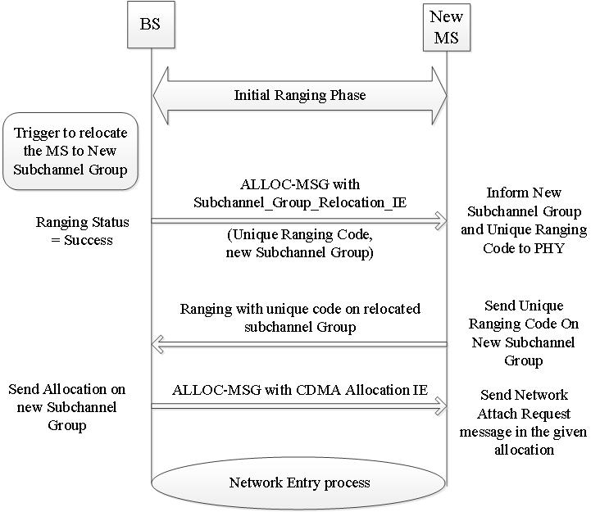

Figure 12 : Subchannel group relocation pre-network entry

Allocation_IE for Subchannel group Relocation

Syntax | Size  (Bit) | Notes
Allocation _IE () { | __ | Total 48 bits
Direction | 1 | Uplink, set to 1
UIUC | 4 | SubchannelGroup_Relocation_IE , set to value 11
New Subchannel group | 10 | Up to 512 subchannel groups
Unique Ranging code | 8 | code for ranging in new subchannel group
Ranging code | 8 | Initial ranging code to intimate which remote
Reserved | 17 | Unused, Set to 0
Table 10 : Allocation IE format for Subchannel group relocation

Post-Network Entry
- BS can relocate a connected remote (Network entered remote) to different subchannel group at any point of time.
- BS will send “SubchannelGroup_Relocation_Request” management message on basic CID to remote it intends to relocate. This message will contain information about the new subchannel group and the unique ranging code with which remote needs to do ranging in the new relocated subchannel group.
- BS will monitor the remote relocation to new subchannel group by starting a Relocation Timer.
- On receiving unique ranging code on the new relocated subchannel group the BS will stop the relocation timer and will proceed towards allocating in the new subchannel group for the remote. If unique ranging code it not received within the relocation time, BS will attempt for retries by resending SubchannelGroup_Relocation_Request message.

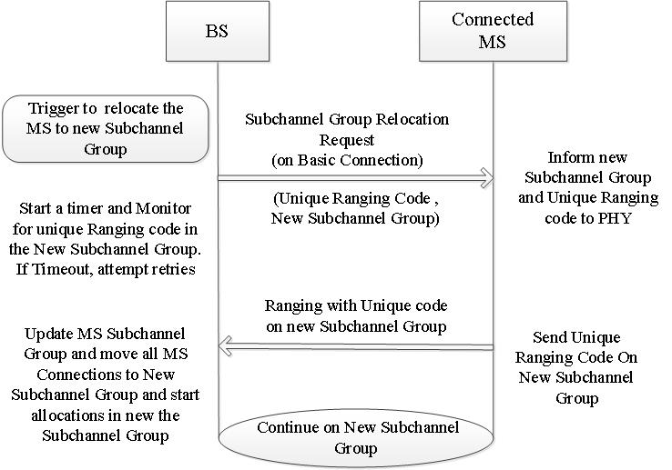
Figure 13 :Post-Network Entry Subchannel group Relocation

Syntax | Size  (Bit) | Notes
SubchannelGroup_Relocation_Request () {
Management Message Type | 8 | __
New Subchannel group | 10 | Up to 512 subchannel groups
Unique Ranging code | 8 | code for ranging in new subchannel group
}
Table 11 : Subchannel Group Relocation Request message format

