IEEE802.16t Air Interface Protocol – Physical Layer
December 1, 2022

Contents
1 Introduction 4
2 Terminology 4
3 PHY Layer Description 5
3.1 Effective channels, their partitioning into subchannels and subchannel groups. 5
3.1.1 Partitioning of a non-continuous effective channel 5
3.1.2 Partitioning of a non-continuous effective channel 5
3.1.3 Partitioning of a continuous effective channel 6
3.2 Channel span 6
3.3 Self sufficiency 7
3.3.1 Base station 7
3.3.2 Remote 7
3.3.3 Subchannel groups 7
3.3.4 Self-sufficiency advantages: 7
3.4 Waveforms 7
3.4.1 Downlink 7
3.4.2 Uplink 8
3.4.2.2 SC-FDMA Baseband Signal Generation (Single subchannel) 8
3.5 Frame structure 10
3.5.1 TDD Frame Structure 10
3.5.2 Frame Duration 11
3.5.3 TTG and RTG configuration 12
3.6 Resolution of air interface resource allocation 12
3.6.1 Bins and slots formation 12
3.6.2 Modulation and FEC Rates: 13
3.6.3 Mapping of bins into slots & bytes vs MCS 13
3.7 Downlink transmitter 14
3.7.1 Channel coding 14
3.7.2 Slot Formation 16
3.7.3 Sub-Carrier Mapping 16
3.7.4 IFFT & CP Addition 16
3.7.5 TX signal filtering 16
3.7.6 Downlink Preamble Transmission 17
3.8 Uplink transmitter 19
3.8.1 Channel coding 20
3.8.2 Slot Formation 20
3.8.3 DFT 20
3.8.4 Sub-Carrier Mapping 20
3.8.5 IFFT & CP Addition 20
3.8.6 TX Filtering 20
3.8.7 Ranging 20
3.9 Channel quality measurements 21
3.10 Transmitter requirements 21
3.11 Receiver requirements 21
3.12 Frequency control requirements 21
4 Informative Section – rationale for changes: 22
4.1 System-level PHY Design Aspects 22
4.1.1 Performance Analysis (derived from SRD:) 22

Introduction
This document describes a proposed PHY layer to meet the IEEE802.16t SRD and SDD. It is designed to support operation in channel bandwidths greater than or equal to 5 kHz and less than 100 kHz. It also supports aggregated operation in adjacent and non-adjacent channels.

Terminology
- Continuous band: a continuous spectrum range allocated to an organization and under its exclusive control. Example: the IVDS band in the US consists of 1 MHz between 218 MHz to 219 MHz.
- DL: Downlink
- UL: Uplink
- Private Land Mobile Radio (PLMR) system: traditional Push to Talk (PTT) conventional or trunked radio system.
- PLMR channel: an RF channel allocated to PLMR system usage. This is typically a 6.25 kHz, a 12.5 kHz or a 25 kHz wide channel but other channel bandwidths are also used, e.g., 7.5 kHz, 15 kHz and 50 kHz.
- PLMR band: a spectrum range containing some adjacent or non-adjacent PLMR channels.
- Subchannel: a partition of a PLMR channel or a partition of a continuous band which serves as a minimal entity for allocation in the frequency domain. A PLMR channel may be considered a single subchannel or it may be partitioned into multiple subchannels. For example, in a PLMR band with a mix of 6.25 kHz, 12.5 kHz and 25 kHz wide PLMR channels, the subchannel bandwidth may be defined as 6.25 kHz. In this case, a 6.25 kHz PLMR channel will be considered a single subchannel, a 12.5 kHz PLMR channel will be two subchannels and a 25 kHz PLMR channel will be considered to be four subchannels. Subchannel bandwidth is configurable and can go as low as 5 kHz.
- Subchannel group: any subset of subchannels configured as such. The subchannels within the subchannel group may be adjacent or non-adjacent to each other. A subchannel group may consist of one or more subchannels.
- Effective channel: an aggregation of adjacent or non-adjacent subchannels used in one sector. Two types of effective channels are supported by this standard:
  - Continuous effective channel: all subchannels within the effective channel are available.
  - Non continuous effective channel: One or more subchannels within the effective channel are not available.
- Effective channel span: the frequency range extending from the low edge of the lowest frequency subchannel to the high edge of the highest frequency subchannel in the effective channel.
- Peer-to-peer communication: communication between two remotes.
- Direct peer-to-peer communication: peer-to-peer communication when no infrastructure is used. A DPPRS may be used for range extension if needed (a new mode being defined in the 16t amendment).
- Peer-to-peer communication through base station infrastructure: peer-to-peer communication through the PtMP base station infrastructure (already defined in 802.16-2017 as multi-hop relay).
- Direct Peer-to-Peer Repeater Station (DPPRS): A repeater that uses direct peer-to-peer communication between direct peer-to-peer stations.
- Direct Peer-to-Peer Station (DPPS): Equipment that supports direct peer-to-peer communication.

PHY Layer Description

Effective channels, their partitioning into subchannels and subchannel groups.
Figure 1, Figure 2 and Figure 3 show three examples of non-continuous and continuous channels

Partitioning of a non-continuous effective channel
Figure 1 shows the partitioning of a non-continuous effective channel into subchannels and subchannel groups. Subchannel group 1 consists of a single subchannel while subchannel group 3 consists of eight subchannels. Certain subchannels, e.g., subchannels 2, 7, 8, 17, 19, 22 etc. are not available. All subchannel groups in this example consists of adjacent subchannels.
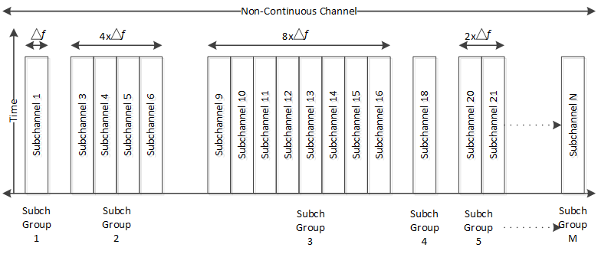
Figure 1: An example of non-continuous effective channel partitioning

Partitioning of a non-continuous effective channel
Figure 2 shows the partitioning of a non-continuous effective channel into subchannel groups, some of which consist of adjacent subchannels and some of which consist of non-adjacent subchannels. Subchannel groups 2 and 3 consist of non-adjacent subchannels. As in the Figure 1 case, certain subchannels, e.g., subchannels 2, 4, 7, 8, 14, 17, 19, 22 etc. are not available.
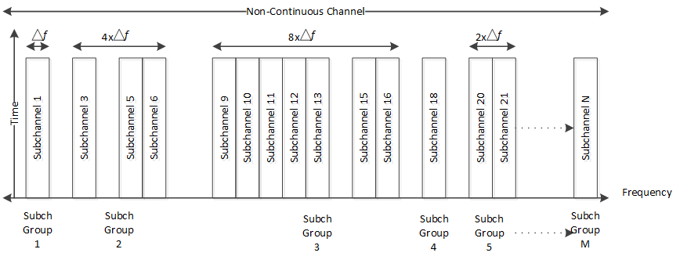
Figure 2: Partitioning of a non-continuous effective channel with a non-adjacent subchannel group

Partitioning of a continuous effective channel
Figure 3 shows the partitioning of a continuous effective channel into subchannels and subchannel groups.
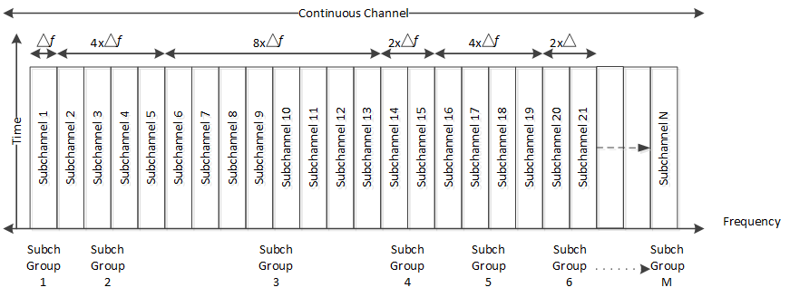
Figure 3: Partitioning of a continuous effective channel

Channel span
The effective channel span may be between the minimum bandwidth of a single subchannel (5 kHz) and up to 10 MHz. Aggregation of the two bands of a paired spectrum where the separation between the two bands exceeds 10 MHz can be implemented by means of frequency translation but such means are not part of this standard.

Self sufficiency

Base station
The sector base station controls the bandwidth of an entire effective channel:
- All the downlink traffic to the remotes in the sector is transmitted by the base station.
- All the uplink traffic in the sector from the remotes is received at the base station.
- The base station allocates the air interface resources within the effective channel to the remotes in the sector.

Remote
Each of the remotes in the sector operate over one subchannel group.

Subchannel groups
Subchannel groups are self-sufficient in terms of supporting communication between the base station and remote stations including DL and UL synchronization, ranging, bandwidth allocation, and network entry. The remotes send and receive data over one subchannel group. To support its communication with the base station, the remote does not need to listen on any other subchannel outside its subchannel group.

Self-sufficiency advantages:
  - Multiple types of remotes can be developed depending on the application. For example, the system may employ a low-end remote designed to operate on a single subchannel and a high-end remote designed to operate on multiple subchannels.
  - A remote transmitting on one subchannel does not need as much power as a remote transmitting on multiple subchannels.
  - By receiving on one subchannel, a remote may be able to better mitigate interference caused by other subchannel signals.
  - Low end remote can be cost effective and will have better battery life.
  - Partitioning of channel can be done based on the application needs.

Waveforms

Downlink
Transmission in the downlink direction employs OFDM with a single subcarrier per subchannel. FFT sizes of 16, 32, …. through 512 are proposed to support up to 512 subchannels. A subchannel bit map is used to turn off any unused subchannel.
Refer section 8.4.2.3 to 8.4.2.5.

Uplink
Transmission in the uplink direction employs Single Carrier FDMA (SC-FDMA).
The objective of the SC-FDMA waveform is to reduce Peak to Average Power Ratio (PAPR) relative to OFDM. This allows lower peak TX power for a given average TX power and thereby improve remotes’ implementation complexity and power efficiency.
Data symbols are mapped into bins and slots as descried in 3.6 . DFT is applied to the modulated data with DFT size depending on the number of subchannels used for transmission. Further they are mapped to the subchannels corresponding to data and pilot.
In the continuous time domain, the signal generated is a sum of scaled exponentials each having a frequency corresponding to the subchannel the modulated symbol belongs to. The scaling factor is the DFT applied modulated symbol in the subchannel. Since the adjacent subchannels are separated by a frequency Δf, the frequency of the exponential corresponding to the kth subchannel is given by kΔf. An additional half subchannel shift is done to diminish the DC distortion making the overall frequency (k+½)Δf. Each of these waveforms spanning for a time duration equal to the symbol duration (symbol duration = reciprocal of the subchannel spacing) along with cyclic prefix addition are summed up to form the resultant waveform.

SC FDMA baseband signal generation, Subchannel grouping
The equations are as given below for odd and even number of subchannels. After the waveform in the continuous time have been obtained for one symbol, this method is repeated for the total number of symbols in the slots.
The time-continuous symbol l signal sl(t) is defined by
For even number of subchannels ($N_{subchannel}$)
$$S_{l}(t) = \sum_{k=-\left[N_{subchannel}/2\right]}^{\left[N_{subchannel}/2\right] -1}{a_{k,l} . e^{j2π(k+1/2)∆f(t - N_{cp}T_{s})} }$$

For odd number of subchannels ($N_{subchannel}$)
$$S_{l}(t) = \sum_{k=-\left[(N_{subchannel }- 1)/2\right]}^{\left[{(N}_{subchannel} - 1)/2\right]}{a_{k,l} . e^{j2π(k+1/2)∆f(t - N_{cp}T_{s})} }$$

SC-FDMA Baseband Signal Generation (Single subchannel)
The time-continuous signal S_{k,l}(t) for sub-channel index k in SC-FDMA symbol l in an uplink slot is defined by
$$S_{(k,l)}\left(t\right)= a_{k,l .}e^{\begin{aligned}j2π\left(k+\frac{1}{2}\right)∆f\left(t-N_{cp}T_{s}\right) \\ \end{aligned}}$$
for 0 ≤ t < (Ncp + $N_{fft}$) x Ts,
where $N_{fft}$ is the size of FFT,
Ncp is the number of CP,
Δf is the subchannel bandwidth,
ak,l is the content of l symbol in the k subchannel (which is obtained after DFT) ,
$k^{(-)}=k+\left[N_{subchannel}/2\right]$ for even number of subchannels or
$k^{(-)}=k+\left[{(N}_{subchannel}-1)/2\right]$ for odd number of subchannels and
$l = 0,1, ...........,N_{slot}N_{bin}N_{sym} – 1$
Equivalently, in the discrete time, the samples can be obtained by performing IFFT operation on the DFT applied symbols after it has been mapped onto the subchannels. Further, cyclic prefix is added followed by half subchannel shift.

Frame structure

TDD Frame Structure
The general TDD frame structure is shown in Figure 4. It has a DL subframe followed by TTG and then UL subframe followed by RTG.
Figure 4: TDD Frames
Figure 5 and Figure 6 show the frame structure in more detail. (Note: The PLMR channels may or may not be contiguous.) To maintain per frame overhead at an acceptable level, the per frame overhead components (preamble, ALLOC-MSG) are decoupled from the frame, i.e., they are not present in every frame.
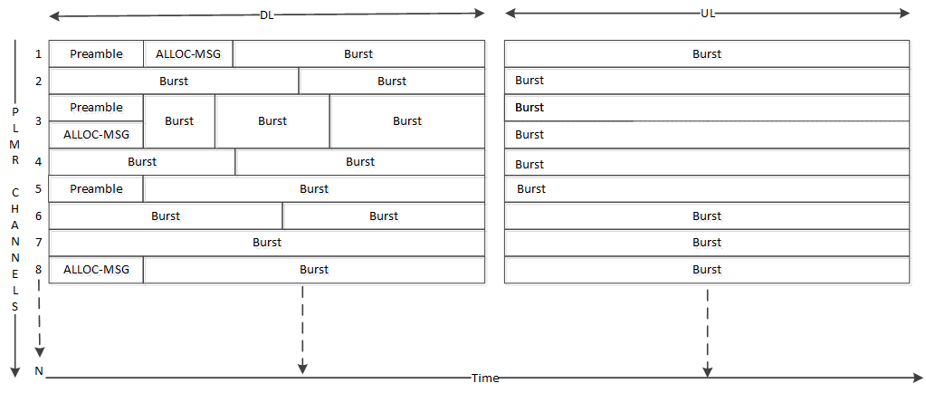
Figure 5: TDD Frame Example 1
Each subchannel group can be shared by multiple remotes in DL and UL directions. Each of the bursts in Figure 5 and Figure 6 can be allocated to a distinct remote.

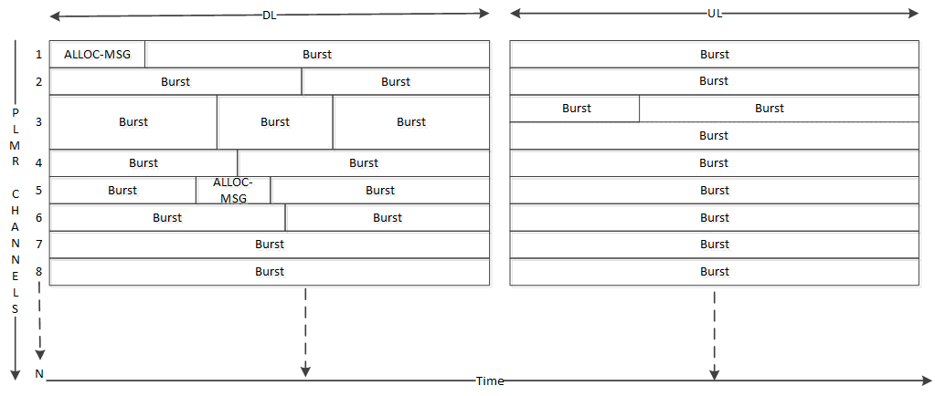
Figure 6: TDD Frame Example 2
Preamble, pilots ALLOC-MSGs are transmitted within every subchannel group. They are not required to be transmitted at every frame. Their periodicity is determined as follows:
- Preamble, and pilot signal periodicity is determined by RF channel dynamics as needed to maintain synchronization, e.g., static vs mobile application.
- ALLOC-MSG’s periodicity is determined by the characteristics of the application and the need to support efficient air interface resource allocation.
Figure 5 shows an example of a frame containing Preamble, ALLOC-MSGs in every subchannel within the frame. Figure 6 shows subchannels 2, 4, 5, 6, and 7 with no ALLOC-MSG, indicating the allocation is informed in previous frame whereas remaining subchannels are having the ALLOC-MSGs in the shown frames. In addition, subchannels 2, 4 and 6 do not have a preamble in this frame.

Frame Duration
The TDD frame duration will be configured based on the application requirements, e.g., latency and throughput, considering the subchannel bandwidth. Table 1 shows the minimum frame duration vs subchannel bandwidth.

Δf, kHz | Frame Duration, ms
5 | 100
6.25 | 62.5
12.5 | 50
25 | 20
50 | 10
Table 1: Minimum Frame Duration vs Subcarrier spacing.

TTG and RTG configuration
  - TTG configuration is done based on the round-trip delay to be supported.
  - RTG configuration will be based on the RF switching delay requirements.

Resolution of air interface resource allocation

Bins and slots formation
- The minimum air interface resource allocation in the downlink and in the uplink is the slot. It is constructed using configurable bins such that one slot contains 48 data symbols.
- A bin spans over one subcarrier/tone across multiple symbols in time, e.g., 9 symbols.
- A slot is formed such that it contains the 48 data symbols, e.g., 6 bins each carrying 8 data symbols is shown in Figure 8.
Figure 7: Bin Definition
- The structure of a bin containing 9 symbols is shown in Figure 7. This can be modified to improve the spectral efficiency by increasing the data symbols to pilot ratio.
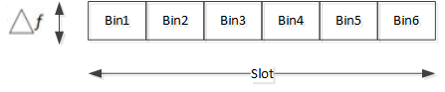
Figure 8: Slot Definition with each bin containing 8 data symbols

Modulation and FEC Rates:
- Preamble and pilots will be modulated with the BPSK modulation.
- Convolutional Coding (CC) and convolutional Turbo codes (CTC) is used with various rates as listed in Table 2.

Modulation | FEC rate
QPSK | 1/2
QPSK | 3/4
QAM16 | 1/2
QAM16 | 3/4
QAM64 | 3/4
QAM64 | 5/6
QAM256 | 7/8

Table 2: Modulation and FEC rate

Mapping of bins into slots & bytes vs MCS
The minimum number of bins needed to form the minimum bytes based on the different modulation and coding schemes is as given in Table 3.

S No | Modulation | FEC Rate | Min Bins for Byte/s | Min Bytes for min bins | Min Bytes for FEC  Block | Min Slots allocation  for FEC block
1 | QPSK | ½ | 1 | 1 | 6 | 1
2 | QPSK | ¾ | 2 | 3 | 9 | 1
3 | 16QAM | ½ | 1 | 2 | 12 | 1
4 | 16QAM | ¾ | 1 | 3 | 18 | 1
5 | 64QAM | ¾ | 2 | 9 | 27 | 1
6 | 64QAM | 5/6 | 1 | 5 | 30 | 1
7 | 256QAM | 7/8 | 1 | 7 | 42 | 1
Table 3: Mapping of bins into bytes and slots
Table 3 indicates that for QPSK 1/2 a minimum of 1 bin is needed to allocate 1 byte and a minimum of 6 bytes is required to form a FEC block. Therefore, 1 slot is needed to allocate 1 FEC block of 6 bytes. This information can be used to calculate number of slots required for a particular size of data. For example, consider 24 bytes to be allocated:
- QPSK ½: 24*1/6 = 4 slots will be required for transmission.
- 16QAM ½: 24*1/12 = 2 slots will be required for transmission.
- 64QAM 5/6: Minimum byte allocation is 30. 6 bytes [padding is needed. This will require 1 slot for transmission.

Downlink transmitter
Downlink burst data shall follow the procedure described below for the transmission, the Figure 9 shows the functions involved in the processing.

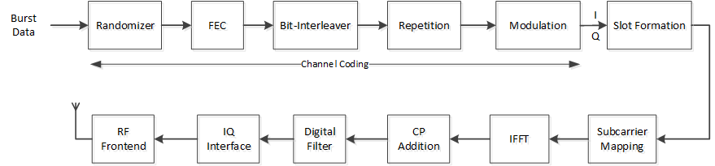
Figure 9: DL TX Chain

Channel coding

Randomizer
Randomization shall be performed as per the section 8.4.9.1.

Forward Error Correction
FEC shall be performed as per the section 8.4.9.2, 8.4.9.2.1 (CC Encoding), 8.4.9.2.3 (CTC Encoding).

Interleaving
Interleaving shall be performed as per the section 8.4.9.3.

Modulation
Modulation shall be performed as per the section 8.4.9.4. In addition, 256-QAM modulation may be supported.
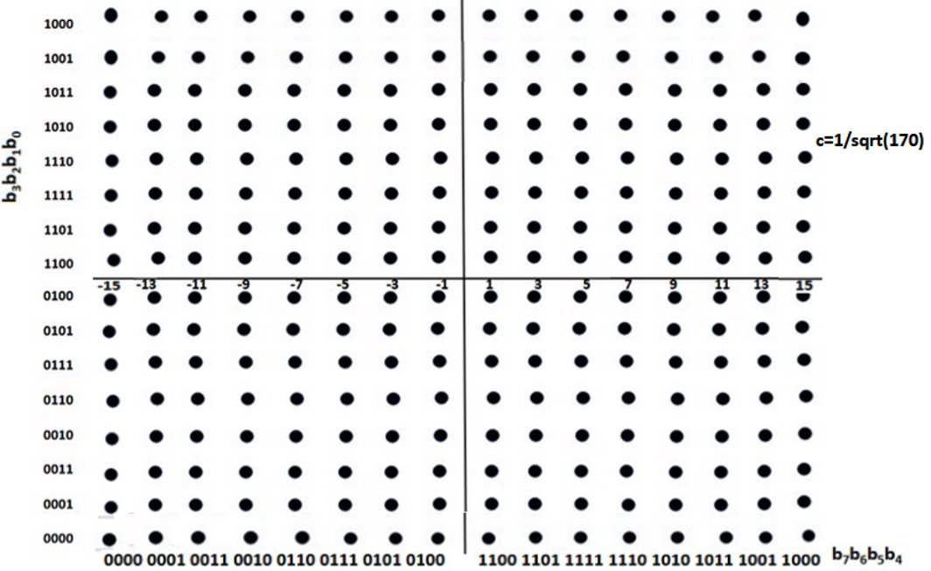
Figure 10 256-QAM constellation Mapping
Each M interleaved bits (M = 8) shall be mapped to the constellation bits b(M – 1) – b0 in MSB-first
order (i.e., the first bit shall be mapped to the higher index bit in the constellation).

Repetition
Repetitions will be used to improve the receiver sensitivity in both DL and UL. Up to 128 repetitions will be supported. The repetition will reduce the channels data capacity by a repetition factor. This repetition scheme is applied only to the QPSK modulation with all coding schemes.

Figure 11: Repetition procedure
Consider one FEC block with 6 slots as original data as shown below
Figure 12 Original Data
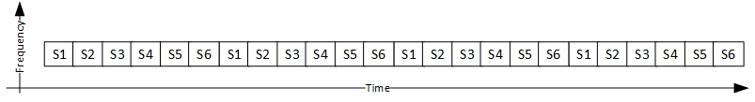
Figure 13 Repeated data new scheme

Slot Formation
Refer to section Bins and slots 3.6. Modulated data samples and pilot signals are placed in respective symbols in a bin. Once slot is formed with the allotted bins, then slot is mapped into a respective subcarrier.

Sub-Carrier Mapping
Data symbols are mapped to a subset of subcarriers.

IFFT & CP Addition
Refer to section 8.4.2.

TX signal filtering
TX signal spectrum containment for satisfying the spectral emission masks needs filtering.
The filter is characterized by the following parameters.
Number of filter taps: 257
Normalised Passband edge: 0.082*pi
Normalised Stopband edge: 0.120*pi
Stopband attenuation: 90 dB
Any of the filter design techniques can be used to obtain a filter that satisfies the above.

The response of the filter in the frequency domain for a single subchannel where the center subchannel is occupied is given below.
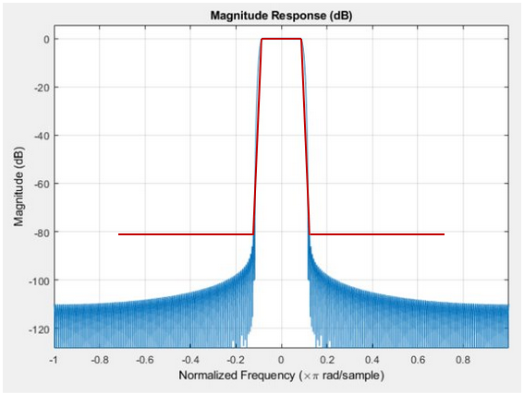
Figure 14 Magnitude Response of the desired filter

Downlink Preamble Transmission
The preamble contains the synchronization sequence. The preamble is sent over a single subchannel within a subchannel group based on the periodicity time configuration. Periodicity of the preamble is configured in terms of the number of frames e.g., periodicity of 5 means every 5th frame preamble will be present, and other frames data will be sent in the place of preamble below figure shows the same:
Figure 15 Preamble Periodicity.
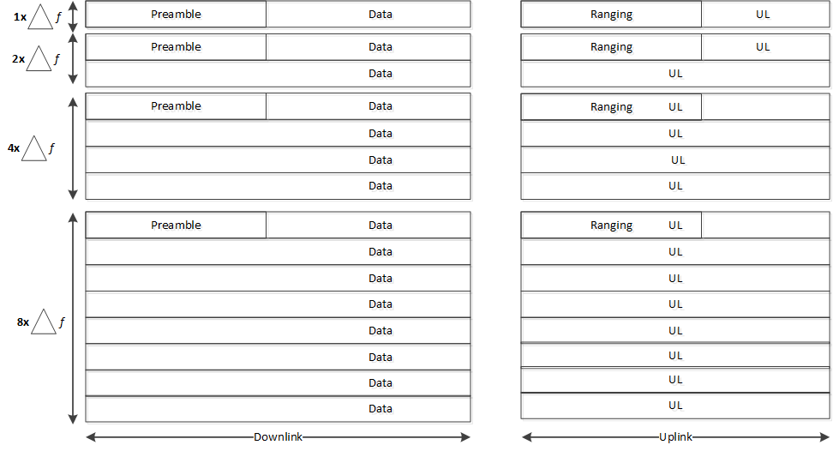
Figure 16: Preamble in Various Partitioned Continuous effective channels
Figure 16 shows the way preamble will be transmitted in groups of 1,2,4,8 continuous subchannels. The preamble will be sent over time in one subchannel. Each subchannel group will transmit different preamble sequence selecting in the order below from the available set
PmbSubch_i = PreambleSet( i modulo(N+2))
PmbSubch_i represents the Preamble sequence on i^{th} subchannel/subchannel group.
PreambleSet represents the set of Preamble sequences.
The preamble is transmitted with a configurable periodicity of frames. When a preamble is not included in a frame, data will be transmitted instead of preamble. In a frame where preamble is to be transmitted, it is placed in the first N symbols. BPSK modulated preamble sequence is transmitted in one of the subchannels over the subchannel group. Below are the possible length sequences which can be configured.
S No | Length
1 | 31
2 | 63
3 | 127
4 | 255
Table 4 Gold Sequence Lengths

Gold sequence
The preamble sequence is a pseudo noise (PN) Gold sequence of length N. Gold sequences are product codes achieved by performing modulo 2 adding of two different maximum length sequences (m sequence) of same length; m sequences are generated using simple shift registers. Length N of the preamble sequence is determined based on the RX sensitivity requirements. Generation of the Gold sequence is described below:
- Select the preferred pair of m sequences u,v with polynomial order n from the Table 5. The length of the Gold sequence ${N=2}^{n}-1$.
- The set of the N+2 Gold sequences $G\left(u,v\right)$ is generated with below equation
$$G\left(u,v\right)=\{u,v, u XOR v, u XOR Sv, u XOR S^{2}v, …,u XOR S^{N-1}v\}$$
$S$ represents the cyclic shift operator to left by one place.
$XOR$ represent the modulo 2 addition.
Cross-correlation between any two, or between any shifted versions of them takes three values: -t(n), -1 or t(n)-2 where t(n) is given by
$$t\left(n\right)=\left\{\begin{aligned}1+2^{\frac{n+2}{2}}, even n \\ 1+2^{\frac{n+1}{2}}, odd n\end{aligned}\right.$$
E.g. for n =5 the cross correlation values can be -9, -1, 7.
n | $${N=2}^{n}-1$$ | Preferred m-sequence pair
5 | 31 | [5,3] [5,4,3,2]
6 | 63 | [6,1] [6,5,2,1]
7 | 127 | [7,3] [7,3,2,1]
8 | 255 | [8,7,6,5,2,1] [8,7,6,1]
Table 5 Preferred m sequences pair
Below Figure 17 shows the gold sequence generation for length 31.
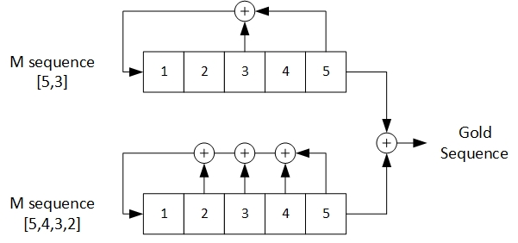
Figure 17 Gold Sequence generation

Uplink transmitter
Uplink burst data shall follow the procedure described below for the transmission, the Figure 18 shows the functions involved in the processing.

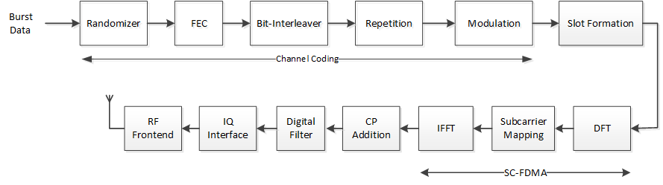
Figure 18 UL TX Chain

Channel coding
Channel coding procedure shall be followed same as section 3.7.1

Slot Formation
Refer section Bins and slots 3.6. Modulated data samples and pilot signals are placed in respective symbols in a bin. Once slot is formed with the allotted bins, then slot is mapped into a respective subcarrier.

DFT
The transmitter groups the modulation symbols into blocks each containing M symbols. The first step in modulating the Single Carrier FDMA subcarriers is to perform a M point discrete Fourier transform (DFT), to produce a frequency domain representation of the input symbols.

Sub-Carrier Mapping
DFT output of the data symbols is mapped to a subset of subcarriers, a process called subcarrier mapping. The subcarrier mapping assigns DFT output complex values to the assigned subcarriers.

IFFT & CP Addition
Refer to section 8.4.2.

TX Filtering
TX filtering shall be applied as per section 3.7.5

Ranging
Ranging is performed by the remote to synchronize the uplink time and power of transmissions. Ranging allocations will be sent periodically with some offset to the preamble transmission frame. BPSK modulated Gold sequences will be used for Ranging, refer section 3.7.6.1. The ranging sequences are grouped into the 4 categories Initial ranging, periodic ranging, bandwidth request ranging, HO ranging.
Ranging is done in two stages, initial ranging and periodic ranging. For initial ranging any random Gold sequence is selected out of the reserved sequences for initial ranging category, then this N-length sequence is placed in 2*N symbols in one subcarrier by repeating each symbol twice. Repetition is done in such a way that for first symbol it is placed with cyclic prefix in the beginning and for second symbol with cyclic suffix is placed in the end of symbol and so on for the entire N length sequence. So, N length sequence is mapped on to 2*N symbols in time axis and single subcarrier in frequency axis.
Ranging sequence for periodic ranging, bandwidth request ranging or HO ranging is selected randomly from the sequences allocated to the respective category then normal time axis mapping over a single subcarrier is done with no repetition across symbols and with cyclic prefix placed in the beginning of the symbol.
Base station needs to detect the round-trip delay, TTG configured should be enough for the remote to do the timing advance for UL transmission.

Channel quality measurements
Refer section 8.4.12

Transmitter requirements
Refer section 8.4.13

Receiver requirements
Refer section 8.4.14

Frequency control requirements
Refer section 8.4.15

Informative Section – rationale for changes:

System-level PHY Design Aspects

Performance Analysis (derived from SRD:)

Repetition
- Analysis of the gain due to time diversity.
- Analysis of the changes needed to meet the maximum gain achieved by repetition factor 128.

The terms “effective channel”, “subchannel” and “subchannel group” are common to both the PLMR band and the continuous band.

