IEEE 802.16t Direct Peer-to-Peer PHY Layer Proposal

Introduction
This document presents the four configurations for Direct Peer-to-Peer (DPP) communication, each designed for a different scenario. The document describes the Channel access methods and Over the Air (OTA) PHY protocol.

Channel Access Methods
- The following four schemes are proposed for DPP communication:
  - Half Duplex with Carrier-Sense Multiple Access with Collision Avoidance (CSMA/CA). The same frequency is used in both directions.
  - CSMA/CA with Request to Send (RTS), Clear to Send (CTS). The same frequency is used in both directions.
  - Each of the two schemes above, can also use a distinct frequency to communicate in each direction.
- Based on the deployment/application scenario two parameters are configured.
  - Maximum time of the burst.
  - Maximum continuous time usage of the channel in one direction
The maximum time of the burst shall be used for doing the random back-off for re-transmissions. And maximum continuous time usage parameter shall be used to avoid excessive usage of the channel this considers the transmit and response time also.

Detailed description of the four communication schemes

CSMA/CA
In this scheme, the RX carrier is sensed first, and once confirmed it is idle, the transmission is started. In the case the channel is not idle, random backoff is used before carrier sense is tried again. The below figure shows the flow.
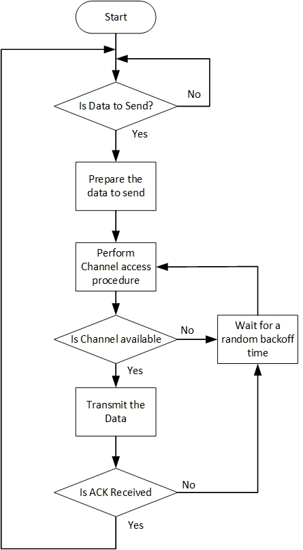
Figure 1 CSMA/CA flowchart
This method has the known problem of hidden nodes hence is preferred in the scenario where bi-directional traffic flows with intervals e.g., voice call, this increases the possibility of hidden nodes sensing the channel is busy avoiding further collisions.
To reduce the probability of collisions an Acknowledgement (ACK) message can be added as a configurable option. Sending of the ACK makes communication bi-directional and can help the hidden node to sense the channel is busy.
In case ACK has not been received the transmitter must do the random back off and initiate the channel access procedure again before doing the re-transmission.

CSMA/CA with RTS, CTS
In addition to CSMA/CA, before transmitting the actual data, the DPP remote sends a RTS message and waits for a CTS message. This helps resolve the hidden node problem. With the CTS response, automatic MCS selection converges faster due to the bidirectional traffic. With RTS/CTS, larger packets can be sent, RTS CTS can be used to inform other listening nodes about the transaction details to avoid further collisions. Below figure shows the flow:
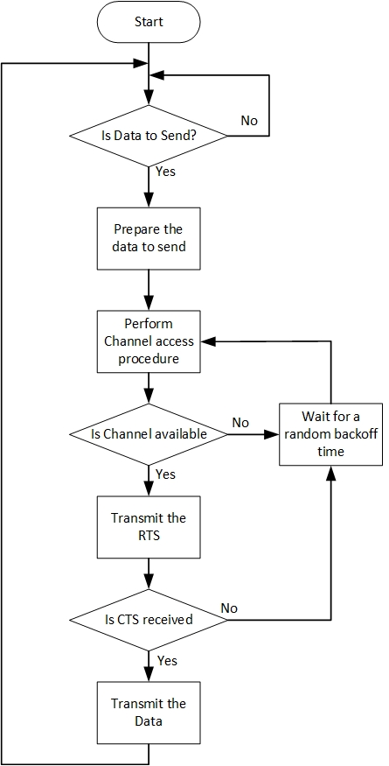
Figure 2 CSMA/CA RTS CTS flowchart

Link Adaptation
To begin with, unless bi-directional traffic flows the link adaptation (LA) will not be possible, LA can. Below are the steps proposed for the link adaptation:
- Begin the transmission with the Robust FEC and start the measurement report response timer (MEAS REP RSP). This timer is used to make sure the measurement report received is valid i.e., recent, if the timer expires then the report will not be used for LA, and the timer is restarted again with the next transmission.
- Use the valid report and update the MCS for the next transmission at the same time LA hold timer is started. LA hold timer is used to maintain the same MCS till timer expiry. In case any ACK/Response/data is received the MCS is updated, and the LA hold timer is reset.
The below figure shows the above steps
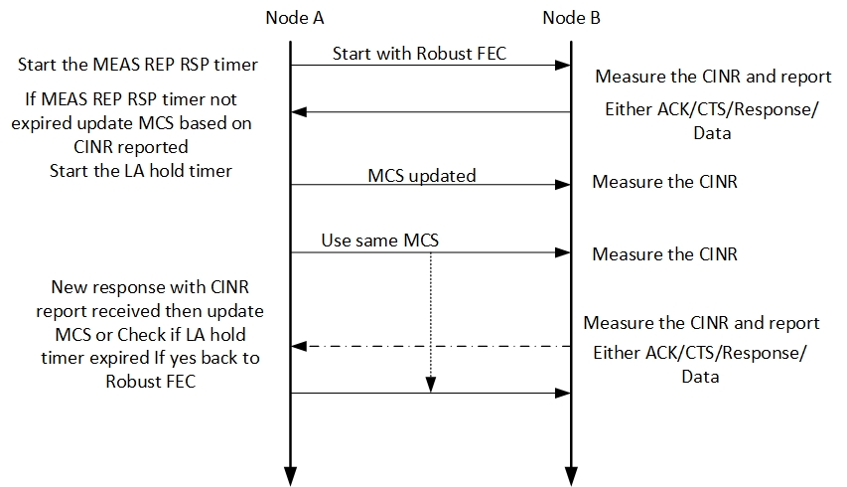
Figure 3 LA procedure

OTA protocol
There are no periodic transmissions, and DPP communication generates on-demand bursty traffic. The transmitter will be transmitting at the fixed configured power and the receiver will do the Automatic Gain Control. Figure 1 shows the OTA burst structure. The waveform used for the transmission is the same as mentioned in 802.16t PHY specification document with k=0, refer to the section “3.4.2.2 SC-FDMA Baseband Signal Generation (Single subchannel)”.
Refer to 802.16t PHY specification document, section “3.6 Resolution of air interface resource allocation”
Refer to 802.16t PHY specification document, section “3.8 Uplink transmitter” except the Ranging section.

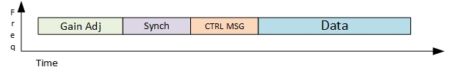
Figure 4 OTA burst structure

Gain Adjustment Period
The transmitter shall transmit the one slot worth alternate 1’s and 0’s BPSK modulated signal for a receiver to adjust the gain.

Synchronization
Preamble is used as a synchronization signal carrying Gold sequence of length 63, details are mentioned in 802.16t PHY specification document, refer to the section “3.7.2 Downlink Preamble Transmission”.

Control Message
The control message shall carry the information about the Data content such as the MCS, length of the allocation etc. It may carry the receiver and sender IDs or addresses. CTRL MSG shall be transmitted with the robust FEC.
Additionally, the CTRL MSG can carry the measurements report done at the receiver for doing the LA.

Data
The data will be transmitted in the same manner as it is processed in the 802.16t. Refer to 802.16t PHY specification document, section “3.8 Uplink transmitter” except the Ranging section.

DPP MAC layer topics to be addressed
- Security related Authentication and encryption.
- Defining link adaptation related messages.
- Quality of services.
- Packet Header Suppression.
- Defining the contents of ACK, RTS, CTS, and CTRL MSG.
- Defining OTA PDU structure.

