IEEE802.16t Air Interface Protocol – MAC Layer
November 15th , 2022

Contents
2 Objective 3
3 Definition of Terms 3
4 ieee802.16t MAC layer design considerations 4
4.1 Minimizing MAC and PHY layer overhead 4
4.2 Support of low latency applications 4
4.3 Allocation messages reduction 5
4.4 Support of BSC by the BS MAC layer 5
5 Frame Formats 6
5.1 Frame Structure 6
6 Timelines 8
6.1 Super Frame Structure 8
6.2 Interval and Period 8
6.3 Frame duration and Super-frame duration 8
6.4 Synchronization 9
6.4.1 Between BS and Remotes 9
6.4.2 Between BSC and BSs in the control area 9
7 Bandwidth Allocation Services 9
7.1 Unsolicited Grant Service (UGS) 9
7.2 Semi Persistent Service (SPS) 10
7.3 Bulk Allocation Service (BAS) 11
7.4 Instantaneous Allocation Service 12
7.5 BS Scheduler 12
8 Allocation messages 13
8.1 Allocation Message (ALLOC-MSG) Format 13
8.1.1 Allocation_IE 13
9 Simplified Network Entry 14
9.1 Simplified Network Entry with Authentication 15
10 Simplified Reporting Mechanism 15
11 Subchannel relocation of Remotes 16

Objective
This document describes the proposed MAC layer modifications for the ieee802.16t air interface protocol.
The modifications are designed to reduce overhead, improve frequency utilization, and reduce latency when operating in narrow channels. In addition, the MAC layer modifications are designed to support resource allocations by a Base Station Controller.

Definition of Terms
BSC – Base Station Controller – A software system which coordinates use of Air Interface Resources for a set Base Stations and associated Remote Stations within a defined Control Area for the purpose of avoiding radio frequency Interference.
BS – Base Station
RS – Remote Station
MS – Mobile Station - a mobile remote radio.
Sector - An area under the control of a Base Station. All the Remote Stations (Fixed & Mobile) within this area communicate with the Base Station controlling the sector. A single base station can support more than one sector.
Control Area - A set of Base Stations under control of a single instance of the Base Station Controller.
AIR - Air Interface Resources - as defined by IEEE 802.16t, an allocation of radio frequencies and time.
PDU – Protocol Data Unit. The data unit transmitted/received over the air.
SDU – Service Data Unit. The packet transmitted/received over an Ethernet or serial interface, e.g., an Ethernet frame.
MCS – Modulation & Coding Scheme
UGS – Unsolicited Grant Service. A scheduling mode with a priori periodic allocation of bandwidth per service flow. UGS parameters are fixed.
SPS – Semi-Persistent allocations Service. A periodic allocation mode characterized by an allocation interval, allocation size, a validity period, an activation condition, and a termination condition. Both interval and validity period are defined in terms of frames.
BAS – Bulk Allocation Service. On demand or unsolicited resource allocation mode not related to a specific service flow.

ieee802.16t MAC layer design considerations

Minimizing MAC and PHY layer overhead
- The ieee802.16 MAC layer was originally designed to support channel bandwidth down to 1.25 MHz. The throughput at this channel size is relatively high. It can sustain highly dynamic, on demand, bandwidth allocation schemes with little impact on end user throughput and latency.
- The ieee802.16s/ieee802.16-2017 includes couple of MAC layer changes to enable support for channel bandwidth down to 100 KHz while maintaining the air interface protocol overhead in check. The original ieee802,16 scheduling modes (BE, NRTPS, RTPS, ERTPS & UGS) are maintained. Also, the DL & UL MAP messages are still transmitted at every frame along with the preamble and FCH which limits the minimal frame duration.
- The ieee802.16t air interface protocol is designed to support much narrower channels. As such, more drastic changes are needed here including the addition of new, less dynamic scheduling modes, the reduction in the volume of allocation messages and the decoupling of allocation messages from the frame.
- A significant overhead component in the air interface protocol is the DL and UL bandwidth allocation messages. This overhead is reduced by the introduction of new less dynamic scheduling modes, e.g., Semi-Persistent Service (SPS) scheduling mode and maintaining bandwidth allocation messages only for bursty applications. The bandwidth allocation messages are not tied to the frame and the allocation can be done into future frames beyond the current or the next frame.
- MAC and PHY layer overhead will be configurable, based on the application requirements. For example, the rate of preamble and the rate of all MAC messages (e.g., closed loop power control, link adaptation etc.) is optimized depending on whether the remotes are mobile or fixed and if mobile, depending on their speed.

Support of low latency applications
  - In a non-congested network, the latency is determined by the frame duration and the scheduling mode.
  - The frame duration is configurable. The frame duration is minimized for low latency applications. The per-frame MAC and PHY overhead is minimized by decoupling the preamble and the bandwidth allocation messages from the frame. Once decoupled, the MAC layer overhead does not depend on frame duration. The frame duration is now configured such that it can carry a full time sensitive SDU. Note that fragmentation can be used to transmit a SDU using frames shorter than the SDU length, but the latency will then be determined by the number of frames required to carry the entire SDU.
  - Latency reduction is also supported by a priori bandwidth allocation scheme, i.e., Unsolicited Grant (UGS), Semi-Persistent Service (SPS) and Bulk Allocation Service (BAS) scheduling modes.
  - Regular MAP messages are not used. Regular DL and UL traffic will employ UGS and SPS scheduling modes. In addition, optional Bulk Allocation Service (BAS) mode can be used to allocate bandwidth to the basic remote service flow in the UL and DL directions, even before the low latency SDU is received. The BS/Remote scheduler will use BAS allocations to serve new SDUs in the DL/UL direction based on their priority. Ad hoc allocation messages will be used for low latency bursty applications whenever bulk allocations are not available.

Allocation messages reduction
  - Reduction of allocation messages overhead for low-rate regular traffic applications and for the use of bulk allocations requires more flexible bandwidth allocation messages compared to the current MAP messages. New allocation messages will have the ability to specify allocations in the future beyond the current or the next frame.

Support of BSC by the BS MAC layer
  - The ieee802.16t BS MAC layer can operate in either stand-alone MAC or secondary scheduler MAC mode.
  - While operating in secondary scheduler MAC mode, the BS will support procedures required to send bandwidth requests and receive allocations from the BSC. These procedures include:
- Send to the BSC instantaneous, semi-persistent and bulk bandwidth requests.
- Bandwidth requests will cover both uplink and downlink direction.
- An instantaneous bandwidth allocation will cover the Time to Live (TTL) of the request. The SPS bandwidth request will specify the periodicity, the size per allocation and the validity of the request.
  - The BSC can also send unsolicited SPS and BAS allocations to the BSs.
  - When the BS operates in secondary scheduler mode, the BSC is responsible for the allocation of bandwidth in a way that avoids self- interference. Separation between interfering sectors may be done in either frequency or time or both. A super-frame structure with a configurable number of frames will be available to support flexible separation in time. The super frame structure will be synchronized between the BSC and all BSs within the control area.

Frame Formats

Frame Structure
- A Frame can start with Preamble or Data burst depending on the allocations.
- The frame duration is configurable. Assuming minimum of 3 slots in DL and 3 slots in UL for non-fragmentable connectivity maintenance, the minimum supported frame duration values as per the channel bandwidth is given in Table 1.

Δf, kHz | Frame Duration, ms | DL+UL slots Per Frame
5 | 100 | 9
6.25 | 62.5 | 7
12.5 | 50 | 11
25 | 20 | 9
50 | 10 | 9
Table 1: Minimum Frame Duration vs Subcarrier spacing.

- The DL:UL ratio is configurable based upon the application requirements.
- Bandwidth allocation will employ allocation messages (ALLOC-MSG) instead of MAPs. The allocation messages are decoupled from frames and are transmitted when needed.
- Given below are three possible frames formats which can occur at different times.

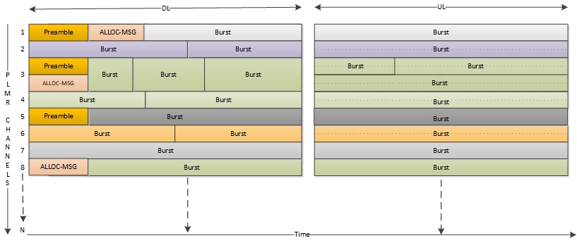

Figure 1 : Example Frame with Preamble, Allocation message and data burst

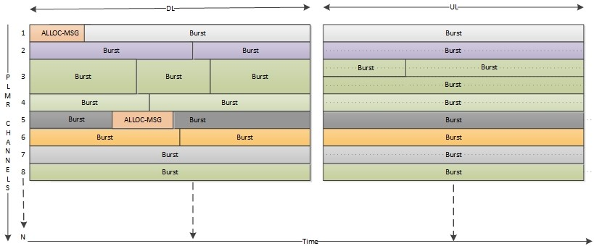
Figure 2 : Example Frame with Allocation message and data burst

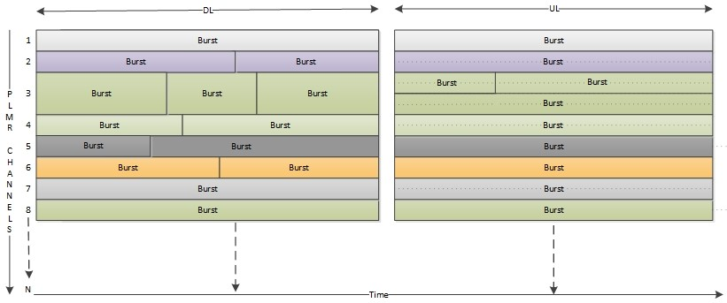

Figure 3 : Example Frame with data bursts

Timelines

Super Frame Structure
  - Time is divided into super-frames which are divided into frames. The number of frames in a super-frame is configurable.
  - There will be maximum limit for super-frame numbers after which it will reset.
Figure below is an example of a super-frame consisting of 10 frames where the duration of a frame is 100 ms.

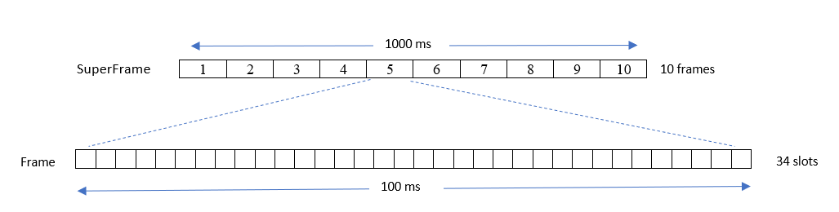
Figure 4 : Example Super frame structure

Interval and Period
- The time duration between two successive allocations is termed as intervals. There will be fixed size allocation at every interval. The interval will be indicated in terms of frames.
- Period is the time for which the allocations will be valid. Validity of the period can be infinite or finite. The finite validity period can be indicated in the number of intervals for which it is valid, i.e., finite period can be defined as an integer multiple of intervals.
- For example, allocation with interval of two frames and validity period of 10 intervals, will span for 20 frames.
- The location of the allocation in the frame which is the slot offset is considered from the beginning of the frame.

Frame duration and Super-frame duration
- The objective of the frame duration is to address the low latency requirement of high priority applications.
- The objective of the super-frame is to provide an additional dimension for the scheduler. Scheduler is scheduling for future frames and when the frame duration is small, the super-frame will provide a bigger scheduling window for the scheduler.
- The duration of a super-frame will be greater than the maximum interval among all UGS/SPS allocations.

Synchronization

Between BS and Remotes
- All Remotes will time synchronize with the BS using Preamble or GPS.
- BS will indicate the current frame number during network entry, in the initial response message sent to remotes. Remotes will use the frame number to synchronize with the frame number of the BS.

Between BSC and BSs in the control area
- All BSs will be time synchronized using GPS.
- BSC will start the super-frame numbering when it starts up based on frame duration configuration.
- BSC shall indicate the super-frame number, duration, and the super-frame start time (actual time in millisecond granularity) in the initial message sent to BS.
- All new BSs shall use the above-mentioned super-frame related information to synchronize with BSC. After initial synchronization, super-frame numbers will be used as reference for further communication.

Bandwidth Allocation Services

Unsolicited Grant Service (UGS)
- The scheduler will allocate fixed size grants per interval and convey the allocation through a one-time allocation message.
- The 802.16t UGS implementation is different from its 802.16-2017 implementation, each fixed size grant allocation is conveyed in MAP message occurring every frame and the placement (location within the frame) of each grant may vary. In 802.16t, the placement of the fixed size grant does not vary, and the allocation is conveyed one-time in single allocation message.
- UGS service is started after service flow creation and the allocation is based on QOS parameters of the service flow.
- The validity is infinite.
- The interval of a UGS allocation is defined in terms of frames.
- The following parameters are included in a UGS allocation.
  - The interval between successive allocations.
  - The size of the grant in bytes within each interval.
- The grant size is defined in bytes and the allocation is in slots assuming worst case MCS, i.e., the number of slots per allocation depends on the MCS. In case there is change in MCS the allocation size or grant may change but location of allocation remains fixed.
- If the MCS is below the assumed worst case, the remote may use other low priority service flow allocation.
- This scheduling mode is suitable for serving time sensitive applications with regular transmission cycles.
- UGS should be supported in both UL and DL.

Semi Persistent Service (SPS)
- SPS is a variation of UGS. It is dynamically activated and terminated.
- SPS is designed to serve a specific application with known characteristics. The respective SPS parameters are designed to accommodate the periodicity and packet size of the application.
- The service has a validity period which can be finite.
- The following parameters are included in an SPS allocation.
  - The interval between successive allocations.
  - The size of the individual allocation within each interval.
  - The validity period of the SPS allocation.
  - The activation and termination criteria.
- SPS can be established and terminated dynamically during operation. SPS service flow parameters are defined in the SF configuration file.
- The activation condition is the detection of an SDU with one or more classifiers matching the condition. The termination of the SPS service flow is the absence of the SDU matching the condition for a certain period of time. SPS service flows may be established in both DL and UL.
- Remote can use bandwidth request mechanism to indicate activation and termination. For example, the remotes may request the BS to start the allocation by indicating the desired allocation size in bandwidth request signaling header and in case remote wants to stop the allocation, it can indicate by setting the size to zero.
- As for UGS, need to define what does the BS/MS do when the MCS degrades, and the periodic allocation cannot accommodate the PDU.

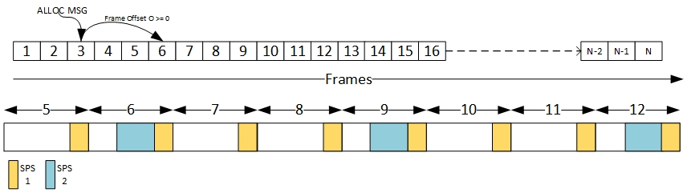

Figure 5 : SPS allocations
The figure above shows:
- First row with frames spanning from 1 to N.
- Allocation message in frame 3 indicating SPS allocation (SPS2) with interval of 3 frames starting from the 6th frame (Frame offset O = 3).
- Second row is the enlarged view of frames with allocations. The allocations can be applied to DL or UL subframes.
- SPS1 is an ongoing SPS allocation with 1 frame interval and SPS2 has started from frame number 6.

Bulk Allocation Service (BAS)
- On demand or unsolicited allocations to all the remotes in uplink.
- The bulk allocation may be either a onetime allocation or a repeated allocation.
- In the repeated allocation case, unlike in the case of SPS, the allocation is not designed to serve a specific application with specific periodicity and packet size. Here are the BAS use case examples:
  - Connectivity maintenance in DL and UL.
  - In advance allocation of bandwidth by the BS equally between all remotes or non-equally, depends on the volume of DL/UL traffic to/from each remote.
  - BAS will be used to allocate bandwidth in both DL and UL.
- Trigger for Bulk allocations could be resource availability in a continuous span of frames?
- How many future frames should scheduler consider when allocating Bulk allocations?

Instantaneous Allocation Service
This allocation mode is used when the BAS resource allocations are not available to serve the SDU.
- The scheduler will consider on demand bandwidth request.
- In case of secondary scheduler MAC mode, the BS will request bandwidth for each SDU, but the BS may also send a request for multiple SDUs with the same attributes (same direction, same priority, etc.).
- The scheduler will allocate resources to remotes considering priority and maximum latency.
- There can be an upper limit on the resource allocated per remote. This is to avoid starvation of other waiting remotes.

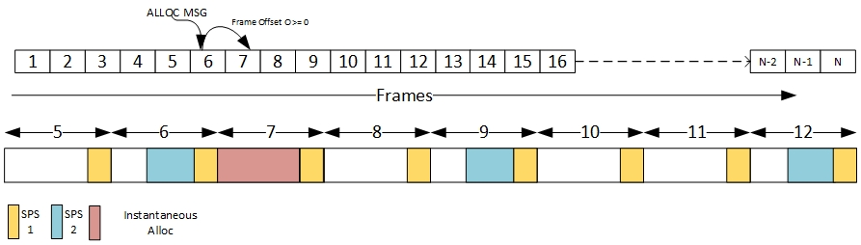

Figure 6 : Instantaneous allocation along with SPS
The figure above shows:
- Allocation message in frame 6 indicating Instantaneous allocation in Frame 7 with an offset of 1 frame (Frame Offset O= 1).
- The allocations can be applied to DL or UL subframes.

BS Scheduler
- The BS scheduler will be scheduling for future frames as follows:
  - Instantaneous allocations within a time spanning one super-frame.
  - SP and bulk allocations, within a time spanning one super-frame. The allocation will be available at any super-frame within the validity period.
- The scheduler will maintain information of scheduled allocations which are valid. When scheduling a request, the scheduler must use this information to determine the resource availability in the future frames and accordingly allocate the resources.
- The scheduler will schedule on a “subchannel group” basis.
- The allocations are communicated to the remotes by Allocation messages (ALLOC-MSG). Allocation messages are sent over each self-sufficient subchannel group for allocations to remotes present in that subchannel group.
- In case secondary scheduler MAC mode, the BS scheduler will determine the resource available on any subchannel group based on the downlink and uplink allocations granted by the BSC for that subchannel group.
- In case of standalone MAC mode, the BS scheduler will calculate the resource available on any subchannel group based on the number of subchannels in the group.

Allocation messages
- Allocation message will be transmitted when needed on robust modulation (configured minimum DL FEC).
- Depending on the traffic needs, an allocation message can have DL allocations only, UL allocations only or both DL and UL allocations.
- Resource allocations will be of three types, instantaneous, semi persistent and bulk
- An allocation message will indicate the future frame number, slot offset within the frame where the allocations starts and the number of slots within the allocations.

Allocation Message (ALLOC-MSG) Format
- Allocation message defines instantaneous and semi-persistent allocations in DL and UL.
- Allocation message can have DL allocations only, UL allocations only or both DL and UL allocations.

Syntax | Size(bit) | Notes
Allocation_Message () { | --- | ----
Extended length | 4 | Total length in terms of slots. 0: not extended
Allocation_IE | 48 | See Allocation_IE format
HCS | 8 | CRC for upper 5 bytes with polynomial different from GMAC header.
If (Extended length!= 0) { | ---
No of allocations | 4 | More allocations
for (i = 0; i < No of allocations; i++) { | --- | ---
Allocation_IE | 48 | ---
Reserved } | 4
if !(byte boundary) Padding | 4 | Padding to byte boundary need to be done
HCS | 8 | CRC for extended (bytes considered after first HCS till the end of extended message)
} | --- | ----
Table 2: Allocation message format

Allocation_IE

Syntax | Size  (Bit) | Notes
Allocation _IE () { | __ | __
Allocation Type | 3 | 0: Instantaneous 1: Semi-persistent 2 : Bulk
Direction | 1 | 0: Downlink 1: Uplink
DIUC/UIUC | 4 | FEC code
CID | 8
Slots | 8
Frame offset | 8 | Frame offset indicating future frame in case of Instantaneous allocation. Frame offset and interval in case of SPS allocation
Slot offset | 8 | Slot offset within the future frame
Period | 8 | Period of SPS allocation 0: infinite 1 to 0xFF : finite
}
Table 3: Allocation IE format

Simplified Network Entry
- The 802.16-2017 network entry procedure involves multiple message exchanges between BS and remote after initial ranging phase. In 802.16t implementation the network entry procedure is simplified with minimum message exchanges between BS and MS.
- The multiple network entry states (Ranging, Capability negotiation (SBC), Registration) are replaced with a single state (Network Attach).
- The Network Attach message exchanges will carry only essential parameters required for network entry.
- The figure below describes the Simplified Network entry procedure, starting from the DL acquisition.

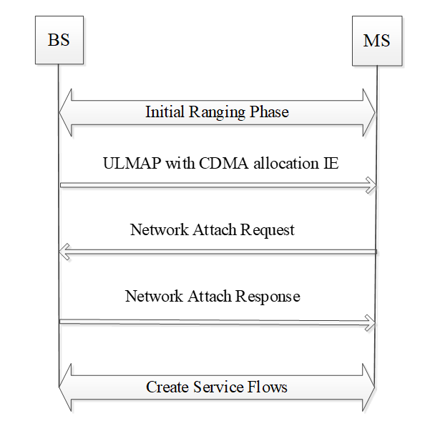
Figure 7 : Simplified network entry

Simplified Network Entry with Authentication
- With Authentication, there is an intermediate message exchange between BS and MS before network entry. The message Pre-Network Attach response message will carry all the necessary parameters needed for remote to proceed to Authentication phase.
- After completing Authentication, the remote will send Post Authentication Network Attach request message and BS will respond with Network Attach Response.

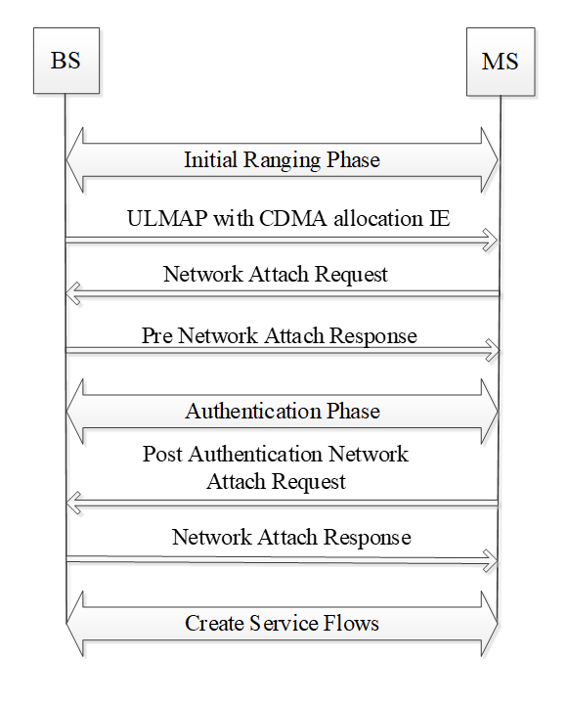
Figure 8 : Simplified Network entry with Authentication

Simplified Reporting Mechanism
- Remote will send unsolicited Compressed Report response message to BS at an indicated or configured periodicity.
- This message carries minimum parameters needed for Link adaptation as compared to 802.16e standard Report response message.

Syntax | Size(bit) | Notes
Compressed_Report_Response () { | --- | ----
Management Message Type | 8 | ----
CINR | 8 | Averaged CINR measurement report
RSSI | 16 | Averaged RSSI measurement report
Current Tx power | 8 | Current transmission power of MS
Max DL FEC | 4 | Max FEC code supported by MS which can be changed on the fly using CLI
Max UL FEC | 4 | Max FEC code supported by MS which can be changed on the fly using CLI
}
Table 4: Compressed Report Response

Subchannel relocation of Remotes

