IEEE P802.15
Wireless Specialty Networks

Project | IEEE P802.15 Working Group for Wireless Specialty Networks (WSNs) – 802.15.4ab
Title | Proposed Text for 4ab MAC - Hyper Block-based Mode
Date Submitted | 14 November 2022
Source | Youngwan So, Mingyu Lee, Taeyoung Ha, Aniruddh Rao Kabbinale, Ankur Bansal, Karthik Srinivasa Goplan, Clint Chaplin (Samsung Electronics) | E-mail: [youngwan.so@samsung.com]
Re: | Developing technical content for actual specification text, 15-22-0386-00-04ab-Flexible block structure
Abstract | This document provides details of MAC features for 4ab especially for Hyper block-based mode
Purpose | Support development of technical content for the draft
Notice | This document has been prepared to assist the IEEE P802.15. It is offered as a basis for discussion and is not binding on the contributing individual(s) or organization(s). The material in this document is subject to change in form and content after further study. The contributor(s) reserve(s) the right to add, amend or withdraw material contained herein.
Release | The contributor acknowledges and accepts that this contribution becomes the property of IEEE and may be made publicly available by P802.15.

Insert the new sub-clause 6.9.7.3.5 after 6.9.7.3.4 as follows:

6.9.7.3.5 Hyper block-based mode
A hyper block is a group of ranging blocks. Hyper block-based mode uses the time structure that is periodic. Figure 6-XXX shows an example timing diagram of hyper block-based mode.
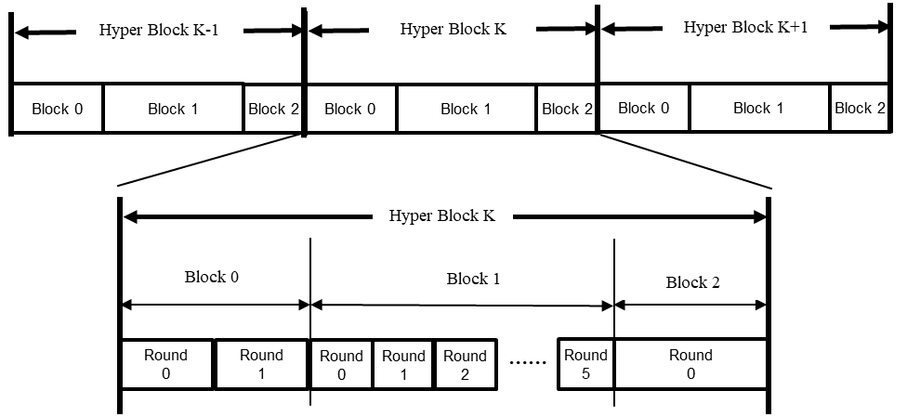
Figure 6-XXX – Example of timing diagram of hyper block-based mode
Each hyper block consists of a whole number of blocks. In the hyper block-based mode, it allows for the different blocks within a hyper block to have different configuration for block duration, round duration, and slot duration, etc. On the other hand, the different hyper blocks are initially limited to have the same configuration with each other.
The configuration for the hyper block structure can be repeatedly transmitted in every RCM by the controller. Hyper Block Structure IE (HBS IE), as defined in 7.4.4.56, can be used to signal the durations of each block in a hyper block. The HBS IE specifies the index of the corresponding block and includes list of block durations of all blocks within the hyper block. On reception of the HBS IE with the RCM, a controlee can assume that hyper block structure is followed. Each block structure can be setup by specifying the Ranging Block Duration field, the Ranging Round Duration field, and the Ranging Slot Duration field in the ARC IE with the RCM.
The controller may include a RIU IE to specify the interval between the start of the block with same index in every hyper block. For example, the controller can transmit RCM with RIU IE at the start of block 0 of every hyper block in Figure 6-xxx. Since RCM is transmitted at the start of block 0 in the hyper block K with RIU IE, the Block Interval field indicates the remaining time until the start time of block 0 in the hyper block K + 1. Alternatively, the hyper block structure may be setup and/or fixed by the next higher layer.

Revise Table 7-52f as follows:
Table 7-52f—Values of Time Structure Indicator field in the ARC IE
Time Structure Indicator field value | Selected ranging time structure behavior
0 | The time structure is interval-based and the RIU IE  described in 7.4.4.37 is used to control the ranging interval  updates.  The time structure is hyper-block based and the HBS IE described in 7.4.4.56 is used to configure the hyper block structure. RIU IE described in 7.4.4.37 may be used to indicate the time remaining in RTSU until the start of the next block of the next hyper block relative to the start of the current packet.
1 | The time structure is block-based and the RR IE described  in 7.4.4.38 and RBU IE described in 7.4.4.39 are used to  control the ranging interval updates.

Revise the subclause 7.4.4.37 as follows:
The RIU IE is used to update the ranging interval in interval-based mode and hyper block-based mode.

Insert the new subclause 7.4.4.56 after 7.4.4.55 as follows:
7.4.4.56 Hyper Block Structure IE (HBS IE)
The HBS IE is used by controller to send the hyper block structure configuration to controlees through RCM message. The Content field of HBS IE shall be formatted as illustrated in Figure 6-ZZZ.
Octets: 1 | 1 | variables
Block Index | Block Duration List Length | Block Duration List
Figure 6-ZZZ – HBS IE Content field format
The Block Index field specifies the index of the block for the hyper block.
The Block Duration List Length field specifies the number of elements in the Block Duration List field. This is whole number of blocks comprising a hyper block.
The Block Duration List field indicate the durations of each blocks for the hyper block, each of which is formatted as per Figure 6-QQQ and is ordered in ascending order according by using the index of block in the hyper block.
Octets: 3
Block Duration
Figure 6-QQQ – Block Duration List element format
The Block Duration field is an unsigned integer that specifies the duration of a block in the unit of RSTU (as defined in 6.9.1.5).

