IEEE P802.15
Wireless Personal Area Networks

Project | IEEE P802.15 Working Group for Wireless Personal Area Networks (WPANs)
Title | UWB Sensing Technical Framework Proposal
Date Submitted | Feb 28, 2023
Source | Xiaohui Peng, Li Sun, Bin Qian, Kuan Wu, David Xun Yang, Lei Huang, Peng Liu, Ziyang Guo, Chenchen Liu, Wei Lin, Jia Jia, Edward Au, Stephen McCann (Huawei), Pooria Pakrooh, Bin Tian, Steve Shellhammer, Koorosh Akhavan (Qualcomm)
Re: | Contribution to IEEE 802.15.4ab
Abstract
Purpose | This submission proposes text to for the IEEE Std 802.15.4ab specification framework document.
Notice | This document does not represent the agreed views of the IEEE 802.15 Working Group or IEEE 802.15.4ab Task Group. It represents only the views of the participants listed in the “Source(s)” field above. It is offered as a basis for discussion and is not binding on the contributing individual(s) or organization(s). The material in this document is subject to change in form and content after further study. The contributor(s) reserve(s) the right to add, amend or withdraw material contained herein.

Contents
1. Acronyms and Abbreviations 3
2. UWB Sensing 4
2.1 Introduction 4
2.2 Terminology 4
2.3 Operational modes for UWB sensing 4
2.3.1 Basic sensing modes 4
2.4 Sensing Procedure 5
2.4.1 General 5
2.4.2 Session setup 5
2.4.3 Sensing measurement instances 5
2.4.3.1 Sensing measurement report 6
2.4.3.1.1 Window-based CIR measurement report 6
2.4.3.1.2 Processed target feature report 8
2.4.4 Sensing session termination phase 8
2.5 Sensing block and round structure 8
2.6 UWB Sensing PHY 9
2.6.1 RF requirements: Sensing Pulse Shape 9
2.6.2 Sensing PPDU format 11
2.6.2.1 General 11
2.6.2.2 SHR field 11
2.6.2.2.1 SYNC field 11
2.6.2.2.2 SFD field 12
2.6.2.3 PHR field 12
2.6.2.4 PHY Payload field 12
2.6.2.5 SENS field 12

- Acronyms and Abbreviations
SDEV sensing device
CIR channel impulse response
OTA over the air
IE information element
MLME MAC layer management entity
OOB out of band
OSR oversampling ratio
SSR sensing sequence repetition
AoA angle of arrival
RSSI received signal strength index

- UWB Sensing
  - Introduction
Sensing is the use of PHY and MAC features of UWB devices to obtain measurements to estimate features such as range, velocity, and motion of objects in an area of interest. Sensing measurements can enable various applications such as presence detection and environmental mapping. Support for UWB sensing is optional. A device that supports the mandatory set of sensing features defined in this document is called a Sensing Capable Device (SDEV).
  - Terminology
The following nomenclature is used for SDEVs:

Sensing Initiator: An SDEV that initiates the RF sensing session with one or more other SDEVs.

Sensing Responder: An SDEV that responds to the sensing initiator.

Sensing Transmitter: An SDEV that sends the channel sounding PPDU to enable channel estimation for RF sensing purposes.

Sensing Receiver: An SDEV that receives the channel sounding PPDU from the transmitter and performs channel estimation.

Sensing Requesting Device: An SDEV that requests the sensing Channel Impulse Response (CIR) measurement report in a proxy application.

Sensing Requesting Relay Device: An SDEV that relays the sensing requesting message and sensing measurement report in a hierarchical proxy mode.

  - Operational modes for UWB sensing
In this section, an overview of sensing scenarios is provided. Based on the roles of the initiator and responder devices in the sensing task, we present possible sensing modes for 802.15.4ab.
    - Basic sensing modes
In most RF sensing scenarios, the sensing initiator is the device where the RF sensing applications reside, and hence the sensing initiator may require the sensing measurement report. For the cases that the sensing initiator is the sensing transmitter, an Over-the-Air (OTA) sensing measurement report may be sent by the sensing responder to provide the measurement report to the sensing initiator. Additionally, in a proxy application, the device requesting the proxy operation may receive OTA CIR measurement report from the sensing initiator. Based on the roles of sensing devices, the possible scenarios are listed below:

- Mono-Static Sensing
- Bi-Static Sensing [Initiator=sensing receiver]
- Bi-Static Sensing [Initiator=sensing transmitter]
- Multi-Static Sensing [Initiator=sensing receiver]
- Multi-Static Sensing [Initiator=sensing transmitter], supporting scheduling of OTA CIR measurement reports from multiple responders.

- Basic Proxy Mode [There is no relay between the sensing requesting device and the initiator]
- Hierarchical Proxy Mode [There exist one or more relay(s) between the sensing requesting device and the initiator]
  - Sensing Procedure
    - General
The sensing procedure defines sensing frame exchange sequences for each of the sensing modes listed in Section 2.3. A sensing session consists of three phases:

- Session setup
- Sensing measurement instance(s)
- Session termination

    - Session setup
It is possible that SDEVs consume more power when sensing is enabled, therefore, a natural default for an application would be to have sensing disabled. The higher layer is responsible for enabling sensing in SDEVs involved in a sensing session.

During the session setup phase, a sensing initiator and one or more sensing responders exchange capabilities and agree on the operational parameters of a sensing session. These parameters may include:
- Sensing mode: Bi-static sensing, or multi-static sensing
- Role of the initiator: Sensing receiver, sensing transmitter, sensing transmitter and sensing receiver
- Role of the responder: Sensing receiver, sensing transmitter, sensing transmitter and sensing receiver
- Sensing packet format (Section 2.5.2)
- Measurement report transmission mode: In-band, Out-of-Band (OOB)
- Measurement result format: Window-based CIR report or processed target report (Section 2.4.2.1)
- Frequency stitching enabled: Enable frequency stitching or disable frequency stitching
- Channel configuration for frequency stitching: The details are TBD
- Measurement report configuration for frequency stitching: The details are TBD.
The session setup phase consists of the following steps:
- Transmission of a sensing session setup request frame by the sensing initiator to a sensing responder, followed by transmission of an Ack frame by the responder, and
- Transmission of a sensing session setup response by the responder to the sensing initiator to either
  - Accept the parameters proposed by the initiator, or
  - Reject and provide responder’s preferred operational parameters in the sensing session response frame,
followed by the transmission of an Ack frame by the sensing initiator.
    - Sensing measurement instances
A sensing session consists of one or more measurement instances. A measurement instance consists of sensing control phase, sensing phase, and optional sensing measurement report phase.

Sensing Control Phase
Sensing Phase
Sensing Measurement
Report Phase

Figure 1: Sensing Measurement Instance

Sensing session parameters configured during session setup phase may be updated during the control phase.

A sensing initiator or a sensing responder starts a sounding phase by transmitting a sounding PPDU type which is agreed upon during the session setup or control phase.

An optional measurement report phase may follow the sounding PPDU transmission.
      - Sensing measurement report
An optional measurement report phase may be performed after the measurement phase. Measurement report can be transmitted in-band or via OOB methods.

Two types of sensing measurement reports are specified. The MLME sensing measurement report is used to transmit the sensing measurement results to the application layer of the initiator device. It is sent from the MAC layer to the upper layers within a device over the MAC Layer Management Entity (MLME). Depending on the role of the sensing devices, an OTA sensing measurement report may also be required to transmit the sensing measurement results from a responder to the initiator or from the initiator to the sensing requesting device in the proxy mode.

Both an MLME sensing measurement report and OTA sensing measurement report carry the sensing measurement results. Two types of sensing measurement result formats are considered:

- An SDEV shall support a window-based CIR measurement report which carries the CIR in a specified window. This type is used for most bi-static and multi-static sensing applications.

- Processed target feature report: An SDEV may optionally process the CIR report, to generate range/velocity and Angle of Arrival (AoA) for each object. The definition of computation methods is TBD.
The selection of the sensing result format depends on the sensing application, sensing mode and sensing node capability. It is negotiated during the sensing session set up phase through the sensing capability exchange.

        - Window-based CIR measurement report
The CIR is estimated from the received sensing PPDU packets. In this case, a window-based approach for the CIR sensing report is used to provide consistency for multiple CIR measurement reports across packets. A sensing report bitmap is used to signal the taps present in the CIR report. The bitmap offset (${BM}_{offset}$) specifies the offset of the first tap from the reference tap, as shown in Figure 2.

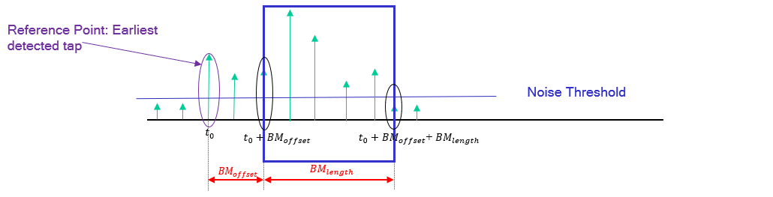
Figure 2: Sensing window parameters defined relative to the reference tap

Single CIR window with bitmap of a fixed length is specified through OOB means. The bitmap length is negotiated and determined through other means, and it is fixed during sensing session.

In the mandatory mode, initiator proposes the bitmap, based on its sensing area of interest, from a limited set of bitmap options. Bitmap is fixed during the session and does not change from packet to packet.
Support for an optional variable bitmap mode in which the bitmap varies from packet to packet is under consideration.

Following CIR report parameters and specifications shall be supported by an SDEV:

- The earliest detected CIR tap is the reference tap for the window. Optional support for other reference tap options is under consideration:
  - Other specific time instances can be specified as reference points (for example via OOB) when there is external synchronization.
  - The strongest detected tap, if there are multiple equally strongest taps, then the earliest one is selected.
- The CIR measurement report shall be sampled at Over Sampling Ratio (OSR) of 2, to balance reasonable accuracy, complexity, and report overhead. OSR is defined with respect to signal BW.
  - When the CIR of an effective larger bandwidth is obtained by an SDEV, OSR is defined with respect to the aggregated BW.
- The CIR measurement report signed I/Q values for each Rx chain shall be represented using 16 bits.
In the window-based CIR report, the CIR measurement report consists of two parts:

- The first part contains sensing control parameters. It consists of the number of receiving antennas, bitmap length, bitmap offset, and the bitmap. The sensing control parameters may or may not be present in the CIR Measurement Report depending on when the initiator needs them.
- The second part contains content fields for the CIR measurement report. It consists of CIR in-phase and quadrature values for each chain, normalization factor for each chain, and Received Signal Strength Index (RSSI) for each chain. Table 1 illustrates the mandatory baseline parameters for CIR report.

Table 1: Mandatory baseline CIR report parameters
Field | Field length | Comments
Control fields
Number of Rx antennas | 2 bits | Up to 4
Bitmap length | 2 bits | 32, 64, 128, 256
Bitmap offset | 10 bits | Up to 1 SENS symbol
Bitmap | Variable, up to 256 bits | Max length = 256
Content fields for each receiver chain
Timing offset of the reference tap | 6 bits | First arrival tap offset from CIR report grid. In units of Ranging counter time unit defined in section 6.1.9.4 of 802.15.4z-2020.
Normalization factor for I/Q | TBD | Common normalization value for In-phase and Quadrature values
RSSI | TBD | Indication of per packet power level
CIR In-phase values | 16 bits | Per tap; normalized
CIR Quadrature values | 16 bits | Per tap; normalized
For the sensing modes where the sensing initiator is the sensing transmitter, the CIR report may be sent OTA, and would be forwarded to the initiator’s upper layer for further processing.
        - Processed target feature report
For mono-static sensing where inherent synchronization is available, and for bi-static and multi-static sensing where external synchronization is utilized, a processed target feature report may be generated. Support for the processed target feature report is optional. An SDEV may optionally process the CIR report, to generate range/velocity and Angle of Arrival (AoA) for each object. The definition of computation methods is TBD.
    - Sensing session termination phase
In the sensing session termination phase, UWB devices stop performing measurements and terminate the sensing session.
  - Sensing block and round structure
The ranging block/round/slot structure in Figure 6-48j of 802.15.4z-2020 can be generalized to define sensing blocks, rounds, and slots.
Sensing
Round 0
Sensing
Round 1
Sensing
Round 2
Sensing
Round 3
Sensing
Round N-1
…..
Sensing
Slot 0
Sensing
Slot 1
Sensing
Slot 2
Sensing
Slot 3
Sensing
Slot M-1
…..
Sensing Block
Figure 3: Illustration of sensing block, round and slot structure

A sensing block is a period for sensing. Each sensing block consists of several sensing rounds, where a sensing round is a period of sufficient duration to complete one entire sensing measurement instance. Each sensing round is subdivided into an integer number of sensing slots where a sensing slot is a period of sufficient duration for the transmission of at least one sensing PPDU. The time unit used in specifying the duration of sensing block, sensing round, and sensing slot is the RSTU as specified in Section 6.9.1.5 of 802.15.4z-2020.

Two example of measurement instance realization using sensing block structure are given below.

- Bi-Static Sensing [Initiator=sensing transmitter], with measurement report.
…..
Sensing Round: One measurement instance
Sensing Slot
Sensing phase phase
Measurement report phase
…..
Sensing Slot
Control phase
Figure 4: Sensing round for bi-static sensing with measurement report

- Bi-Static Sensing [Initiator=sensing receiver], no measurement report is required.
Sensing Round: One measurement instance
Sensing Slot
Sensing phase
…..
Sensing Slot
Control phase

Figure 5: Sensing round for bi-static sensing without measurement report
  - UWB Sensing PHY
    - RF requirements: Sensing Pulse Shape
The same pulse shape shall be used for the entire sensing packet and all the pulses within one sensing packet shall be modulated with a constant amplitude.

The transmitted pulse shape p(t) shall be constrained by its cross-correlation function with a standard reference pulse shape, r(t). The normalized cross-correlation function between two waveforms is defined as follows:
$$ϕ\left(τ\right)=\frac{1}{\sqrt{E_{r}E_{p}}}Re\int_{-∞}^{∞}{r\left(t\right)p^{*}(t+τ)dt}$$
where E_{r} and E_{p} are the energies of r(t) and p(t), respectively, p* denotes the complex conjugate of p, and Re{.} indicates that the real part is used.

The reference pulse r(t) is a time-bounded Kaiser pulse with a parameter of $β$. The value of $β$ is TBD. Mathematically this is as follows:
$$r(t)=\left\{\begin{aligned}\frac{1}{L}\frac{I_{0}\left[β\sqrt{1-{\left(\frac{2t}{L}\right)}^{2}}\right]}{I_{0}\left[β\right]}, \left|t\right|≤L/2 \\ 0, \left|t\right|>L/2\end{aligned}\right.$$
where I₀ is the zeroth-order modified Bessel function of the first kind, L is the duration of the pulse which is set to 3 chips.

The transmitted pulse p(t) shall have a magnitude of the cross-correlation function $\left|ϕ(τ)\right|$ whose main lobe is greater than or equal to TBD1 for a duration of at least T_{w,} as defined in 802.15.4-2020 table 15-12, and any sidelobe shall be no greater than TBD2. For the purposes of testing a pulse for compliance, the following are defined: Let $ϕ\left(τ\right)$ be the magnitude of the cross-correlation of p(t) and r(t), and $τ_{i}$, for i = 1, 2,…, be a set of critical points as follows:
$$\frac{d}{dτ}{\left|ϕ\left(τ\right)\right|}_{τ=τ_{i}}=0$$
The maximum of the function occurs at one of these critical points, $τ_{max}$, where $\left|ϕ\left(τ_{max}\right)\right|≥\left|ϕ(τ)\right|$ for all values of $τ$. The requirements thus states that for some continuous set of values that contain the point $τ_{max}$, the function $\left|ϕ(τ)\right|$ is no greater than TBD1. In addition, the second constraint on the value of sidelobes may be stated mathematically as $\left|ϕ\left(τ_{i}\right)\right|≤TBD2$ for all $τ_{i}$.

To help with interoperability in sensing scenarios, the transmitted pulse should exhibit both minimum precursor energy and minimum postcursor energy. The transmitted pulse shape p(t) should be constrained by a symmetric time domain mask with solid line shown below, where A’, B’ and C’ are the points A, B and C mirrored in t = 0, respectively. The values of x1,x2,y1 and y2 are TBD. Tp is the inverse of the chip frequency.

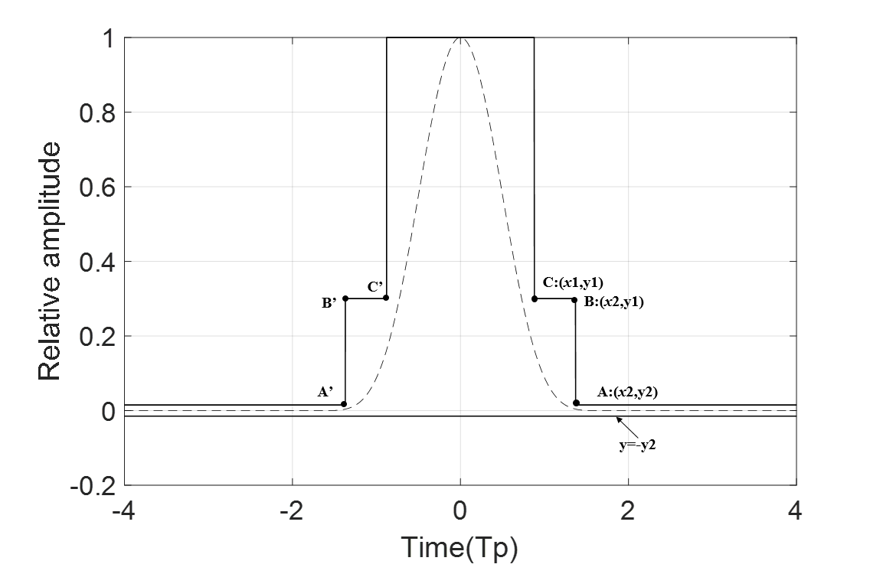
Figure 6: Recommended time domain mask for UWB sensing PHY pulse.

    - Sensing PPDU format
      - General
An SDEV shall support transmission and reception of packets as specified in Table 2. Figure 7 depicts the position of sensing field in the packets.

Table 2: PPDU SENS packet structure configurations

SENS packet configuration specifier | Position of SEN in the PPDU | Support
0 | The SENS field is placed after SFD. | Mandatory
1 | The SENS field is placed after SFD and before PHR | Optional
2 | The SENS field is placed after Payload | Optional

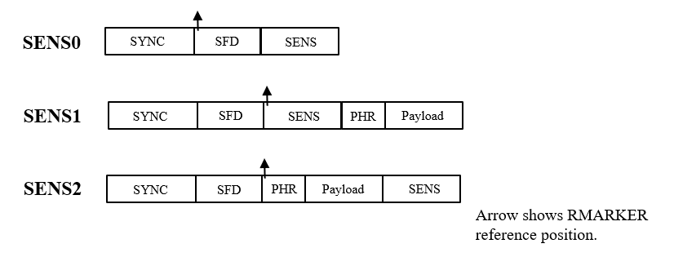

Figure 7: PPDU packet formats for sensing

Sensing primitives and PHY attributes will be defined such that higher layers can request a packet configuration for sensing.

For each sensing packet, one RMARKER is defined to enable potential non-secure ranging using sensing packets. The position of the RMARKER is at the peak of first pulse after SFD.

      - SHR field
        - SYNC field
The SDEV shall support the length 91 codes specified in Table 15-7a with the parameters specified in Table 15-7b.

The SDEV shall support transmission and reception of PSR values of 32, and 64. Support for PSR values of 16, 128 and 256 is optional.
        - SFD field
There are no changes in the SFD field of sensing packets from those already defined in 802.15.4z-2020, specified in table 15-7c.
      - PHR field
There are no changes in the PHR field of SENS1 and SENS2 packets from those already defined in 802.15.4z-2020, section 15.2.7.3.
      - PHY Payload field
Payload data rates of 1.95, 7.8, 31.2, 62.4 Mbps shall be supported for SENS1 and SENS2. The support of 124.8 Mbps is optional.

BCC K=7 is used as the FEC for SNES1 and SENS2 packets.

      - SENS field
The SDEV shall support length 91 codes specified in Table 15-7a of 802.15.4z-2020. The code sequences are spread using the delta function δL of length L=4, to generate sensing symbol $S_{i}$ according to table 15-7b of 802.15.4z-2020. when both SENS and SYNC use length 91 sequences, they shall use same code index from table 15-7a.

The SENS field consists of one to four blocks of active segments, separated by gaps. Support for 2, 3 and 4 segments are optional for an SDEV. The number of symbols in a segment is defined as sensing symbol repetition (SSR). The duration of each gap interval is one SENS symbol, or equivalently 364 chips (~729ns). The SDEV shall support transmission and reception of SSR= 32, 64, 128. Support for SSR=16, 256 and 512 is optional. . Figure 8 shows SENS field in SENS0 and SENS2 fields, and Figure 9 shows the SENS field in SENS1 packet. These figures represent the case of one or two segments, and they can be generalized to three or four segments.

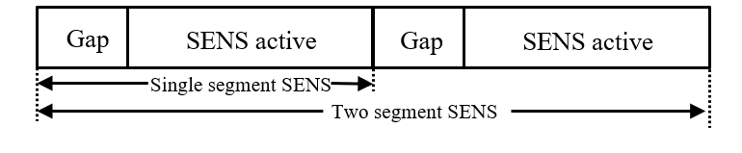
Figure 8: SENS Segments for SENS0 and SENS2 packets

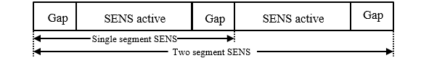
Figure 9: SENS Segments for SENS1 packet

Sensing primitives and PHY attributes will be defined such that higher layers can request a given set of values for SSR and number segments.

Packet transmission sequences are under consideration to facilitate optional support for frequency stitching across carrier frequencies spaced apart in multiples of 124.8MHz.

