IEEE P802.15
Wireless Personal Area Networks

Project | IEEE P802.15 Working Group for Wireless Personal Area Networks (WPANs)
Title | High Rate PRF Low Energy (HRP-LE, Non-Coherent PHY Layer proposal for 15.4ab TFD)
Date Submitted | May 2023
Source | Frederic Nabki (Spark Microsystems) - Dries Neirynck (Ultra Radio Ltd) - Mohammad Rahmani (Spark Microsystems) - Benjamin Rolfe (Blind Creek Associates) - Michiel Soer (Spark Microsystems) - Boris Danev (3dB Access) - David Barras (3dB Access)
Re: | Contribution to IEEE 802.15.4ab
Abstract
Purpose | This submission proposes text to for the IEEE Std 802.15.4ab specification framework document.
Notice | This document does not represent the agreed views of the IEEE 802.15 Working Group or IEEE 802.15.4ab Task Group. It represents only the views of the participants listed in the “Source(s)” field above. It is offered as a basis for discussion and is not binding on the contributing individual(s) or organization(s). The material in this document is subject to change in form and content after further study. The contributor(s) reserve(s) the right to add, amend or withdraw material contained herein.

Contents
1 PHY – High Rate PRF Low Energy (HRP-LE) option 3
1.1 Introduction 3
1.2 Channel plan 3
1.3 Preamble symbol structure 3
1.4 SYNC 4
1.5 SFD 4
1.6 Payload symbol structure 4
1.6.1 On-off keying 4
1.6.2 Burst position modulation 5
1.6.3 Manchester OOK 5
1.7 PHR 5
1.8 Forward error correction 5
1.9 Conclusion 6
1.10 References 6

PHY – High Rate PRF Low Energy (HRP-LE) option

Introduction
In this document, we propose optional PHY layer parameters aimed at non-coherent data comms while ensuring orthogonality with secure ranging applications. Coexistence with legacy devices is considered in this proposal.

The benefits of such non-coherent detection can be summarized as:
- Obviating the need for RF carrier generation.
- Fast (sub ms) channel hopping is possible (with the help of fast synthesizer
settling time). This leads to efficient duty cycling between frames.
- Fast radio start-up (few ms) is possible.
- Relaxed requirements of the frequency and phase accuracy of the system.
- Coverage benefits from multipath within SOI due to lower phase sensitivity compared with coherent detection.
- High symbol rate of the PHY layer allows to reduce frame airtime.
- Reduced latency due to shorter frame time.
- Allows for aggressive duty cycle of the radio which results in a much higher energy efficiency of the radio.
- Long preambles are not required for data streaming and this can further reduce frame overhead.
The proposed additions to HRP complement existing and proposed capabilities for ranging and sensing applications and can be used without undue disruption of those links.

Actual Technical Framework Proposal
Clauses numbers are based on draft 802.15.4me+z-DF00-redline.

15.1 General
Add at the end of the section:
An optional HRP low energy (HRP-LE) PHY provides simplified, non-coherent data communications for applications that don’t require secure ranging functionality.

15.2 HPR UWB PPDU format

15.2.6 SHR field

15.2.6.2 SYNC field
Add at the end of the section:
In case of the optional HRP-LE mode, the SYNC sequence uses the OOK modulation from 15.3.5.1 to transmit repetitions of 1/0 symbols. The LFSR from section 15.3.2 shall be used to scramble the phase of the chips. For this purpose, the LFSR shall be initialised with the sequence 1/0/1/0/1/0/…
The SYNC length in case of the optional HRP-LE mode may be 16, 32, 64 or 128 symbols.

15.2.6.3 SFD field
Add at the end of the section:
The SFD sequence for the optional HRP-LE transmissions shall be one of the following sequences (left most bit transmitted first):
- 5EA6C11D
- BF166129
- B94F9606
- A5843F66
- 9B52FC60
- 6819CBD5
- F29F5C88
- EE415A3C

15.2.7 PHR field
Add a new clause 15.2.7.4 PHR for HRP-LE
15.2.7.4 PHR field for HRP-LE
In the HRP-LE mode, the PHR shall be formatted as shown in Figure AA. The PHR shall always be transmitted using Manchester OOK as defined in 15.3.5.2.
Bits: 0-3 | 4-11 | 12-13 | 14 | 15-20
Number of pulses and modulation | Payload length | Puncturing | Reserved | SECDED
Figure AA – HRP-LE PHY header
Bits 0-3 inform the receiver about the number of pulses per symbol and the payload modulation format (see 15.3.5) of the frame, as per Table BB.
Table BB – Number of pulses and modulation
Bits 0-3 | Number of pulses | Modulation format
0 0 0 0 | 1 | On-Off Keying
0 0 0 1 | 1 | Manchester OOK
0 0 1 0 | 1 | Burst Position Modulation
0 0 1 1 | 2 | On-Off Keying
0 1 0 0 | 2 | Manchester OOK
0 1 0 1 | 2 | Burst Position Modulation
0 1 1 0 | 4 | On-Off Keying
0 1 1 1 | 4 | Manchester OOK
1 0 0 0 | 4 | Burst Position Modulation

Bits 4-11 encode the length of the PHY payload in octets. The PHY payload length field shall be passed to the modulator most significant bit first.
Bits 12-13 encode the puncturing used in the frame (see 15.3.3.3), as per Table CC.
Table CC – Puncturing
Bits 12-13 | Puncturing
0 0 | 1/1
0 1 | 4/3
1 0 | 5/3
1 1 | 2/1

Bits 15-20 contain a single-error-correction, double-error-detection (SECDED) code. The definition of the bits shall be per Table DD.
Table DD – SECDED for HRP-LE mode
Bit | Definition
b15 | xor(b0,b1,b2,b3,b4,b5,b6,b7,b8,b9,b10,b11,b12,b13,b14,b16,b17,b18,b19,b20)
b16 | xor(b4,b11,b0,6,b13,b1,b8,b15,b3,b10)
b17 | xor(b5,b12,b0,b,b6,b13,b,b2,b9,b3,b10)
b18 | xor(b7,b14,b1,b8,b2,b9,b3,b10)
b19 | xor(b4,b5,b6,b7,b8,b9,b10)
b20 | xor(b11,b12,b13,b14)

15.3 – Modulation

15.3.2 – Spreading
Add below table 15-19:
In case of the optional HRP-LE mode, the LFSR shall be initialised using 1/0/1/0/1/0/…

15.3.3 FEC

15.3.3.3 Convolutional encoding
Add at the end of the section:
The use of the K = 7 convolutional coding is mandatory when the optional HRP-LE mode is used, with puncturing ratios 1/1, 4/3, 5/3 and 2/1.
The puncturing patterns shall be as defined in Table EE. There A, B, C, D, E and F correspond to 5 uncoded bits, while A0, A1, B0, B1, C0, C1, D0, D1, E0, E1 and F0, F1 correspond to g0 and g1 when the uncoded bits A, B, C, D, E and F are shifted into the convolutional encoder.
Table EE – puncturing patterns for HRP-LE mode
Puncturing ratio | Puncturing Pattern
2/1 | A0, A1, B0, B1, C0, C1, D0, D1, E0, E1, F0, F1
5/3 | A0, A1, B0, B1, C1, D0, D1, E0, E1, F1
4/3 | A0, A1, B1, C1, D0, D1, E1, F1
1/1 | A, B, C, D, E, F

Add 15.3.5 Modulation in HRP-LE mode:

15.3.5 Modulation in HRP-LE
Three modulation formats may be used by devices supporting the optional HRP-LE mode.

15.3.5.1 On-Off Keying
The OOK symbol shall consist of 24 chips, transmitted at a chip rate of 499.2 MHz, corresponding to a symbol rate of 20.8 MHz.
A symbol may have 1, 2 or 4 active chips. The burst of active chips shall be transmitted at the beginning of the symbol. The same number of active chips shall be maintained throughout the PPDU.
The burst within the symbol is either active when transmitting a ‘1’ or inactive when transmitting a ‘0’.
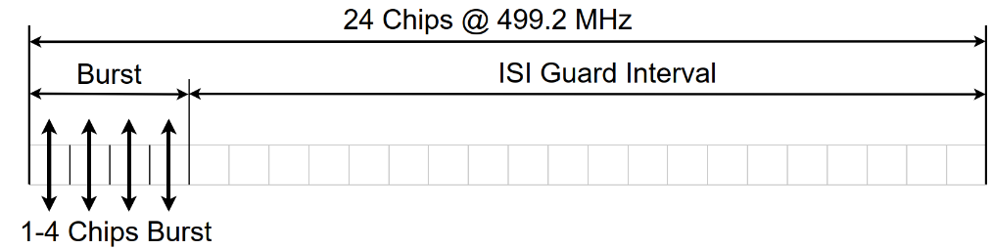
The usage of the on-off keying mode is mandatory during the SYNC part of the PPDU.

15.3.5.2 Manchester OOK
The Manchester OOK symbol consists of 48 chips, transmitted at a chip rate of 499.2 MHz, corresponding to a 10.4 MHz symbol rate.
A symbol may have 1, 2 or 4 active chips. The burst of active chips shall be transmitted at the beginning of the symbol. The same number of active chips shall be maintained throughout the PPDU.
The burst of active chips is either located at the beginning of the first or second half of the symbol. An active burst in the first position corresponds to a ‘0’ bit, in the second position to a ‘1’.
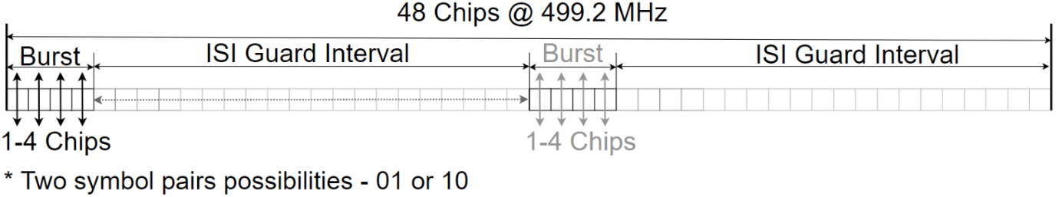The usage of the on-off keying mode is mandatory during the PHR part of the PPDU.

15.3.5.3 Burst position modulation
The BPM symbol consists of 24 chips, transmitted at a chip rate of 499.2 MHz, corresponding to a 20.8 MHz symbol rate.
A symbol may have 1, 2 or 4 active chips. The burst of active chips shall be transmitted at the beginning of the symbol. The same number of active chips shall be maintained throughout the PPDU.
The burst of active chips is either located at the beginning of the first or second half of the symbol. An active burst in the first position corresponds to a ‘0’ bit, in the second position to a ‘1’.
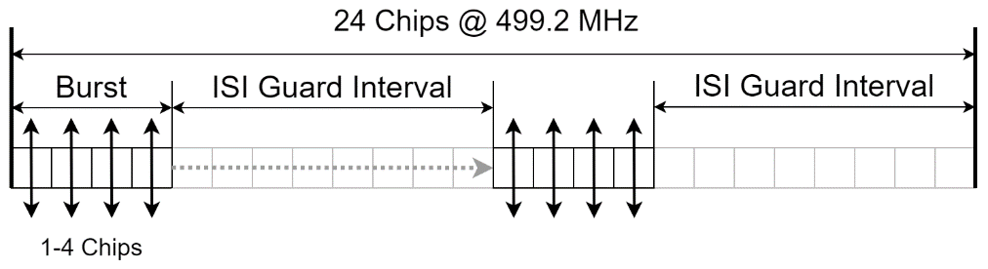

15.4 RF requirements

15.4.1 Operating frequency bands
Center frequencies f_{c} can be any integer multiple of 124.8 MHz and are characterized by an integer number N_{c} according to
f_{c} = 499.2 MHz + N_{c} 124.8 MHz
where N_{c} may range from 0 to 97.

15.4.6 Chip rate clock and chip carrier alignment
In front of the last sentence, add that the link between chip rate and carrier frequency does not apply to HRP-LE:
Except for the HPR-LE PHY, tThe carrier center frequency and the chip rate frequency shall be derived from the same reference oscillator.

15.4.9 Transmit centre frequency tolerance
At the end of the section add:
In case of the optional HRP-LE PHY, the transmit centre frequency tolerance shall be ±100 MHz.

Conclusion
An optional non-coherent mode tailored to low-power, low-latency data communications with minimal impact on standard definition is proposed in this document. Among other benefits cited in the introduction, the proposed optional PHY modifications increase the trade-off space by introducing more options for low power, higher rate communications. Moreover, it reduces the potential for disrupting ranging applications by shortening packet duration and symbol structure.

References
- 15-22-0409-04-04ab-Non-coherent HRP Option for data communication - channel plan and experiment
- 15-21-0585-04-04ab-low-power-operation-for-non-ranging-applications
- 15-22-0297-04-04ab-non-coherent-hrp-option-for-data-communication
- 15-22-0047-04-04ab-mac-layer-considerations-for-uwb-data-streaming

