IEEE P802.15
Wireless Personal Area Networks

Project | IEEE P802.15 Working Group for Wireless Personal Area Networks (WPANs)
Title | Non-Coherent PHY Layer proposal for 15.4ab TFD
Date Submitted | November 2022
Source | Frederic Nabki (Spark Microsystems) - Dries Neirynck (Ultra-radio) - Mohammad Rahmani (Spark Microsystems) - Benjamin Rolfe (Blind Creek Associates) - Michiel Soer (Spark Microsystems) - Boris Danev (3dB Access) - David Barras (3dB Access)
Re: | Contribution to IEEE 802.15.4ab
Abstract
Purpose | This submission proposes text to for the IEEE Std 802.15.4ab specification framework document.
Notice | This document does not represent the agreed views of the IEEE 802.15 Working Group or IEEE 802.15.4ab Task Group. It represents only the views of the participants listed in the “Source(s)” field above. It is offered as a basis for discussion and is not binding on the contributing individual(s) or organization(s). The material in this document is subject to change in form and content after further study. The contributor(s) reserve(s) the right to add, amend or withdraw material contained herein.

Contents
1 PHY – Non-coherent option 3
1.1 Introduction 3
1.2 Channel plan 3
1.3 Preamble symbol structure 4
1.4 SYNC 4
1.5 SFD 5
1.6 Payload symbol structure 5
1.6.1 On-off keying 5
1.6.2 Burst position modulation 6
1.6.3 Manchester OOK 6
1.7 PHR 6
1.8 Forward error correction 6
1.9 Conclusion 7
1.10 References 7

PHY – Non-coherent option

Introduction
In this document, we propose optional PHY layer parameters aimed at non-coherent data comms while ensuring orthogonality with secure ranging applications. Coexistence with legacy devices is considered in this proposal.

The benefits of such non-coherent detection can be summarized as:
- Obviating the need for RF carrier generation.
- Fast (sub ms) channel hopping is possible (with the help of fast synthesizer
settling time). This leads to efficient duty cycling between frames.
- Fast radio start-up (few ms) is possible.
- Relaxed requirements of the frequency and phase accuracy of the system.
- Coverage benefits from multipath within SOI due to lower phase sensitivity compared with coherent detection.
- High symbol rate of the PHY layer allows to reduce frame airtime.
- Reduced latency due to shorter frame time.
- Allows for aggressive duty cycle of the radio which results in a much higher energy efficiency of the radio.
- Long preambles are not required for data streaming and this can further reduce frame overhead.
The proposed additions to HRP complement existing and proposed capabilities for ranging and sensing applications and can be used without undue disruption of those links.

Channel plan
Center frequencies f_{c} can be any integer multiple of 124.8 MHz and are characterized by an integer number N_{c} according to

f_{c} = 499.2 MHz + N_{c} 124.8 MHz

where it is proposed to let N_{c} range from 0 to 97 to cover from the current HRP channel 0 (f_{c} = 499.2 MHz) up to 12,608.4 MHz. This takes into account both the desire to have overlapping channels (e.g. for sensing applications) and to provide for a potential extension of the UWB spectrum beyond 10.6 GHz.

It is proposed that the actual values of N_{c} are defined by the higher layers, taking into account the local regulatory conditions in the place of operation.

Add rows to Table 10-9:

Channel number | Center frequency (MHz) | HRP UWB band
16 | 6739.2 | High Band
17 | 6864.0
18 | 7113.6
19 | 7238.4
20 | 7363.2
21 | 7612.8
22 | 7737.6
23 | 7862.4
24 | 8112.0
25 | 8236.8
26 | 8361.6
27 | 8611.2
28 | 8736.0
29 | 8860.8
30 | 9110.4
31 | 9235.2
32 | 9360.0
33 | 9609.6
34 | 9734.4
35 | 9859.2
36 | 10108.8
37 | 10233.6
38 | 11107.2 | Extended High Band
39 | 11232
40 | 11356.8
41 | 11481.6
42 | 11606.4
43 | 11731.2
44 | 11856.0
45 | 11980.8
46 | 12105.6
47 | 12230.4
48 | 12355.2
49 | 12480.0
50 | 12604.8

Preamble symbol structure
- The 499.2 MHz chip rate of the current HRP PHY is maintained.
- A symbol consists of 24 chips, corresponding to a 20.8 MHz symbol rate
- Active chips are located in the beginning of the symbol. Lower amplitude transmitters may increase the symbol power by having 1, 2 or 4 active chips.

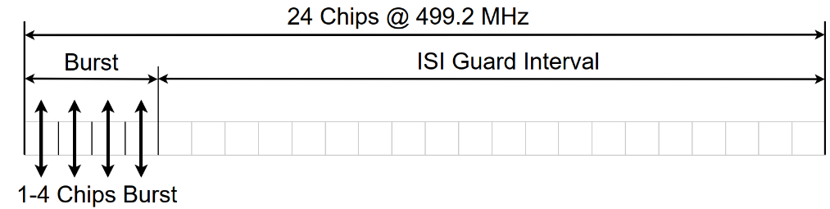

SYNC
The SYNC sequence uses an OOK modulation to transmit repetitions of 1/0 symbols. The phase of the pulses shall be scrambled to whiten the spectrum. The existing LFSR will be used for this, initialized with a 0/1/0/1/... sequence.
Supported SYNC sequence lengths shall be 16, 32, 64 and 128 symbols.

SFD
• Proposal:32 bits sequence.
• Use a list of orthogonal sequences for added network separation opportunity.

The following sequences are proposed based on minimizing the maximum cross correlation between SFD sequences (left most bit transmitted first):

- 5EA6C11D
- BF166129
- B94F9606
- A5843F66
- 9B52FC60
- 6819CBD5
- F29F5C88
- EE415A3C

Payload symbol structure
The 499.2 MHz chip rate of the current HRP PHY is maintained.
The payload symbol shall use the same number of active chips as the preamble symbol.

On-off keying
A symbol consists of 24 chips, corresponding to a 20.8 MHz symbol rate.
The burst within the symbol is either active when transmitting a ‘1’ or inactive when transmitting a ‘0’.

Burst position modulation
A symbol consists of 24 chips, corresponding to a 20.8 MHz symbol rate.
The burst is either located at the beginning of the first or second half of the symbol. An active burst in the first position corresponds to a ‘0’ bit, in the second position to a ‘1’.

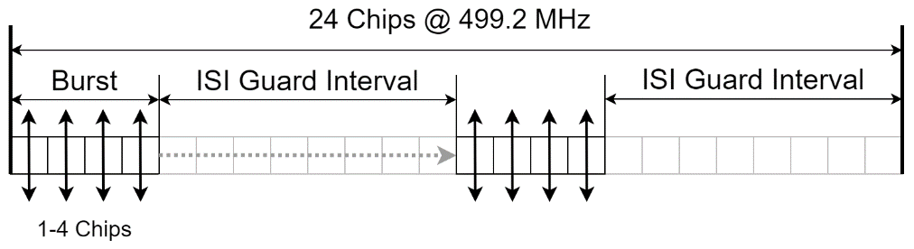

Manchester OOK
A symbol consists of 48 chips, corresponding to a 10.4 MHz symbol rate.
The burst is either located at the beginning of the first or second half of the symbol. An active burst in the first position corresponds to a ‘0’ bit, in the second position to a ‘1’.

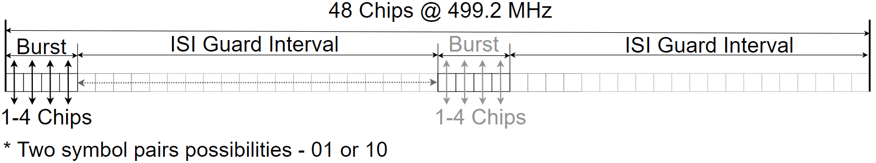

PHR
From the PHR onwards, the phase of the pulses shall be scrambled using the existing LFSR, initialized with the preamble sequence 1/0/1/0/1/0/…
The PHR always uses the Manchester OOK symbol.
Definition of the 19 bits PHR bits to be decided. Potentially include:
- Number of pulses per symbol (3 options)
- Payload modulation format
- Puncturing ratios
- Payload length (255 bytes max payload)
Error correction: SECDED or K==7 CC based.

Forward error correction
The existing convolutional code with constraint length K=7 will be used, with optional puncturing ratios 1/1, 4/3, 5/3 and 2/1

Conclusion
An optional non-coherent mode tailored to low-power, low-latency data communications with minimal impact on standard definition is proposed in this document. Among other benefits cited in the introduction, the proposed optional PHY modifications increase the trade-off space by introducing more options for low power, higher rate communications. Moreover, it reduces the potential for disrupting ranging applications by shortening packet duration and symbol structure.

References
- 15-22-0409-04-04ab-Non-coherent HRP Option for data communication - channel plan and experiment
- 15-21-0585-04-04ab-low-power-operation-for-non-ranging-applications
- 15-22-0297-04-04ab-non-coherent-hrp-option-for-data-communication
- 15-22-0047-04-04ab-mac-layer-considerations-for-uwb-data-streaming

