IEEE P802.15
Wireless Specialty Networks

Project | IEEE P802.15 Working Group for Wireless Specialty Networks (WSNs)
Title | SSBD Technical Specification Framework Contribution
Date Submitted | 15 March 2023
Source | Benjamin Rolfe (Blind Creek Associates), Dries Neirynck (Ultra-radio), Frederic Nabki (Spark), Frank Leong (NXP), Peng Liu, Ziyang Guo, Lei Huang, David Xun Yang (Huawei) | E-mail: [ben.rolfe @ ieee.org ]
Re: | Developing technical content
Abstract | This document provides proposed text for the TFD add the SSBD channel access method.
Purpose | Support development of technical content for the draft
Notice | This document has been prepared to assist the IEEE P802.15. It is offered as a basis for discussion and is not binding on the contributing individual(s) or organization(s). The material in this document is subject to change in form and content after further study. The contributor(s) reserve(s) the right to add, amend or withdraw material contained herein.
Release | The contributor acknowledges and accepts that this contribution becomes the property of IEEE and may be made publicly available by P802.15.

Spectrum Sensing Based Deferral
  - Technical Specification Framework Contribution

Overview

Purpose
This contribution provides proposed text to support addition of the Spectrum Sensing Based Deferral (SSBD) to the 802.15.4 channel access methods. It is intended to be an optional feature. This contribution has been developed to support latency constrained use of the UWB PHYs, but is also suitable for use with any PHY in which the non-exponential backoff and optional alternative channel access method is useful. The SSBD algorithm itself is not dependent upon the PHY type. It assumes the PHY supports CCA mode 1, energy above threshold, with the proposed modifications contained in this document.
SSBD operation and motivation is explained in reference [1], and further enhanced in reference [2]. This document provides (only) a starting point for developing draft text.

References

- Spectrum Sensing Based Deferral (SSBD) channel access, https://mentor.ieee.org/802.15/dcn/22/15-22-0485-01-04ab-ssbd-channel-access.pptx
- Spectrum Sensing Based Deferral Evaluation and Enhancement, https://mentor.ieee.org/802.15/dcn/22/15-22-0606-00-04ab-spectrum-sensing-based-deferral-evaluation-and-enhancement.pptx

Definitions, acronyms, and abbreviations

Definitions
None

Acronyms and abbreviations
SSBD – Spectrum Sensing Based Deferral

Format conventions
No proposed text

General description
Add the following in Clause 5:
Spectrum sensing based deferral (SSBD) Overview of SSBD (goes into clause 5)

For applications that use the UWB PHY where channel access latency needs to be bounded, the Spectrum sensing based deferral channel access method is provided. SSBD is described in clause 6.2.5.x. The key elements of SSBD include:
- The duration of sensing the channel during CCA default value is 9us (i.e., for 9 x 1025ns symbol periods) with 1us as a minimum value and 31us as a maximum value.
- Deferral on CCA busy is provided, with random delay and linear back-off to bound channel access latency.
- To provide for bounding channel access latency, after a configurable number of CCA attempts the algorithm can revert to unslotted Aloha – proceed as if the channel is idle and continue with transmission of the frame (i.e., as if CCA Mode 4 was used).
- Conflict resolution by enlarging backoff window after unsuccessful packet transmission.

MAC Functional Description
Insert new subclause in 6.2.5:
6.2.5.x Spectrum sensing based deferral (SSBD)
Spectrum sensing based deferral (SSBD) can be used for channel access where bounding latency in the channel access is desired. SSBD is optional in all device types. SSBD may be used for unscheduled random access or with one of the scheduled access schemes. SSBD employs channel sensing using CCA and bounded deferral using linearly growing random backoff at each deferral.
The timing and behaviour of SSBD is controlled by the attributes macMinBf, macMaxBf, macMaxSSBDBackoffs and macSSBDBOEndAction (see 8.4.3). Figure 6-<ssbd1> illustrates the steps of the SSBD algorithm. When the algorithm ends in “Success” the MAC shall commence transmission of the frame. Otherwise, the algorithm terminates with a channel access failure.
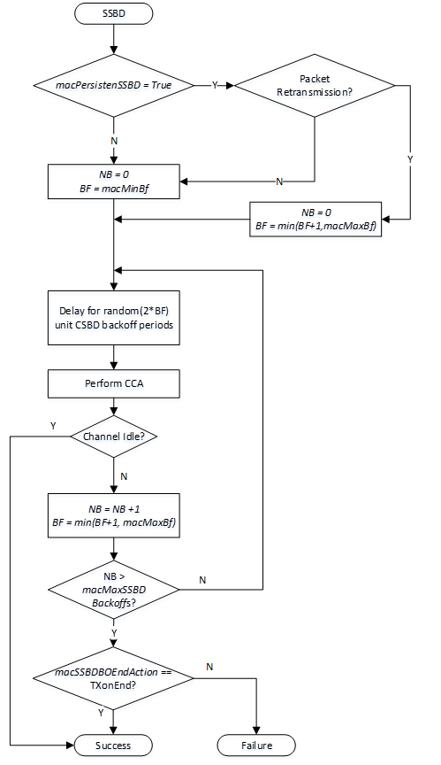

Figure 6-<ssbd1> SSBD algorithm

When performing the SSBD algorithm, the variables NB and BF are maintained. NB is the number of times the SSBD algorithm was required to backoff due to channel busy condition. NB shall be initialized to zero for each new SSBD attempt. BF is the backoff factor. Prior to each CCA, the algorithm shall delay for a random delay value between 0 and 2*BF, using the backoff period defined by macSSBDUnitBackoffPeriod.
SSBD includes a persistence option. For each SSBD attempt, BF is initialized as follows: When macPersistentSSBD is set, then the initial value of the backoff factor is set based upon the whether the channel access attempt is for retransmission of a frame. For retransmissions, the initial value of BF shall be set to the terminating value from the last SSBD access +1. When macPersistentSSBD is not set, or when the channel access attempt is not for a retransmission, BF shall be initialized to macMinBf
When CCA returns busy, NB and BF shall be incremented and the backoff executed.
The algorithm shall terminate with Success when CCA returns idle. The action when NB exceeds macMaxSSBDBackoffs depends on the value of macSSBDBOEndAction: when set to TXonEnd, the algorithm shall end with Success. When the value of macSSBDBOEndAction is FailOnEnd, the algorithm shall end with Failure.
Retransmission is indicated as an input to the SSBD procedure. Retransmission is performed according to [6.7.4].
When used for SSBD, and CCA Mode 1 or Mode 3 are used, the CCA threshold shall be set to phyCcaEDthreshold and the CCA detection time shall be set to phyCcaDuration.
Two examples that illustrate SSBD control parameters settings and the corresponding bounded channel access latency are provided in Appendix A.
6.7.4.4 Retransmissions
Insert after the 4th paragraph:
When the SSBD channel access method is being used, the Retransmission shall be indicated to the SSBD procedure.

8.4.3 MAC PIB attributes
Insert the following attributes into table 8-94 in order:
Attribute | Type | Range | Description | Default
macMaxBf | Integer | 1 - 63 | The maximum value of the backoff factor (BF) in the SSBD algorithm as described in 6.2.5.x. | 5
macMaxSSBDBackoffs | Integer | 1 – 255 | The maximum number of deferral iterations the SSBD algorithm will attempt before exiting. | 5
macMinBf | Integer | 1 - macMaxBf | The minimum value of the backoff factor (BF) in the SSBD algorithm as described in 6.2.5.x. | 1
macSSBDBOEndAction | Enumeration | TxOnEnd,  FailOnEnd | Determines the termination result of the SSBD algorithm upon exceeding the maximum back-off count, as described in 6.2.5.x. | TxOnEnd
macSSBDUnitBackoffPeriod | Integer | 1 - 31 | The unit time period use for deferral in the SSBD algorithm, in microseconds | 1
macSSBDCcaDuration | Integer | 1 - 31 | CCA Duration in microseconds | 9

10.2.8 Clear channel assessment (CCA)
Change the last paragraph of 10.2.8 as indicated:
The PHY PIB attribute phyCcaMode, as described in 11.3, shall indicate the appropriate operation mode. The CCA parameters are subject to the following criteria:
- Except for the SUN O-QPSK PHYs and when SSBD is being used, the ED threshold shall correspond to a received signal power of at most 10 dB greater than the specified receiver sensitivity for that PHY, or in accordance with local regulations. For the SUN O-QPSK PHY, the ED threshold shall comply with the specification in 21.5.13. When SSBD is being used, the ED threshold shall comply with the specification in 6.2.5.x.
- Except for the 920 MHz band PHYs and the RCC PHYs and when SSBD is being used, the CCA detection time shall be equal to aCcaTime, as defined in as defined in Table 11-1. For the 920 MHz band, and the RCC PHYs, phyCcaDuration symbol periods shall be used. When SSBD is being used, the CCA detection time shall comply with the specification in 6.2.5.x.

Appendix A – SSBD Latency Examples
The following examples illustrate how the SSBD control parameters are used to bound channel access latency.
Example 1: Default values from Table 8-94:
macMinBF = 1
macMaxBf = 5
macMaxSSBDBackoffs = 5
macSSBDUnitBackoffPeriod = 1
macSSBDCcaDuration = 1
Assuming worse case of maximum random delay at each iteration, the Channel Access Latency will not exceed 46 usec.
Example 2: To bound the maximum delay to about 2 ms, the follow parameters can be used:
macMinBF = 3
macMaxBf = 10
macMaxSSBDBackoff = 7
macSSBDUnitBackoffPeriod = 20
macSSBDCcaDuration = 1

Assuming worse case of maximum random delay at each iteration, the Channel Access Latency will not exceed 2.088 ms .
Note the delay at each iteration is random between 0 and 2*BF and thus normal values will be less.
Note that these examples do not consider the additional latency that results when persistence is enabled, and the packet is a retransmission.

