IEEE P802.15
Wireless Specialty Networks

Project | IEEE P802.15 Working Group for Wireless Specialty Networks (WSNs) – 802.15.4ab
Title | Text for Co-scheduling for Sensing and Ranging
Date Submitted | 09 September 2022
Source | Aniruddh Rao Kabbinale, Ankur Bansal, Karthik Srinivasa Gopalan (Samsung Electronics) | E-mail: [aniruddh.rao@samsung.com]
Re:
Abstract | This document provides details of MAC features for 4ab
Purpose | Support development of technical content for the draft
Notice | This document has been prepared to assist the IEEE P802.15. It is offered as a basis for discussion and is not binding on the contributing individual(s) or organization(s). The material in this document is subject to change in form and content after further study. The contributor(s) reserve(s) the right to add, amend or withdraw material contained herein.
Release | The contributor acknowledges and accepts that this contribution becomes the property of IEEE and may be made publicly available by P802.15.

*************************************************************************************Draft of co-scheduling for sensing and ranging
*************************************************************************************
6.9 Ranging, relative positioning, localization and sensing
6.9.1 Measurements
6.9.1.1 Overview
Insert the new text at the end of 6.9.1.1 as follows
An ERDEV that supports sensing is called a sensing-capable ERDEV (SC-ERDEV). Sensing can be achieved by an SC-ERDEV by using the HRP UWB PHY defined in the standard. Support for sensing is optional.
6.9.7.2 Ranging Block and round structure
Insert the new text at the end of 6.9.7.2 as follows
A controller may perform both ranging and sensing activities with its controlees by using ranging block and round structure. Figure 6-9-xx shows an illustration of block structure with ranging and sensing being performed in multiple rounds. Each block consists of a whole number of rounds, where a round is a period of sufficient duration to complete one entire sensing cycle involving the set of SC-ERDEVs participating in the sensing exchange or a period of sufficient duration to complete one entire range-measurement cycle involving the set of ERDEVs participating in ranging exchange. Each round, based on whether it is a sensing round or a ranging round, is further sub-divided into an integer number of sensing slots or ranging slots respectively. In Figure 6-9-xx, the block is divided into N rounds, which may cater to either sensing or ranging activity. Each sensing round consists of P sensing slots. Each ranging round consists of M ranging slots. The sensing slot and the ranging slot duration may be different from each other. The slot duration and the number of slots making up a round can be changed between rounds. A controller sending an RCM with the modified configuration whenever a change is required can achieve this.
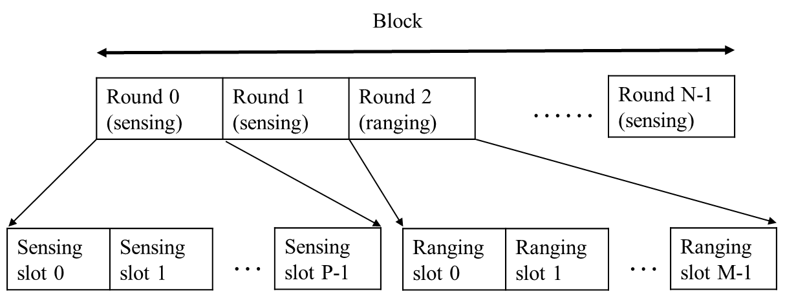
Figure 6-9-xx Illustration of block, round and slot with sensing and ranging performed in multiple rounds

