IEEE P802.15
Wireless Personal Area Networks

Project | IEEE P802.15 Wireless Specialty Networks (WSNs)
Title | Relaying resolution
Date Submitted | 09 September 2022
Source | Bober, Kai Lennert  Fraunhofer HHI | Voice: -  Fax: -  E-mail: bober@ieee.org
Re:
Abstract | This document contains resolutions on the relaying
Purpose | Aid comment resolution
Notice | This document has been prepared to assist the IEEE P802.15. It is offered as a basis for discussion and is not binding on the contributing individual(s) or organization(s). The material in this document is subject to change in form and content after further study. The contributor(s) reserve(s) the right to add, amend or withdraw material contained herein.
Release | The contributor acknowledges and accepts that this contribution becomes the property of IEEE and may be made publicly available by P802.15.

Legend:
- Arial size 13 indicates subsections for individual comments
- Red underlined text needs to be adapted during the comment implementation (e.g., because it is a reference).
- Bold italic text is an instruction to the editor to implement the text
Add a new subclause before 6.11.1 (“Overview”) with the following content:
The following subclauses define transmissions between the coordinator and a relayed device via a relay device.
Relaying is supported in OWPANs operating in the scheduled channel access mode.
When multiple OFEs are used by the coordinator, relaying shall not be used.
Replace P58L11-19 with the following text:
A potential relay device shall indicate capRelayDevice during the association as described in 6.5.6.1. After receiving an Association Response element indicating successful association and confirming the use of capRelayDevice, the relay device starts listening to its environment and collecting the transmitter addresses of observed MPDUs.
A potential relayed device shall indicate capRelayedDevice during the association as described in 6.5.6.1. After receiving an Association Response element indicating successful association and confirming the use of capRelayedDevice, the relayed device starts listening to its environment and collecting the transmitter addresses of observed MPDUs.
NOTE—Due to the nature of wireless communications, a device in the OWPAN will be able to receive and decode transmissions from all other devices complying with this standard that are in the same coverage area.
Relay devices and relayed devices periodically transmit a Reachable Address element to the coordinator. When to transmit the element to the coordinator is implementation specific. Figure A shows the exchange of the Reachable Address element between the devices and the coordinator.
The Reachable Address element contains the MAC address of all observed transmitter addresses and a potentially usable MCS for transmissions from the observed transmitter to the device sending the Reachable Address element.
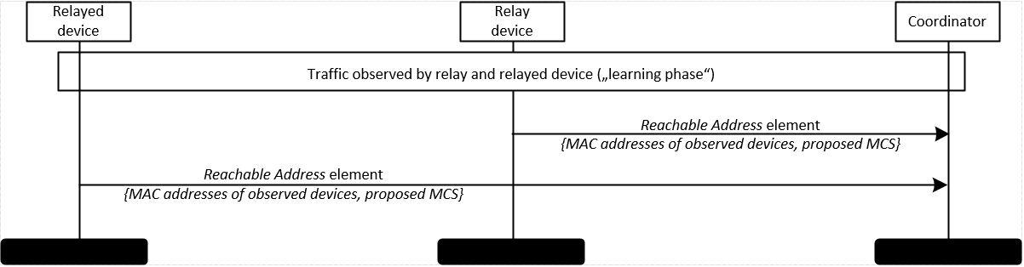
Figure A – Detection of potential relay links

Replace the content of clause 6.11.2 (Activating a relay link) with the following text:
The activation procedure of a relay link is depicted in Figure B.
To configure a relay device and activate a relay link, the coordinator shall send Relay Device Configuration Request element, defined in 7.2.36, to the intended relay device with the Relay Active field set to one and the Relay Link Address field set to the address of the device intended to have the relay link. The coordinator shall select an MCS to be used for future transmissions from the relay device to the relayed device based on the information it obtained during association of the devices and through the Reachable Address element received from the intended relayed device and include it in the element.
Upon receiving the Relay Device Configuration Request element from the coordinator, the intended relay device shall answer with a Relay Device Configuration Response element. It shall set the Status field to SUCCESS if the request was accepted and DENIED otherwise and include the MAC address of the relayed device.
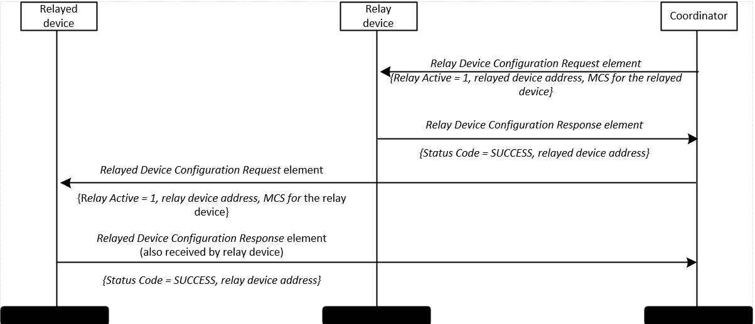
Figure B – Activation of a relay link
Upon receiving a Relay Device Configuration Response element with Status set to SUCCESS from the intended relay device, the coordinator shall transmit Relayed Device Configuration Request element to the intended relayed device. The Relayed Device Configuration Request element shall have the Relay Active field set to one. The element shall further include the MAC address of the intended relay device, as well as the MCS to be used for future transmissions from the relayed device to the relay device.
NOTE – The MCS to be used for transmissions from the relayed device to the relay device may be different from the MCS to be used for transmissions from the relay device to the relayed device.
Upon receiving the Relayed Device Configuration Request element from the coordinator, the intended relayed device shall answer with a Relayed Device Configuration Response element. It shall set the Status field to SUCCESS if the request was accepted and DENIED otherwise. The intended relayed device shall include the MAC address of the relay device in the Relayed Device Configuration Response element.
If the coordinator receives a Relayed Device Configuration Response element with Status other than SUCCESS from the intended relayed device, or it does not receive any response after an implementation specific timeout, the coordinator shall undo the configuration of the relay device as described in 6.11.3.
The content of clause 6.11.4 (Relaying frames) with the following text:
The relaying of MPDUs is depicted in Figure C. The relay device obtains GTS for relayed transmissions like any other device as described in 6.3.6.
MPDUs that are supposed to be relayed shall be sent with Relayed Frame field set to one as described in 7.1.2. The Relay Address field shall be set to all zeros by the original transmitter of the MPDU.
The MPDUs, either sent from coordinator to device or from device to coordinator, are also received by the relay device. The relay device shall store valid MPDUs with the Relayed Frame field set to one and the receiver address or transmitter address set to the MAC address of a relayed device for that a relay link was set up.
The relay device shall transmit stored MPDUs in its own GTS to the relayed device or the coordinator. The MCS to use for relayed frames shall be the one configured at relay link activation as described in 6.11.2. When relaying a frame, the relay device shall insert its MAC address into Relay Address of the Relay Control field of the relayed MPDU.
A relay device shall not perform acknowledgement and retransmission of MPDUs that it relays. MPDUs with the ACK Request field set to one and MPDUs containing a Single ACK element or Block ACK element shall be relayed like other frames.
MPDUs with a destination address equal to the broadcast address shall not be relayed.
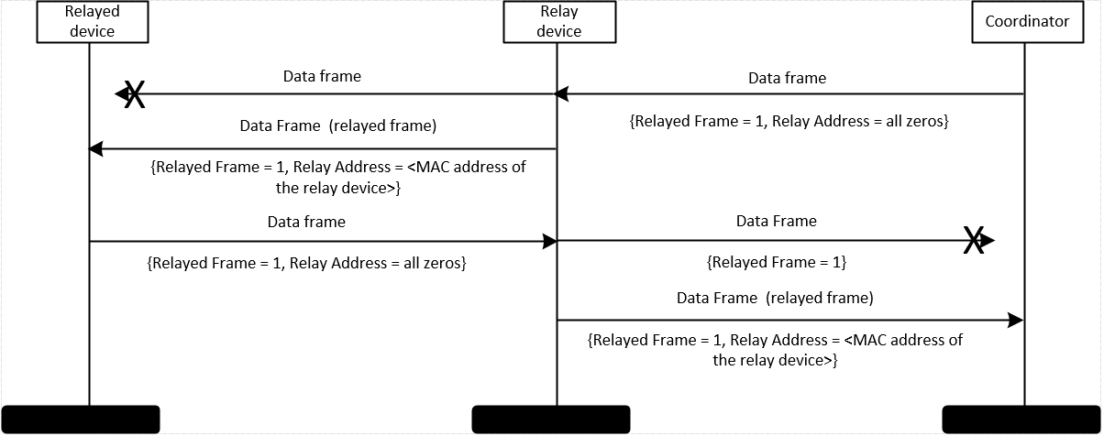
Figure C – Relay operation sequence chart

Replace the contents of 7.2.35 with the following content:
The format of the Reachable Address element is shown in Figure FE.
1 Octet | 6 Octets | variable | … | 6 Octets | variable
Address Count  (N) | Reachable  Address 1 | Requested  MCS 1 | … | Reachable  Address N | Requested  MCS N
Figure FE - Reachable Address element
Address Count: The Address Count field is an integer indicating the number of addresses in the Reachable Addresses fields 1 to N.
Reachable Address 1 … N: These fields contain one or more MAC addresses of reachable, i.e., observed, devices.
Requested MCS 1 … N: These fields contain the MCS that the device requests for potential future relayed transmission to it from the respective observed device. Each field shall contain a Requested MCS element as defined in <clause of MCS Request element>.

Add a new field “Requested MCS” into the Relay Device Configuration Request element with variable width and the following field description:
Requested MCS: This field shall contain a Requested MCS element as defined in <clause of MCS Request element>. The field shall contain a requested MCS for future transmissions from the relay device to the relayed device.

Remove MCS ID field from the Relay Device Configuration Response element.
Add a new field “Requested MCS” into the Relayed Device Configuration Request element with variable width and the following field description:
Requested MCS: This field shall contain a Requested MCS element as defined in <clause of MCS Request element>. The field shall contain a requested MCS for future transmissions from the relayed device to the relay device.

Remove MCS ID field from the Relayed Device Configuration Response element.
Move subclauses for MCS Request and Supported MCS elements close to each other. Also change in element table and PICS.
Rename PM-PHY MCS element to PM-PHY MCS List element
Rename HB-PHY MCS element to HB-PHY MCS List element
Rename MCS Request element to PM-PHY MCS Request element
Rename BAT Request element to HB-PHY MCS Request element
Add the following new element subclause:

X.X.X MCS Request element
The MCS Request element, depicted in Figure D is used to request use of a specific MCS from a device for future transmissions.
1 Octet | variable
PHY  ID | Requested  MCS  Element
Figure D – MCS Request element
PHY ID: The ID of the PHY for that the MCS Request element contains a requested MCS. Valid PHY IDs are listed in TA.
Requested MCS Element: A PHY-specific element indicating a requested MCS. The format depends on the value of the PHY ID field. The contained element for each PHY ID is given in table TA.
Table TA PHY IDs and corresponding MCS elements
PHY ID | PHY | MCS element
0 | PM-PHY  (defined in Clause 10) | PM-PHY MCS element  (defined in <clause of PM-PHY MCS Request element>)
1 | HB-PHY  (defined in Clause 11) | HB-PHY MCS element  (defined in <clause of HB-PHY MCS Request element>)
others | reserved | reserved

TODO: Include value of N in HB-PHY Request (BAT Request)

Add the new MCS Request element to the PICS
Update MR-AT2 and MR-AT1 – rename to PM-PHY specific and HB-PHY specific. Update dependency with elements.

Rename the following PICS entries according to the earlier described renaming changes:
- Rename PM-PHY MCS element to PM-PHY MCS List element (in the whole document)
- Rename HB-PHY MCS element to HB-PHY MCS List element (in the whole document)
- Rename MCS Request element to PM-PHY MCS Request element (in the whole document)
- Rename BAT Request element to HB-PHY MCS Request element (in the whole document)

Rename 6.9.3.2 to HB-PHY MCS request procedure
Check whether clause references are still correct in the PICS

Add a new subclause “5.3.4 Relay topology” with the following content:

In the relay topology, the OWPAN includes at least one relay device. The relay topology is depicted in Figure X. Relaying is supported within the coverage of the OWPAN. Relaying requires direct connectivity between the coordinator, the relay device and the relayed device.
In the downlink, if the coordinator decides that connectivity via the relay would be better than via the direct link, the coordinator can decide to setup the link via the relay device. Similarly in the uplink, the relayed device may choose to transmit its frames via the relay device to the coordinator.

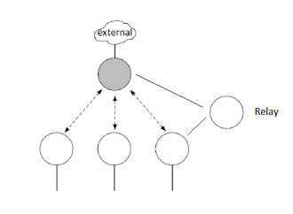
Figure X – Relay topology

