Summary of properties and experiments on use of Gold/Zc sequence for syncronization:
- Sequences correlation properties
For the task of syncronization, sequences with desired autocorrelation (AC) and cross-correlation (CC) properties are required. AC of the sequence should ideally resemble a delta function. CC between two different sequences should be close to zero for all lags. We consider two classes of sequences which demonstrate the desired qualities.
Zadoff-Chu (ZC) sequences belong to the class of chirp-like polyphase sequences with optimal correlation properties (complex sequences with magnitude 1).
- For a given length N, ZC sequences are given by
$x_{R}\left(n\right)=exp⁡(-\frac{2πiRn\left(n+1\right)}{n})$, n=0, 1, …..N-1.
There are N-1 sequences of length N. one for each R from 1 to N-1.
- In order to obtain optimal periodic correlation properties, N must be chosen to be an odd number.
- For odd N ZC sequences have the following properties:
Periodic AC for zero lag is maximum and zero for all other lags.
Periodic CC is constant for any 2 sequences for all lags and is equal to $√N$.
Gold sequences are bipolar PN sequences which are derived from specific type of m-sequences (maximal length shift register sequences) of the same length.
- For a given length $N=2^{m}-1$, we can generate N+2 gold sequences by combining two preferred m-sequences. Such a sequence has a period of N.

The figure below demonstrates generation of Gold sequence of length 31 by XOR of two preferred m-sequences.

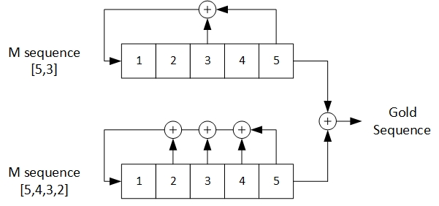
Gold Sequence generation
- Let $t=2^{0.5\left(m+1\right)}+1$, if m is odd and ${t=2}^{0.5\left(m+2\right)}+1$, if m is even. Then, Gold sequences of length N have the following properties:

Periodic AC for zero lag has maximum value of N. For non-zero lag it takes on one of the 3 values {-1, -t, t-2}.
Periodic CC for all lags takes on one of the 3 values {-1, -t, t-2}.
- The shift registers tap connections needed to the generate the m-sequences necessary to generate a given length Gold sequence are given in the table below.

m | $$N=2^{m}-1$$ | Preferred m-sequence pair
5 | 31 | [5,3];[5,4,3,2]
6 | 63 | [6,1];[6,5,2,1]
7 | 127 | [7,3];[7,3,2,1]
8 | 255 | [8,7,6,5,2,1];[8,7,6,1]
9 | 511 | [9,6,4,3];[9,8,4,1]

Examples:
Let us now consider examples for N=127. The absolute value of AC and CC for both types of sequences are plotted below. It is clear that ZC sequence is preferable to Gold sequence in both respects.
Zero lag AC= 127 for both
CC for ZC= 11.2694
The 3-value set for Gold sequence is {-1, -17, 15}
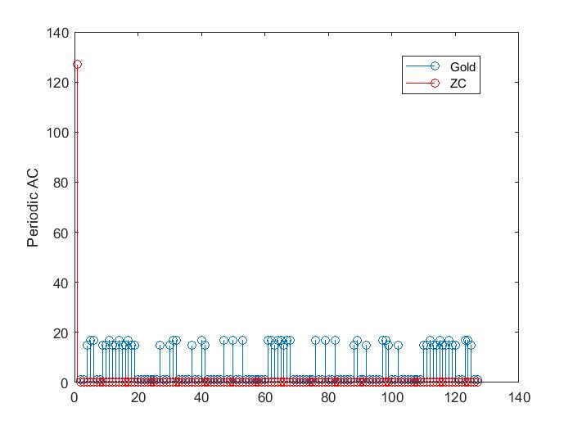
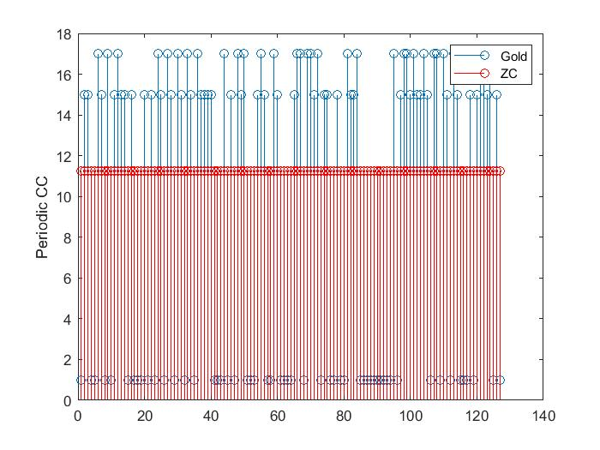

- Time and frequency offset estimation using ZC/ Gold sequences
In communication systems time and frequency errors are introduced at the receiver due to variable transmission delay and frequency mismatch/drift of the local oscillator. To correct these errors, synchronization algorithm is used.
The time and frequency offset are estimated by comparison with a known transmitted sequence. We will be using ZC and Gold sequence for this purpose.
Setup:
N is the FFT size / number of modulation alphabet in an OFDM symbol
N_cp is the length of cyclic prefix
P =N + N_cp
L_f is the frame length in symbols
N_tot=L_f$×$P
L is the length of preamble (Gold sequence, GS). The sequence is contained in a single subcarrier, spread across L symbols.
Time domain processing window size is L $×$ P time samples

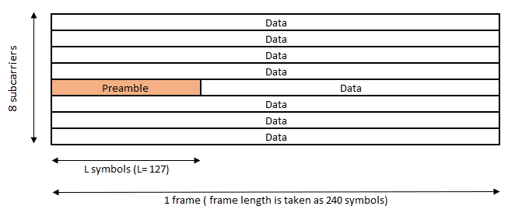

Experiments:
In the following experiments, we compare the accuracy of time and frequency estimates obtained by the synchronization algorithm using ZC and GC respectively.
Frequency error/offset is modeled as multiplication by complex exponential $exp⁡(i∆n)$. Since DFT bin size is 2π/N, $∆=\frac{2π}{N}δ$. The offset δ can be either an integer or fraction of subcarrier (SC) spacing in a OFDM system.
SC spacing for OFDM system is taken to be 6.25 KHz. Frequency offset (FOFF) is ±625 Hz and time offset (TOFF) is 45 samples.
N=8, N_cp=1, L_f=240, L=127

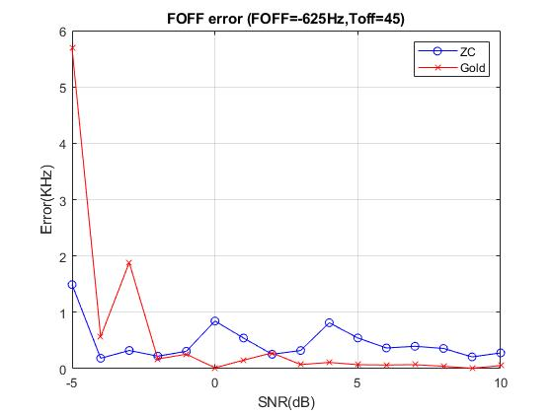

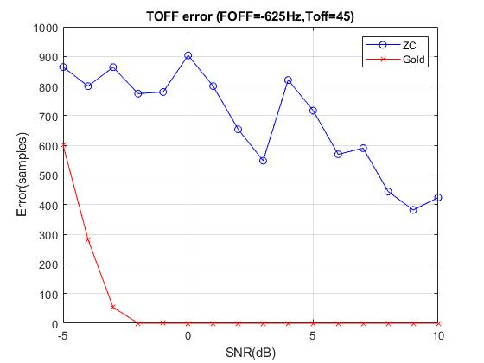
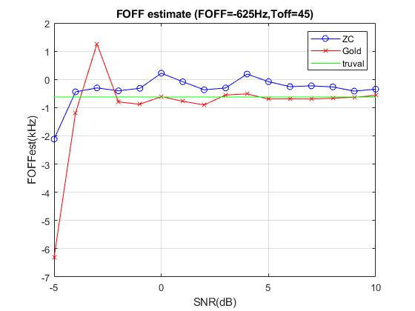
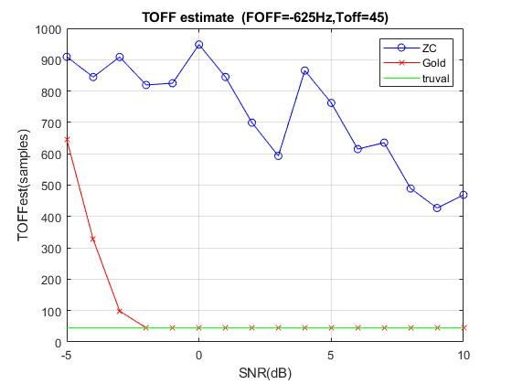
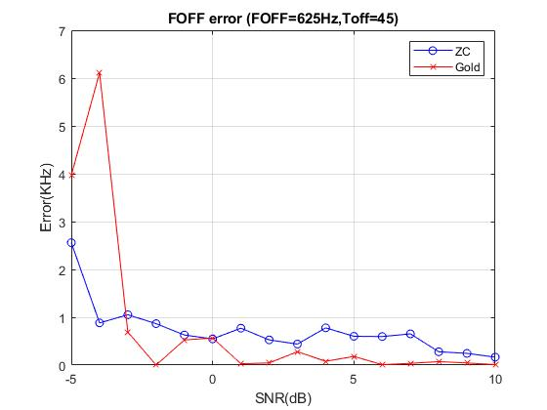

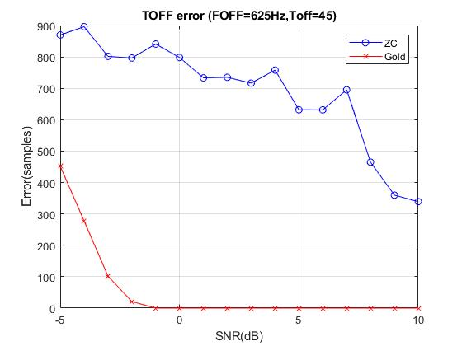
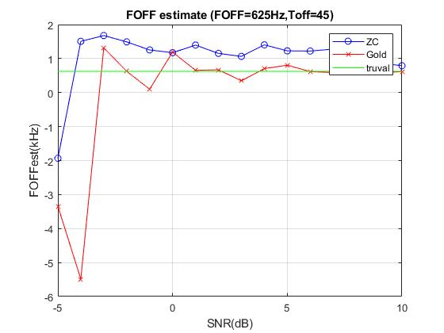
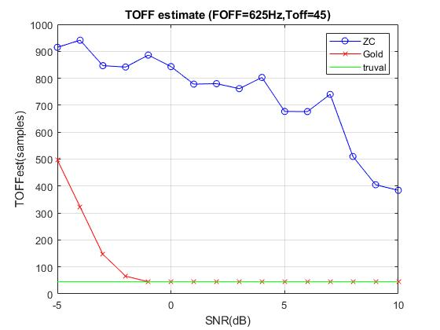

Conclusion:
Based on the experimental results so far, Gold codes are recommended. ZC sequences seem to be better with no timing offset at low SNR, but their performance is poor with timing offset. We will have timing uncertainty both in DL and UL, and hence Gold codes are recommended.

