WINDOWING AND FILTERING SPECIFICATIONS for 802.16t Transmitter

The combination of time domain windowing and filtering is used to meet the Adjacent Channel Leakage Ratio (ACLR) and Error Vector Magnitude (EVM) requirements at the transmitter.
The specifications for the windowing and filtering techniques are given below.

RAISED COSINE WINDOWING:
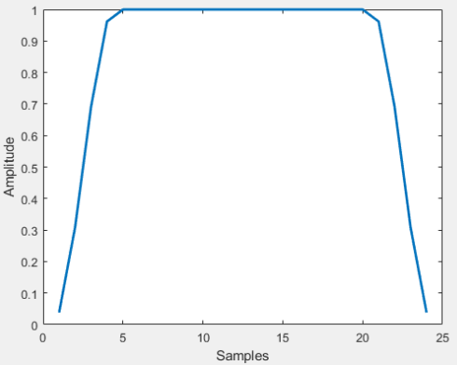
Figure 1 RC Window in Time Domain
The above figure depicts the raised cosine window in the time domain. The windowing is applied such that only the cyclic prefix and cyclic suffix samples of a time domain symbol undergo pulse shaping and the data samples are unaltered. The filter generation is as follows.
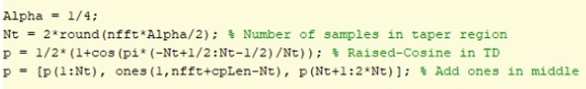
The alpha parameter in the above equation is set according to the length of the cyclic prefix samples. The below image shows the process.
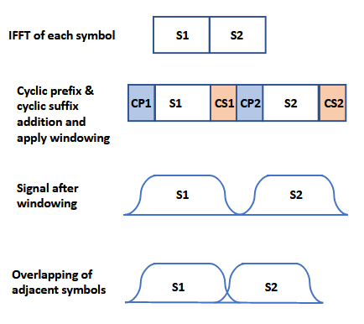
Figure 2 RC Windowing Steps

FILTERING:
The response of the filter in the frequency domain for a single subchannel where the center subchannel is occupied is given below.
MIDDLE SINGLE SUBCHANNEL
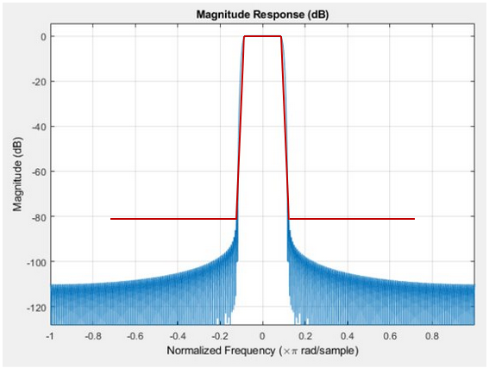
Figure 3 Magnitude Response of the desired filter

The filter is characterized by the following parameters.
Number of filter taps: 257
Normalised Passband edge: 0.082*pi
Normalised Stopband edge: 0.120*pi
Stopband attenuation: 90 dB

Any of the filter design techniques can be used to obtain a filter that satisfies the above.
One such example is low pass FIR filter designed using MATLAB DSP tool as given below for single subchannel for sampling rate of 168 kHz.
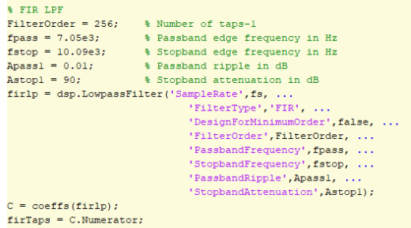

Below spectrum is obtained with the RC time windowing followed by the low pass FIR filtering, FCC Mask D is also applied on top of it.
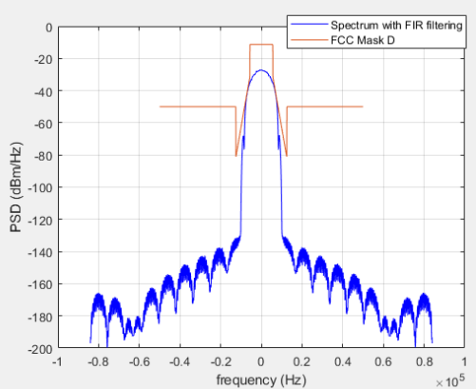
Figure 4 FIR filtered spectrum with FCC Mask-D
For the EVM measurement the TX signal with 256 QAM modulation is generated and then the RC windowing and FIR filtering is applied to it. Below figure shows the constellation of the 256QAM data and EVM and SNR computation is also done. This analysis shows the EVM requirements are met for 256QAM at the transmitter along with the FCC Mask-D.
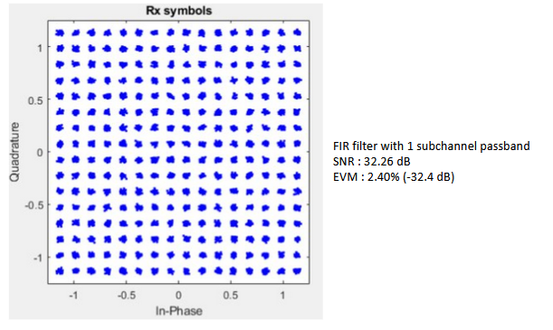
Figure 5 Constellation and EVM for 256 QAM

