IEEE P802.15
Wireless Personal Area Networks

Project | IEEE P802.15 Working Group for Wireless Personal Area Networks (WPANs)
Title | NBA-MMS-UWB ranging text proposal for 15.4ab TFD
Date Submitted | July 2022
Source | Yong Liu, Santhosh Kumar Mani, Robert Golshan, Alexander Krebs, Lochan Verma, Jinjing Jiang, SK Yong (Apple)
Re: | Contribution to IEEE 802.15.4ab
Abstract
Purpose | This submission proposes text to for the IEEE Std 802.15.4ab specification framework document.
Notice | This document does not represent the agreed views of the IEEE 802.15 Working Group or IEEE 802.15.4ab Task Group. It represents only the views of the participants listed in the “Source(s)” field above. It is offered as a basis for discussion and is not binding on the contributing individual(s) or organization(s). The material in this document is subject to change in form and content after further study. The contributor(s) reserve(s) the right to add, amend or withdraw material contained herein.

- NBA-MMS-UWB Ranging
  - Overview
The NBA-MMS-UWB ranging uses the following nomenclature to indicate ERDEV roles, as defined in 6.9.7.1 of IEEE 802.15.4z.
- Controller
- Controlee
- Initiator
- Responder
The NBA-MMS-UWB ranging also uses
- the ranging block and round structure, as specified in 6.9.7.2 of IEEE 802.15.4z, and
- the blocked-based mode, as specified in 6.9.7.3.3 of IEEE 802.15.4z.
Figure 6-48j and Figure 6-48r of IEEE 802.15.4z are quoted below as Figure 1 and Figure 2, respectively.
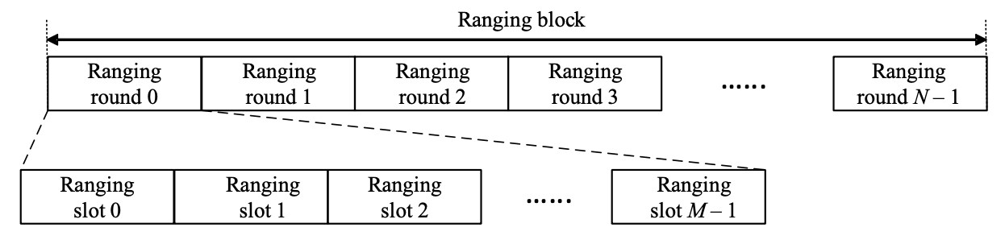
Figure 1 - Illustration of ranging block, ranging round, and ranging slot
The ranging block structure can be setup by specifying:
- the ranging block duration
- the ranging round duration
- the ranging slot duration
The time unit used in specifying the durations of ranging block, ranging round, and ranging slot is the RSTU as specified in 6.9.1.5 of IEEE 802.15.4z. Ranging devices shall realize this ranging block structure such that the tolerance in the ranging block duration with respect to the PHY clock shall be within ±100 ppm (TBD).
For a given block configuration, each ranging block is referenced by a ranging block index relative to the first block in that configuration (block number zero). Each ranging round in any ranging block is referenced by a ranging round index relative to the first ranging round in the current ranging block. Similarly, each ranging slot in a ranging round is referenced by a ranging slot index relative to the first ranging slot in the ranging round.
A ranging round is a period of sufficient duration to complete one entire range-measurement cycle. A controller and a controlee may use one or multiple ranging rounds from the first ranging block of a ranging session and repeat the same ranging round usage pattern in subsequent ranging blocks. The round hopping, as specified in 6.9.7.3.3 of IEEE 802.15.4z, may be optionally applied to an NBA-MMS-UWB ranging session, while the transmission offset does not apply to the NBA-MMS-UWB ranging.
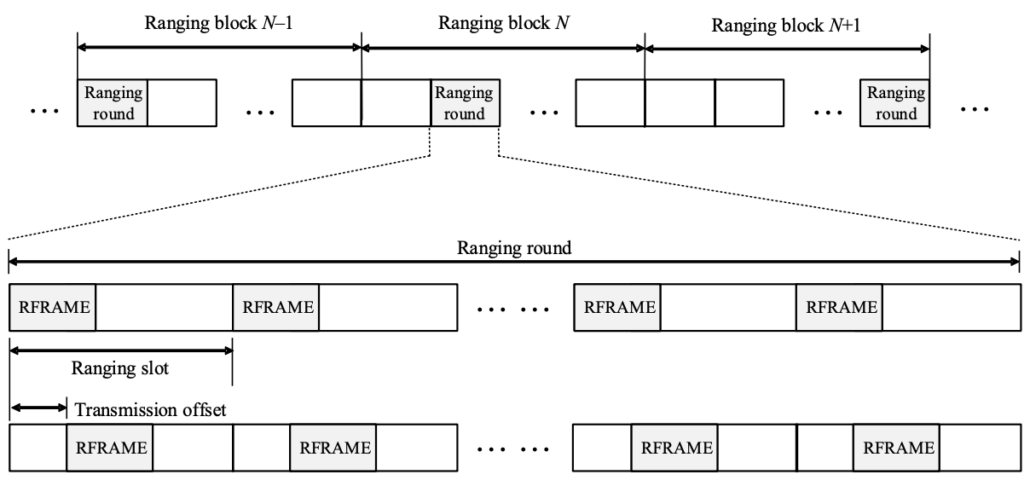
Figure 2 – Time diagram for an example of block-based mode
A range-measurement cycle can be uniquely identified by a ranging block index and a ranging round index.
In the NBA-MMS-UWB ranging, a range-measurement cycle consists of following phases:
- ranging control phase
- ranging phase
- measurement report phase
Each phase consists of an integer number of ranging slots.
The ranging control phase and ranging phase are mandatorily required in a range-measurement cycle, while the measurement report phase may be optionally included in a range-measurement cycle.
Figure 3 illustrates the NBA-MMS-UWB ranging round, range-measurement cycle, and phases.
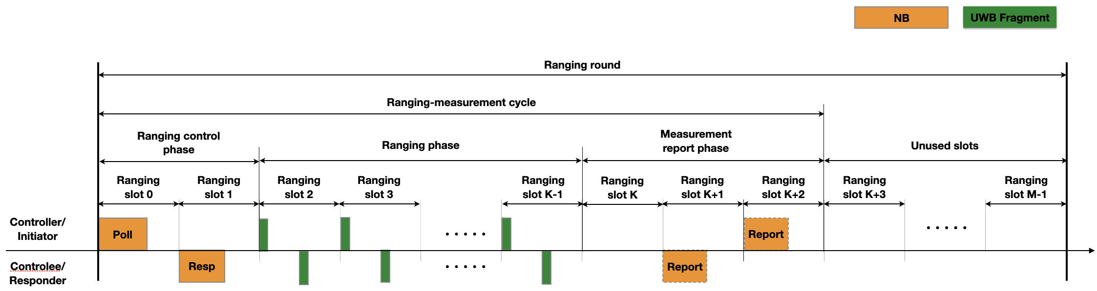
Figure 3 – Illustration of NBA-MMS-UWB ranging round, range-measurement cycle, and phases
The following nomenclature is used for NB control and report messages:
- Poll message: A NB message transmitted by a controller at the beginning of the first ranging slot of a ranging round to initiate a range-measurement cycle within the ranging round.
- Response message: A NB message transmitted by a controlee at the beginning of a subsequent ranging slot after the first ranging slot, in response to a received Poll message.
- Report message: a NB message transmitted by either an initiator or a responder to report the ranging measurement to the peer.
  - NBA-MMS-UWB range-measurement cycle
    - NBA-MMS-UWB ranging control phase
An NBA-MMS-UWB ranging control phase starts at the beginning of an NBA-MMS-UWB range-measurement cycle and includes at least 2 ranging slots.
A controller starts an NBA-MMS-UWB ranging control phase by transmitting a Poll message to a controlee at the beginning of the first ranging slot of a ranging round. The controlee that receives the Poll message successfully shall transmit a Response message back to the controller after an NB RX-to-TX interval. The controlee that transmits the Response message successfully shall continue the NBA-MMS-UWB range-measurement cycle and enter the ranging phase. The controller that receives the Response message successfully shall also continue the NBA-MMS-UWB range-measurement cycle and enter the ranging phase.
If LBT is required before a NB transmission in the corresponding operating band (referring to [4]), a transmitter shall perform LBT in advance of the start of expected transmission. If the performed LBT cannot warrant the transmission at the beginning of the ranging slot, the transmitter shall not commence the transmission.
A controller shall discontinue an NBA-MMS-UWB range-measurement cycle if one of following conditions is met:
- the LBT does not warrant the transmission of the Poll message.
- the controller fails to receive the Response message at the expected ranging slot.
A controlee shall discontinue an NBA-MMS-UWB range-measurement cycle if one of following conditions is met:
- the controlee fails to receive the Poll message at the beginning of the expected ranging round.
- the LBT does not warrant the transmission of the Response message.
If a range-measurement cycle is terminated before its completion, the involved ERDEVs shall stop the NB and UWB transmissions until the next range-measurement cycle.
Figure 4 illustrates an example of the NBA-MMS-UWB ranging control phase.
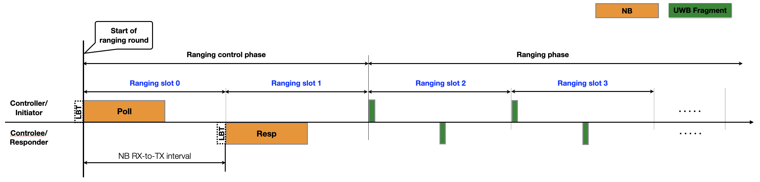
Figure 4 - An example of the NBA-MMS-UWB ranging control phase
    - NBA-MMS-UWB ranging phase
An NBA-MMS-UWB ranging phase starts immediately after an NBA-MMS-UWB ranging control phase.
An initiator starts an NBA-MMS-UWB ranging phase by transmitting a UWB fragment at an Initiator UWB starting offset measured from the start of the Poll message. The initiator may transmit multiple UWB fragments within the ranging phase. The intervals between the UWB fragments are TBD (referring to [5]).
A responder transmits the first UWB fragment at a Responder UWB starting offset measured from the start of the Response message. The responder may transmit multiple UWB fragments within the ranging phase. The intervals between the UWB fragments are TBD (referring to [5]).
After an ERDEV, being either an initiator or a responder, completes the reception of all UWB fragments for the ranging phase, it shall generate the ranging measurement report, if it is required to send the measurement report to a peer.
If an NBA-MMS-UWB measurement report phase presents in an NBA-MMS-UWB range-measurement cycle, an ERDEV which completes its ranging phase shall enter the measurement report phase, if
- it is required to send the measurement report to a peer during the measurement report phase, and it generates the measurement report successfully; or
- it expects to receive the measurement report from a peer during the measurement report phase.
An ERDEV shall discontinue an NBA-MMS-UWB range-measurement cycle if it is required to send the measurement report to a peer, but it fails to generate the measurement report.
If an NBA-MMS-UWB measurement report phase is not included in an NBA-MMS-UWB range-measurement cycle, the involved ERDEVs conclude the range-measurement cycle after they complete the ranging phase. An ERDEV which is required to send the measurement report to a peer may either pass the measurement report to the next higher layer and request the next higher layer to transmit the measurement report to the peer, or it may include the measurement report in the NB Poll or NB Response message of the next range-measurement cycle.
Figure 5 illustrates an example of the NBA-MMS-UWB ranging phase.
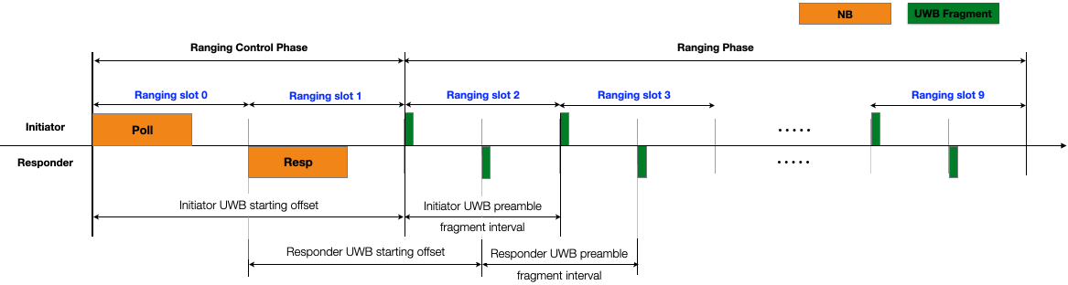
Figure 5 - An example of the NBA-MMS-UWB ranging phase
    - NBA-MMS-UWB measurement report phase
An NBA-MMS-UWB measurement report phase, if present in an NBA-MMS-UWB range-measurement cycle, starts immediately after an NBA-MMS-UWB ranging phase.
If an ERDEV is required to send the ranging measurement report to a peer during the measurement report phase and generates the measurement report successfully, it shall transmit a NB Report message to the peer after an Initiator or Responder report offset from the start of the measurement report phase. If both an initiator and a responder are required to transmit the measurement report to each other. The interval between the NB Report messages shall be no less than the NB RX-to-TX interval.
If LBT is required before a NB transmission in the corresponding operating band (referring to [4]), a transmitter shall perform LBT in advance of the start of the expected transmission. If the performed LBT cannot warrant the transmission at the beginning of the ranging slot, the transmitter shall not commence the transmission.
If an ERDEV fails to transmit the measurement report to a peer, it may either pass the measurement report to the next higher layer and request the next higher layer to transmit the measurement report to the peer, or it may include the measurement report in the NB Poll or NB Response message of the next rang-measurement cycle.
If an ERDEV fails to receive the measurement report from a peer, it may either request the next higher layer to solicit the measurement report from the peer, or it may solicit the peer to transmit the measurement report in the range control phase of the next range-measurement cycle.
After an ERDEV finishes its last operation in the measurement report phase, being either the transmission of the measurement report or the reception of the measurement report, it completes the range-measurement cycle. The ERDEV may enter a low-power mode until the next range-measurement cycle.
Figure 6 illustrates an example of the NBA-MMS-UWB measurement report phase.
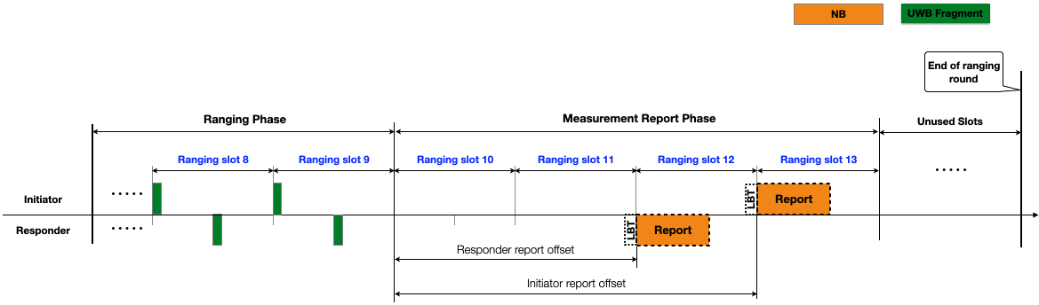
Figure 6 - An example of the NBA-MMS-UWB measurement report phase
  - NBA-MMS-UWB ranging session setup and update
Before an NBA-MMS-UWB ranging session is started, the ranging block structure and the range-measurement cycle are set up by the next higher layer. During an NBA-MMS-UWB ranging session, some parameters of the ranging block structure and the range-measurement cycle may be updated by the next higher layer. For each parameter update, the next higher layer shall indicate the index of a future ranging block when the new parameters become effective. How the next higher layers of a controller and a controlee synchronize the parameters and the effective time is beyond the scope of this standard.
A controller and a controlee shall use the parameters which are set or updated by the next higher layers as the long-term operating parameters.
A controller may overwrite the long-term operating parameters of a range-measurement cycle by indicating a new set of short-term parameters in an NB Poll message. The short-term parameters are only effective to the range-measurement cycle started by the NB Poll message. The long-term operating parameters resume effective in the next range-measurement cycle unless they are overwritten again by the NB Poll message starting the next range-measurement cycle.
A controlee may recommend new operating parameters for future range-measurement cycles by indicating a new set of parameters in an NB Response message. The controller may adopt the recommendation or ignore.
Table 1, Table 2, and Table 3 illustrate the NBA-MMS-UWB ranging session general parameters, block structure parameters, and the range-measurement cycle parameters, respectively.
Table 1 – NBA-MMS-UWB ranging session general parameters (example)
Parameters | Value range/options | Default value | Reconfigurable during ranging session | Description
NB band | UNII-3 or UNII-5 | UNII-3 (TBD) | No
NB channel | Key, allowlist (TBD) [4] | TBD | TBD
UWB channel | 5, 6, 8, 9, 10, … | 9 | TBD
PHY rate | #1 - #5 [6] | #1 | TBD
UWB PHY security | Yes, No [5] | TBD | No
NB LBT | Yes, No [4] | TBD | No
Control role | Controller, controlee | N/A | No
Sequence role | Initiator, Responder | N/A | No
Others

Table 2 – NBA-MMS-UWB block structure parameters (example)
Parameters | Value range/options | Default value | Reconfigurable during ranging session | Description
Ranging block duration | 48, 96, 192 ms | 96 ms | Yes
Ranging round duration | 8, 12, 16 ms | 12 ms (TBD) | Yes
Ranging slot duration | 1ms, 2ms, … | 1 ms (≈1200 RSTU) | Yes
Round hopping | Yes/No | No | Yes
Others?

Table 3 – NBA-MMS-UWB range-measurement cycle parameters (example)
Phases | Parameters | Value range/options | Default value | Reconfigurable during ranging session | Overwritten by Poll | Description
Ranging control phase | Ranging control phase duration | 2, 3, 4, … slot | 2 slot | Yes | Yes
 | NB RX-to-TX interval | 1, 2, … slot | 1 slot | Yes | Yes
Ranging phase | Initiator and Responder UWB starting offset tuples | <2, 1.5>, <3, 2.5>, … slot | <2, 1.5> slot | Yes | No
 | Number of I2R preamble fragments (X in [5]) | 1, 2, 4, 8, … | TBD | Yes | TBD
 | Number of I2R integrity fragments (Y in [5]) | 0, 1, 2, 4, 8, … | TBD | Yes | TBD
 | Number of R2I preamble fragments (X in [5]) | 1, 2, 4, 8, … | TBD | Yes | TBD
 | Number of R2I integrity fragments (Y in [5]) | 0, 1, 2, 4, 8, … | TBD | Yes | TBD
 | Initiator preamble fragment interval | 1, 2, … slot | 1 slot | TBD | TBD
 | Initiator Integrity fragment interval | 1, 2, … slot | 1 slot | TBD | TBD
 | Initiator preamble to integrity interval (Z in [5]) | 1, 2, … slot | 1 slot | TBD | TBD
 | Responder preamble fragment interval | 1, 2, … slot | 1 slot | TBD | TBD
 | Responder integrity fragment interval | 1, 2, … slot | 1 slot | TBD | TBD
 | Responder preamble to integrity interval (Z in [5]) | 1, 2, … slot | 1 slot | TBD | TBD
Measurement Report | Measurement report phase skipped | Yes, No | No | Yes | Yes
 | Report method | OOB, NB report, Next cycle | NB report | Yes | Yes
 | R2I report | Yes/No | N/A | No | No
 | I2R report | Yes/No | N/A | No | No
 | Responder report offset | 1, 2, … slot | 2 slot | Yes | No
 | Initiator report offset | 1, 2, … slot | 3 slot | Yes | No

References:
[1] 15-21-0409-01-04ab-narrowband-assisted-multi-millisecond-uwb
[2] 15-21-0605-00-04ab-nba-mms-uwb-mac-considerations
[3] 15-22-0080-00-04ab-nba-mms-uwb-mac-followup
[4] 15-22-0340-01-04ab-narrowband-channel-access-and-interference-mitigation-for-nba-mms-uwb
[5] 15-22-0392-00-04ab-more-on-mixed-mms-for-ranging-integrity
[6] 15-22-0341-00-04ab-nba-uwb-technical-framework-proposal (2022-July)

