IEEE P802.15
Wireless Personal Area Networks
NOTE: To change <title> and other required fields, select FileProperties and update the appropriate fields in the Summary tab. DO NOT replace field codes with text. After updates are entered, delete this paragraph and update all fields (ctl-A then F9) Note: dates will not be updated until document is saved. After fields are updated, delete this paragraph..

Project | IEEE P802.15 Working Group for Wireless Specialty Networks (WSNs) – 802.15.4ab
Title | Multiple Transmissions in a Ranging Slot
Date Submitted | 8 July 2022
Source | Youngwan So, Mingyu Lee, Taeyoung Ha, Karthik Srinivasa Goplan, Aniruddh Rao Kabbinale, Ankur Bansal, Clint Chaplin (Samsung Electronics) | Voice: [+82-10-2795-7033 ]  E-mail: [ youngwan.so@samsung.com ]
Re: | Developing technical content, 15-22-0179-00-04ab-multiple-transmissions-in-a-ranging-slot
Abstract | This document provides details of multiple transmission feature in a ranging slot
Purpose | To provide the technical contents for the initial draft
Notice | This document has been prepared to assist the IEEE P802.15. It is offered as a basis for discussion and is not binding on the contributing individual(s) or organization(s). The material in this document is subject to change in form and content after further study. The contributor(s) reserve(s) the right to add, amend or withdraw material contained herein.
Release | The contributor acknowledges and accepts that this contribution becomes the property of IEEE and may be made publicly available by P802.15.

7.4.4.44 Ranging Device Management IE (RDM IE)

The RDM IE is used by the controller to control the devices participating in a set of ranging rounds when the controller knows the device identities. The content field of the RDM IE shall be formatted as shown in Figure 7-106m.

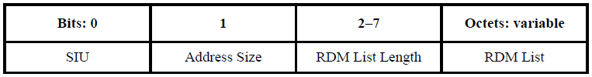
Figure 7-106m—RDM IE Content field format

The SIU field indicates whether the Slot Index field of the RDM List element is used (when the SIU field is one) or not (when the SIU field is zero). When the SIU field is zero, the RDM IE is used to assign the ranging role, that isinitiator or responder, to controlees for contention-based ranging. When the SIU field is one, the RDM IE is used to allocate time slots and assign the ranging roles of controlees for the scheduling-based ranging.

The Address Size field specifies the size of the addresses used in the RDM List field. If the Address Size field is zero, all addresses in the RDM List elements are short addresses. If the Address Size field is one, all addresses are extended addresses.

The RDM List Length field indicates the number of elements in the RDM List field, each of which is formatted as per Figure 7-106n. This is the number of participating ERDEVs selected by the RDM IE, and, when the SIU field is one, the number of slots assigned by the RDM IE. It is allowed for RDM List to have multiple RDM List elements having the same ranging slot index but with different addresses. It means concurrent transmission from different ranging devices may happen within a slot. If the concurrent transmissions happen, a ranging device should be either transmitting to or receiving from a single device in the designated ranging slot.

The codes that may be used for concurrent transmissions in the single slot are restricted, and the particular code assignments for slots of each channels also follow Table 15-6 and Table 15-7. If there are multiple RDM List elements having the same ranging slot index but with the different addresses in a RDM List, code index for each address is assigned at its increasing order at RDM List. For example, in channel 9, initiator at first RDM List element is assigned with code index 3, while responder at second RDM List element is assigned with code index 4, etc. It implies that maximum number of concurrent transmissions in the single slot is bounded with the number of codes indexes in the channel.

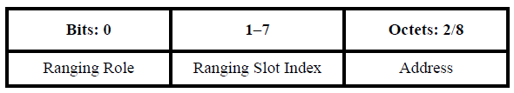
Figure 7-106n—RDM List element format

The Ranging Role field specifies whether the selected device is to be an initiator or a responder. When the Ranging Role field has a value of zero the selected device is a responder. When the Ranging Role field has a value of one the selected device is an initiator.

The Ranging Slot Index field is used (when the SIU field is one) to assign a slot index to the device identified by the address field. When the SIU field is zero this field is unused/reserved.

The Address field identifies each participating device. The size of the Address field is specified by the Address Size field of the RDM IE. A network of mixed address size devices can be catered for by using two RDM IEs, one for the short address devices and the other for the extended address devices.

The RDM IE can be used by the controller to exchange scheduling information among the ERDEVs for a set of ranging rounds specified by the same RCM. Upon reception of the RCM, a controlee knows whether it is selected to participate in the ranging round(s).

