IEEE 802.15
Wireless Specialty Networks

Project | IEEE 802.15 Working Group for Wireless Specialty Networks
Title | UWB Channel Models Document
Date Submitted | July 14th, 2022
Source | Takumi Kobayashi^{1,2}, Marco Hernandez^{1,3}, Ryuji Kohno^{1,2}, Minsoo Kim²¹YRP-IAI, ²YNU, Japan, ³CWC Oulu Univ. Finland Marco.Hernandez@ieee.org Kohno@ynu.ac.jp Kobayashi-Takumi-ch@ynu.ac.jp Minsoo@minsookim.com
Response | To call for contributions
Abstract | This document contains the channel models to evaluate proposals.
Purpose | For contributions to P802.15.6ma
Notice | This document has been prepared to assist the IEEE P802.15.6ma. It is offered as a basis for discussion and is not binding on the contributing individual(s) or organization(s). The material in this document is subject to change in form and content after further study. The contributor(s) reserve(s) the right to add, amend or withdraw material contained herein.

Contributors
Name & affiliation | Email
Marco Hernandez, CWC, Oulu Univ. Finland, YRP-IAI Japan. | Marco.Hernandez@ieee.org
Ryuji Kohno, YRP-IAI, YNU, Japan | Kohno@ynu.ac.jp
Takumi Kobayashi, YRP-IAI, YNU, Japan | Kobayashi-Takumi-ch@ynu.ac.jp
Minsoo Kim, YRP-IAI, Japan. | Minsoo@minsookim.com
Kamran Sayrafian, NIST, USA. | kamran.sayrafian@nist.gov
Daisuke Anzai, Nagoya Institute of Technology, Japan. | Anzai@nitech.ac.jp

Revision history
Revision | Date | Notes
0 | 7/12/2022 | Document created
1 | 7/14/2022 | Information has been added on Section 6.2.
2 | 9/12/2022

Contents

1. Introduction 1
2. Scenarios for 15.6 revision 2
2.1 Scenario 2.1 2
2.2 Scenario 2.2 (BCI optional) 3
2.3 Scenario 4.1 ( BCI) 3
2.4 Scenario 6.1 (1st generation BCI) 4
2.5 Scenario 8.1 (passenger bus and HBANs) 5
3. Antenna Effect 6
3.1 Electrical antennas, such as dipole 6
3.2 Magnetic antennas, such as loop 6
4. Channel Characterization 7
4.1 Electrical Properties of Body Tissues 7
4.2 Model Types 7
4.3 Fading 7
4.3.1 Small-Scale Fading 7
4.3.1.1 UWB Channel model 8
4.3.1.2 Simulation methodology 8
4.3.1.3 MatLab™ code 9
4.3.2 Large-Scale Fading 11
4.4 Path loss 11
4.5 Shadowing 11
5. Models and Scenarios 12
5.1 Human BAN (HBAN) Channel models 12
5.2 In-body 12
5.2.1 Implant (upper body) to Body Surface CM2.1 (Scenario S2.1) for 3.1 – 10.6 GHz 12
5.2.2 Implant (head) to Body Surface CM2.2 (Scenario S2.2) for 3.1 – 106 GHz 12
5.2.3 Implant (upper body) to External 14
5.3 Body surface 14
5.3.1 Body surface to body surface CM3 (Scenario S4 & S5) for 3.1-10.6 GHz 14
5.3.2 Body surface to external CM4 (Scenario S6 & S7) for 3.1-10.6 GHz 15
5.3.3 Dynamic channel model for body surface to body surface CM3 (Scenario S4 & S5) at 4.5 GHz 16
5.4 Vehicle BAN (VBAN) channel models 22
5.5 In Vehicle 22
5.5.1 In vehicle to in vehicle 22
5.5.1.1 Engine compartment to engine compartment (Scenario 8.X, CM X) 22
5.5.1.2 In-vehicle to In-vehicle (Scenario 8, CM 8) 3.1 - 10.6GHz 23
5.5.1.3 Cabin room to cabin room in omnibus (Scenario 8.1) 3.1 - 10.6GHz 24
5.5.1.4 Cabin room to engine compartment [asymmetric] (Scenario 8.X, CM X) 3.1 – 10.6GHz 26
5.5.1.5 Engine compartment to cabin room [symmetric] (Scenario 8.X CMx) 3.1 - 10.6GHz 27
5.6 On vehicle 27
5.6.1 On-vehicle to on-vehicle (Scenario 11, 12, CM11, 12) 27
5.6.2 In-vehicle to on vehicle (Scenario 9, CM9) 3.1 – 10.6 GHz 28
5.7 External 28
5.7.1 In-vehicle to External (Scenario 10, CM 10) 3.1 – 10.6GHz 28
5.7.2 On-vehicle to External with mobility consideration (Scenario 13 & 14 & 13) 29
Annex A Bibliography 31
Annex B (informative) Matlab code for IEEE802.15.4a UWB channel model 33
Annex C (informative) MATLAB script for the IEEE 802.15.4a channel model 46

- Introduction
The channel models used by IEEE Std 802.15.6-2012 Wireless Body Area Network (BAN) during the development of the Std cover use cases for medical and non-medical applications inside or on the surface of the human body. The frequency bands of operation are ISM bands used by narrowband and UWB implementations [1] .
The channel models covered in this document are for the UWB band intended for body surfaces and vehicles. The channel models are aimed for the development of the PHY and MAC for the revision of IEEE 802.15.6 Std.
The channel model document of IEEE Std 802.15.6-2012 defined seven scenarios and four-channel models shown in Table 1 for illustration.

- —Channel models used in IEEE Std 802.15.6-2012
Scenario | Description | Frequency Band | Channel Model
S1 | Implant to Implant | 402-405 MHz | CM1
S2 | Implant to Body Surface | 402-405 MHz | CM2
S3 | Implant to External | 402-405 MHz | CM2
S4 | Body Surface to Body  Surface (LOS) | 13.5, 50, 400, 600, 900 MHz  2.4, 3.1-10.6 GHZ | CM3
S5 | Body Surface to Body  Surface (NLOS) | 13.5, 50, 400, 600, 900 MHz  2.4, 3.1-10.6 GHZ | CM3
S6 | Body Surface to External  (LOS) | 900 MHz  2.4, 3.1-10.6 GHZ | CM4
S7 | Body Surface to External  (NLOS) | 900 MHz  2.4, 3.1-10.6 GHZ | CM4

Figure 1 illustrates such channel models.
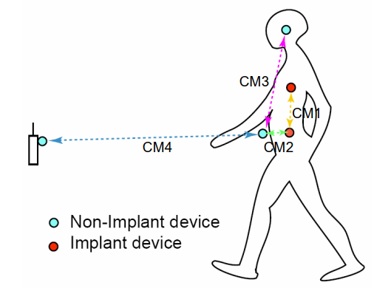
- —Channel models for IEEE Std 802.15.6-2012

- Scenarios for 15.6 revision

- —15.6ma HBAN scenarios (notation in [1] ).
Scenario | Description | Frequency Band | Channel Model
S2 | Implant to Body Surface | 402-405 MHz | CM2
S2.1 | Implant (upper body) to Body Surface | 3.1-10.6 GHz | CM2.1
S2.2 | Implant (head) to Body Surface | 3.1-10.6 GHz | CM2.2
S3 | Implant (upper body) to External | 402-405 MHz  3.1-10.6GHz | CM3
S4 | Body Surface to Body  Surface (LOS) | 400, 600, 900 MHz  2.4, 3.1-10.6 GHz | CM3
S4.1 | Body Surface (head) to Body  Surface (LOS) | 400, 600, 900 MHz  2.4, 3.1-10.6 GHz | CM4.1
S5 | Body Surface to Body  Surface (NLOS) | 400, 600, 900 MHz  2.4, 3.1-10.6 GHz | CM3
S6 | Body Surface to External  (LOS) | 900 MHz  2.4, 3.1-10.6 GHz | CM4
S6.1 | Body Surface (head) to External  (LOS) | 900 MHz  2.4, 3.1-10.6 GHz | CM6.1
S7 | Body Surface to External  (NLOS) | 900 MHz  2.4, 3.1-10.6 GHz | CM4

The present document describes the new channel models for scenarios S2.1, S2.2, S4.1 and S6.1.
  - Scenario 2.1
The new scenario S2.1 is for the implant (upper body) to body surface on the UWB band for applications such as capsule endoscopy.

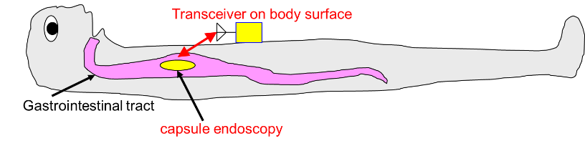
- —Scenario 2.1: Capsule endoscopy application

  - Scenario 2.2 (BCI optional)
The new scenario S2.2 is for the implant (head) to the body surface on the UWB band for applications such as the brain-computer interface (BCI). Note the transmitting antenna is integrated into the transmitter device.

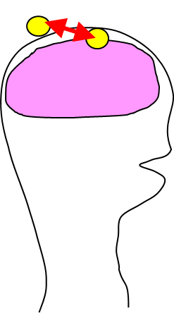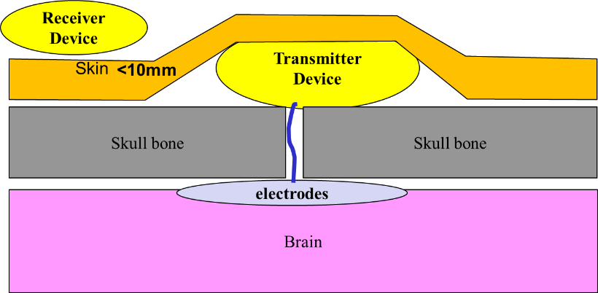

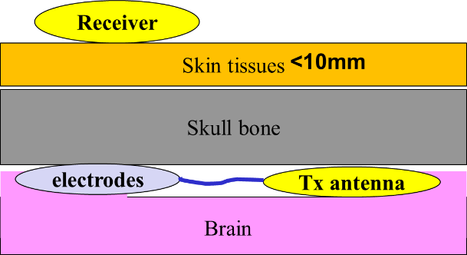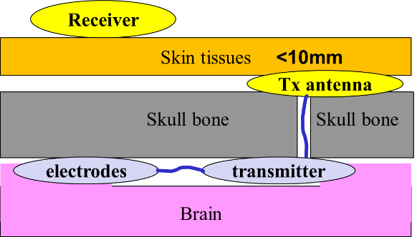

- —Scenario 2.2: implant (head) in-body to body surface.
  - Scenario 4.1 ( BCI)
The new scenario S4 is for on-body (head) to the body surface in LOS for BCI applications.
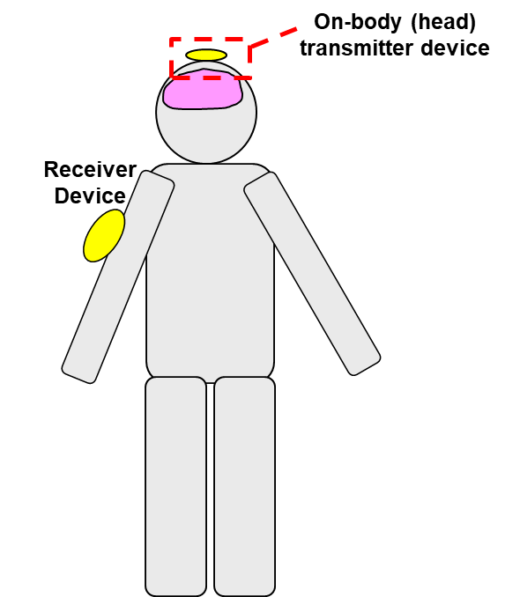
- – Scenario S4 body surface (head) to body surface
  - Scenario 6.1 (1st generation BCI)
The new scenario S6 is for on-body (head) to external in LOS for BCI applications.
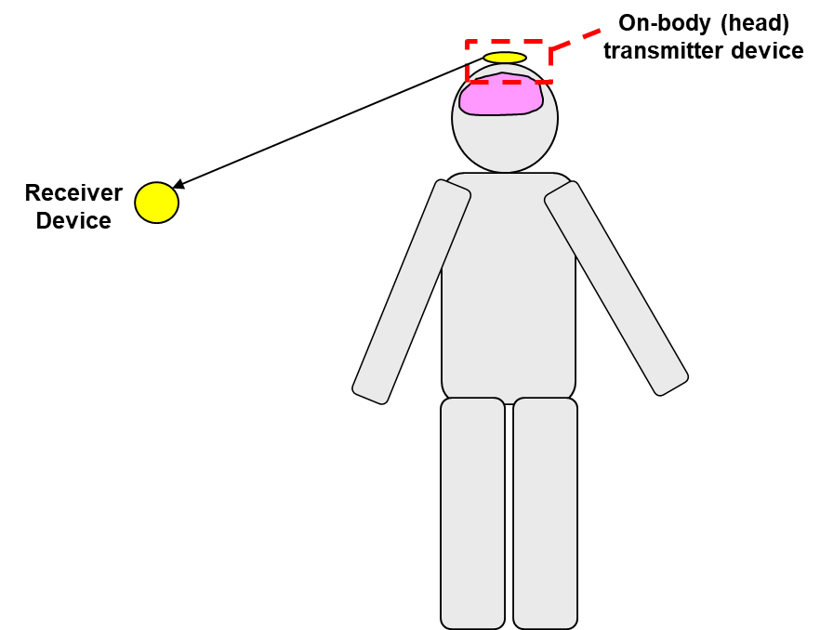
- – Scenario S6 body surface (head) to external

- —15.6 VBAN scenarios
Scenario | Description | Frequency Band | Channel Model
S8 | In-vehicle to In-vehicle (sedan) | 2.4, 3.1-10.6 GHZ | CM8
S8.1 | In-vehicle to In-vehicle (passenger bus) | 2.4, 3.1-10.6 GHZ | CM8.1
S9 | In-vehicle to On-vehicle | 2.4, 3.1-10.6 GHZ | CM9
S10 | In vehicle to External | 2.4, 3.1-10.6 GHZ | CM10
S11 | On-vehicle to on-vehicle (LOS) | 2.4, 3.1-10.6 GHZ | CM11
S12 | On-vehicle to on-vehicle  (NLOS) | 2.4, 3.1-10.6 GHZ | CM12
S13 | On-vehicle to external (LOS) | 2.4, 3.1-10.6 GHZ | CM13
S14 | On-vehicle to external (NLOS) | 2.4, 3.1-10.6 GHZ | CM14

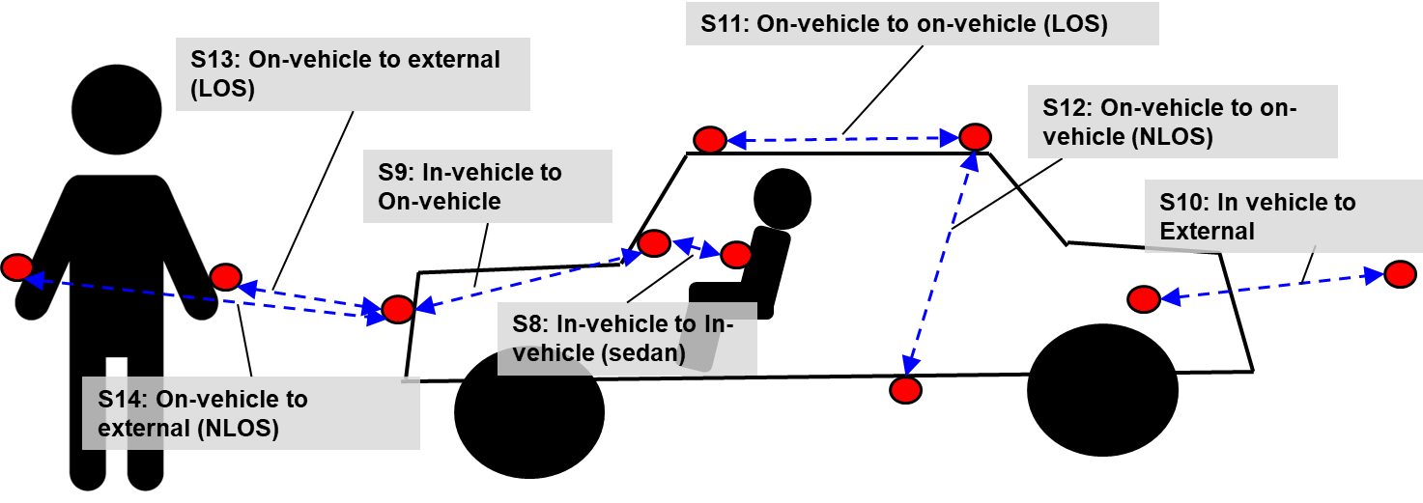
- —Channel models and scenarios for VBAN

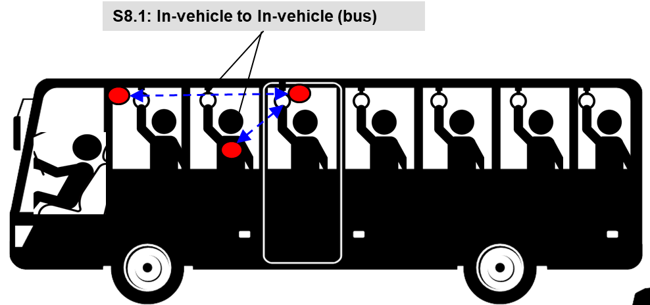
- —Scenario S8.1: In-vehicle to In-vehicle (bus)

  - Scenario 8.1 (passenger bus and HBANs)

- Antenna Effect
An antenna placed on the surface or inside a body will be heavily influenced by its surroundings [2] . The consequent changes in antenna pattern and other characteristics need to be understood and accounted for during any propagation measurement campaign.
The form factor of an antenna will be highly dependent on the requirements of the application. For MICS applications, for example, a circular antenna may be suitable for a pacemaker implant, while a helix antenna may be required for a stent or urinary implant. The form factor will affect the performance of the antenna and, the antenna performance will be very important to the overall system performance. Therefore, an antenna which has been designed with respect to the body tissues (or considered the effect of human body) shall be used for the channel model measurements [3] .
  - Electrical antennas, such as dipole
Electrical antenna typically generates large components of E-field normal to the tissue interface, which overheat the fat tissue. This is because boundary conditions require the normal E-field at the interface to be discontinuous by the ratio of the permittivity, and since fat has a lower permittivity than muscle, the E-field in the fat tissue is higher.
  - Magnetic antennas, such as loop
Magnetic antenna produces an E-field mostly tangential to the tissue interface, which seem not to couple as strongly to the body as electrical antennas. Therefore, it does not overheat the fat.
There are antennas same as helical-coil, which is similar to a magnetic antenna in some respect, but its heating characteristics appear to be more like an electrical antenna. The strong E-field generated between the turns of coil is mainly responsible for tissue heating
It should be noted that SAR in the near field of the transmitting antenna depends mainly on the H-field; however, SAR in the far field of the transmitting antenna depends mainly on the E-field.

- Channel Characterization
  - Electrical Properties of Body Tissues
The human body is not an ideal medium for radio frequency wave transmission. It is partially conductive and consists of materials of different dielectric constants, thickness, and characteristic impedance. Therefore depending on the frequency of operation, the human body can lead to high losses caused by power absorption, central frequency shift, and radiation pattern destruction. The absorption effects vary in magnitude with both frequency of applied field and the characteristics of the tissue [[4] [5] [6] [7] ].
  - Model Types
In all cases, two types of models may be generated:
- A theoretical or mathematical model including numerical simulation based modeling.
- An empirical model
A theoretical model may be traceable back to the fundamental principles of electromagnetic propagation and will permit precise modeling of a specific situation at radio link level. It is intended for detailed exploration of, for example, the influence of body structures on antenna patterns. It will require a detailed description of the propagation environment and is therefore probably not suitable for modeling of macro environments.
An empirical model may be traceable to an agreed set of propagation measurements and is intended to provide a convenient basis for statistical modeling of the channel. Compared to the theoretical model, the empirical model will use a greatly simplified description of the environment and, although statistically accurate at network level, will not be precise at link level. Appropriate efforts could be made to ensure that the two sets of models are consistent with each other.
  - Fading
In the body area network communications, propagation paths can experience fading due to different reasons, such as energy absorption, reflection, diffraction, shadowing by body, and body posture. The other possible reason for fading is multipath due to the environment around the body. Fading can be categorized into two categories; small scale and large-scale fading.
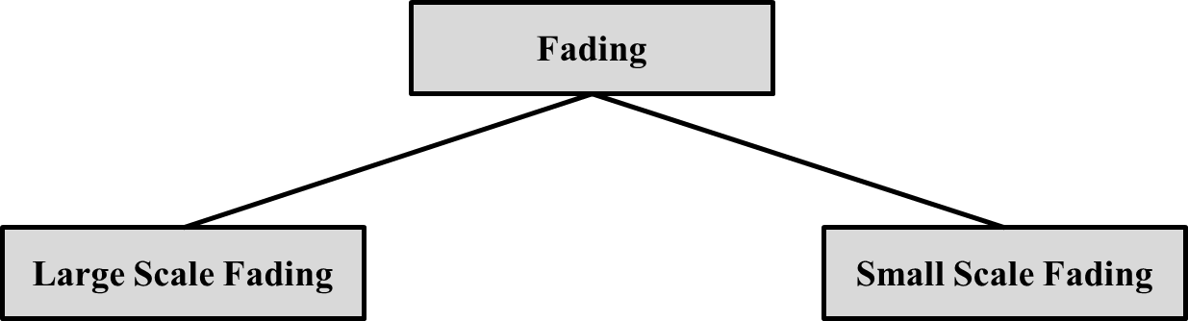
    - Small-Scale Fading
Small scale fading refers to the rapid changes of the amplitude and phase of the received signal within a small local area due to small changes in location of the on-body device or body positions, in a given short period of time. The small-scale fading can be further divided into flat fading and frequency selective fading.
Averaging the attenuation between each antenna position on the body and each antenna location in the room will remove the effect of small scale fading due to small changes in the body position.
      - UWB Channel model
The UWB channel impulse responses are taken from the channel models document of former IEEE802.15.4a TG. Scenarios, bandwidths and central frequencies are similar to the ones targeted for IEEE802.15.8 TG. The MatLab code is attach in Annex A.
      - Simulation methodology
The power delay profiles are taken from the extended ITU channel models described in [8] with Doppler spectrum characterized by the Jakes spectrum shape and maximum Doppler frequency shift, as suggested in [9] . The spatial correlation is described in [8] . Figure 8 shows the schematic flow for simulation of Kronecker model, already implemented in Matlab Simulink. In Figure 9, the correlated MIMO channel simulation is delineated.
- — Schematic flow of simulation for the Kronecker model.

where is the power of the channel coefficient of qth tap resulting between the coupling of ith antenna at transmitter to jth antenna at receiver.

- — Channel simulation methodology.
      - MatLab™ code
The following scripts were written in MatLabR2011 and the Communications Toolbox. It exploits the new interface between Matlab and Simulink for optimizing speed.

% %
% function [H] = ExtendedITU_MIMOChannel(model,correlation, %
% configuration,fd,fs) %
% %
% Return object for FIR taps of Extended ITU MIMO channel models %
% %
% INPUT PARAMETERS: %
% model = Extended ITU channel model %
% correlation = Spatial correlation level %
% configuration = Antenna configuration %
% fd = Maximum Doppler shift in Hz %
% fs = Simulation sampling frequency in Hz %
% %
% OUTPUT VALUE: %
% H = complex channel taps %
% %
% Author: Marco Hernandez, v1.0 %
% ***************************************************************** %

function [H] = ExtendedITU_MIMOChannel(model,correlation,configuration,fd,fs)

switch model
case 'pedestrian'
% vector of path delays in sec
tau = [0 30 70 80 110 190 410]*1e-9;
% vector of average path power gains in dB
pdb = [0 -1 -2 -3 -8 -17.2 -20.8];
case 'vehicular'
tau=[0 30 150 310 370 710 1090 1730 2510]*1e-9;
pdb=[0 -1.5 -1.4 -3.6 -0.6 -9.1 -7 -12 -16.9];
case 'urban'
tau=[0 50 120 200 230 500 1600 2300 5000]*1e-9;
pdb=[-1 -1 -1 0 0 0 -3 -5 -7];
otherwise
error('Model not implemented.');
end

switch correlation
case 'low'
a=0; b=0;
case 'medium'
a=0.3; b=0.9;
case 'high'
a=0.9; b=0.9;
otherwise
error('Spatial correlation profile not implemented.');
end

switch configuration
case '1x2'
Nt=1; Nr=2; Rt=1; Rr=[1 b;b 1];
case '2x1'
Nt=2; Nr=1; Rt=[1 a;a 1]; Rr=1;
case '2x2'
Nt=2; Nr=2; Rt=[1 a;a 1]; Rr=[1 b;b 1];
case '4x2'
Nt=4; Nr=2; Rt=[1 a^(1/9) a^(4/9) a;a^(1/9) 1 a^(1/9) a^(4/9);a^(4/9) a^(1/9) 1 a^(1/9);a a^(4/9) a^(1/9) 1];
Rr=[1 b;b 1];
case '2x4'
Nt=2; Nr=4; Rt=[1 a;a 1];
Rr=[1 b^(1/9) b^(4/9) b;b^(1/9) 1 b^(1/9) b^(4/9);b^(4/9) b^(1/9) 1 b^(1/9);b b^(4/9) b^(1/9) 1];
case '4x4'
Nt=4; Nr=4; Rt=[1 a^(1/9) a^(4/9) a;a^(1/9) 1 a^(1/9) a^(4/9);a^(4/9) a^(1/9) 1 a^(1/9);a a^(4/9) a^(1/9) 1];
Rr=[1 b^(1/9) b^(4/9) b;b^(1/9) 1 b^(1/9) b^(4/9);b^(4/9) b^(1/9) 1 b^(1/9);b b^(4/9) b^(1/9) 1];
otherwise
error('Antenna configuration not implemented.');
end

% Object MIMO multipath fading channel
H=comm.MIMOChannel(...
'SampleRate', fs,...
'PathDelays', tau,...
'AveragePathGains', pdb,...
'MaximumDopplerShift', fd,...
'DopplerSpectrum', doppler.jakes,...
'NumTransmitAntennas', Nt,...
'NumReceiveAntennas', Nr,...
'TransmitCorrelationMatrix', Rt,...
'ReceiveCorrelationMatrix', Rr,...
'FadingDistribution', 'Rayleigh',...
'RandomStream', 'mt19937ar with seed',...
'Seed', 99,...
'NormalizePathGains', true,...
'NormalizeChannelOutputs', true,...
'PathGainsOutputPort', false );

end

    - Large-Scale Fading
Large scale fading refers to the fading due to motion over large areas; this is referring to the distance between antenna positions on the body and external node (home, office, or hospital).
  - Path loss
Unlike traditional wireless communications, the path loss for body area network system (on body applications), is both distance and frequency dependent. The frequency dependence of bod tissues shall be considered. The path loss model in dB between the transmitting and the receiving antennas as a function of the distance d based on the Friis formula in free space is described by [[10] [11] ]:

where PL₀ is the path loss at a reference distance d₀, and n is the path-loss exponent.

The path loss near the antenna depends on the separation between the antenna and the body due
to antenna mismatch. This mismatch indicates that a body-aware antenna design could improve
system performance.

  - Shadowing
Due to the variation in the environment surrounding of body or even movement of the body parts, path loss will be different from the mean value for a given distance as shown in equation (1). This phenomenon is called shadowing, and it reflects the path loss variation around the mean. The shadowing should be considered for stationary and non-stationary position of body.

When considering shadowing, the total path loss PL can be expressed by:
where PL(d) is expressed by the Equation (1) and S represents the shadowing component.

- Models and Scenarios
  - Human BAN (HBAN) Channel models
  - In-body

    - Implant (upper body) to Body Surface CM2.1 (Scenario S2.1) for 3.1 – 10.6 GHz
Scenario S2.1 is a model for the implant to the body surface on the UWB band for specific applications such as capsule endoscopy. This model is developed based on doc.# P.802.15-22-0401-00-6a [12] .
- —Scenario 2.1: Capsule endoscopy application
Path Loss (PL) versus distance (d) can be represented by:
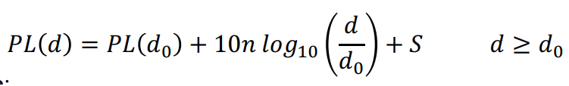……….
Where, d₀ is a reference distance, n is the pathloss exponent, S is the random scatter around the regression line with Normal Distribution with standard deviation σ_{s}

- 6.2.2 Implant to Body Surface CM2.1 for 3.1 – 10.6 GHz parameters
Implant to body surface | PL(d₀) (dB) | n | σ_{s} (dB)
 | 51.9 | 8.14 | 18.19

    - Implant (head) to Body Surface CM2.2 (Scenario S2.2) for 3.1 – 106 GHz
TBD
Scenario S2.2 is for the implant to the body surface on the UWB band for specific applications such as the brain-computer interface (BCI).
- – Scenario S4 body surface (head) to body surface

Path loss model is defined as
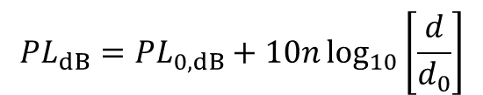.
Path loss parameters are simulated and provided in [13] as follows.

- 6.2.2 Implant to Body Surface CM2.2 for 3.1 – 10.6 GHz parameters
Transmitting antenna | Received components | d₀ [m] | PL₀ (dB) | n
x | x | 0.48 | 109.8 | 2.22
 | y |  | 100.8 | 3.12
 | z |  | 118.5 | 1.23
y | x |  | 103.9 | 0.85
 | y |  | 85.3 | 3.02
 | z |  | 101.4 | 2.16
z | x |  | 87.2 | 0.91
 | y |  | 68.2 | 3.27
 | z |  | 84.7 | 2.23

    - Implant (upper body) to External
  - Body surface
    - Body surface to body surface CM3 (Scenario S4 & S5) for 3.1-10.6 GHz
The following path loss model is based on measurements that cover frequencies of 3.1-10.6 GHz. Measurement set up, derivation and data analysis can be found in [14] . The table below summarizes the model and corresponding parameters.

- Parameters of the path loss model for CM3 (S4 & S5)
 | Hospital Room | Anechoic Chamber
Path loss model | PL(d)[dB] = a log₁₀(d) + b + N
a | 19.2 | 34.1
b | 3.38 | -31.4
σ_{N} | 4.40 | 4.85

- a and b : Coefficients of linear fitting
- d : Tx -Rx distance in mm
- N : Normally distributed variable with zero mean and standard deviation σ_{N}

A power delay profile (PDP) model for 3.1 – 10.6 GHz is also given in [14] . The table below summarizes this model and corresponding parameter.

- Parameters of the PDP model for CM3 (S4 & S5)
PDP Model | φ_{l} is modeld by a uinform distribution over [0,2π)
a_{l} | γ₀ | -4.60 dB
 | Γ | 59.7
 | σ_{s} | 5.02 dB
t_{l} | 1/λ | 1.85 ns
L | $$\overline{L}$$ | 38.1

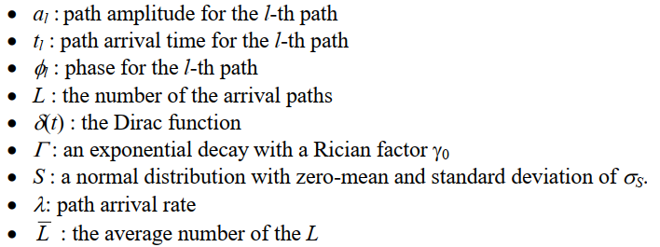

Option 2

The following path loss model is based on measurements that cover frequencies of 3.1-10.6 GHz. Measurement set up, derivation and data analysis can be found in [15] . The table below summarizes the corresponding parameters.

- Parameters of the path loss model for CM3 (S4 & S5) (Option 2)

Path loss model | 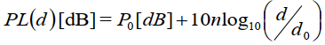
Around torso
Antenna separation from  body surface | 0 mm | 5 mm
P0 [dB] | 56.1 | 48.4
d0 [m] | 0.1 | 0.1
n | 5.8 | 5.9
Along torso
Antenna separation from  body surface | 0 mm | 5 mm
P0 [dB] | 56.5 | 44.6
d0 [m] | 0.1 | 0.1
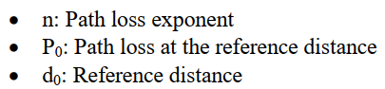

    - Body surface to external CM4 (Scenario S6 & S7) for 3.1-10.6 GHz
Measurement for the UWB frequency band of 3.1-10.6 GHz has been performed in [16] . On body antenna characteristics were measured in anechoic chamber, while channel measurements were done in office environment. For this measurement, the Tx antenna is fixed near to wall, while the Rx antenna (placed on body) positions were changed in office area. The effect of ground is considered in measurements. All data were averaged for statically analysis; therefore, the detail data of each measurement is not provided. The Further detail on set-up, derivation and data analysis can be found in [16] . The following figures summarize the delay profile of front, side, and backside of body while the Tx antenna is in the front of body.
- Parameters of the path loss model for CM4 (Scenario S6 & S7) for 3.1-10.6 GHz
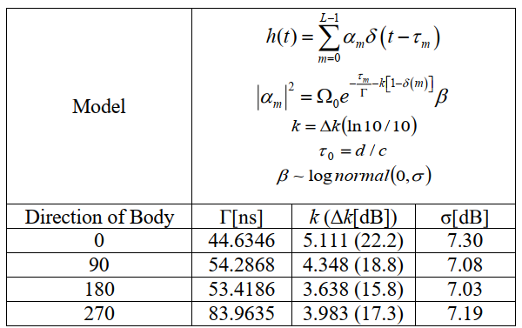

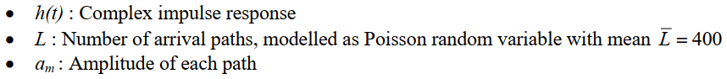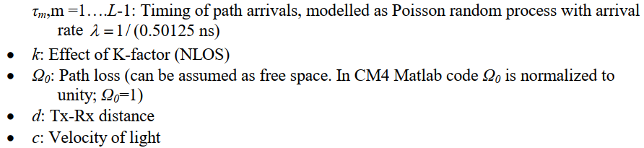

    - Dynamic channel model for body surface to body surface CM3 (Scenario S4 & S5) at 4.5 GHz
A real time channel measurements by use of channel sounder has been performed in [17] . The channel measurements were carried out in an anechoic chamber with center frequency of 4.5 GHz and bandwidth of 120 MHz. Details of the measurement set up, derivation and data analysis can be found in [17] . The measurements are focusing on the fading effect due to movements of the human body, therefore conducted in an anechoic chamber, where the multipath from the surrounding objects are negligible.
The transmitter antenna was fixed on around navel. The table below summarize the position of receiving antennas and distance between Tx and Rx antennas.

- Summary of the position of receiving antennas and distance between Tx and Rx antennas for CM3 (Scenario S4 & S5) at 4.5 GHz
Position | Distance [mm]
A Right wrist | 440 ~ 525
B Right upper arm | 360
C Left ear | 650
D Head | 710
E Shoulder | 310
F Chest | 230
G Right rib | 183
H Left waist | 140
I Thigh | 340
J Ankle | 815 ~ 940
To provide a statistical model, the probability distribution functions such as normal, log-normal and Weibull distributions have been tried to fill the measurement results. The tables below summarize the normal, log-normal and Weibull distributions.

- Summary of the normal distributions parameter for CM3 (Scenario S4 & S5) at 4.5 GHz
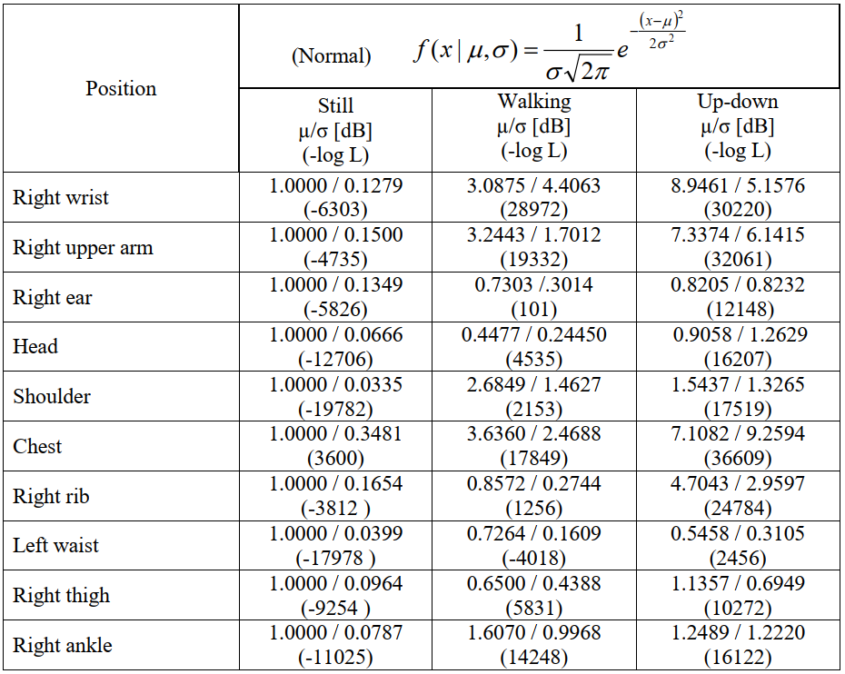
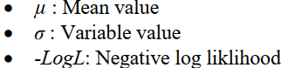

- Summary of the log-normal distribution parameters for CM3 (Scenario S4 & S5) at 4.5 GHz
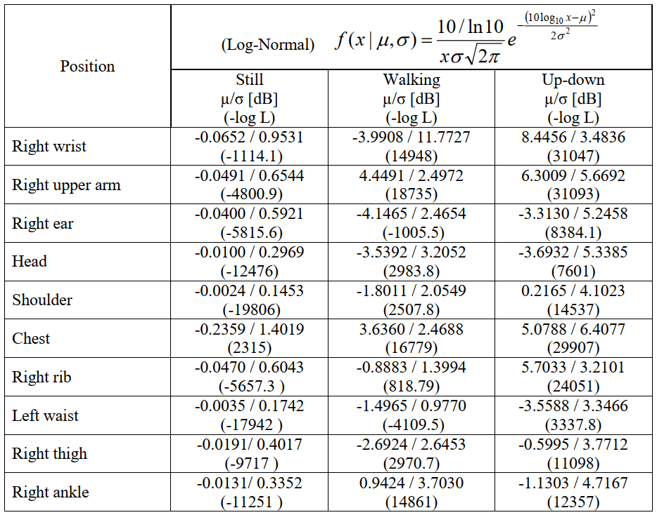

- μ: Mean value
- σ: Variable value
- -LogL: Negative log loklihood

- Summary of the Weibull distribution parameters for CM3 (Scenario S4 & S5) at 4.5 GHz
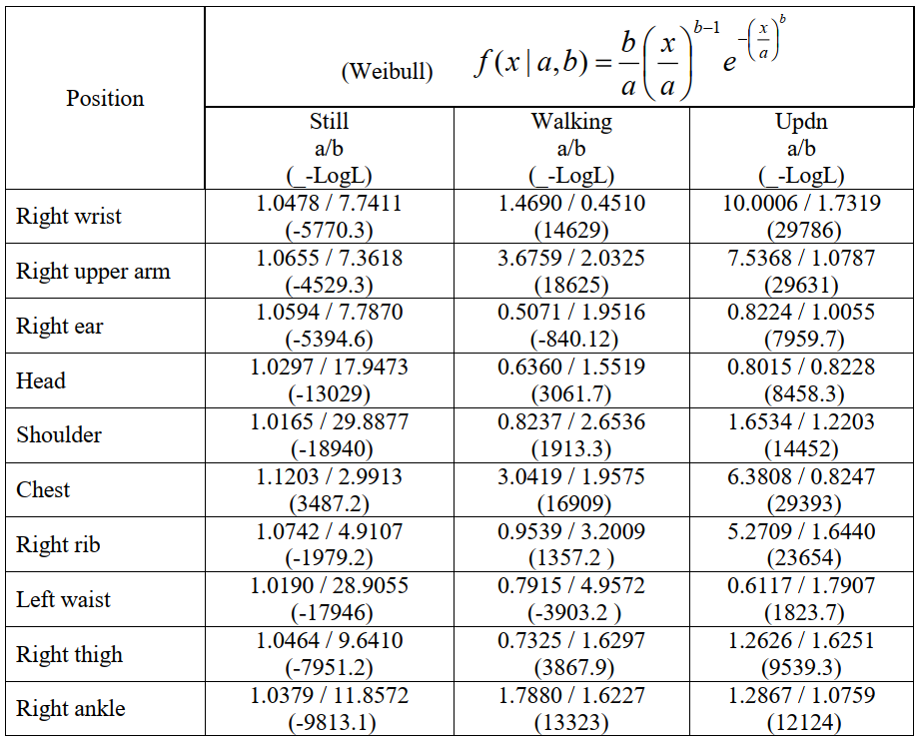

- a : Scale factor
- b: Shape factor
- -LogL: Negative log loklihood

The below table summarize the best fitting distributions for dynamic channel at 4.5 GHz.

- Summary of the best fitting distributions for dynamic channel parameters for CM3 (Scenario S4 & S5) at 4.5 GHz
Position | Still | Walking | Up-down
Right wrist | Normal | Weibull | Weibull
Right upper arm | Log-normal | Weibull | Weibull
Right ear | Normal | Log-normal | Weibull
Head | weibull | Log-normal | Log-normal
Shoulder | Log-normal | Weibull | Weibull
Chest | Log-normal | Log-normal | Weibull
Right rib | Log-normal | Log-normal | Weibull
Left waist | Normal | Log-normal | Weibull
Right thigh | Log-normal | Log-normal | Weibull
Right ankle | Log-normal | Weibull | Weibull
- Normal distribution seems to fit the still posture best, but it can be seen that fittings with any distributions have large from the PDFs.
- Log-normal distribution shows good match in cases of still postures and small movements such as walking posture in case of head , right ear, chest, right rib, left waist, right thigh, and stand up/down posture in case of head.
- Weibull distribution can represent much better large movement behaviors such as walking posture in case of right wrist, right upper arm, shoulder, right ankle, and all stand up/down postures except for head.

Based on statistical analysis of fading duration a 5-state Fritchman model for dynamic on-body channels, as shown in the below Figure, has been used to classifies channel states according to the dwelling time (ϴ) in different channel qualities to quantitatively describe the time-varying property of on-body channels.

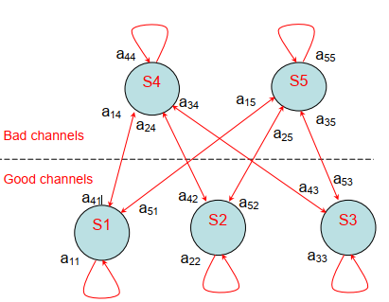
- Five-state Fritchman model for dynamic on-body channels

The five-state Fritchman model for describing the burst behaviors of on-body channels are:
- S1: unstable error-free state, good channels which last less than 20 ms;
- S2: semi-constant error-free state, good channel which are over 20 ms and less than 400
- ms;
- S3: constant error-free state, good channel which are over 400 ms;
- S4: unstable error state, bad channel which last less than 20 ms, and
- S5: semi-constant error state, bad channel which are less than 400 ms.
The statistical parameters for the on-body dynamic channel at ϴ=-10dB for different locations are;

- statistical parameters for the on-body dynamic channel
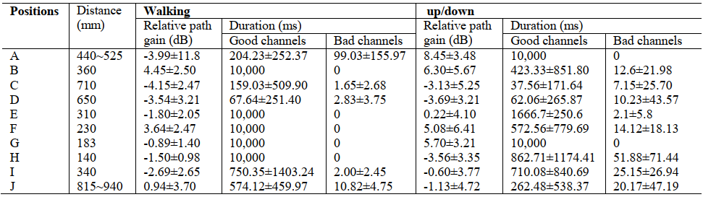

The statistical parameters for the on-body dynamic channel at ϴ=-10dB in different states are

- — statistical parameters for the on-body dynamic channel
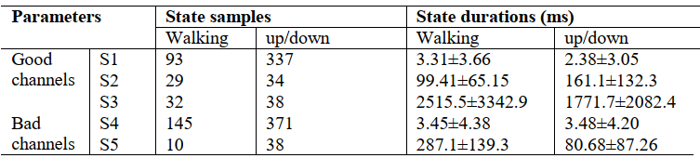

Parameters of the 5-state Fritchman model for different action scenarios are

- Parameters of the five-state Fritchman model for different action scenarios
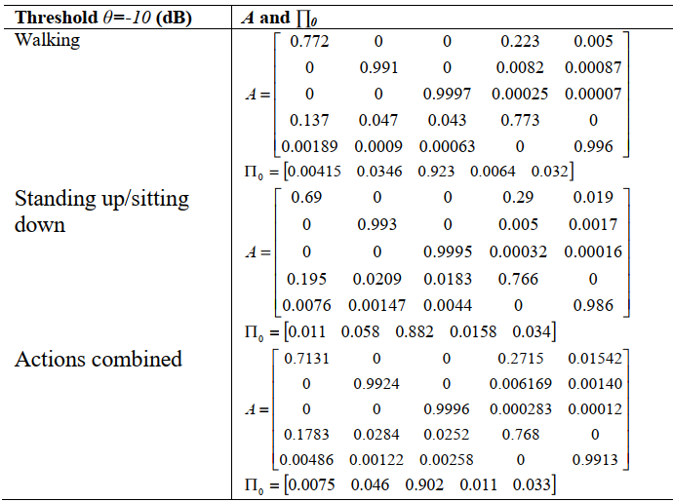

  - Vehicle BAN (VBAN) channel models
VBAN channel models are defined as four cases; in-vehicle to in-vehicle, on-vehicle to on-vehicle and on-vehicle to surrounding vehicle cases.
The considered channel models are based on the IEEE 802.15.4a channel model document [18] .
  - In Vehicle
    - In vehicle to in vehicle
      - Engine compartment to engine compartment (Scenario 8.X, CM X)

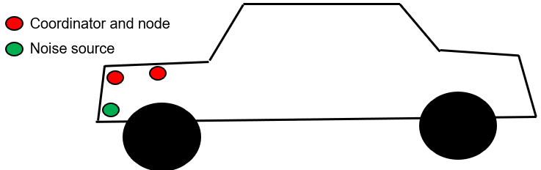
- — 6.5.1.1 Engine compartment to engine compartment (Scenario 8.X, CM X)

The model was defined as UWB channel model for industrial environments in [18] which was extracted based on measurements that cover a range from 2 to 8 m, though the path gain also relies on values from the literature, 3-8m. The measurements are described in [19] .

- —Parameters for Scenario 8 (CM8 and CMx) 3.1 - 10.6GHz

Industrial | LOS | NLOS
valid range of d | 2 - 8 m | 2 - 8 m | comments
Pathloss |  |  | valid up to 10 m distance
n | 1.2 | 2.15 | NLOS case taken from [20]
σ_{s} [dB] | 6 | 6 | extracted from measurements of[20] , [21]
PL₀ [dB] | 56.7 | 56.7
A_{ant} | 3 dB | 3dB
k | -1.103 | -1.427
Power delay profile
$$\overline{L}$$ | 4.75 | 1 | The NLOS case is described by a single PDP shape
Λ [1/ns] | 0.0709 | NA
λ [1/ns] | NA | NA
Γ | 13.47 | NA
k_{γ} | 0.926 | NA
γ0 | 0.651 | NA
σ_{cluster} [dB] | 4.32 | NA
Small-scale fading
m₀ | 0.36 dB | 0.30 dB
k_{m} | 0 | 0
$${\hat{m}}_{0}$$ | 1.13 | 1.15
$${\hat{k}}_{m}$$ | 0 | 0
${\tilde{m}}_{0}$ [dB] | 12.99 |  | only for first cluster; all later components have same m
χ | NA | 1
γ_{rise}[ns] | NA | 17.35
γ₁ [ns] | NA | 85.36

      - In-vehicle to In-vehicle (Scenario 8, CM 8) 3.1 - 10.6GHz

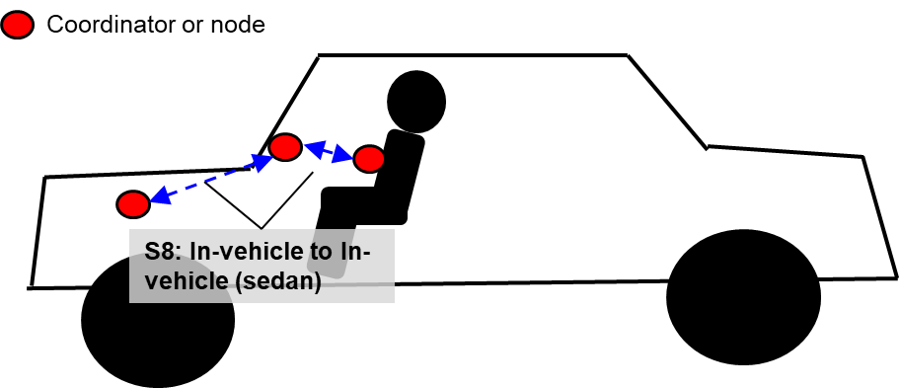
- —In-vehicle to In-vehicle (Scenario 8.X, CM X)

The model was defined as UWB channel model for residential environments in [18] which was extracted based on measurements that cover a range from 7-20m, up to 10 GHz. The derivation and justification of the parameters can be found in document [04-452], and all measurements are included in [04-290]

- — Parameters for Scenario 8 (CM8 and CM8) 3.1 - 10.6GHz

 | LOS | NLOS
valid range of d | 7 - 20 m | 7 - 20 m
Path gain
PL₀ [dB] | -43.9 | -48.7
n | 1.79 | 4.58
S [dB] | 2.22 | 3.51
κ | 1.12 ± 0.12 | 1.53 ± 0.32
Power delay profile
$\overline{L}$ | 3 | 3.5
Λ [1/ns] | 0.047 | 0.12
λ₁, λ₂ [1/ns], β | 1.54, 0.15, 0.095 | 1.77, 0.15, 0.045
Γ [ns] | 22.61 | 26.27
k_{γ} | 0 | 0
γ₀ [ns] | 12.53 | 17.50
σ_{cluster} [dB] | 2.75 | 2.93
Small-scale fading
m₀ [dB] | 0.67 | 0.69
k_{m} | 0 | 0
${\hat{m}}_{0}$ [dB] | 0.28 | 0.32
$${\hat{k}}_{m}$$ | 0 | 0
${\tilde{m}}_{0}$ [dB] | NA : all paths have | same m-factor distribution

      - Cabin room to cabin room in omnibus (Scenario 8.1) 3.1 - 10.6GHz
In large vehicle like omnibus type of vehicle, multiple HBAN is in the same cabin room. In such situation, channel model CM8.1 can be applied to analyze communication between VBAN and multiple HBANs.

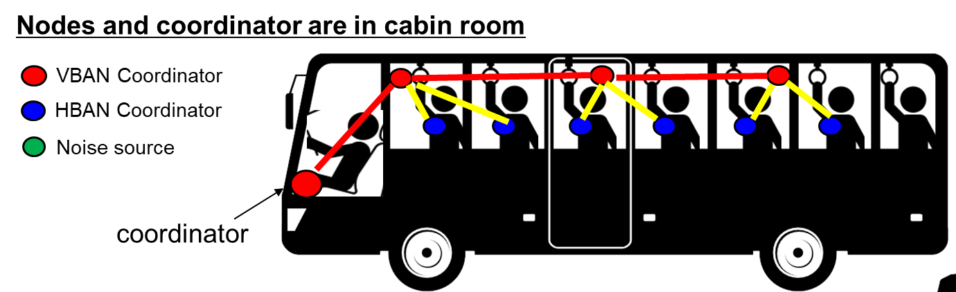
- —Scenario8.1 for Omnibus HBANs to VBAN connection

In multiple passengers on a vehicle such as omnibus, VBAN coordinator is connected with multiple VBAN nodes and also connected with HBAN coordinator as well as HBAN nodes that is used passengers personally. In this situation channel models are defined as three ways bellow.
OPTION 1
Option 1 is based on a FDTD method simulation with simplified bus and human body tissue models[13] . . This model provides simulated path-loss in omnibus emvironment.
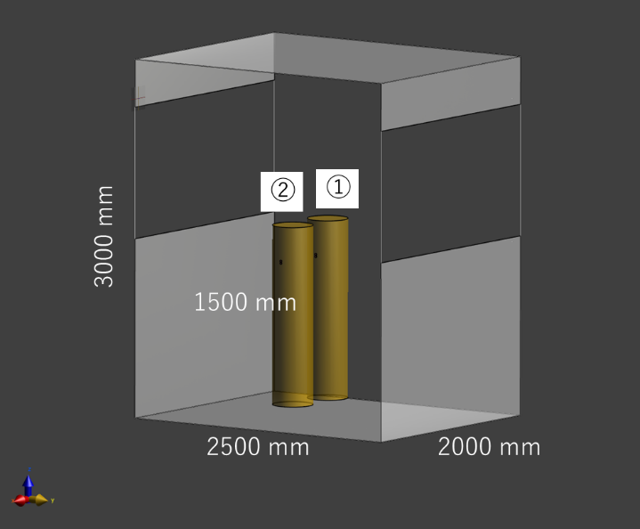
- —simplified omnibus 3D models for FDTD simulation

- On-vehicle to on-vehicle pathloss model parameters in S8.1
 | PL(d₀) (dB) | n | σ₂ (dB)
LOS | xxx | Xxx | xxx

OPTION 2
Option 1 is based on a channel model on IEEE802.15.6-2012 channel models document[1] . This is suitable to use for more focusing on HBAN centric analysis.
Measurement for the UWB frequency band of 3.1-10.6 GHz has been performed in [1] . On body antenna characteristics were measured in anechoic chamber, while channel measurements were done in office environment. For this measurement, the Tx antenna is fixed near to wall, while the Rx antenna (placed on body) positions were changed in office area. The effect of ground is considered in measurements. All data were averaged for statically analysis; therefore, the detail data of each measurement is not provided. The Further detail on set-up, derivation and data analysis can be found in [16] . The following figures summarize the delay profile of front, side, and backside of body while the Tx antenna is in the front of body.
- Parameters of the path loss model for CM8.1 (Scenario S8.1) for 3.1-10.6 GHz

This model is commonly used for CM4 for HBAN.
OPTION 3
Option 2 is based on a channel model on IEEE802.15.4a channel model final report[18] . This is suitable to use for more focusing on VBAN centric analysis.
The model was defined as UWB channel model for residential environments in[18] which was extracted based on measurements that cover a range from 7-20m, up to 10 GHz. The derivation and justification of the parameters can be found in document [04-452], and all measurements are included in [04-290]

- — Parameters for Scenario 8.X (CM8.X and CM8.x) 3.1 - 10.6GHz
 | LOS | NLOS
valid range of d | 7 - 20 m | 7 - 20 m
Path gain
PL₀ [dB] | -43.9 | -48.7
n | 1.79 | 4.58
S [dB] | 2.22 | 3.51
κ | 1.12 ± 0.12 | 1.53 ± 0.32
Power delay profile
$\overline{L}$ | 3 | 3.5
Λ [1/ns] | 0.047 | 0.12
λ₁, λ₂ [1/ns], β | 1.54, 0.15, 0.095 | 1.77, 0.15, 0.045
Γ [ns] | 22.61 | 26.27
k_{γ} | 0 | 0
γ₀ [ns] | 12.53 | 17.50
σ_{cluster} [dB] | 2.75 | 2.93
Small-scale fading
m₀ [dB] | 0.67 | 0.69
k_{m} | 0 | 0
${\hat{m}}_{0}$ [dB] | 0.28 | 0.32
$${\hat{k}}_{m}$$ | 0 | 0
${\tilde{m}}_{0}$ [dB] | NA : all paths have | same m-factor distribution

      - Cabin room to engine compartment [asymmetric] (Scenario 8.X, CM X) 3.1 – 10.6GHz

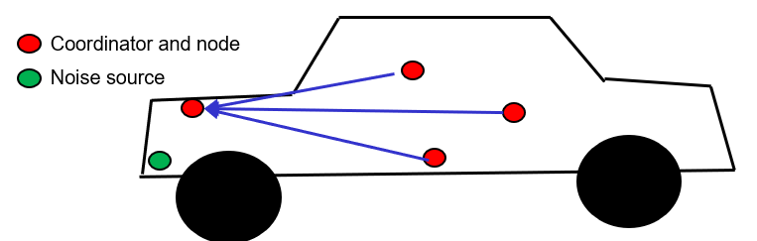
- —Cabin room to engine compartment (Scenario 8.X, CM X)
TBD
- Cabin room to engine compartment parameters [TBD]
Direction | PL(d₀) (dB) | n | σ₂ (dB)
Cabin room to engine compartment | [TBD] | xxx | Xxx
Engine compartment to cabin room | xxx | Xxx | xxx

      - Engine compartment to cabin room [symmetric] (Scenario 8.X CMx) 3.1 - 10.6GHz

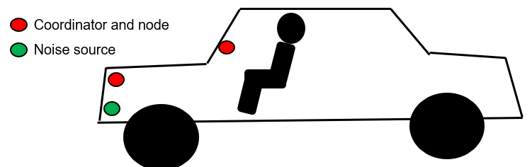
- —Engine compartment to cabin room (Scenario 8.X CMx)
TBD
- Cabin room to engine compartment pathloss model parameters [TBD]
Direction | PL(d₀) (dB) | n | σ₂ (dB)
Cabin room to engine compartment | Xxx | xxx | Xxx
Engine compartment to cabin room | xxx | Xxx | xxx

  - On vehicle
    - On-vehicle to on-vehicle (Scenario 11, 12, CM11, 12)

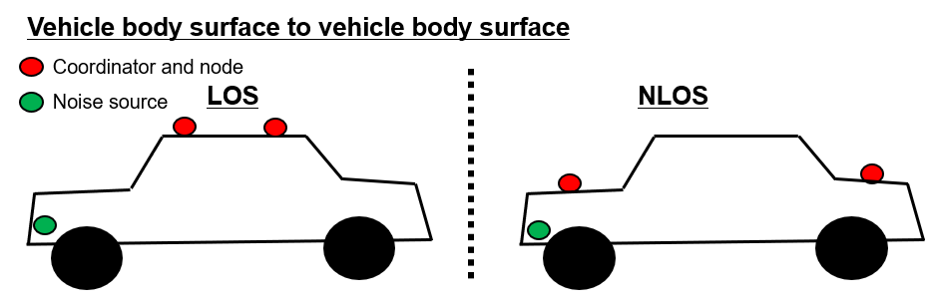
- —On-vehicle to on-vehicle (Scenario 11, 12, CM 11, 12)
TBD
- On-vehicle to on-vehicle pathloss model parameters [TBD]
 | PL(d₀) (dB) | n | σ₂ (dB)
LOS (S11) | Xxx | xxx | Xxx
NLOS (S12) | xxx | Xxx | xxx

    - In-vehicle to on vehicle (Scenario 9, CM9) 3.1 – 10.6 GHz
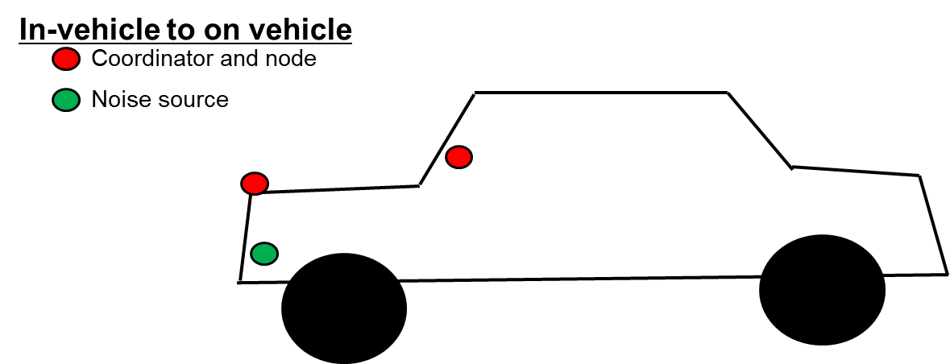
- ―In-vehicle to on vehicle (Scenario 9, CM9) 3.1 – 10.6 GHz
TBD
- On-vehicle to on-vehicle pathloss model parameters [TBD]
 | PL(d₀) (dB) | n | σ₂ (dB)
NLOS | xxx | Xxx | xxx

  - External
    - In-vehicle to External (Scenario 10, CM 10) 3.1 – 10.6GHz
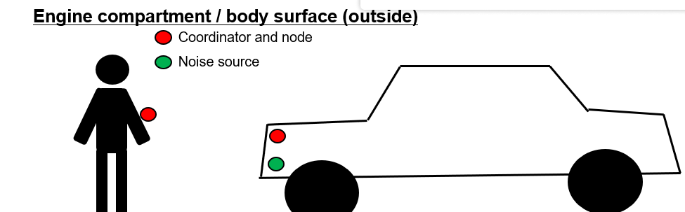
- —In-vehicle to external (Scenario 10, CM10) 3.1 – 10.6 GHz

The model was extracted based on measurements that cover a range from 5-17m, 3-6 GHz. A description of the model derivation can be found in [04-383, 04-385, 04-439, 04-440]. The Farm area model was extracted based on measurements in a snow-covered open area, and simulations of a farm area. The derivation of the model and a description of the simulations (for the farm area) can be found in [04-475]
- Parameters of the channel models for Scenario 10, CM 10
Outdoor | LOS | NLOS | Farm(LOS)
valid range of d | 5 - 17 m | 5 - 17 m
Pathloss
n | 1.76 | 2.5 | 1.58
σ_{S} | 0.83 | 2 | 3.96
PL₀ | 45.6 | 73.0 | 48.96
A_{ant} [dB] | 3 | 3 | 3
κ | 0.12 | 0.13 | 0
Power delay profile
L | 13.6 | 10.5 | 3.31
Λ [1/ns] | 0.0048 | 0.0243 | 0.0305
λ₁ [1/ns] | 0.27 | 0.15 | 0.0225
λ₂ [1/ns] | 2.41 | 1.13 | 0
β | 0.0078 | 0.062 | 0
Γ [ns] | 31.7 | 104.7 | 56
k_{γ} | 0 | 0 | 0
γ₀ [ns] | 3.7 | 9.3 | 0.92
σ_{cluster} [dB] | 3
Small-scale fading
m₀ | 0.77 dB | 0.56 dB | 4.1 dB
k_{m} | 0 | 0 | 0
$\hat{m_{0}}$ | 0.78 | 0.25 | 2.5 dB
$${\hat{k}}_{m}$$ | 0 | 0 | 0
$${\tilde{m}}_{0}$$ | NA | NA | 0
χ | NA | NA | NA
γ_{rise} | NA | NA | NA
γ₁ | NA | NA | NA

    - On-vehicle to External with mobility consideration (Scenario 13 & 14 & 13)
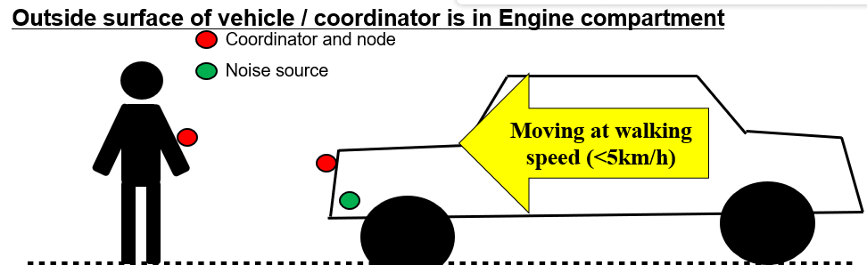
- —On-vehicle to External with mobility consideration (Scenario 13 & 14, CM 13)

- — Parameters of the channel models for Scenarios 13 & 14 & X, CM X

Outdoor | LOS | NLOS | Farm
valid range of d | 5 - 17 m | 5 - 17 m
Path gain
n | 1.76 | 2.5 | 1.58
σS | 0.83 | 2 | 3.96
G0 | -45.6 | -73.0 | -48.96
κ | 0.12 | 0.13 | 0
Power delay profile
L | 13.6 | 10.5 | 3.31
Λ [1/ns] | 0.0048 | 0.0243 | 0.0305
λ1 [1/ns] | 0.27 | 0.15 | 0.0225, 0, 0
λ2 [1/ns] | 2.41 | 1.13
β | 0.0078 | 0.062
Γ [ns] | 31.7 | 104.7 | 56
k  γ | 0 | 0 | 0
γ0 [ns] | 3.7 | 9.3 | 0.92
σcluster [dB] | 3
Small-scale fading
m0 | 0.77 dB | 0.56 dB | 4.1 dB
mb 0 | 0.78 | 0.25 | 2.5 dB
me 0 | NA | NA | 0

Bibliography
- Kamya Yekeh Yazdandoost, Kamran Sayrafian-Pour, “Channel Model for Body Area Network (BAN),” IEEE P802.15 Working Group for Wireless Personal Area Networks (WPANs), IEEE P802.15-08-0780-12-0006, Nov., 2012.
- W.-T. Chen; H.-R. Chuang, “Numerical computation of human interaction with arbitrarily oriented superquadric loop antennas in personal communications,” IEEE Trans. on Antenna and Propagation, vol.46, no. 6, pp. 821-828, June 1998.
- Kamya Y. Yazdandoost and Ryuji Kohno, “The Effect of Human Body on UWB BAN Antennas,” IEEE802.15-07-0546-00-0ban.
- C. H. Duney, H. Massoudi, and M. F. Iskander, “Radiofrequency radiation dosimetry handbook,” USAF School of Aerospace Medicine, October 1986.
- C. Gabriel and S. Gabriel, “Compilation of the dielectric properties of body tissues at RF and microwave frequencies,” AL/OE-TR-1996-0037, June 1996, http://www.brooks.af.mil/AFRL/HED/hedr/reports/dielectricReport/Report.html.
- Italian National Research Council, Institute for Applied Physics, “Dielectric properties of body tissues,” http://niremf.ifac.cnr.it
- P. Gandhi, “.Biological effects and medical applications of electromagnetic energy,” Prentice Hall, Englewood Cliffs, N.J., 1990.
- Marco Hernandez, Huan-Bang Li, Igor Dotlić, Ryu Miura, “Channel Models for TG8,” IEEE P802.15 Working Group for Wireless Personal Area Networks (WPANs), IEEE P802. 15-12-0459-07-0008, Sept., 2012
- 3GPP TS 36.104, Evolved Universal Terrestrial Radio Access; Base Station radio transmission and reception
- E. Reusens, W. Joseph, G. Vermeeren, and L. Martens, „On-body measurements and characterization of wireless communication channel fro arm and torso of human,“ International Workshop on Wearable and Implantabel Body Sensor Networks, BSN07, Achen, March 2007, pp. 26-28.
- A. Fort, J. Ryckaert, C. Desset, P. De Doncker, P. Wambacq, and L. Van Biesen, “ Ultrawideband channel model for communication around the human body, ” IEEE Journal on Selected Areas in Communications, vol. 24, pp.927-933, April 2006.
- Kamran Sayrafian, doc.# P.802.15-22-0401-00-6a, 2022.
- Daisuke Anzai, “Propagation characteristics of UWB communication applications including medical implants, BCI and passengers bus,” doc.# P.802. 15-22-0469-00-006a, 2022
- Takahiro Aoyagi, Jun-ichi Takada, Kenichi Takizawa, Norihiko Katayama, Takehiko Kobayashi, Kamya Yekeh Yazdandoost, Huan-bang Li and Ryuji Kohno, “Channel model for wearable and implantable WBANs,” IEEE 802.15-08-0416-04-0006, November 2008.
- Guido Dolmans and Andrew Fort, “Channel models WBAN-Holst centre/IMEC-NL,” IEEE 802.15-08-0418-01-0006, July 2008.
- Hirokazu Sawada, Takahiro Aoyagi, Jun-ichi Takada, Kamya Yekeh Yazdandoost, Ryuji Kohno, “Channel model between body surface and wireless access point for UWB band,” IEEE 802.15-08-0576-00-0006, August 2008.
- Minseok Kim, Jun-ichi Takada, Bin Zhen, Lawrence Materum, Tomoshige Kan, Yuuki Terao, yohei Konishi, Kenji Nakai, Takahiro Aoyagi, Ryuji Kohno, “Statistical property of dynamic BAN channel gain at 4.5 GHz,” IEEE 802-.15-08-0489-02-0006, June 2010.
- Andreas F. Molisch, Kannan Balakrishnan, Dajana Cassioli, Chia-Chin Chong, Shahriar Emami, Andrew Fort,Johan Karedal, Juergen Kunisch, Hans Schantz, Ulrich Schuster, Kai Siwiak, “IEEE 802.15.4a channel model - final report,”
- J. Karedal, S. Wyne, P. Almers, F. Tufvesson, and A. F. Molisch, “Statistical analysis of the uwb channel in an industrial environment,” in Proc. VTC fall 2004, 2004.
- T. S. Rappaport 1989.
- W. Pietsch 1994.

(informative)
Matlab code for IEEE802.15.4a UWB channel model

% modified S-V channel model evaluation
%%Written by Sun Xu, Kim Chee Wee, B. Kannan & Francois Chin on 22/02/2005
clear;
no_output_files = 1; % non-zero: avoids writing output files of continuous-time responses
num_channels = 100; % number of channel impulse responses to generate
randn(’state’,12); % initialize state of function for repeatability
rand(’state’,12); % initialize state of function for repeatability
cm_num = 6; % channel model number from 1 to 8
% get channel model params based on this channel model number
[Lam,Lmean,lambda_mode,lambda_1,lambda_2,beta,Gam,gamma_0,Kgamma, ...
sigma_cluster,nlos,gamma_rise,gamma_1,chi,m0,Km,sigma_m0,sigma_Km, ...
sfading_mode,m0_sp,std_shdw,kappa,fc,fs] = uwb_sv_params_15_4a( cm_num );
fprintf(1,[’Model Parameters\n’ ...
’ Lam = %.4f, Lmean = %.4f, lambda_mode(FLAG) = %d\n’ ...
’ lambda_1 = %.4f, lambda_2 = %.4f, beta = %.4f\n’ ...
’ Gam = %.4f, gamma0 = %.4f, Kgamma = %.4f, sigma_cluster = %.4f\n’ ...
’ nlos(FLAG) = %d, gamma_rise = %.4f, gamma_1 = %.4f, chi = %.4f\n’ ...
’ m0 = %.4f, Km = %.4f, sigma_m0 = %.4f, sigma_Km = %.4f\n’ ...
’ sfading_mode(FLAG) = %d, m0_sp = %.4f, std_shdw = %.4f\n’, ...
’ kappa = %.4f, fc = %.4fGHz, fs = %.4fGHz\n’], ...
Lam,Lmean,lambda_mode,lambda_1,lambda_2,beta,Gam,gamma_0,Kgamma, ...
sigma_cluster,nlos,gamma_rise,gamma_1,chi,m0,Km,sigma_m0,sigma_Km,...
sfading_mode,m0_sp,std_shdw,kappa,fc,fs);
ts = 1/fs; % sampling frequency
% get a bunch of realizations (impulse responses)
[h_ct,t_ct,t0,np] = uwb_sv_model_ct_15_4a(Lam,Lmean,lambda_mode,lambda_1, ...
lambda_2,beta,Gam,gamma_0,Kgamma,sigma_cluster,nlos,gamma_rise,gamma_1, ...
chi,m0,Km,sigma_m0,sigma_Km,sfading_mode,m0_sp,std_shdw,num_channels,ts);
% change to complex baseband channel
h_ct_len = size(h_ct, 1);
phi = zeros(h_ct_len, 1);
for k = 1:num_channels
phi = rand(h_ct_len, 1).*(2*pi);
h_ct(:,k) = h_ct(:,k) .* exp(phi .* i);
end
% now reduce continuous-time result to a discrete-time result
[hN,N] = uwb_sv_cnvrt_ct_15_4a( h_ct, t_ct, np, num_channels, ts );
if N > 1,
h = resample(hN, 1, N); % decimate the columns of hN by factor N
else
h = hN;
end
% add the frequency dependency
[h]= uwb_sv_freq_depend_ct_15_4a(h,fc,fs,num_channels,kappa);
%********************************************************************
% Testing and ploting
%********************************************************************
% channel energy
channel_energy = sum(abs(h).^2);
h_len = length(h(:,1));
t = [0:(h_len-1)] * ts; % for use in computing excess & RMS delays
excess_delay = zeros(1,num_channels);
RMS_delay = zeros(1,num_channels);
num_sig_paths = zeros(1,num_channels);
num_sig_e_paths = zeros(1,num_channels);
for k=1:num_channels
% determine excess delay and RMS delay
sq_h = abs(h(:,k)).^2 / channel_energy(k);
t_norm = t - t0(k); % remove the randomized arrival time of first cluster
excess_delay(k) = t_norm * sq_h;
RMS_delay(k) = sqrt( ((t_norm-excess_delay(k)).^2) * sq_h );
% determine number of significant paths (paths within 10 dB from peak)
threshold_dB = -10; % dB
temp_h = abs(h(:,k));
temp_thresh = 10^(threshold_dB/20) * max(temp_h);
num_sig_paths(k) = sum(temp_h > temp_thresh);
% determine number of sig. paths (captures x % of energy in channel)
x = 0.85;
temp_sort = sort(temp_h.^2); % sorted in ascending order of energy
cum_energy = cumsum(temp_sort(end:-1:1)); % cumulative energy
index_e = min(find(cum_energy >= x * cum_energy(end)));
num_sig_e_paths(k) = index_e;
end
energy_mean = mean(10*log10(channel_energy));
energy_stddev = std(10*log10(channel_energy));
mean_excess_delay = mean(excess_delay);
mean_RMS_delay = mean(RMS_delay);
mean_sig_paths = mean(num_sig_paths);
mean_sig_e_paths = mean(num_sig_e_paths);
fprintf(1,’Model Characteristics\n’);
fprintf(1,’ Mean delays: excess (tau_m) = %.1f ns, RMS (tau_rms) = %1.f\n’, ...
mean_excess_delay, mean_RMS_delay);
fprintf(1,’ # paths: NP_10dB = %.1f, NP_85%% = %.1f\n’, ...
mean_sig_paths, mean_sig_e_paths);
fprintf(1,’ Channel energy: mean = %.1f dB, std deviation = %.1f dB\n’, ...
energy_mean, energy_stddev);
figure(1); clf; plot(t, abs(h)); grid on
title(’Impulse response realizations’)
xlabel(’Time (nS)’)
figure(2); clf; plot([1:num_channels], excess_delay, ’b-’, ...
[1 num_channels], mean_excess_delay*[1 1], ’r–’ );
grid on
title(’Excess delay (nS)’)
xlabel(’Channel number’)
figure(3); clf; plot([1:num_channels], RMS_delay, ’b-’, ...
[1 num_channels], mean_RMS_delay*[1 1], ’r–’ );
grid on
title(’RMS delay (nS)’)
xlabel(’Channel number’)
figure(4); clf; plot([1:num_channels], num_sig_paths, ’b-’, ...
[1 num_channels], mean_sig_paths*[1 1], ’r–’);
grid on
title(’Number of significant paths within 10 dB of peak’)
xlabel(’Channel number’)
figure(5); clf; plot([1:num_channels], num_sig_e_paths, ’b-’, ...
[1 num_channels], mean_sig_e_paths*[1 1], ’r–’);
grid on
title(’Number of significant paths capturing > 85% energy’)
xlabel(’Channel number’)
temp_average_power = sum((abs(h))’.*(abs(h))’, 1)/num_channels;
temp_average_power = temp_average_power/max(temp_average_power);
average_decay_profile_dB = 10*log10(temp_average_power);
threshold_dB = -40;
above_threshold = find(average_decay_profile_dB > threshold_dB);
ave_t = t(above_threshold);
apdf_dB = average_decay_profile_dB(above_threshold);
figure(6); clf; plot(ave_t, apdf_dB); grid on
title(’Average Power Decay Profile’)
xlabel(’Delay (nsec)’)
ylabel(’Average power (dB)’)
if no_output_files,
return
end
%**************************************************************************
%Savinge the data
%**************************************************************************
%%% save continuous-time (time,value) pairs to files
save_fn = sprintf(’cm%d_imr’, cm_num);
% A complete self-contained file for Matlab users
save([save_fn ’.mat’], ’t’, ’h’,’t_ct’, ’h_ct’, ’t0’, ’np’, ’num_channels’, ’cm_num’);
% Three comma-delimited text files for non-Matlab users:
% File #1: cmX_imr_np.csv lists the number of paths in each realization
dlmwrite([save_fn ’_np.csv’], np, ’,’); % number of paths
% File #2: cmX_imr_ct.csv can open with Excel
% n’th pair of columns contains the (time,value) pairs for the n’th realization
% save continous time data
th_ct = zeros(size(t_ct,1),3*size(t_ct,2));
th_ct(:,1:3:end) = t_ct; % time
th_ct(:,2:3:end) = abs(h_ct); % magnitude
th_ct(:,3:3:end) = angle(h_ct); % phase (radians)
fid = fopen([save_fn ’_ct.csv’], ’w’);
if fid < 0,
error(’unable to write .csv file for impulse response, file may be open in another application’);
end
for k = 1:size(th_ct,1)
fprintf(fid,’%.4f,%.6f,’, th_ct(k,1:end-2));
fprintf(fid,’%.4f,%.6f\r\n’, th_ct(k,end-1:end)); % \r\n for Windoze end-of-line
end
fclose(fid);
% File #3: cmX_imr_dt.csv can open with Excel
% discrete channel impulse response magnitude and phase pair realization.
% the first column is time. phase is in radians
% save discrete time data
th = zeros(size(h,1),2*size(h,2)+1);
th(:,1) = t’; % the first column is time scale
th(:,2:2:end) = abs(h); % even columns are magnitude
th(:,3:2:end) = angle(h); % odd columns are phase
fid = fopen([save_fn ’_dt.csv’], ’w’);
if fid < 0,
error(’unable to write .csv file for impulse response, file may be open in another application’);
end
for k = 1:size(th,1)
fprintf(fid,’%.4f,%.6f,’, th(k,1:end-2));
fprintf(fid,’%.4f,%.6f\r\n’, th(k,end-1:end)); % \r\n for Windoze end-of-line
end
fclose(fid);
return; % end of program
function [Lam,Lmean,lambda_mode,lambda_1,lambda_2,beta,Gam,gamma_0,Kgamma, ...
sigma_cluster,nlos,gamma_rise,gamma_1,chi,m0,Km,sigma_m0,sigma_Km, ...
sfading_mode,m0_sp,std_shdw,kappa,fc,fs] = uwb_sv_params_15_4a( cm_num )
% Written by Sun Xu, Kim Chee Wee, B. Kannan & Francois Chin on 22/02/2004
% Return modified S-V model parameters for standard UWB channel models
%————————————————————————–
% Lam Cluster arrival rate (clusters per nsec)
% Lmean Mean number of Clusters
% lambda_mode Flag for Mixture of poission processes for ray arrival times
% 1 -> Mixture of poission processes for the ray arrival times
% 2 -> tapped delay line model
% lambda_1 Ray arrival rate for Mixture of poisson processes (rays per nsec)
% lambda_2 Ray arrival rate for Mixture of poisson processes (rays per nsec)
% beta Mixture probability
%————————————————————————–
% Gam Cluster decay factor (time constant, nsec)
% gamma0 Ray decay factor (time constant, nsec)
% Kgamma Time dependence of ray decay factor
% sigma_cluster Standard deviation of normally distributed variable for cluster energy
% nlos Flag for non line of sight channel
% 0 -> LOS
% 1 -> NLOS with first arrival path starting at t ~= 0
% 2 -> NLOS with first arrival path starting at t = 0 and diffused first cluster
% gamma_rise Ray decay factor of diffused first cluster (time constant, nsec)
% gamma_1 Ray decay factor of diffused first cluster (time constant, nsec)
% chi Diffuse weight of diffused first cluster
%————————————————————————–
% m0 Mean of log-normal distributed nakagami-m factor
% Km Time dependence of m0
% sigma_m0 Standard deviation of log-normal distributed nakagami-m factor
% sigma_Km Time dependence of sigma_m0
% sfading_mode Flag for small-scale fading
% 0 -> All paths have same m-factor distribution
% 1 -> LOS first path has a deterministic large m-factor
% 2 -> LOS first path of each cluster has a deterministic
% large m-factor
% m0_sp Deterministic large m-factor
%————————————————————————–
% std_shdw Standard deviation of log-normal shadowing of entire impulse response
%————————————————————————–
% kappa Frequency dependency of the channel
%————————————————————————–
% fc Center Frequency
% fs Frequency Range
%%
modified by I2R
if cm_num == 1, % Residential LOS
% MPC arrival
Lam = 0.047; Lmean = 3;
lambda_mode = 1;
lambda_1 = 1.54; lambda_2 = 0.15; beta = 0.095;
%MPC decay
Gam = 22.61; gamma_0 = 12.53; Kgamma = 0; sigma_cluster = 2.75;
nlos = 0;
gamma_rise = NaN; gamma_1 = NaN; chi = NaN; % dummy in this scenario
% Small-scale Fading
m0 = 0.67; Km = 0; sigma_m0 = 0.28; sigma_Km = 0;
sfading_mode = 0; m0_sp = NaN;
% Large-scale Fading – Shadowing
std_shdw = 2.22;
% Frequency Dependence
kappa = 1.12;
fc = 6; % GHz
fs = 8; % 2 - 10 GHz
elseif cm_num == 2, % Residential NLOS
% MPC arrival
Lam = 0.12; Lmean = 3.5;
lambda_mode = 1;
lambda_1 = 1.77; lambda_2 = 0.15; beta = 0.045;
%MPC decay
Gam = 26.27; gamma_0 = 17.5; Kgamma = 0; sigma_cluster = 2.93;
nlos = 1;
gamma_rise = NaN; gamma_1 = NaN; chi = NaN; % dummy in this scenario
% Small-scale Fading
m0 = 0.69; Km = 0; sigma_m0 = 0.32; sigma_Km = 0;
sfading_mode = 0; m0_sp = NaN;
% Large-scale Fading – Shadowing
std_shdw = 3.51;
% Frequency Dependence
kappa = 1.53;
fc = 6; % GHz
fs = 8; % 2 - 10 GHz
elseif cm_num == 3, % Office LOS
% MPC arrival
Lam = 0.016; Lmean = 5.4;
lambda_mode = 1;
lambda_1 = 0.19; lambda_2 = 2.97; beta = 0.0184;
%MPC decay
Gam = 14.6; gamma_0 = 6.4; Kgamma = 0; sigma_cluster = 3; % assumption
nlos = 0;
gamma_rise = NaN; gamma_1 = NaN; chi = NaN; % dummy in this scenario
% Small-scale Fading
m0 = 0.42; Km = 0; sigma_m0 = 0.31; sigma_Km = 0;
sfading_mode = 2; m0_sp = 3; % assumption
% Large-scale Fading – Shadowing
std_shdw = 0; %1.9;
% Frequency Dependence
kappa = 0.03;
fc = 6; % GHz
fs = 8; % 3 - 6 GHz
elseif cm_num == 4, % Office NLOS
% MPC arrival
Lam = 0.19; Lmean = 3.1;
lambda_mode = 1;
lambda_1 = 0.11; lambda_2 = 2.09; beta = 0.0096;
%MPC decay
Gam = 19.8; gamma_0 = 11.2; Kgamma = 0; sigma_cluster = 3; % assumption
nlos = 2;
gamma_rise = 15.21; gamma_1 = 11.84; chi = 0.78;
% Small-scale Fading
m0 = 0.5; Km = 0; sigma_m0 = 0.25; sigma_Km = 0;
sfading_mode = 0; m0_sp = NaN; % assumption
% Large-scale Fading – Shadowing
std_shdw = 3.9;
% Frequency Dependence
kappa =0.71;
fc = 6; % GHz
fs = 8; % 3 - 6 GHz
elseif cm_num == 5, % Outdoor LOS
% MPC arrival
Lam = 0.0448; Lmean = 13.6;
lambda_mode = 1;
lambda_1 = 0.13; lambda_2 = 2.41; beta = 0.0078;
%MPC decay
Gam = 31.7; gamma_0 = 3.7; Kgamma = 0; sigma_cluster = 3; % assumption
nlos = 0;
gamma_rise = NaN; gamma_1 = NaN; chi = NaN; % dummy in this scenario
% Small-scale Fading
m0 = 0.77; Km = 0; sigma_m0 = 0.78; sigma_Km = 0;
sfading_mode = 2; m0_sp = 3; % assumption
% Large-scale Fading – Shadowing
std_shdw = 0.83;
% Frequency Dependence
kappa = 0.12;
fc = 6; % GHz
fs = 8; % 3 - 6 GHz
elseif cm_num == 6, % Outdoor NLOS
% MPC arrival
Lam = 0.0243; Lmean = 10.5;
lambda_mode = 1;
lambda_1 = 0.15; lambda_2 = 1.13; beta = 0.062;
%MPC decay
Gam = 104.7; gamma_0 = 9.3; Kgamma = 0; sigma_cluster = 3; % assumption
nlos = 1;
gamma_rise = NaN; gamma_1 = NaN; chi = NaN; % dummy in this scenario
% Small-scale Fading
m0 = 0.56; Km = 0; sigma_m0 = 0.25; sigma_Km = 0;
sfading_mode = 0; m0_sp = NaN; % assumption
% Large-scale Fading – Shadowing
std_shdw = 2; % assumption
% Frequency Dependence
kappa = 0.13;
fc =6; % GHz
fs = 8; % 3 - 6 GHz
elseif cm_num == 7, % Industrial LOS
% MPC arrival
Lam = 0.0709; Lmean = 4.75;
lambda_mode = 2;
lambda_1 = 1; lambda_2 = 1; beta = 1; % dummy in this scenario
%MPC decay
Gam = 13.47; gamma_0 = 0.615; Kgamma = 0.926; sigma_cluster = 4.32;
nlos = 0;
gamma_rise = NaN; gamma_1 = NaN; chi = NaN; % dummy in this scenario
% Small-scale Fading
m0 = 0.36; Km = 0; sigma_m0 = 1.13; sigma_Km = 0;
sfading_mode = 1; m0_sp = 12.99;
% Large-scale Fading – Shadowing
std_shdw = 6;
% Frequency Dependence
kappa = -1.103;
fc = 6; % GHz
fs = 8; % 2 - 8 GHz
elseif cm_num == 8, % Industrial NLOS
% MPC arrival
Lam = 0.089; Lmean = 1;
lambda_mode = 2;
lambda_1 = 1; lambda_2 = 1; beta = 1; % dummy in this scenario
%MPC decay
Gam = 5.83; gamma_0 = 0.3; Kgamma = 0.44; sigma_cluster = 2.88;
nlos = 2;
gamma_rise = 47.23; gamma_1 = 84.15; chi = 0.99;
% Small-scale Fading
m0 = 0.3; Km = 0; sigma_m0 = 1.15; sigma_Km = 0;
sfading_mode = 0; m0_sp = NaN; % m0_sp is assumption
% Large-scale Fading – Shadowing
std_shdw = 6;
% Frequency Dependence
kappa = -1.427;
fc = 6; % GHz
fs = 8; % 2 - 8 GHz
elseif cm_num == 9, % Open Outdoor Environment NLOS (Fram, Snow-Covered Open Area)
% MPC arrival
Lam = 0.0305; Lmean = 3.31;
lambda_mode = 1;
lambda_1 = 0.0225; lambda_2 = 1; beta = 1;
%MPC decay
Gam = 56; gamma_0 = 0.92; Kgamma = 0; sigma_cluster = 3; % sigma_cluster is assumption
nlos = 1;
gamma_rise = NaN; gamma_1 = NaN; chi = NaN;
% Small-scale Fading
m0 = 4.1; Km = 0; sigma_m0 = 2.5; sigma_Km = 0;
sfading_mode = 0; m0_sp = NaN; % m0_sp is assumption
% Large-scale Fading – Shadowing
std_shdw = 3.96;
% Frequency Dependence
kappa = -1; % Kappa is assumption
fc = 6; % GHz
fs = 8; % 2 - 8 GHz
else
error(’cm_num is wrong!!’)
end
return
function [h]= uwb_sv_freq_depend_ct_15_4a(h,fc,fs,num_channels,kappa)
% This function is used to include the frequency dependency
f0 = 5; % GHz
h_len = length(h(:,1));
f = [fc-fs/2 : fs/h_len/2 : fc+fs/2]./f0;
f = f.^(-2*(kappa));
f = [f(h_len : 2*h_len), f(1 : h_len-1)]’;
i = (-1)^(1/2); % complex i
for c = 1:num_channels
% add the frequency dependency
h2 = zeros(2*h_len, 1);
h2(1 : h_len) = h(:,c); % zero padding
fh2 = fft(h2);
fh2 = fh2 .* f;
h2 = ifft(fh2);
h(:,c) = h2(1:h_len);
% Normalize the channel energy to 1
h(:,c) = h(:,c)/sqrt(h(:,c)’ * h(:,c) );
end
return
function [h,t,t0,np] = uwb_sv_model_ct_15_4a(Lam,Lmean,lambda_mode,lambda_1, ...
lambda_2,beta,Gam,gamma_0,Kgamma,sigma_cluster,nlos,gamma_rise,gamma_1, ...
chi,m0,Km,sigma_m0,sigma_Km,sfading_mode,m0_sp,std_shdw,num_channels,ts)
% Written by Sun Xu, Kim Chee Wee, B. Kannan & Francois Chin on 22/02/2005
% IEEE 802.15.4a UWB channel model for PHY proposal evaluation
% continuous-time realization of modified S-V channel model
% Input parameters:
% detailed introduction of input parameters is at uwb_sv_params.m
% num_channels number of random realizations to generate
% Outputs
% h is returned as a matrix with num_channels columns, each column
% holding a random realization of the channel model (an impulse response)
% t is organized as h, but holds the time instances (in nsec) of the paths whose
% signed amplitudes are stored in h
% t0 is the arrival time of the first cluster for each realization
% np is the number of paths for each realization.
% Thus, the k’th realization of the channel impulse response is the sequence
% of (time,value) pairs given by (t(1:np(k),k), h(1:np(k),k))
%%
modified by I2R
% initialize and precompute some things
std_L = 1/sqrt(2*Lam); % std dev (nsec) of cluster arrival spacing
std_lam_1 = 1/sqrt(2*lambda_1);
std_lam_2 = 1/sqrt(2*lambda_2);
% std_lam = 1/sqrt(2*lambda); % std dev (nsec) of ray arrival spacing
h_len = 1000; % there must be a better estimate of # of paths than this
ngrow = 1000; % amount to grow data structure if more paths are needed
h = zeros(h_len,num_channels);
t = zeros(h_len,num_channels);
t0 = zeros(1,num_channels);
np = zeros(1,num_channels);
for k = 1:num_channels % loop over number of channels
tmp_h = zeros(size(h,1),1);
tmp_t = zeros(size(h,1),1);
if nlos == 1,
Tc = (std_L*randn)^2 + (std_L*randn)^2; % First cluster random arrival
else
Tc = 0; % First cluster arrival occurs at time 0
end
t0(k) = Tc;
if nlos == 2 & lambda_mode == 2
L = 1; % for industrial NLOS environment
else
L = max(1, poissrnd(Lmean)); % number of clusters
end
%%%%%%%%%%%%%%%%%%%%%%%%%%%%%%%%%%%%%%%%%%%%%%%%%
if Kgamma ~= 0 & nlos == 0
Tcval = []; Tc_cluster= [];
Tc_cluster(1,1)=Tc;
for i_Tc=2:L+1
Tc_cluster(1,i_Tc)= Tc_cluster(1,i_Tc-1)+(std_L*randn)^2 + (std_L*randn)^2;
end
end
%%%%%%%%%%%%%%%%%%%%%%%%%%%%%%%%%%%%%%%%%%%%%%%%%
cluster_index = zeros(1,L);
path_ix = 0;
nak_m = [];
for ncluster = 1:L
% Determine Ray arrivals for each cluster
Tr = 0; % first ray arrival defined to be time 0 relative to cluster
cluster_index(ncluster) = path_ix+1; % remember the cluster location
gamma = Kgamma*Tc + gamma_0; % delay dependent cluster decay time
if nlos == 2 & ncluster == 1
gamma = gamma_1;
end
Mcluster = sigma_cluster*randn;
Pcluster = 10*log10(exp(-1*Tc/Gam))+Mcluster; % total cluster power
Pcluster = 10^(Pcluster*0.1);
%%%%%%%%%%%%%%%%%%%%%%%%%%%%%%%%%%%%%%%%
if Kgamma ~= 0 & nlos == 0
Tr_len=Tc_cluster(1,ncluster+1)-Tc_cluster(1,ncluster);
else
Tr_len = 10*gamma;
end
%%%%%%%%%%%%%%%%%%%%%%%%%%%%%%%%%%%%%%%
while (Tr < Tr_len),
t_val = (Tc+Tr); % time of arrival of this ray
if nlos == 2 & ncluster == 1
% equation (22)
h_val = Pcluster*(1-chi*exp(-Tr/gamma_rise))*exp(-Tr/gamma_1) ...
*(gamma+gamma_rise)/gamma/(gamma+gamma_rise*(1-chi));
else
% equation (19)
h_val = Pcluster/gamma*exp(-Tr/gamma)/(beta*lambda_1+(1-beta)*lambda_2+1);
end
path_ix = path_ix + 1; % row index of this ray
if path_ix > h_len,
% grow the output structures to handle more paths as needed
tmp_h = [tmp_h; zeros(ngrow,1)];
tmp_t = [tmp_t; zeros(ngrow,1)];
h = [h; zeros(ngrow,num_channels)];
t = [t; zeros(ngrow,num_channels)];
h_len = h_len + ngrow;
end
tmp_h(path_ix) = h_val;
tmp_t(path_ix) = t_val;
% if lambda_mode == 0
% Tr = Tr + (std_lam*randn)^2 + (std_lam*randn)^2;
if lambda_mode == 1
if rand < beta
Tr = Tr + (std_lam_1*randn)^2 + (std_lam_1*randn)^2;
else
Tr = Tr + (std_lam_2*randn)^2 + (std_lam_2*randn)^2;
end
elseif lambda_mode == 2
Tr = Tr + ts;
else
error(’lambda mode is wrong!’)
end
% generate log-normal distributed nakagami m-factor
m_mu = m0 - Km*t_val;
m_std = sigma_m0 - sigma_Km*t_val;
nak_m = [nak_m, lognrnd(m_mu, m_std)];
end
Tc = Tc + (std_L*randn)^2 + (std_L*randn)^2;
%%%%%%%%%%%%%%%%%%%%%%%%%%%%%%%%%%%%%%%%%%%%%
if Kgamma ~= 0 & nlos == 0
Tc = Tc_cluster(1,ncluster+1);
end
%%%%%%%%%%%%%%%%%%%%%%%%%%%%%%%%%%%%%%%%%%%%%
end
% change m value of the first multipath to be the deterministic value
if sfading_mode == 1
nak_ms(cluster_index(1)) = m0_sp;
elseif sfading_mode == 2
nak_ms(cluster_index) = m0_sp;
end
% apply nakagami
for path = 1:path_ix
h_val = (gamrnd(nak_m(path), tmp_h(path)/nak_m(path))).^(1/2);
tmp_h(path) = h_val;
end
np(k) = path_ix; % number of rays (or paths) for this realization
[sort_tmp_t,sort_ix] = sort(tmp_t(1:np(k))); % sort in ascending time order
t(1:np(k),k) = sort_tmp_t;
h(1:np(k),k) = tmp_h(sort_ix(1:np(k)));
% now impose a log-normal shadowing on this realization
% fac = 10^(std_shdw*randn/20) / sqrt( h(1:np(k),k)’ * h(1:np(k),k) );
% h(1:np(k),k) = h(1:np(k),k) * fac;
end
return
function [hN,N] = uwb_sv_cnvrt_ct_15_4a( h_ct, t, np, num_channels, ts )
% convert continuous-time channel model h_ct to N-times oversampled discrete-time samples
% h_ct, t, np, and num_channels are as specified in uwb_sv_model
% ts is the desired time resolution
%%hN will be produced with time resolution ts /
N.
% It is up to the user to then apply any filtering and/or complex downconversion and then
% decimate by N to finally obtain an impulse response at time resolution ts.
min_Nfs = 100; % GHz
N = max( 1, ceil(min_Nfs*ts) ); % N*fs = N/ts is the intermediate sampling frequency before decimation
N = 2^nextpow2(N); % make N a power of 2 to facilitate efficient multi-stage decimation
Nfs = N / ts;
t_max = max(t(:)); % maximum time value across all channels
h_len = 1 + floor(t_max * Nfs); % number of time samples at resolution ts / N
hN = zeros(h_len,num_channels);
for k = 1:num_channels
np_k = np(k); % number of paths in this channel
t_Nfs = 1 + floor(t(1:np_k,k) * Nfs); % vector of quantized time indices for this channel
for n = 1:np_k
hN(t_Nfs(n),k) = hN(t_Nfs(n),k) + h_ct(n,k);
end
end

(informative)
MATLAB script for the IEEE 802.15.4a channel model

% modified S-V channel model evaluation
%%Written by Sun Xu, Kim Chee Wee, B. Kannan & Francois Chin on 22/02/2005
clear;
no_output_files = 1; % non-zero: avoids writing output files of continuous-time responses
num_channels = 100; % number of channel impulse responses to generate
randn(’state’,12); % initialize state of function for repeatability
rand(’state’,12); % initialize state of function for repeatability
cm_num = 6; % channel model number from 1 to 8
% get channel model params based on this channel model number
[Lam,Lmean,lambda_mode,lambda_1,lambda_2,beta,Gam,gamma_0,Kgamma, ...
sigma_cluster,nlos,gamma_rise,gamma_1,chi,m0,Km,sigma_m0,sigma_Km, ...
sfading_mode,m0_sp,std_shdw,kappa,fc,fs] = uwb_sv_params_15_4a( cm_num );
fprintf(1,[’Model Parameters\n’ ...
’ Lam = %.4f, Lmean = %.4f, lambda_mode(FLAG) = %d\n’ ...
’ lambda_1 = %.4f, lambda_2 = %.4f, beta = %.4f\n’ ...
’ Gam = %.4f, gamma0 = %.4f, Kgamma = %.4f, sigma_cluster = %.4f\n’ ...
’ nlos(FLAG) = %d, gamma_rise = %.4f, gamma_1 = %.4f, chi = %.4f\n’ ...
’ m0 = %.4f, Km = %.4f, sigma_m0 = %.4f, sigma_Km = %.4f\n’ ...
’ sfading_mode(FLAG) = %d, m0_sp = %.4f, std_shdw = %.4f\n’, ...
’ kappa = %.4f, fc = %.4fGHz, fs = %.4fGHz\n’], ...
Lam,Lmean,lambda_mode,lambda_1,lambda_2,beta,Gam,gamma_0,Kgamma, ...
sigma_cluster,nlos,gamma_rise,gamma_1,chi,m0,Km,sigma_m0,sigma_Km,...
sfading_mode,m0_sp,std_shdw,kappa,fc,fs);
ts = 1/fs; % sampling frequency
% get a bunch of realizations (impulse responses)
[h_ct,t_ct,t0,np] = uwb_sv_model_ct_15_4a(Lam,Lmean,lambda_mode,lambda_1, ...
lambda_2,beta,Gam,gamma_0,Kgamma,sigma_cluster,nlos,gamma_rise,gamma_1, ...
chi,m0,Km,sigma_m0,sigma_Km,sfading_mode,m0_sp,std_shdw,num_channels,ts);
% change to complex baseband channel
h_ct_len = size(h_ct, 1);
phi = zeros(h_ct_len, 1);
for k = 1:num_channels
phi = rand(h_ct_len, 1).*(2*pi);
h_ct(:,k) = h_ct(:,k) .* exp(phi .* i);
end
% now reduce continuous-time result to a discrete-time result
[hN,N] = uwb_sv_cnvrt_ct_15_4a( h_ct, t_ct, np, num_channels, ts );
if N > 1,
h = resample(hN, 1, N); % decimate the columns of hN by factor N
else
h = hN;
end
% add the frequency dependency
[h]= uwb_sv_freq_depend_ct_15_4a(h,fc,fs,num_channels,kappa);
%********************************************************************
% Testing and ploting
%********************************************************************
% channel energy
channel_energy = sum(abs(h).^2);
h_len = length(h(:,1));
t = [0:(h_len-1)] * ts; % for use in computing excess & RMS delays
excess_delay = zeros(1,num_channels);
RMS_delay = zeros(1,num_channels);
num_sig_paths = zeros(1,num_channels);
num_sig_e_paths = zeros(1,num_channels);
for k=1:num_channels
% determine excess delay and RMS delay
sq_h = abs(h(:,k)).^2 / channel_energy(k);
t_norm = t - t0(k); % remove the randomized arrival time of first cluster
excess_delay(k) = t_norm * sq_h;
RMS_delay(k) = sqrt( ((t_norm-excess_delay(k)).^2) * sq_h );
% determine number of significant paths (paths within 10 dB from peak)
threshold_dB = -10; % dB
temp_h = abs(h(:,k));
temp_thresh = 10^(threshold_dB/20) * max(temp_h);
num_sig_paths(k) = sum(temp_h > temp_thresh);
% determine number of sig. paths (captures x % of energy in channel)
x = 0.85;
temp_sort = sort(temp_h.^2); % sorted in ascending order of energy
cum_energy = cumsum(temp_sort(end:-1:1)); % cumulative energy
index_e = min(find(cum_energy >= x * cum_energy(end)));
num_sig_e_paths(k) = index_e;
end
energy_mean = mean(10*log10(channel_energy));
energy_stddev = std(10*log10(channel_energy));
mean_excess_delay = mean(excess_delay);
mean_RMS_delay = mean(RMS_delay);
mean_sig_paths = mean(num_sig_paths);
mean_sig_e_paths = mean(num_sig_e_paths);
fprintf(1,’Model Characteristics\n’);
fprintf(1,’ Mean delays: excess (tau_m) = %.1f ns, RMS (tau_rms) = %1.f\n’, ...
mean_excess_delay, mean_RMS_delay);
fprintf(1,’ # paths: NP_10dB = %.1f, NP_85%% = %.1f\n’, ...
mean_sig_paths, mean_sig_e_paths);
fprintf(1,’ Channel energy: mean = %.1f dB, std deviation = %.1f dB\n’, ...
energy_mean, energy_stddev);
figure(1); clf; plot(t, abs(h)); grid on
title(’Impulse response realizations’)
xlabel(’Time (nS)’)
figure(2); clf; plot([1:num_channels], excess_delay, ’b-’, ...
[1 num_channels], mean_excess_delay*[1 1], ’r–’ );
grid on
title(’Excess delay (nS)’)
xlabel(’Channel number’)
figure(3); clf; plot([1:num_channels], RMS_delay, ’b-’, ...
[1 num_channels], mean_RMS_delay*[1 1], ’r–’ );
grid on
title(’RMS delay (nS)’)
xlabel(’Channel number’)
figure(4); clf; plot([1:num_channels], num_sig_paths, ’b-’, ...
[1 num_channels], mean_sig_paths*[1 1], ’r–’);
grid on
title(’Number of significant paths within 10 dB of peak’)
xlabel(’Channel number’)
figure(5); clf; plot([1:num_channels], num_sig_e_paths, ’b-’, ...
[1 num_channels], mean_sig_e_paths*[1 1], ’r–’);
grid on
title(’Number of significant paths capturing > 85% energy’)
xlabel(’Channel number’)
temp_average_power = sum((abs(h))’.*(abs(h))’, 1)/num_channels;
temp_average_power = temp_average_power/max(temp_average_power);
average_decay_profile_dB = 10*log10(temp_average_power);
threshold_dB = -40;
above_threshold = find(average_decay_profile_dB > threshold_dB);
ave_t = t(above_threshold);
apdf_dB = average_decay_profile_dB(above_threshold);
figure(6); clf; plot(ave_t, apdf_dB); grid on
title(’Average Power Decay Profile’)
xlabel(’Delay (nsec)’)
ylabel(’Average power (dB)’)
if no_output_files,
return
end
%**************************************************************************
%Savinge the data
%**************************************************************************
%%% save continuous-time (time,value) pairs to files
save_fn = sprintf(’cm%d_imr’, cm_num);
% A complete self-contained file for Matlab users
save([save_fn ’.mat’], ’t’, ’h’,’t_ct’, ’h_ct’, ’t0’, ’np’, ’num_channels’, ’cm_num’);
% Three comma-delimited text files for non-Matlab users:
% File #1: cmX_imr_np.csv lists the number of paths in each realization
dlmwrite([save_fn ’_np.csv’], np, ’,’); % number of paths
% File #2: cmX_imr_ct.csv can open with Excel
% n’th pair of columns contains the (time,value) pairs for the n’th realization
% save continous time data
th_ct = zeros(size(t_ct,1),3*size(t_ct,2));
th_ct(:,1:3:end) = t_ct; % time
th_ct(:,2:3:end) = abs(h_ct); % magnitude
th_ct(:,3:3:end) = angle(h_ct); % phase (radians)
fid = fopen([save_fn ’_ct.csv’], ’w’);
if fid < 0,
error(’unable to write .csv file for impulse response, file may be open in another application’);
end
for k = 1:size(th_ct,1)
fprintf(fid,’%.4f,%.6f,’, th_ct(k,1:end-2));
fprintf(fid,’%.4f,%.6f\r\n’, th_ct(k,end-1:end)); % \r\n for Windoze end-of-line
end
fclose(fid);
% File #3: cmX_imr_dt.csv can open with Excel
% discrete channel impulse response magnitude and phase pair realization.
% the first column is time. phase is in radians
% save discrete time data
th = zeros(size(h,1),2*size(h,2)+1);
th(:,1) = t’; % the first column is time scale
th(:,2:2:end) = abs(h); % even columns are magnitude
th(:,3:2:end) = angle(h); % odd columns are phase
fid = fopen([save_fn ’_dt.csv’], ’w’);
if fid < 0,
error(’unable to write .csv file for impulse response, file may be open in another application’);
end
for k = 1:size(th,1)
fprintf(fid,’%.4f,%.6f,’, th(k,1:end-2));
fprintf(fid,’%.4f,%.6f\r\n’, th(k,end-1:end)); % \r\n for Windoze end-of-line
end
fclose(fid);
return; % end of program
function [Lam,Lmean,lambda_mode,lambda_1,lambda_2,beta,Gam,gamma_0,Kgamma, ...
sigma_cluster,nlos,gamma_rise,gamma_1,chi,m0,Km,sigma_m0,sigma_Km, ...
sfading_mode,m0_sp,std_shdw,kappa,fc,fs] = uwb_sv_params_15_4a( cm_num )
% Written by Sun Xu, Kim Chee Wee, B. Kannan & Francois Chin on 22/02/2004
% Return modified S-V model parameters for standard UWB channel models
%————————————————————————–
% Lam Cluster arrival rate (clusters per nsec)
% Lmean Mean number of Clusters
% lambda_mode Flag for Mixture of poission processes for ray arrival times
% 1 -> Mixture of poission processes for the ray arrival times
% 2 -> tapped delay line model
% lambda_1 Ray arrival rate for Mixture of poisson processes (rays per nsec)
% lambda_2 Ray arrival rate for Mixture of poisson processes (rays per nsec)
% beta Mixture probability
%————————————————————————–
% Gam Cluster decay factor (time constant, nsec)
% gamma0 Ray decay factor (time constant, nsec)
% Kgamma Time dependence of ray decay factor
% sigma_cluster Standard deviation of normally distributed variable for cluster energy
% nlos Flag for non line of sight channel
% 0 -> LOS
% 1 -> NLOS with first arrival path starting at t ~= 0
% 2 -> NLOS with first arrival path starting at t = 0 and diffused first cluster
% gamma_rise Ray decay factor of diffused first cluster (time constant, nsec)
% gamma_1 Ray decay factor of diffused first cluster (time constant, nsec)
% chi Diffuse weight of diffused first cluster
%————————————————————————–
% m0 Mean of log-normal distributed nakagami-m factor
% Km Time dependence of m0
% sigma_m0 Standard deviation of log-normal distributed nakagami-m factor
% sigma_Km Time dependence of sigma_m0
% sfading_mode Flag for small-scale fading
% 0 -> All paths have same m-factor distribution
% 1 -> LOS first path has a deterministic large m-factor
% 2 -> LOS first path of each cluster has a deterministic
% large m-factor
% m0_sp Deterministic large m-factor
%————————————————————————–
% std_shdw Standard deviation of log-normal shadowing of entire impulse response
%————————————————————————–
% kappa Frequency dependency of the channel
%————————————————————————–
% fc Center Frequency
% fs Frequency Range
%%
modified by I2R
if cm_num == 1, % Residential LOS
% MPC arrival
Lam = 0.047; Lmean = 3;
lambda_mode = 1;
lambda_1 = 1.54; lambda_2 = 0.15; beta = 0.095;
%MPC decay
Gam = 22.61; gamma_0 = 12.53; Kgamma = 0; sigma_cluster = 2.75;
nlos = 0;
gamma_rise = NaN; gamma_1 = NaN; chi = NaN; % dummy in this scenario
% Small-scale Fading
m0 = 0.67; Km = 0; sigma_m0 = 0.28; sigma_Km = 0;
sfading_mode = 0; m0_sp = NaN;
% Large-scale Fading – Shadowing
std_shdw = 2.22;
% Frequency Dependence
kappa = 1.12;
fc = 6; % GHz
fs = 8; % 2 - 10 GHz
elseif cm_num == 2, % Residential NLOS
% MPC arrival
Lam = 0.12; Lmean = 3.5;
lambda_mode = 1;
lambda_1 = 1.77; lambda_2 = 0.15; beta = 0.045;
%MPC decay
Gam = 26.27; gamma_0 = 17.5; Kgamma = 0; sigma_cluster = 2.93;
nlos = 1;
gamma_rise = NaN; gamma_1 = NaN; chi = NaN; % dummy in this scenario
% Small-scale Fading
m0 = 0.69; Km = 0; sigma_m0 = 0.32; sigma_Km = 0;
sfading_mode = 0; m0_sp = NaN;
% Large-scale Fading – Shadowing
std_shdw = 3.51;
% Frequency Dependence
kappa = 1.53;
fc = 6; % GHz
fs = 8; % 2 - 10 GHz
elseif cm_num == 3, % Office LOS
% MPC arrival
Lam = 0.016; Lmean = 5.4;
lambda_mode = 1;
lambda_1 = 0.19; lambda_2 = 2.97; beta = 0.0184;
%MPC decay
Gam = 14.6; gamma_0 = 6.4; Kgamma = 0; sigma_cluster = 3; % assumption
nlos = 0;
gamma_rise = NaN; gamma_1 = NaN; chi = NaN; % dummy in this scenario
% Small-scale Fading
m0 = 0.42; Km = 0; sigma_m0 = 0.31; sigma_Km = 0;
sfading_mode = 2; m0_sp = 3; % assumption
% Large-scale Fading – Shadowing
std_shdw = 0; %1.9;
% Frequency Dependence
kappa = 0.03;
fc = 6; % GHz
fs = 8; % 3 - 6 GHz
elseif cm_num == 4, % Office NLOS
% MPC arrival
Lam = 0.19; Lmean = 3.1;
lambda_mode = 1;
lambda_1 = 0.11; lambda_2 = 2.09; beta = 0.0096;
%MPC decay
Gam = 19.8; gamma_0 = 11.2; Kgamma = 0; sigma_cluster = 3; % assumption
nlos = 2;
gamma_rise = 15.21; gamma_1 = 11.84; chi = 0.78;
% Small-scale Fading
m0 = 0.5; Km = 0; sigma_m0 = 0.25; sigma_Km = 0;
sfading_mode = 0; m0_sp = NaN; % assumption
% Large-scale Fading – Shadowing
std_shdw = 3.9;
% Frequency Dependence
kappa =0.71;
fc = 6; % GHz
fs = 8; % 3 - 6 GHz
elseif cm_num == 5, % Outdoor LOS
% MPC arrival
Lam = 0.0448; Lmean = 13.6;
lambda_mode = 1;
lambda_1 = 0.13; lambda_2 = 2.41; beta = 0.0078;
%MPC decay
Gam = 31.7; gamma_0 = 3.7; Kgamma = 0; sigma_cluster = 3; % assumption
nlos = 0;
gamma_rise = NaN; gamma_1 = NaN; chi = NaN; % dummy in this scenario
% Small-scale Fading
m0 = 0.77; Km = 0; sigma_m0 = 0.78; sigma_Km = 0;
sfading_mode = 2; m0_sp = 3; % assumption
% Large-scale Fading – Shadowing
std_shdw = 0.83;
% Frequency Dependence
kappa = 0.12;
fc = 6; % GHz
fs = 8; % 3 - 6 GHz
elseif cm_num == 6, % Outdoor NLOS
% MPC arrival
Lam = 0.0243; Lmean = 10.5;
lambda_mode = 1;
lambda_1 = 0.15; lambda_2 = 1.13; beta = 0.062;
%MPC decay
Gam = 104.7; gamma_0 = 9.3; Kgamma = 0; sigma_cluster = 3; % assumption
nlos = 1;
gamma_rise = NaN; gamma_1 = NaN; chi = NaN; % dummy in this scenario
% Small-scale Fading
m0 = 0.56; Km = 0; sigma_m0 = 0.25; sigma_Km = 0;
sfading_mode = 0; m0_sp = NaN; % assumption
% Large-scale Fading – Shadowing
std_shdw = 2; % assumption
% Frequency Dependence
kappa = 0.13;
fc =6; % GHz
fs = 8; % 3 - 6 GHz
elseif cm_num == 7, % Industrial LOS
% MPC arrival
Lam = 0.0709; Lmean = 4.75;
lambda_mode = 2;
lambda_1 = 1; lambda_2 = 1; beta = 1; % dummy in this scenario
%MPC decay
Gam = 13.47; gamma_0 = 0.615; Kgamma = 0.926; sigma_cluster = 4.32;
nlos = 0;
gamma_rise = NaN; gamma_1 = NaN; chi = NaN; % dummy in this scenario
% Small-scale Fading
m0 = 0.36; Km = 0; sigma_m0 = 1.13; sigma_Km = 0;
sfading_mode = 1; m0_sp = 12.99;
% Large-scale Fading – Shadowing
std_shdw = 6;
% Frequency Dependence
kappa = -1.103;
fc = 6; % GHz
fs = 8; % 2 - 8 GHz
elseif cm_num == 8, % Industrial NLOS
% MPC arrival
Lam = 0.089; Lmean = 1;
lambda_mode = 2;
lambda_1 = 1; lambda_2 = 1; beta = 1; % dummy in this scenario
%MPC decay
Gam = 5.83; gamma_0 = 0.3; Kgamma = 0.44; sigma_cluster = 2.88;
nlos = 2;
gamma_rise = 47.23; gamma_1 = 84.15; chi = 0.99;
% Small-scale Fading
m0 = 0.3; Km = 0; sigma_m0 = 1.15; sigma_Km = 0;
sfading_mode = 0; m0_sp = NaN; % m0_sp is assumption
% Large-scale Fading – Shadowing
std_shdw = 6;
% Frequency Dependence
kappa = -1.427;
fc = 6; % GHz
fs = 8; % 2 - 8 GHz
elseif cm_num == 9, % Open Outdoor Environment NLOS (Fram, Snow-Covered Open Area)
% MPC arrival
Lam = 0.0305; Lmean = 3.31;
lambda_mode = 1;
lambda_1 = 0.0225; lambda_2 = 1; beta = 1;
%MPC decay
Gam = 56; gamma_0 = 0.92; Kgamma = 0; sigma_cluster = 3; % sigma_cluster is assumption
nlos = 1;
gamma_rise = NaN; gamma_1 = NaN; chi = NaN;
% Small-scale Fading
m0 = 4.1; Km = 0; sigma_m0 = 2.5; sigma_Km = 0;
sfading_mode = 0; m0_sp = NaN; % m0_sp is assumption
% Large-scale Fading – Shadowing
std_shdw = 3.96;
% Frequency Dependence
kappa = -1; % Kappa is assumption
fc = 6; % GHz
fs = 8; % 2 - 8 GHz
else
error(’cm_num is wrong!!’)
end
return
function [h]= uwb_sv_freq_depend_ct_15_4a(h,fc,fs,num_channels,kappa)
% This function is used to include the frequency dependency
f0 = 5; % GHz
h_len = length(h(:,1));
f = [fc-fs/2 : fs/h_len/2 : fc+fs/2]./f0;
f = f.^(-2*(kappa));
f = [f(h_len : 2*h_len), f(1 : h_len-1)]’;
i = (-1)^(1/2); % complex i
for c = 1:num_channels
% add the frequency dependency
h2 = zeros(2*h_len, 1);
h2(1 : h_len) = h(:,c); % zero padding
fh2 = fft(h2);
fh2 = fh2 .* f;
h2 = ifft(fh2);
h(:,c) = h2(1:h_len);
% Normalize the channel energy to 1
h(:,c) = h(:,c)/sqrt(h(:,c)’ * h(:,c) );
end
return
function [h,t,t0,np] = uwb_sv_model_ct_15_4a(Lam,Lmean,lambda_mode,lambda_1, ...
lambda_2,beta,Gam,gamma_0,Kgamma,sigma_cluster,nlos,gamma_rise,gamma_1, ...
chi,m0,Km,sigma_m0,sigma_Km,sfading_mode,m0_sp,std_shdw,num_channels,ts)
% Written by Sun Xu, Kim Chee Wee, B. Kannan & Francois Chin on 22/02/2005
% IEEE 802.15.4a UWB channel model for PHY proposal evaluation
% continuous-time realization of modified S-V channel model
% Input parameters:
% detailed introduction of input parameters is at uwb_sv_params.m
% num_channels number of random realizations to generate
% Outputs
% h is returned as a matrix with num_channels columns, each column
% holding a random realization of the channel model (an impulse response)
% t is organized as h, but holds the time instances (in nsec) of the paths whose
% signed amplitudes are stored in h
% t0 is the arrival time of the first cluster for each realization
% np is the number of paths for each realization.
% Thus, the k’th realization of the channel impulse response is the sequence
% of (time,value) pairs given by (t(1:np(k),k), h(1:np(k),k))
%%
modified by I2R
% initialize and precompute some things
std_L = 1/sqrt(2*Lam); % std dev (nsec) of cluster arrival spacing
std_lam_1 = 1/sqrt(2*lambda_1);
std_lam_2 = 1/sqrt(2*lambda_2);
% std_lam = 1/sqrt(2*lambda); % std dev (nsec) of ray arrival spacing
h_len = 1000; % there must be a better estimate of # of paths than this
ngrow = 1000; % amount to grow data structure if more paths are needed
h = zeros(h_len,num_channels);
t = zeros(h_len,num_channels);
t0 = zeros(1,num_channels);
np = zeros(1,num_channels);
for k = 1:num_channels % loop over number of channels
tmp_h = zeros(size(h,1),1);
tmp_t = zeros(size(h,1),1);
if nlos == 1,
Tc = (std_L*randn)^2 + (std_L*randn)^2; % First cluster random arrival
else
Tc = 0; % First cluster arrival occurs at time 0
end
t0(k) = Tc;
if nlos == 2 & lambda_mode == 2
L = 1; % for industrial NLOS environment
else
L = max(1, poissrnd(Lmean)); % number of clusters
end
%%%%%%%%%%%%%%%%%%%%%%%%%%%%%%%%%%%%%%%%%%%%%%%%%
if Kgamma ~= 0 & nlos == 0
Tcval = []; Tc_cluster= [];
Tc_cluster(1,1)=Tc;
for i_Tc=2:L+1
Tc_cluster(1,i_Tc)= Tc_cluster(1,i_Tc-1)+(std_L*randn)^2 + (std_L*randn)^2;
end
end
%%%%%%%%%%%%%%%%%%%%%%%%%%%%%%%%%%%%%%%%%%%%%%%%%
cluster_index = zeros(1,L);
path_ix = 0;
nak_m = [];
for ncluster = 1:L
% Determine Ray arrivals for each cluster
Tr = 0; % first ray arrival defined to be time 0 relative to cluster
cluster_index(ncluster) = path_ix+1; % remember the cluster location
gamma = Kgamma*Tc + gamma_0; % delay dependent cluster decay time
if nlos == 2 & ncluster == 1
gamma = gamma_1;
end
Mcluster = sigma_cluster*randn;
Pcluster = 10*log10(exp(-1*Tc/Gam))+Mcluster; % total cluster power
Pcluster = 10^(Pcluster*0.1);
%%%%%%%%%%%%%%%%%%%%%%%%%%%%%%%%%%%%%%%%
if Kgamma ~= 0 & nlos == 0
Tr_len=Tc_cluster(1,ncluster+1)-Tc_cluster(1,ncluster);
else
Tr_len = 10*gamma;
end
%%%%%%%%%%%%%%%%%%%%%%%%%%%%%%%%%%%%%%%
while (Tr < Tr_len),
t_val = (Tc+Tr); % time of arrival of this ray
if nlos == 2 & ncluster == 1
% equation (22)
h_val = Pcluster*(1-chi*exp(-Tr/gamma_rise))*exp(-Tr/gamma_1) ...
*(gamma+gamma_rise)/gamma/(gamma+gamma_rise*(1-chi));
else
% equation (19)
h_val = Pcluster/gamma*exp(-Tr/gamma)/(beta*lambda_1+(1-beta)*lambda_2+1);
end
path_ix = path_ix + 1; % row index of this ray
if path_ix > h_len,
% grow the output structures to handle more paths as needed
tmp_h = [tmp_h; zeros(ngrow,1)];
tmp_t = [tmp_t; zeros(ngrow,1)];
h = [h; zeros(ngrow,num_channels)];
t = [t; zeros(ngrow,num_channels)];
h_len = h_len + ngrow;
end
tmp_h(path_ix) = h_val;
tmp_t(path_ix) = t_val;
% if lambda_mode == 0
% Tr = Tr + (std_lam*randn)^2 + (std_lam*randn)^2;
if lambda_mode == 1
if rand < beta
Tr = Tr + (std_lam_1*randn)^2 + (std_lam_1*randn)^2;
else
Tr = Tr + (std_lam_2*randn)^2 + (std_lam_2*randn)^2;
end
elseif lambda_mode == 2
Tr = Tr + ts;
else
error(’lambda mode is wrong!’)
end
% generate log-normal distributed nakagami m-factor
m_mu = m0 - Km*t_val;
m_std = sigma_m0 - sigma_Km*t_val;
nak_m = [nak_m, lognrnd(m_mu, m_std)];
end
Tc = Tc + (std_L*randn)^2 + (std_L*randn)^2;
%%%%%%%%%%%%%%%%%%%%%%%%%%%%%%%%%%%%%%%%%%%%%
if Kgamma ~= 0 & nlos == 0
Tc = Tc_cluster(1,ncluster+1);
end
%%%%%%%%%%%%%%%%%%%%%%%%%%%%%%%%%%%%%%%%%%%%%
end
% change m value of the first multipath to be the deterministic value
if sfading_mode == 1
nak_ms(cluster_index(1)) = m0_sp;
elseif sfading_mode == 2
nak_ms(cluster_index) = m0_sp;
end
% apply nakagami
for path = 1:path_ix
h_val = (gamrnd(nak_m(path), tmp_h(path)/nak_m(path))).^(1/2);
tmp_h(path) = h_val;
end
np(k) = path_ix; % number of rays (or paths) for this realization
[sort_tmp_t,sort_ix] = sort(tmp_t(1:np(k))); % sort in ascending time order
t(1:np(k),k) = sort_tmp_t;
h(1:np(k),k) = tmp_h(sort_ix(1:np(k)));
% now impose a log-normal shadowing on this realization
% fac = 10^(std_shdw*randn/20) / sqrt( h(1:np(k),k)’ * h(1:np(k),k) );
% h(1:np(k),k) = h(1:np(k),k) * fac;
end
return
function [hN,N] = uwb_sv_cnvrt_ct_15_4a( h_ct, t, np, num_channels, ts )
% convert continuous-time channel model h_ct to N-times oversampled discrete-time samples
% h_ct, t, np, and num_channels are as specified in uwb_sv_model
% ts is the desired time resolution
%%hN will be produced with time resolution ts /
N.
% It is up to the user to then apply any filtering and/or complex downconversion and then
% decimate by N to finally obtain an impulse response at time resolution ts.
min_Nfs = 100; % GHz
N = max( 1, ceil(min_Nfs*ts) ); % N*fs = N/ts is the intermediate sampling frequency before decimation
N = 2^nextpow2(N); % make N a power of 2 to facilitate efficient multi-stage decimation
Nfs = N / ts;
t_max = max(t(:)); % maximum time value across all channels
h_len = 1 + floor(t_max * Nfs); % number of time samples at resolution ts / N
hN = zeros(h_len,num_channels);
for k = 1:num_channels
np_k = np(k); % number of paths in this channel
t_Nfs = 1 + floor(t(1:np_k,k) * Nfs); % vector of quantized time indices for this channel
for n = 1:np_k
hN(t_Nfs(n),k) = hN(t_Nfs(n),k) + h_ct(n,k);
end
end

Sample code

