IEEE P802.15
Wireless Personal Area Networks

Project | IEEE P802.15 Working Group for Wireless Personal Area Networks (WPANs)
Title | NBA-UWB Technical Framework Proposal
Date Submitted | July 2022
Source | Xiliang Luo, Vinod Kristem, Moche Cohen, Ayman Naguib, Yong Liu, Shang-Te Yang (Apple), Rias Al-Kadi, Frank Leong, Wolfgang Kuchler, Riku Pirhonen (NXP), Mingyu Lee, Taeyoung Ha, Karthik Srinivasa Goplan, Aniruddh Rao Kabbinale, Ankur Bansal, Clint Chaplin (Samsung Electronics), Huan-Bang Li, Takeshi Matsumura (NICT), Boris Danev, David Barras, Bharat Bhatia (3db), Bjoern Scharfen (Infineon), Jean-Marie Andre (ST), Sven Zeisberg, Erik Mademann (Zigpos), Eberhard Wahl (Trumpf), Zhenzhen Ye, Chunjie Duan, Yongsen Ma (Redpoint Positioning), Bin Tian, Pooria Pakrooh, Koorosh Akhavan (Qualcomm), Bin Qian, Peng Liu, Li Sun, Rani Keren, Wei Lin, David Xun Yang, Ziyang Guo, Kuan Wu, Shimi Shilo, Chenchen Liu, Xiaohui Peng, Stephen McCann, Edward Au, Jia Jia (Huawei), Billy Verso, Michael McLaughlin, Luc Darmon, Carl Murray, Jarek Niewczas, Igor Dotlic, Ciaran McElroy (Qorvo)
Re: | Contribution to IEEE 802.15.4ab
Abstract
Purpose | This submission proposes text to for the IEEE Std 802.15.4ab specification framework document.
Notice | This document does not represent the agreed views of the IEEE 802.15 Working Group or IEEE 802.15.4ab Task Group. It represents only the views of the participants listed in the “Source(s)” field above. It is offered as a basis for discussion and is not binding on the contributing individual(s) or organization(s). The material in this document is subject to change in form and content after further study. The contributor(s) reserve(s) the right to add, amend or withdraw material contained herein.

Contents
1. Narrowband assisted Ultrawideband (NBA-UWB) 3
1.1 Introduction 3
1.2 MAC 3
1.3 PHY 3
1.3.1 O-QPSK 4
1.3.2 UWB 5

- Narrowband assisted Ultrawideband (NBA-UWB)

Introduction
In this document, we would like to provide a skeleton for narrow-band assisted UWB (NBA-UWB) that will be developed into a draft. This is a live document that will evolve over time. All contributions and suggestions are welcome.

There are two main sections: One focuses on MAC aspects of various features that rely on NBA-UWB, and the other one develops the PHY level aspects required to support the features introduced in the MAC section.

MAC
NBA-UWB can be viewed as an umbrella feature that comprises several semi-independent features. All these features share some common principles among which the most important one is that there is a tight clock synchronization between NB and UWB. It is desirable that both PHYs are driven by the same clock so that there is no extra work need to determine relative accuracy. Otherwise, there should be an explicit requirement on the relative clock drift/accuracy between different PHYs/radios. Such a tight coupling between NB and UWB opens a plethora of opportunities for UWB. So far, we have seen contributions for the following features:
- Mirroring channel: An NB channel can be used for discovery and control of a UWB channel. An NB radio can be used as pilot to provide an additional CCA mode for UWB to IEEE 802.15.4-2020.
- Multi-millisecond UWB (including secure MMS): In MMS-UWB, acquisition (CFO/SFO) as well as data-exchange are going to be offloaded to the NB PHY, which will enable link budget improvement as well as time-of-flight (ToF) accuracy improvement.
- NBA-TDOA: Link budget improvement and energy saving carry over to NBA-TDOA as well.
- NBA-Sensing: Multi-static sensing require data exchange for which NB could be useful.
There could be some common themes to be reused between these features as well as unique requirements of each one. Coexistence/interference aspects of both NB and UWB are important to address; considering that NBA-UWB systems will often operate in dense multi-user scenarios. Relevant topics for the NB radio include duty-cycle optimization, channelization, frequency hopping and blocked channel list agreement and Listen-Before-Talk (LBT) scheme. Ranging session definition and PHY level parameters must also be specified. MAC services provide for an open interface to pass the initial timing and frequency synchronization as well as schedule and configuration information obtained from the assisted NB to UWB operation. The goal in the MAC section is to provide a clean and generic baseline for as many use cases as possible. Each application could have slightly different requirements; therefore, instead of trying to find a one-fits-all solution, it is desirable to focus on the common denominator among applications of interest. This would also speed up the standardization efforts.

PHY
The PHY section aims to add and/or improve the relevant IEEE 802.15.4 PHY sections to enable the NBA-UWB based features outlined in the MAC section. In particular, O-QPSK from Clause 12 of IEEE 802.15.4-2020, and UWB from Clause 15 of IEEE 802.15.4-2020 and the amendment 802.15.4z are going to cover the PHY aspects of NBA-UWB with some modifications and improvements. Alternatively, different PHYs other than O-QPSK can assist UWB as well by exploiting the open interfaces provided by MAC services.

O-QPSK
O-QPSK from Clause 12 of IEEE 802.15.4-2020 provides a very good field-tested baseline for the NB aspects of UWB thanks to its good link budget and efficient implementation. The 250 kbps mode is the main workhorse given its relatively optimized air time. The improvements to this chapter are, but not limited to,
- addition of the new bands UNII-3 and UNII-5 in addition to the existing 802.15.4 2450 MHz band as in Clause 10.1.3.3 of IEEE 802.15.4-2020
  - Note UNII-3 band may not be available globally as well as UNII-5
- channelization of these bands to enable frequency-hopping and different services air-time reduction options (reduced preamble length and increased data rate)
- clock accuracy requirements.
- convolutional channel coding with generator polynomials (133, 171) as specified in Clause 21.3.6 of IEEE 802.15.4-2020, LDPC coding is optional
In terms of clock accuracy, the additional NB mode can align with the UWB. Per IEEE 802.15.4z, both the carrier frequency and the chip rate frequency of HRP UWB shall be derived from the same reference oscillator and shall have an accuracy of ± 20 ppm or better. There should be a similar optional mode for O-QPSK to better facilitate the NBA-UWB feature set.

The recommended PPDU formats based on O-QPSK in Clause 12 of IEEE 802.15.4-2020 are listed as follows. Note that PPDU Config-1 provides the baseline data rate of 250kbps to facilitate interop. Other PPDU configurations are defined as optional additions for optimized tradeoff between airtime and link budget. Also note that 1 chip is of duration 0.5us and 1 symbol carries 4 bits (note: these 4 bits are coded ones if FEC is applied). Meanwhile, the number of chips within 1 symbol is referred to as the Spreading Factor (SF).

Preamble | SFD | PHR | Payloads

Config # Data Rate | Preamble  Length (Symbols) | SFD Length (Symbols) | SF in Preamble & SFD | PHR Length (Symbols) | SF in PHR & Payload | FEC in  PHR & Payload
#1  250kbps | 8 | 2 | 32 | 2 | 32  Note-2 | No
#2  500kbps | 4 | 2 | 32 | 7  Note-1 | 8  Note-3 | CL7  Note-6
#3  1000kbps | 4 | 2 | 32 | 7  Note-1 | 8  Note-3 | CL7 for PHR  Note-6  No FEC on Payload
#4  250kbps | 8 | 2 | 32 | 7  Note-1 | 16  Note-4 | CL7  Note-6
#5  1000kbps | 4 | 2 | 32 | 7  Note-1 | 4  Note-5 | CL7  Note-6
Note-1: 7 symbols convey (8 information bits + 6 padding bits) x 2 = 28 coded bits
Note-2: Symbol/bit-to-chip mapping according to Table 12-1 or Table 21-16 in IEEE 802.15.4-2020
Note-3: Symbol/Bit-to-chip mapping according to Table 21-14 in IEEE 802.15.4-2020
Note-4: Symbol/Bit-to-chip mapping according to Table 21-15 in IEEE 802.15.4-2020
Note-5: Symbol/Bit-to-chip mapping as: (c0, c1, c2, c3) = (b0, b1, b2, b3)
Note-6: Rate-1/2 convolutional code with generator polynomials (133, 171) as specified in Clause 21.3.6 of IEEE 802.15.4-2020 or in Clause 15.3.3 of IEEE 802.15.4z-2020

For example, with a PSDU payload of 10 bytes, the data rate and length of each PPDU configuration are given as follows.
- PPDU Config-1: Data Rate = 250kbps
  - Preamble length = 128us, SFD length = 32us, PHR length = 32us, Payload length = 320us
  - Total packet duration: 512us
- PPDU Config-2: Data Rate = 500kbps
  - Both PHR and the payload go through the rate-1/2 convolutional code
  - Preamble length = 64us, SFD length = 32us, PHR length = 28us, Payload length = 172us
    - PHR carries (8+6)x2 = 28 coded bits
    - Payload carrier (80+6)x2 = 172 coded bits
  - Total packet duration: 296us
- PPDU Config-3: Data Rate = 1000kbps
  - Preamble length = 64us, SFD length = 32us, PHR length = 28us, Payload length = 80us
  - Total packet duration: 204us

UWB
The UWB PHY from Clause 15 of IEEE 802.15.4-2020 will be the starting point. The 802.15.4z amendment already introduced a no-data packet format to improve link budget. The multi-millisecond (MMS) UWB can be seen as an extension of this packet format to improve the link budget and ToF accuracy further. In this packet format, there will be short fragments that have a start-to-start spacing of at least a millisecond and the overall packet will span over multiple fragments, hence the name multi-millisecond. Note that 1 millisecond corresponds to 499200 chips.

The improvements to this clause are, but not limited to,
- A preamble-only packet format that will enable efficient and fast CIR generation with multi-millisecond coherent combining.
- A mixed multi-millisecond packet format where each millisecond consists of either preamble-only fragments or fragments containing randomly modulated pulses (a.k.a. ranging integrity fragments), aimed at providing ranging integrity. The fragments of randomly modulated pulses may follow preamble-only fragments. The number of fragments of each type will be defined. Pulse randomization could be based on AES-128, as in the IEEE 802.15.4z-2020 amendment. Ranging integrity is based on 4z schemes.
- Potential enhancements to IEEE 802.15.4z to facilitate better interference detection and ranging performance for NBA-UWB schemes.
- Schemes that only use UWB radio to achieve link budget improvement relative to 802.15.4z with multi-millisecond ranging.
For preamble-only MMS packets, to facilitate incremental processing gain, we recommend the following numerology:
  - The number of preamble fragments X could take one value from the set {1, 2, 4, 8, 16};
  - RMARKER is defined as the 1st pulse in 1st fragment following the SFD.
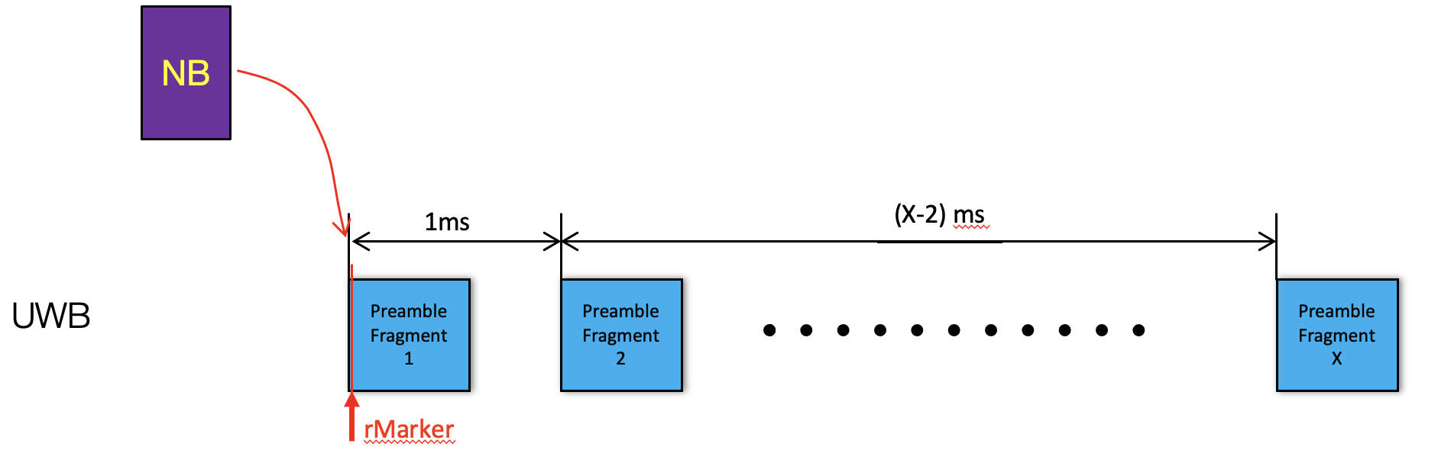
Preamble-only MMS Packet

In the case of mixed MMS packets for ranging integrity, the following numerology is recommended when NB is utilized to assist timing/frequency synchronization:
- RMARKER is better defined as the 1st pulse in 1st fragment following the NB: could be Preamble or Ranging Integrity Fragment;
- The number of preamble fragments: X and the number of fragments for ranging integrity: Y can be configured as follows: X$∈${1, 2, 4, 8}, Y$∈${1, 2, 4, 8} to enable incremental gains;
- Baseline modes are: (X=Y=1,2,3,4), (X=1, Y=2,4,8). Other combinations are allowed as optional additions;
- Additional 1ms gap between preamble fragments and fragments for ranging integrity when Z=1 in the following figure provides additional time budget to process all the preambles before starting processing the fragments for integrity validation.

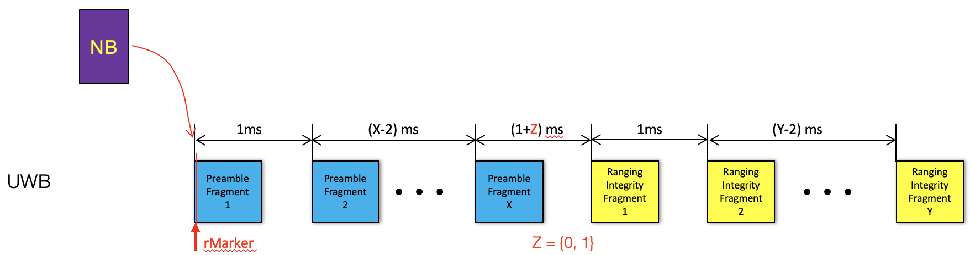
Mixed MMS Packet with NBA

When NB is not exploited to assist timing/frequency synchronization, we recommend the following numerology in the case of mixed MMS packets for ranging integrity:
- SYNC + SFD as shown in the following figure is formatted as in legacy 15.4z HRP;
- RMARKER is defined as the 1st pulse in 1st fragment following the SFD: could be Preamble or Ranging Integrity Fragment;
- General configuration allows the number of preamble fragments: X$∈${0, 1, 2, 4, 8}, and the number of ranging integrity fragments: Y$∈${1, 2, 4, 8} to facilitate incremental gains;
- (X=0, Y=1) is the default baseline mode;
- Additional 1ms gap between preamble fragments and ranging integrity fragments when Z=1 provides additional time budget to process all the preambles before starting to process the fragments for integrity validation.

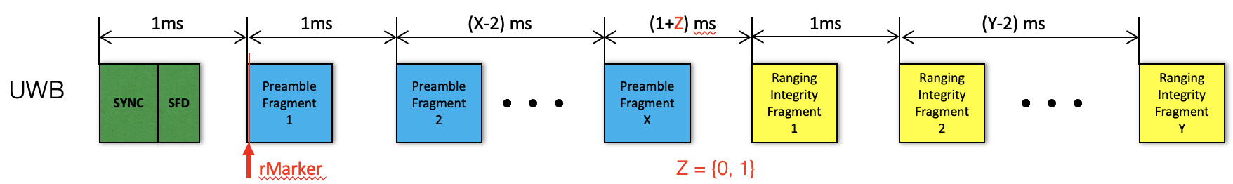
Mixed MMS Packet without NBA

