IEEE 802.16T WG Meeting Minutes

Participants
- Tim Godfrey, EPRI, TG Chair and meeting host
- Nathan Clanney, Siemens Mobility, Inc., Secretary for the meeting
- Daoud Serang, CM Microsystems
- Juha Juntunen, Meteorcomm
- Menashe Shahar, Ondas Networks
- Roshan, Ondas Networks
- Vishal, Ondas Networks
- Bob Finch, Select Spectrum

Meeting Notes
Start at 11:05AM PDT
Chair asked for secretary volunteer. Nathan agreed to take meeting minutes
Reviewed agenda and guidelines. No objections or changes to the agenda.
Review Contribution from Menashe (Ondas) on Filtering Considerations (DCN 15-22-0322-00-016t):
- Discussed expectation that the spec needs to define the filter used to allow for interoperability. We should not leave it vague or unspecified.
- Discussed the meaning of using “cyclic prefix” and “cyclic suffix” with transmitted symbols
- Reviewed in-band rejection (IBR) filter proposal
- Reviewed performance analysis of the proposed filter, spectral mask margin, SNR, constellation distortion, EVM, BER, etc.
Review future meeting plans
- Next meeting during July Plenary in Montreal
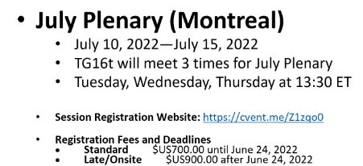
Closing discussion, no other business
Meeting adjourned at 11:55 AM PDT

