IEEE P802.15
Wireless Personal Area Networks

Project | IEEE P802.15 Wireless Specialty Networks (WSNs)
Title | D6 PICS Correction
Date Submitted | 17 May 2022
Source | Bober, Kai Lennert  Fraunhofer HHI | Voice: -  Fax: -  E-mail: bober@ieee.org
Re:
Abstract | This document contains a sequence chart, illustrating the acknowledgment and retransmission procedure
Purpose | Aid comment resolution
Notice | This document has been prepared to assist the IEEE P802.15. It is offered as a basis for discussion and is not binding on the contributing individual(s) or organization(s). The material in this document is subject to change in form and content after further study. The contributor(s) reserve(s) the right to add, amend or withdraw material contained herein.
Release | The contributor acknowledges and accepts that this contribution becomes the property of IEEE and may be made publicly available by P802.15.

Legend:
- Arial size 13 indicates subsections for individual comments
- Red underlined text needs to be adapted during the comment implementation (e.g., because it is a reference).
- Bold italic text is an instruction to the editor to implement the text

R2-30

Add the following figure under 6.7.1:

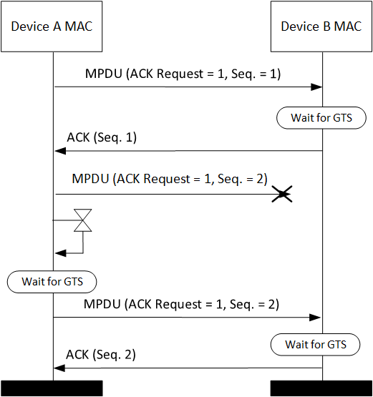

Figure Y: Acknowledgment and retransmission sequence chart

Add the following paragraph at the end of 6.7.1:

Figure Y depicts a frame exchange between two devices A and B, where device A transmits an MPDU with sequence number one to device B. The successful reception of that MPDU is acknowledged by device B in its next GTS. The subsequent MPDU with sequence number two is lost. Device B does therefore not sent an acknowledgment to device A. After the timeout, device A retransmits the MPDU with sequence number two. The second transmission is successful and acknowledged by device B.

