IEEE P802.15

Wireless Specialty Networks
Project | IEEE P802.15 Working Group for Wireless Specialty Networks (WSN)
Title | MAC ideas for BAN with Enhanced Dependability
Date Submitted | September 13th, 2022
Source | Minsoo Kim, Takumi Kobayashi, Marco Hernandez, Ryuji Kohno  (YRP International Alliance Institute, Yokohama National University) | Voice: +81-90-5408-0611  E-mail: minsoo@minsookim.com, kobayashi-takumi-ch@ynu.ac.jp, marco.hernandez@ieee.org, kohno@ynu.ac.jp
Re:
Abstract | MAC ideas for BAN with Enhanced Dependability of P802.15.6ma
Purpose | For discussion in TG6ma
Notice | This document has been prepared to assist the IEEE P802.15. It is offered as a basis for discussion and is not binding on the contributing individual(s) or organization(s). The material in this document is subject to change in form and content after further study. The contributor(s) reserve(s) the right to add, amend or withdraw material contained herein.
Release | The contributor acknowledges and accepts that this contribution becomes the property of IEEE and may be made publicly available by P802.15.

Contributors
Name & affiliation | Email
Minsoo Kim, YRP-IAI, Japan | minsoo@minsookim.com
Marco Hernandez, YRP-IAI, Japan | Marco.Hernandez@ieee.org
Ryuji Kohno, YRP-IAI, YNU, Japan | kohno@ynu.ac.jp
Takumi Kobayashi, YRP-IAI, YNU, Japan | kobayashi-takumi-ch@ynu.ac.jp
Seong-Soon Joo, ETRI, Korea | ssjoo@etri.re.kr

Table of contents
Table of contents 3
1. Channel dedicated to network control frames 5
1.1. Discussion on frame assignments for Control/Data Channels 6
2. Control Channel 8
3. Data Channel 10
4. Frames 11
4.1. General Structure 11
4.1.1. MAC Header 11
4.2. C-Beacon 12
4.3. D-Beacon 13
5. MAC Functions 14
5.1. BAN Creation 14
5.2. Synchronization switching due to proximity of BAN piconets 15
5.3. Node Connection/Disconnection 16
5.4. Contention Free Period Channel Access 16
5.5. Contention Access Period Channel Access 16
6. MAC proposal on interference avoidance in coexisting dependable BAN 17
6.1. Requirements on Dependable BAN Operation 17
6.2. Design Consideration on MAC for 802.15.6ma 17
6.3. Changes on Structure of Beacon Period 17
6.4. Modified Active Superframe Interleaving with Adjustment 18
6.5. Modified Active Superframe Interleaving with Regulation 18
7. Level of coexistence environment 19
7.1. The lowest level (level 0) 19
7.2. Multiple BANs (level 1) 19
7.3. 1 BAN + other UWBs (level 2) 19
7.4. Multiple BANs + other UWBs (level 3) 19

Channel dedicated to network control frames
In IEEE Std 802.15.6-2012, both network control and data exchange take place on the same channel. Network control and data exchange are distinguished by the frame type filed.
We propose to set aside one of the channels for exchanging only network control frames. This can help Clear Channel Assessment (CCA) to be carried out more efficiently, because it has to be done only for one channel. In addition, since the control frame is transmitted on a less congested channel due to the absence of a data frame, the possibility of frame collision can be reduced, thereby improving interoperability of multiple BANs collocated. This common channel also can be used to guarantee interoperability with not only other BANs but also other UWB systems using this channel.

Table 1 shows the UWB frequency bands defined in the original standards, and the example of the frequency band allocation for the revision. Although this may need to be changed depending on regions and regulations, it may be possible to define one channel from each band (e.g., # 0 and # 5) as control channel, and other channels as data channels.
Since two channels are required for both control and data frames, the number of mandatory channels should be two instead of one for each band group. It may be desirable to define mandatory channels for the revision by avoiding mandatory channels of the original standards, because it may reduce unnecessary overhead of interference avoidance procedure.
Table 1 An example of frequency bands allocation
Band group | Channel number | Central frequency (MHz) | Bandwidth (MHz) | Channel attribute  in 802.15.6-2012 | Channel attribute  for the revision
Low band | 0 | 3494.4 | 499.2 | Optional | Control | Mandatory
 | 1 | 3993.6 | 499.2 | Mandatory | Data | Optional
 | 2 | 4492.8 | 499.2 | Optional | Data | Mandatory
High band | 3 | 6489.6 | 499.2 | Optional | Data | Optional
 | 4 | 6988.8 | 499.2 | Optional | Data | Optional
 | 5 | 7488.0 | 499.2 | Optional | Control | Mandatory
 | 6 | 7987.2 | 499.2 | Mandatory | Data | Optional
 | 7 | 8486.4 | 499.2 | Optional | Data | Mandatory
 | 8 | 8985.6 | 499.2 | Optional | Data | Optional
 | 9 | 9484.8 | 499.2 | Optional | Data | Optional
 | 10 | 9984.0 | 499.2 | Optional | Data | Optional

Discussion on frame assignments for Control/Data Channels
The performance will depend not only on the MAC scheme, such as to which channel or period frames are allocated, but also on the conditions in which the system is used, e.g., how many BANs will coexist. Therefore, the MAC scheme should be determined according to the technical requirements and use cases.
Table 2 An example of frame assignment for control/data channels
Channels | Periods | Frames
 |  | From coordinators | From nodes
Control | n/a | - Control Beacon | Not allowed
Data | Network Management | - Data Beacon  - Connection Assignment  - Disconnection Response | - Connection Request  - Disconnection Request
 | Contention Free | - Data | - Data
 | Contention Access | - Data | - Data

Table 3 Another example of frame assignment for control/data channels
Channels | Periods | Frames
 |  | From coordinators | From nodes
Control | n/a | - Control Beacon  - Connection Assignment  - Disconnection Response | - Connection Request  Disconnection Request
Data | Network Management | Not needed | Not needed
 | Contention Free | - Data Beacon  - Data | - Data
 | Contention Access | - Data  - (Data Beacon) | - Data

Control Channel
- Only coordinators shall transmit on control channel (C-Channel).
- Control channel does not have time slot structure.
  - Since BANs are mobile, there is always a possibility that BANs or groups of BANs having different synchronization timings will encounter each other.
  - Therefore, it is reasonable to design MAC under the premise that reliable synchronization between multiple BANs is not possible.
  - This is especially true when we consider the interoperability of BANs and other UWB systems.
- A coordinator shall transmit one control beacon frame (C-Beacon) on C-Channel every T_{C} seconds.
  - The coordinator shall perform clear channel assessment (CCA) before emitting its first C-Beacon.
  - The C-Beacon Period T_{C} shall be chosen randomly by the coordinator within the range from T_{C,min} to T_{C,max}.
    - Reason for choosing T_{C} randomly:
      - Let us consider a case where the transmission timings of C-Beacons from two or more coordinators coincidently overlap.
      - If these beacons are transmitted at the same T_{C} interval, they will collide every time, and therefore cannot be received forever.
      - However, if each coordinator transmits its beacon with a different T_{C}, even if a collision occurs, we can expect that the next beacon will not collide.
      - It may be desirable if the values of T_{C} are relatively prime or have a large greatest common multiple.
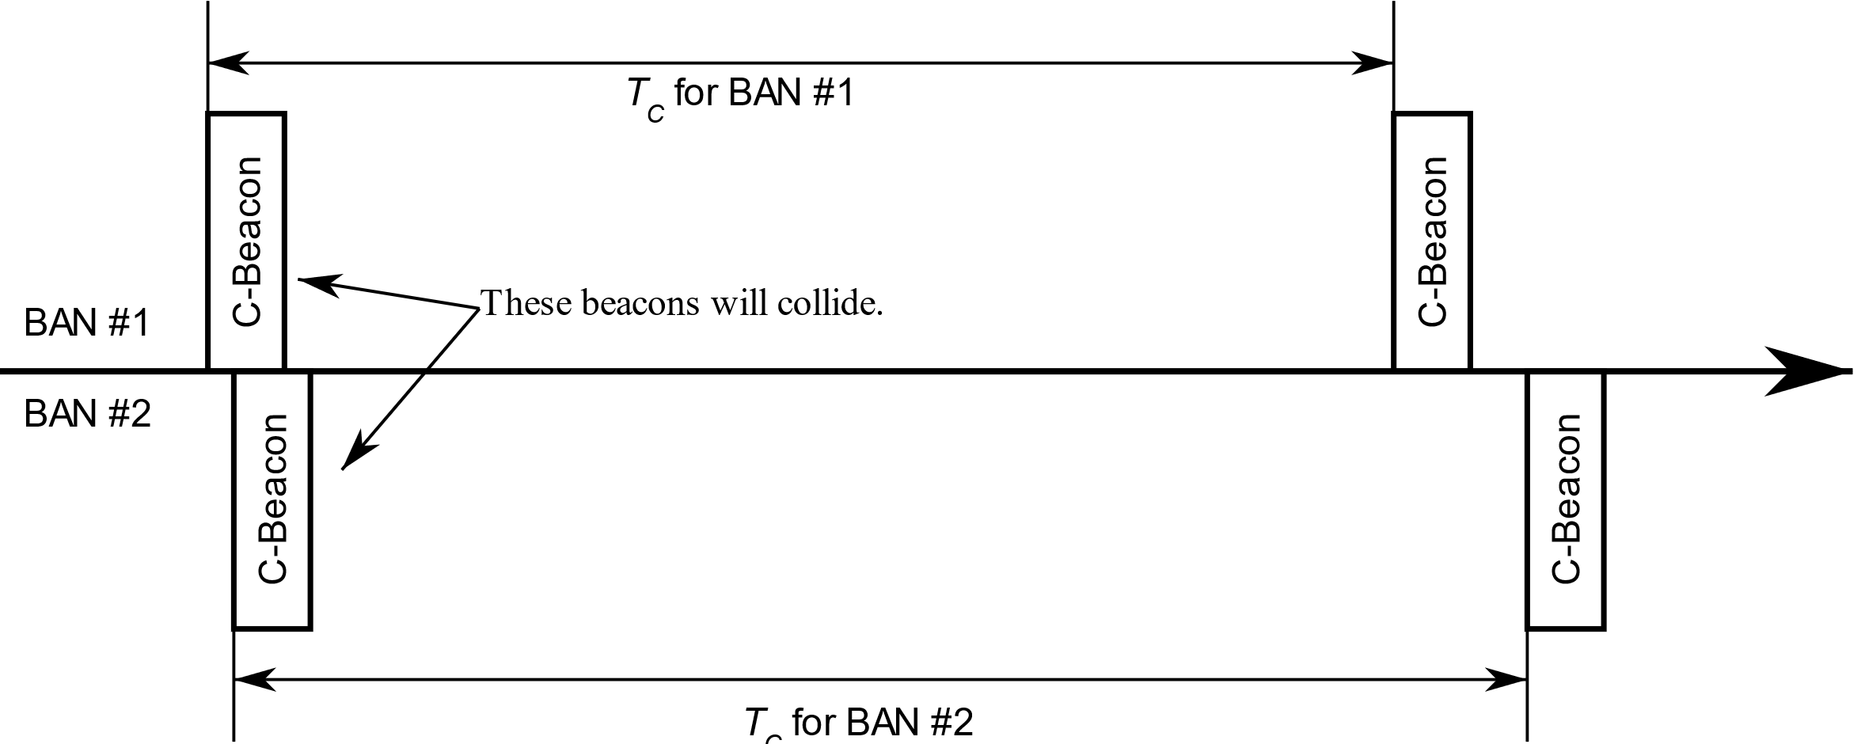
Figure 1 Collision Avoidance of Control Beacon with Different Beacon Interval

Data Channel
- Coordinators and nodes may transmit on the data channel (D-Channel).
- The time axis in a D-Channel is divided into superframes which have equal duration of T_{D} seconds.
- Each superframe is composed of time slots which have equal duration of T_{S} seconds.
- A superframe shall consist of four distinct periods:
  - Network Management Period (NMP), consisting of N_{NMP} time slots, where the network management frames such as data beacons shall be transmitted,
  - Contention Free Period (CFP), consisting of N_{CFP} time slots, where scheduled frames shall be transmitted,
  - Contention Access Period (CAP), consisting of N_{CAP} time slots, where unscheduled frames shall be transmitted,
  - Inactive Period, where no frames shall be transmitted.
- A coordinator shall select one D-Channel.
  - A coordinator may support using two or more D-Channels simultaneously, to achieve higher dependability.
- A coordinator shall transmit a data beacon frame (D-Beacon) on one time slot from NMP at every superframe of the D-Channel.
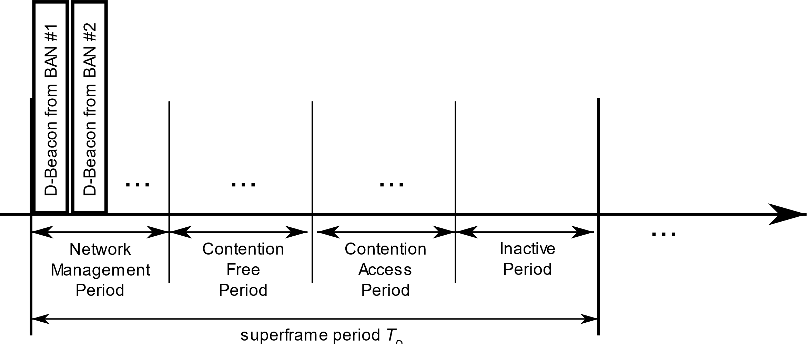
Figure 2 Data Channel

Frames

General Structure

A MAC frame consists of a fixed-length MAC header, a variable-length MAC frame body, and a fixed-length Frame Check Sequence (FCS) field.

Octets: | 7 | L_FB | 2
 | MAC Header | MAC Frame Body | FCS

MAC Header
The MAC Header consists of the Frame Control, the Recipient ID, the Sender ID, and the BAN ID.
Octets: | 4 | 1 | 1 | 1
 | Frame Control | Recipient ID | Sender ID | BAN ID

Bits: | 1 | 2 | 2 | 1 | 1 | 1 | 4
 | Protocol Version | ACK Policy | Security Level | TK Index | BAN Security / Relay | Ack Timing / EAP Indicator / First Frame On Time | Frame Subtype

Bits: | 2 | 1 | 1 | 8 | 3 | 1 | 4
 | Frame Type | More Data | Last Frame / Access Mode / B2 | Sequence Number / Poll-Post Window | Fragment Number / Next / Coexistence | Non-final Fragment / Cancel / Scale / Inactive | Reserved

The Frame Control consist of the following fields:
- Protocol Version
- Acknowledgment (Ack) Policy
- Security Level
- Temporal key (TK) Index
- BAN Security/Relay
- Ack Timing/EAP Indicator/First Frame On Time
- Frame Subtype
- Frame Type
- More Data
- Last Frame/Access Mode/B2
- Sequence Number/Poll-Post Window
- Fragment Number/Next/Coexistence
- Non-final Fragment/Cancel/Scale/Inactive

C-Beacon
(Information for the nodes of the coordinator’s own network)
- BAN ID (n bits)
- D-Channel number (n bits)
- Slot number of D-Beacon in Network Management Period (NMP)
- …
(Information for the coordinator of spatially overlapping BAN)
- BAN ID (n bits)
- D-Channel number (n bits)
- D-Channel Occupancy Index
  - To inform neighboring BANs of the congestion level of the channel.
- Synchronization Reference BAN ID
  - To inform neighboring BANs of which clock it is operating on.
  - BANs that share superframes should have the same value and BANs that do not share superframes should have different values.
- Inertial Mass Index
  - This index indicates the difficulty of moving the slot number of D-Beacon in NMP or D-Channel of a BAN.
  - The number of nodes in a BAN can be used.
  - It is named after the inertial mass of physics, because of the similarity in concept.
  - This index is used to determine which BAN should keep using the D-Channel and which BAN should switch to a new D-Channel when multiple BANs come close.
T.B.D.

D-Beacon
- Slot number where Contention Free Period (CFP) begins
  - Contention management method, refer 15.4a.
- Slot number where Contention Access Period (CAP) begins
  - Listen before talk.
  - Energy detection.
- …
T.B.D.

MAC Functions

BAN Creation
- A coordinator starts monitoring the C-Channel and checks whether there are neighboring BANs.
- The coordinator chooses a BAN ID which is not currently in use by neighboring BANs.
- The coordinator chooses a Data Channel (D-Channel).
  - D-Channel Occupancy Indexes from C-Beacon of neighboring BANs can be used to determine which D-Channel to use.
  - If there are other BAN using the same D-Channel, than the coordinator should synchronize to the other BAN’s superframe.
- The coordinator chooses a slot number of D-Beacon in NMP.
  - It must not overlap with that of other neighboring BANs using the same D-Channel.
- The coordinator transmits Control Beacons (C-Beacon) periodically.
  - The C-Beacon provides the BAN ID, D-Channel number, and slot number of D-Beacon in NMP.
- The coordinator transmits Data Beacons (D-Beacon) periodically.
  - The D-Beacon provides slot numbers where Contention Free Period (CFP) and Contention Access Period (CAP) begin.
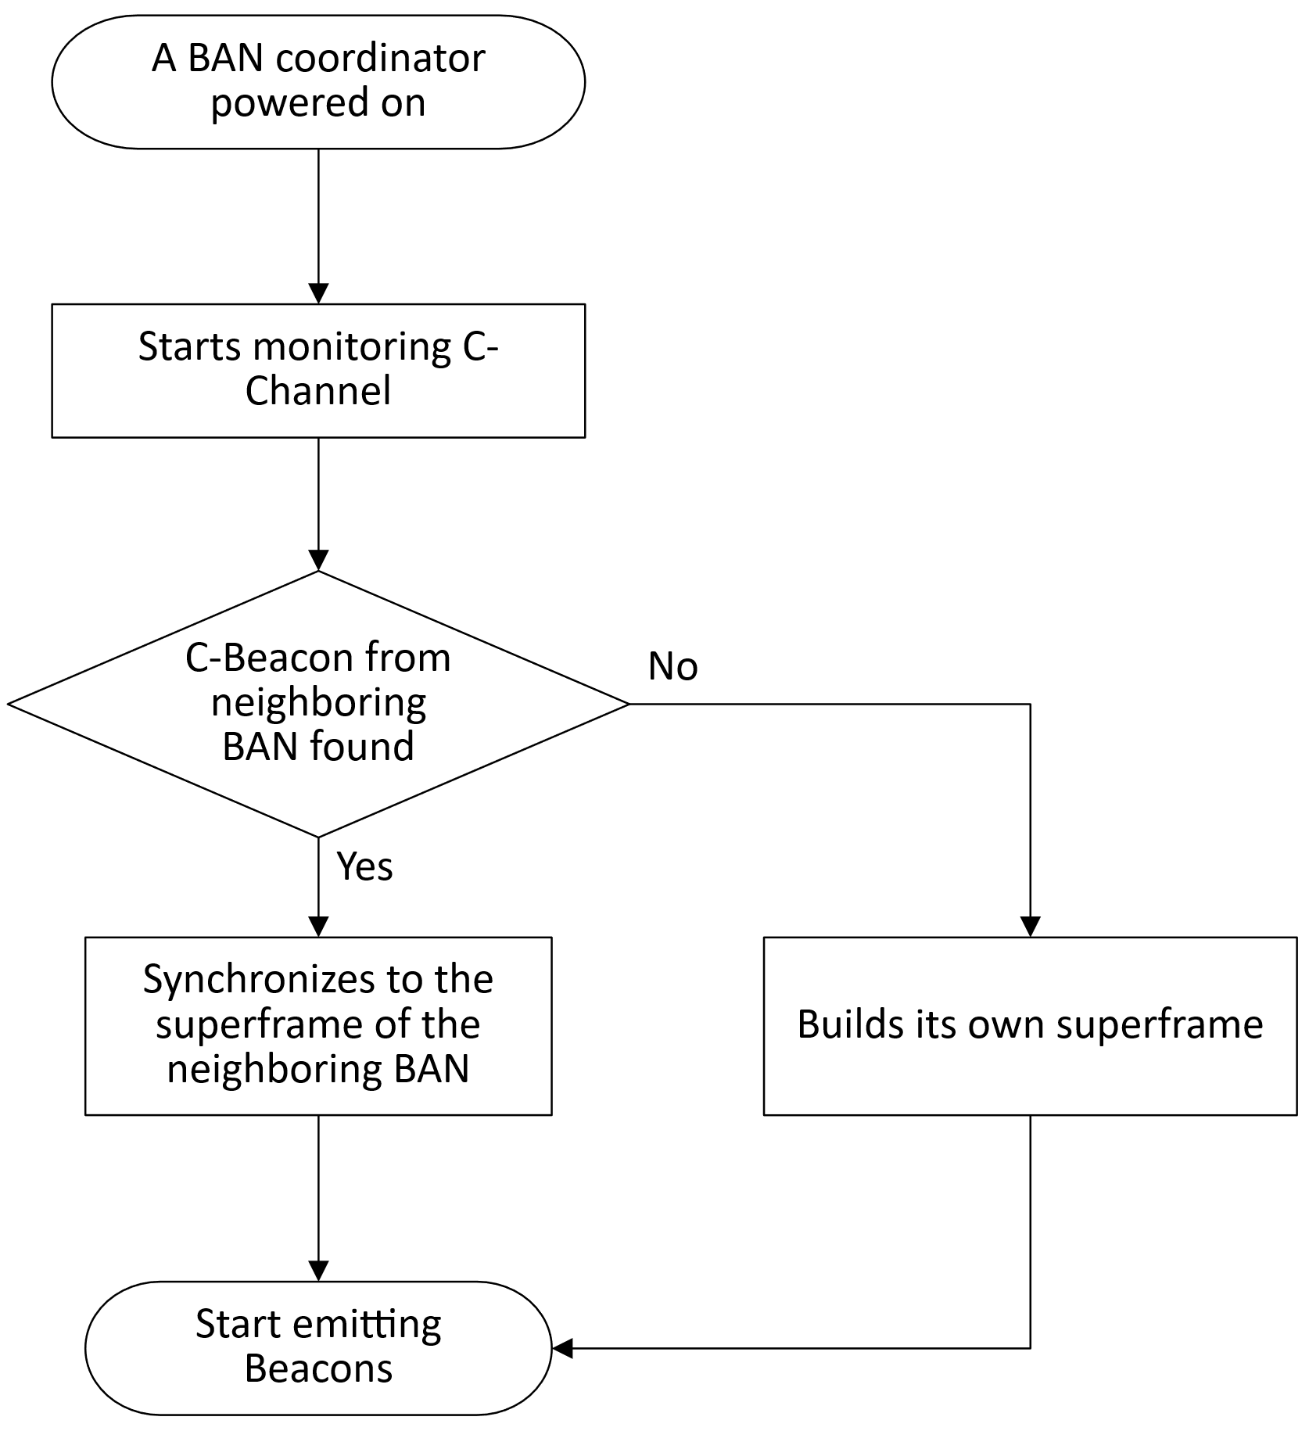
Figure 3 A flowchart for a BAN creation

Synchronization switching due to proximity of BAN piconets
- A coordinator keeps monitoring the C-Channel and checks whether there are neighboring BANs.
- If the coordinator receives C-Beacon with different Synchronization Reference BAN ID value,
  - If the Inertial Mass Index from the C-Beacon is greater than its own value,
    - The coordinator must synchronize with the superframe of the newly met BAN.
- T.B.D.

Node Connection/Disconnection
- The node may monitor the C-Channels to acquire a C-Beacon.
- The node may acquire the BAN ID, D-Channel number, and slot number of D-Beacon in Network Management Period (NMP) from the C-Beacon.
- The node may monitor the D-Channels to acquire a D-Beacon.
- The node may acquire the slot numbers where Contention Free Period (CFP) and Contention Access Period (CAP) begin.
- The node may transmit a Connection Request (C-Request) frame during the CAP using the Contention Access procedure.
- On successful reception of the C-Request frame, the coordinator shall transmit
  - an Acknowledgement,
  - a Connection Assignment (C-Assignment) frame in the next available time slot.
    - The C-Assignment frame shall contain details of allocated resources to the node, including the number of allocated time slot, and node’s allocated Node ID.

Contention Free Period Channel Access
T.B.D.

Contention Access Period Channel Access
T.B.D.

MAC proposal on interference avoidance in coexisting dependable BAN

Requirements on Dependable BAN Operation
- support the dependable service classes
  - up and down transmission every 10 ms with 99.9% possibility
  - up and down transmission every 50 ms with 99% possibility
- coexist with multiple dependable BANs
  - a dependable BAN moves and encounters a dependable BAN in there
  - a hub creates a new dependable BAN on existing BAN area
- extend TSN to dependable BAN nodes
  - time synchronization
  - bounded latency

Design Consideration on MAC for 802.15.6ma
- use leverage of 802.15.6-2012 or not
  - minor change based on the structure of 802.15.6-2012
  - new mandatory feature with fully designed MAC
- use separated control channel or not
  - 802.15.6-2012 superframe structure on a mandatory channel
  - separate control channel and data channel
- design dependable BAN features based on the structure of 802.15.6-2012
  - avoid beacon collision among coexisting dependable BANs
  - avoid scheduled allocation conflicts
  - synchronize network clock among coexisting dependable BANs
  - guarantee periodical transmission with bounded delay for supporting service class
  - satisfy service specific requirements such as the size of a BAN, ...

Changes on Structure of Beacon Period
- beacon access phase
  - consist of beacon slots for coexisting multiple BANs
  - length of beacon access phase
- beacon slot length
  - same to all BANs
  - common divisor of allocation slot length of coexisting BANs, fixed value
- maximum number of coexisting BANs * beacon slot length
- start time of access phase
  - after beacon access phase, time to start EAP
- beacon slot assign rules
  - BAN has a priority according to the service class
  - high priority BAN reserves the earliest beacon slot
  - low priority BAN reserves the latest beacon slot first
- beacon slot adjustment rules
  - if newly joined BAN’s beacon collides to the existing BANs’ beacon
  - newly joined BAN searches beacon access phase and relocates the beacon slot with beacon slot assign rules
- after beacon access phase, newly joined BAN selects an allocation slot to start access
  - to minimize the collision on EAP and scheduled allocation slots to the existing BANs
- increase the maximum number of allocation slot
  - from 256 to 4,096
- increase the scheduled allocation slot period
  - 1-periodic allocation → 1/10-periodic allocation
- share the structure of beacon period among coexisting BANs
  - a hub of newly joined BAN listens the beacon of existing BANs’ beacon
  - after reserving the beacon slot, broadcast the structure of beacon period.

Modified Active Superframe Interleaving with Adjustment
- negotiate active superframe interleaving among coexisting BANs
  - maintain the beacon period length of each BANs
  - adjust beacon slot for a BAN in beacon access phase
- only when EAP and scheduled allocation of MAP of a BAN interfere the ones of existing BANs
- adjust start time of EAP1

Modified Active Superframe Interleaving with Regulation
- regulate the transmission in joined BAN
  - regulate new link allocation when collision
- BAN reject new link allocation depending on access mode priority
  - regulate transmission
- BAN regulate transmission depending on access mode priority
  - access mode priority
- BAP > EAP > Scheduled MAP > RAP > CAP

Level of coexistence environment

The lowest level (level 0)
- In this level, it is assumed that only one BAN operates in a specific space, with no other systems coexisting.
- Requirements such as throughput and latency should be met.

Multiple BANs (level 1)
- In this level, it is assumed that a certain number of BANs (eg, 2 or 3 networks) coexist.
- The coexisting BANs can be 2012 based or revision based.
- The coexisting BANs can be either HBANs or VBANs.
- Requirements such as throughput and latency of each of all BANs should be met.
- The proposed MAC must be able to support this level with only mandatory features.

1 BAN + other UWBs (level 2)
- In this level, it is assumed that there are a certain number of UWB systems which are not based on this standard such as 15.4 coexisting with a BAN.
- Requirements such as throughput and latency of each of all BANs should be met.
- The proposed MAC may support this level with some optional features.

Multiple BANs + other UWBs (level 3)
- In this level, it is assumed that there a certain number of UWB systems which are not based on this standard such as 15.4 coexisting with a certain number of BANs (eg. 2 or 3 networks.)
- The proposed MAC may support this level with some optional features.

