IEEE P802.15

Wireless Specialty Networks
Project | IEEE P802.15 Working Group for Wireless Specialty Networks (WSN)
Title | MAC ideas for BAN with Enhanced Dependability
Date Submitted | July 12th, 2022
Source | Minsoo Kim, Takumi Kobayashi, Marco Hernandez, Ryuji Kohno  (YRP International Alliance Institute, Yokohama National University) | Voice: +81-90-5408-0611  E-mail: minsoo@minsookim.com, kobayashi-takumi-ch@ynu.ac.jp, marco.hernandez@ieee.org, kohno@ynu.ac.jp
Re:
Abstract | MAC ideas for BAN with Enhanced Dependability of P802.15.6ma
Purpose | For discussion in TG6ma
Notice | This document has been prepared to assist the IEEE P802.15. It is offered as a basis for discussion and is not binding on the contributing individual(s) or organization(s). The material in this document is subject to change in form and content after further study. The contributor(s) reserve(s) the right to add, amend or withdraw material contained herein.
Release | The contributor acknowledges and accepts that this contribution becomes the property of IEEE and may be made publicly available by P802.15.

Table of contents
Table of contents 2
1. Channel dedicated to network control frames 3
2. Control Channel 4
3. Data Channel 5
4. Frames 6
4.1. General Structure 6
4.1.1. MAC Header 6
4.2. C-Beacon 6
4.3. D-Beacon 6
5. MAC Functions 8
5.1. BAN Creation 8
5.2. Node Connection/Disconnection 8
5.3. Contention Free Period Channel Access 8
5.4. Contention Access Period Channel Access 9
6. Discussion on frame assignments 10

Channel dedicated to network control frames
In IEEE Std 802.15.6-2012, both network control and data exchange take place on the same channel. Network control and data exchange are distinguished by the frame type filed.
We propose to set aside one of the channels for exchanging only network control frames. This can help Clear Channel Assessment (CCA) to be carried out more efficiently, because it has to be done only for one channel. In addition, since the control frame is transmitted on a less congested channel due to the absence of a data frame, the possibility of frame collision can be reduced, thereby improving interoperability of multiple BANs collocated. This common channel also can be used to guarantee interoperability with not only other BANs but also other UWB systems using this channel.

Table 1 shows the UWB frequency bands defined in the original standards. Although this may need to be changed depending on regions and regulations, it may be possible to define one channel from each band (e.g., # 1 and # 6) as control channel, and other channels as data channels.
In addition, since two channels must be used for both control and data frames, the number of mandatory channels should be two instead of one for each band.
Table 1 UWB operating frequency bands in Std 802.15.6-2012
Band group | Channel number | Central frequency (MHz) | Bandwidth (MHz) | Channel attribute
Low band | 0 | 3494.4 | 499.2 | Optional
 | 1 | 3993.6 | 499.2 | Mandatory
 | 2 | 4492.8 | 499.2 | Optional
High band | 3 | 6489.6 | 499.2 | Optional
 | 4 | 6988.8 | 499.2 | Optional
 | 5 | 7488.0 | 499.2 | Optional
 | 6 | 7987.2 | 499.2 | Mandatory
 | 7 | 8486.4 | 499.2 | Optional
 | 8 | 8985.6 | 499.2 | Optional
 | 9 | 9484.8 | 499.2 | Optional
 | 10 | 9984.0 | 499.2 | Optional

Control Channel
- Only coordinators shall transmit on control channel (C-Channel).
- Control channel does not have time slot structure.
  - Since BANs are mobile, there is always a possibility that BANs or groups of BANs having different synchronization timings will encounter each other. Therefore, it is reasonable to design MAC under the premise that reliable synchronization between multiple BANs is not possible. This is especially true when we consider the interoperability of BANs and other UWB systems.
- A coordinator shall transmit one control beacon frame (C-Beacon) on C-Channel every T_{C} seconds.
- The C-Beacon Period T_{C} shall be chosen randomly by the coordinator within the range from T_{C,min} to T_{C,max}.
  - Reason for choosing T_{C} randomly: Let us consider a case where the transmission timings of C-Beacons from two or more coordinators coincidently overlap. If these beacons are transmitted at the same T_{C} interval, they will collide every time, and therefore cannot be received forever. However, if each coordinator transmits its beacon with a different T_{C}, even if a collision occurs, we can expect that the next beacon will not collide. It may be desirable if the values of T_{C} are relatively prime or have a large greatest common multiple.
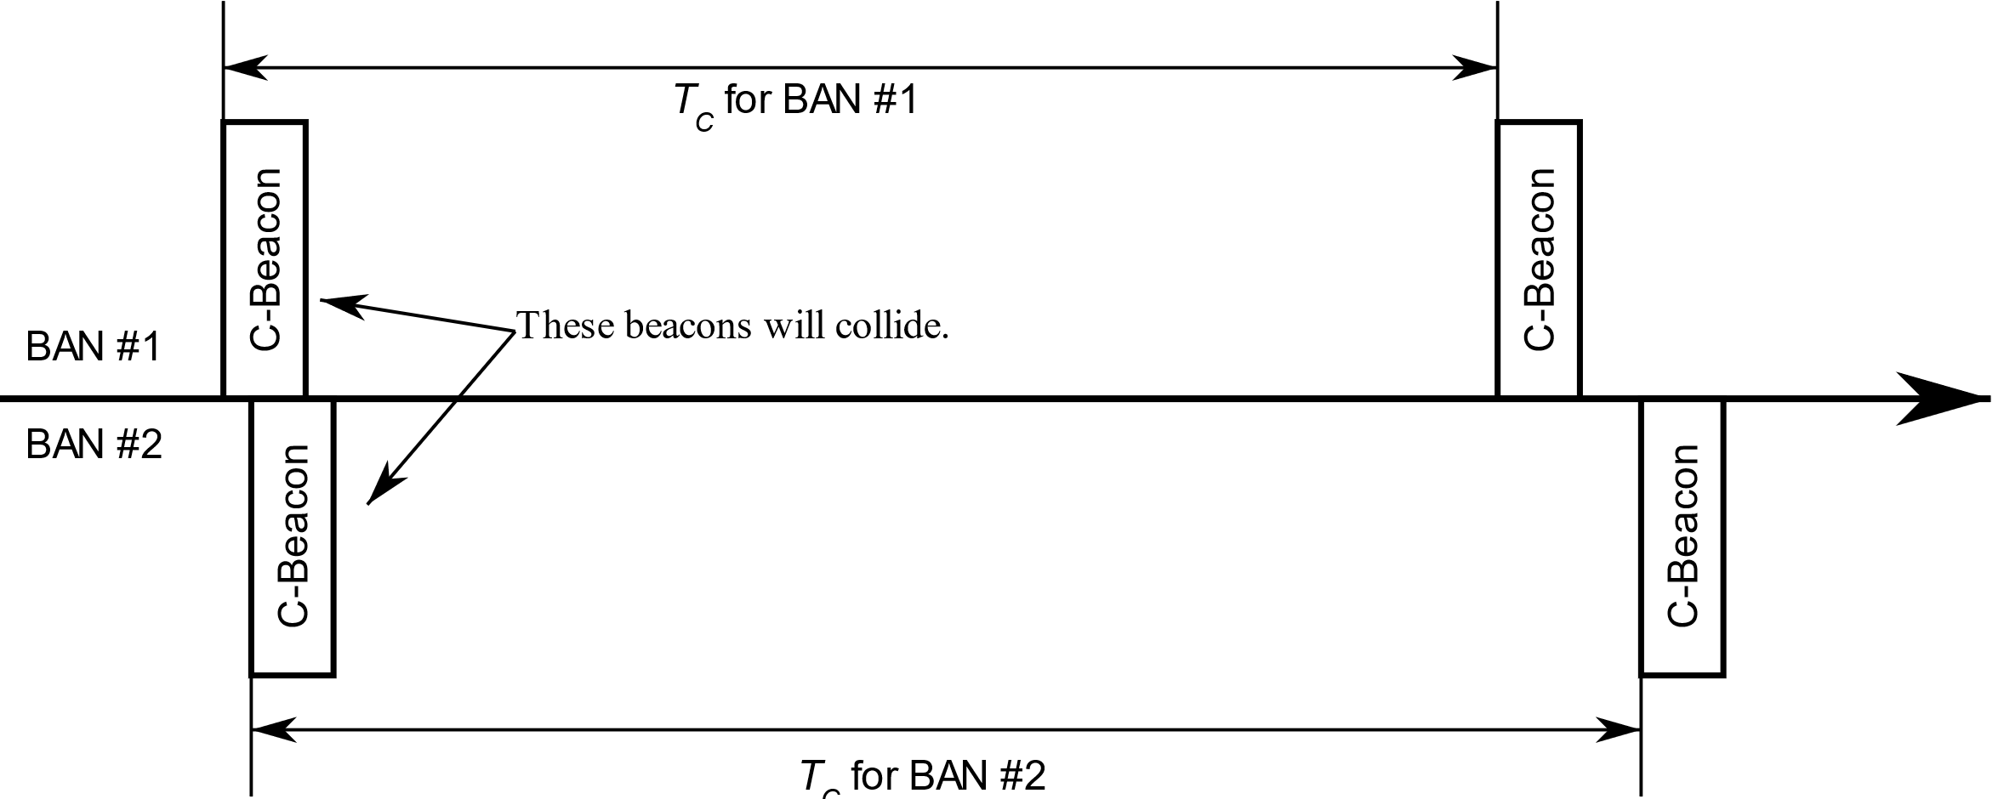
Figure 1 Control Beacons in Control Channel

Data Channel
- Coordinators and nodes may transmit on the data channel (D-Channel).
- The time axis in a D-Channel is divided into superframes which have equal duration of T_{D} seconds.
- Each superframe is composed of time slots which have equal duration of T_{S} seconds.
- A superframe shall consist of four distinct periods:
  - Network Management Period (NMP), consisting of N_{NMP} time slots, where the network management frames such as data beacons shall be transmitted,
  - Contention Free Period (CFP), consisting of N_{CFP} time slots, where scheduled frames shall be transmitted,
  - Contention Access Period (CAP), consisting of N_{CAP} time slots, where unscheduled frames shall be transmitted,
  - Inactive Period, where no frames shall be transmitted.
- A coordinator shall select one D-Channel.
- A coordinator shall transmit a data beacon frame (D-Beacon) on one time slot from NMP at every superframe of the D-Channel.
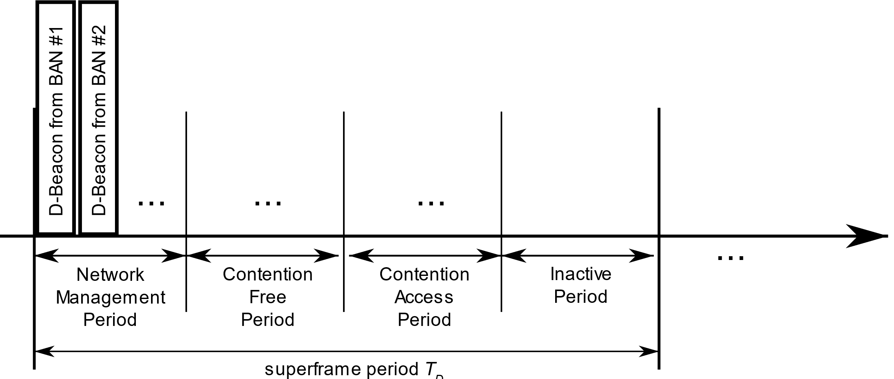
Figure 2 Data Channel

Frames

General Structure
A MAC frame consists of a fixed-length MAC header, a variable-length MAC frame body, and a fixed-length Frame Check Sequence (FCS) field.

MAC Header
The MAC Header consists of the Frame Control, the Recipient ID, the Sender ID, and the BAN ID.
The Frame Control consist of the following fields:
- Protocol Version
- Acknowledgment (Ack) Policy
- Security Level
- Temporal key (TK) Index
- BAN Security/Relay
- Ack Timing/EAP Indicator/First Frame On Time
- Frame Subtype
- Frame Type
- More Data
- Last Frame/Access Mode/B2
- Sequence Number/Poll-Post Window
- Fragment Number/Next/Coexistence
- Non-final Fragment/Cancel/Scale/Inactive

C-Beacon
- BAN ID
- D-Channel number
- Slot number of D-Beacon in Network Management Period (NMP)
- …
T.B.D.

D-Beacon
- Slot number where Contention Free Period (CFP) begins
- Slot number where Contention Access Period (CAP) begins
- …
T.B.D.

MAC Functions

BAN Creation
- A coordinator starts monitoring the C-Channel and checks whether there are neighboring BANs.
- The coordinator chooses a BAN ID which is not currently in use by neighboring BANs.
- The coordinator chooses a Data Channel (D-Channel).
- The coordinator transmits Control Beacons (C-Beacon) periodically.
  - The C-Beacon provides the BAN ID, D-Channel number, and slot number of D-Beacon in Network Management Period (NMP).
- The coordinator transmits Data Beacons (D-Beacon) periodically.
  - The D-Beacon provides slot numbers where Contention Free Period (CFP) and Contention Access Period (CAP) begin.

Node Connection/Disconnection
- The node may monitor the C-Channels to acquire a C-Beacon.
- The node may acquire the BAN ID, D-Channel number, and slot number of D-Beacon in Network Management Period (NMP) from the C-Beacon.
- The node may monitor the D-Channels to acquire a D-Beacon.
- The node may acquire the slot numbers where Contention Free Period (CFP) and Contention Access Period (CAP) begin.
- The node may transmit a Connection Request (C-Request) frame during the CAP using the Contention Access procedure.
- On successful reception of the C-Request frame, the coordinator shall transmit
  - an Acknowledgement,
  - a Connection Assignment (C-Assignment) frame in the next available time slot.
    - The C-Assignment frame shall contain details of allocated resources to the node, including the number of allocated time slot, and node’s allocated Node ID.

Contention Free Period Channel Access
T.B.D.

Contention Access Period Channel Access
T.B.D.

Discussion on frame assignments
The performance will depend not only on the MAC scheme, such as to which channel or period frames are allocated, but also on the conditions in which the system is used, e.g., how many BANs will coexist. Therefore, the MAC scheme should be determined according to the technical requirements and use cases.
Table 3 Frame assignments
Channels | Periods | Frames
 |  | From coordinators | From nodes
Control | n/a | - Control Beacon | Not allowed
Data | Network Management | - Data Beacon  - Connection Assignment  - Disconnection Response | - Connection Request  - Disconnection Request
 | Contention Free | - Data | - Data
 | Contention Access | - Data | - Data

Channels | Periods | Frames
 |  | From coordinators | From nodes
Control | n/a | - Control Beacon  - Connection Assignment  - Disconnection Response | - Connection Request  Disconnection Request
Data | Network Management | Not needed | Not needed
 | Contention Free | - Data Beacon  - Data | - Data
 | Contention Access | - Data  - (Data Beacon) | - Data

