**IEEE P802.15**

**Wireless Personal Area Networks**

|  |  |  |
| --- | --- | --- |
| Project | IEEE P802.15 Working Group for Wireless Personal Area Networks (WPANs) | |
| Title | **Draft D0-Annex: Deep learning for OCC receiver** | |
| Date Submitted | January 2022 | |
| Source | Huy Nguyen,  Md Faisal Ahmed,  Md. Habibur Rahman, and Yeong Min Jang (Kookmin University) | Voice: [ ] Fax: [ ] E-mail: [yjang@kookmin.ac.kr] |
| Re: | [If this is a proposed revision, cite the original document.]  [If this is a response to a Call for Contributions, cite the name and date of the Call for Contributions to which this document responds, as well as the relevant item number in the Call for Contributions.]  [Note: Contributions that are not responsive to this section of the template, and contributions which do not address the topic under which they are submitted, may be refused or consigned to the “General Contributions” area.] | |
| Abstract | [Description of document contents.] | |
| Purpose | [Description of what the author wants P802.15 to do with the information in the document.] | |
| Notice | This document has been prepared to assist the IEEE P802.15. It is offered as a basis for discussion and is not binding on the contributing individual(s) or organization(s). The material in this document is subject to change in form and content after further study. The contributor(s) reserve(s) the right to add, amend or withdraw material contained herein. | |
| Release | The contributor acknowledges and accepts that this contribution becomes the property of IEEE and may be made publicly available by P802.15. | |

# Annex Q

(informative)

Deep learning for OCC receiver

## Q.1. Convolution Neural Network for LED detection with mobility effect.

A neural network (NN) was deployed at the receiver for accurately detecting the LED in both static and mobile conditions. In existing literature, an LED array is detected as a single LED, however, each LED of the LED array can be detected using the proposed NN technique. The NN can classify large image datasets with remarkable characteristics in several spatial layers and automatically learn from data through backpropagation.



Training architecture of neural network based stripe pattern reformation.

Background lights and neighboring LEDs can create noise and interference in the image sensor, respectively. On the other hand, interference occurs if a LED light source unexpectedly appears inside the image sensor FOV. In particular, after detection, several frames are captured and analyzed. If the stripe pattern of a specific area are changed in the subsequent frames, it is recognized as the source LED. Otherwise, it is categorized as the interfering LED and is filtered out subsequently from the image frame.



Testing architecture of stripe pattern reconstruction.



Figure xxx. Flow diagram of proposed neural network technique.

The neural network mainly operated based on the feature extraction technique of the stripe pattern. However, the given flow diagram shows the training and testing procedure and checks the similarity of each iteration. In every iteration, the relative position of the stripe is changed by checking the similarity with the reference pattern. Figure xxx illustrates the entire flow diagram of the proposed neural network.

## Q.2. Support Vector Machine (SVM) classifier

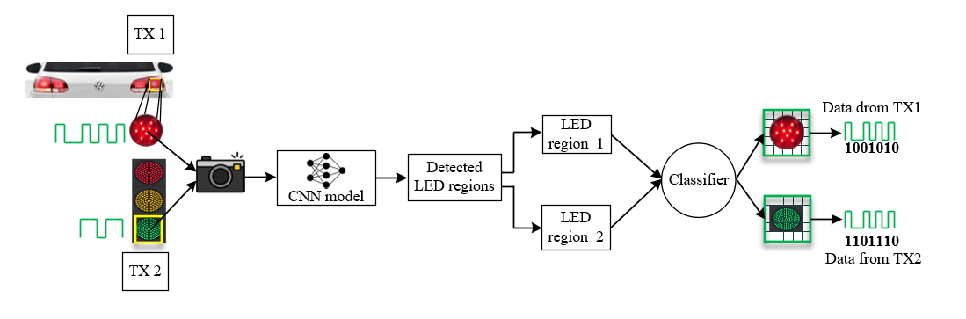

Figure xxx. The architecture of the accurate data transmitting LED detection scheme

In Fig. xxx, the block diagram delineates the overall architecture of the accurate data transmitting LED detection scheme. On the transmitter side, numerous LED regions were present. The LED optical signal was modulated by modulation at a frequency level between 2–4 kHz before sending to the receiver to attenuate the flickering issue in a significant margin. With regard to the transmitting LEDs and other sources of interference, they are not modulated in that particular frequency. The projection of all these light-emitting sources was captured by the image sensor. Interference sources were dispelled when a trained CNN model was used. All the possible LED sources were detected and segmented using image processing techniques. Due to the rolling shutter effect of the CMOS-based image sensor, each image frame gets striated of white and black shade. Afterward, necessary geometrical features have been extracted to classify and recognize accurate data transmitting regions from the range of all possible regions.

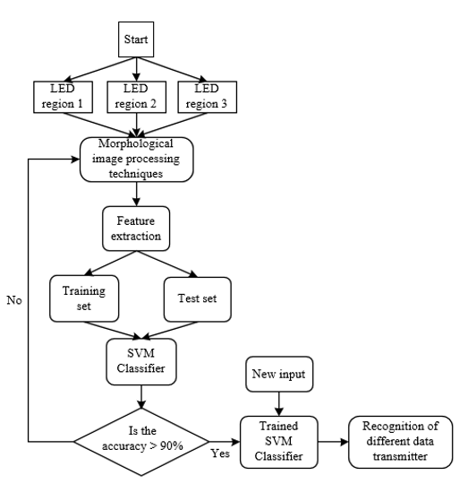

Figure xxx. Classifier structure

In Figure xxx, the detected LED regions with bounding boxes are the output of the CNN. The bounding box LED objects are then processed employing several image processing techniques. At first, each LED image is converted into a grayscale format to specify the distinct pixel intensity values of the stripes generated in the image sensor. Next, a kernel full of ones is used to reduce the shape of the projected stripes by removing small anomalies near the stripe boundaries. To make the receiver an intelligent and robust retrieval system, the system needs to recognize accurate LEDs separately as quickly as possible. Therefore, the selection of features is very important. The extraction of appropriate features is very challenging since the objects are almost the same. LED objects of the same type can have a different shape, stripe pattern based on the communication distance, camera frame rate, and mark and space frequency. To analyze the different geometrical shapes, computation of the features from the contour line has been considered significant distinguishable features. Contours are the outline that is designed using the edges of the object to represent the shape. They contain some geometrical attributes that are effective to recognize and segment objects. However, before performing feature extraction, a closing operation is applied on the selected regions to combine all the neighboring stripes, and the contour is drawn on the shape by combined stripes.