**IEEE P802.15**

**Wireless Personal Area Networks**

|  |  |  |
| --- | --- | --- |
| Project | IEEE P802.15 Working Group for Wireless Personal Area Networks (WPANs) | |
| Title | **Draft D0- Annex: PHY VII, VIII waveforms decoding guide** | |
| Date Submitted | January 2022 | |
| Source | Huy Nguyen,  Md. Shahjalal,  Md. Osman Ali, and  Yeong Min Jang (Kookmin University) | Voice: [ ] Fax: [ ] E-mail: [yjang@kookmin.ac.kr] |
| Re: | [If this is a proposed revision, cite the original document.]  [If this is a response to a Call for Contributions, cite the name and date of the Call for Contributions to which this document responds, as well as the relevant item number in the Call for Contributions.]  [Note: Contributions that are not responsive to this section of the template, and contributions which do not address the topic under which they are submitted, may be refused or consigned to the “General Contributions” area.] | |
| Abstract | [Description of document contents.] | |
| Purpose | [Description of what the author wants P802.15 to do with the information in the document.] | |
| Notice | This document has been prepared to assist the IEEE P802.15. It is offered as a basis for discussion and is not binding on the contributing individual(s) or organization(s). The material in this document is subject to change in form and content after further study. The contributor(s) reserve(s) the right to add, amend or withdraw material contained herein. | |
| Release | The contributor acknowledges and accepts that this contribution becomes the property of IEEE and may be made publicly available by P802.15. | |

# Annex P

(informative)

PHY VII, VIII waveforms decoding guide

## P.1. RS-OFDM decoding method



Figure xxx: Architecture of RS-OFDM decoder

* *Oversampling:*

The Oversampling caused by the frame rate variation of the rolling shutter camera when the frame rate of a rolling-shutter camera becomes many times greater (at least double) than the packet rate of the transmitter, every data packet is sampled at least twice (i.e., two images). At the receiver, we receive the same packet causing confusions of packet merger. To assist the receiver in reducing the effect of the frame rate variation of the camera, the SN is added to DS. Each packet contains DSs with the same SN, which helps the receiver remove redundant data. When the receiver receives a DS, it will choose which has a compatible SN. The receiver will eliminate consecutive packets with the same SN and choose packets with consecutive SN (n-1, n, n+1) to the merger.



Figure xxx. Merging packet method in Oversampling case

* *Undersampling:*

Undersampling occurs if the frame rate drops to below the packet rate of the transmitter. In this case, the payload will be lost. The detection of a missed payload using the SN is shown in figure. If the SN length is long enough, the missed payload can be detected by SN. The data frame achieved from the payload n–1 represents the SN as n–1. The next data frame indicates that the SN is n, but the actual data frame carries SN n+1. This demonstrates that the payload n is missed and the loss is detected by comparing the SN of the two adjacent data sub-packets. However, depending on the length of the SN, a number of different states are generated. For example, if the SN length is 3 bits, seven missing payloads of transmitted packets can be detected by the Sequence Number. The error correction becomes easy if the errors are detected. If two consecutive packets have two non-consecutive SN (n-1 and n+1), respectively.



Figure xxx. Detecting missed packets in Undersampling case

## P.2. MIMO C-OOK decoding method



MIMO C-OOK decoder architecture

* *Oversampling:*

When the frame rate of a rolling shutter camera is at least two times larger than the packet rate of the transmitter, the data packet is sampled multiple times causing the oversampling effect. When the packet is sampled more than once, errors of packet merger are created at the receiver’s end. The SN is added to the DS to deal with this problem because it improves the receiver’s ability to decrease the effect of the frame rate variation of the camera. The redundant data will be removed in the receiver when the same SN value is recognized in the DS of different packets. The receiver will eliminate consecutive packets with the same SN and choose packets with consecutive SN values (n − 1, n, n + 1) for the merger.



Merge Forward and Backward parts in each image (One SF in each image)



Full payload in each image (Multiple SF in each image)



Merging packet of MIMO C-OOK scheme in multiple images

* *Undersampling:*

When the frame rate decreases below the packet rate of the transmitter, undersampling occurs. The payload will be lost in undersampling unlike in the case for oversampling. Figure below shows the scenario in which the missing payload is created and detected using the SN. In this case, the SN is long enough for the receiver to detect the missing payload. The SN of the data frame is increased depending on the sequences of the payload. If one payload is missing, the error can be detected by comparing the SN of the two adjacent DSs. The number of SNs in different states depends on the length of each sub-packet.



Error detection in grouping image during undersampling case

* *Matched filter*

The matched filter is a filter technology achieved by comparing a template signal with the real signal to determine the template signal in the real signal. The matched filter, which is one of the linear filter technologies, optimizes the SNR in the appearance of additive random noise. Matched filters are widely used in almost all wireless communication systems, such as mobile communications and radar systems to maximize the SNR of the system; these filters increase the system performance. To detect preamble positions, the received signal is multiplied with the known preamble signal via the convolution algorithm as Equation (1):

$(f*g)(t)≜\int_{-∞}^{+∞}{f\left(τ\right)g\left(t-τ\right)dτ}$

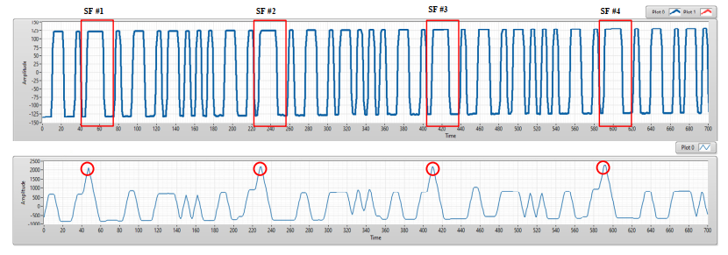

(a) An experimental result of COOK within a rolling image. (b) The results of preamble position detection based on matched filter

After the detect preamble, to decode data, we also used the matched filter to decode data to improve the system performance. By create known patterns as Figure below, the received signal is multiplied with the known preamble signal via the convolution algorithm. From convolution results, we can know that: which patterns are the most like the received signal? From that, it is easy to verify the value of signals (0 or 1). Same with the Manchester code, we can create 16 patterns of 4B6B code to decode data.

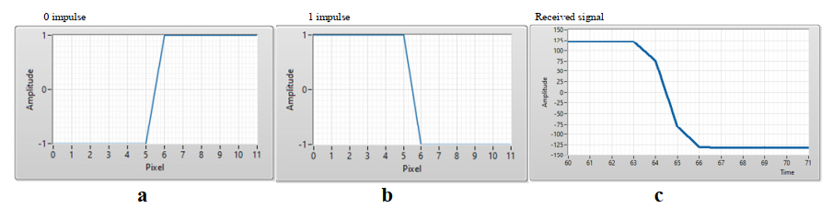

Manchester code signal patterns and COOK received signal. (**a**) 0 impulse, (**b**) 1 impulse, (**c**) COOK received signal.

## P.3. O-NOMA decoding method

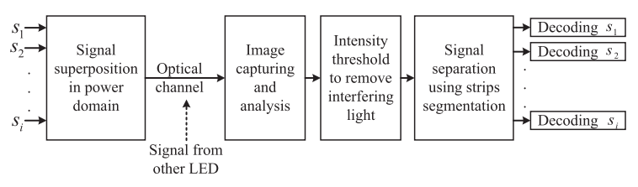

Illustration of NOMA-OCC principle

The image sensor in the smartphone camera or other high-speed cameras comprises a number of unit pixels that capture the light intensity coming into it. In the proposed OCC system, as the transmitter is designed to transmit signals through light modulation at the speed of carrier frequency, the camera has the capability of capturing every lighting state by controlling its shutter speed. The camera’s rolling shutter mechanism helps to capture LED state as horizontal stripes. In this system, LED flickers according to the transmitted bits using two power levels in one-bit duration. The upper half of a bit contains power , and the lower half of a bit contains power level .

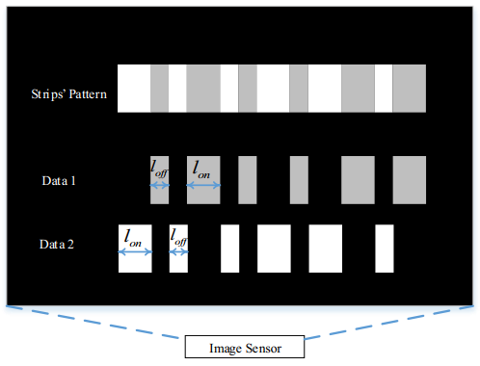

Figure xxx: Two signal separation and data decoding from a captured LED image using intensity threshold in the image sensor.

## P.4. MIMO-OOK decoding method



MIMO-OOK Decoder architecture



Intensity of expected signal via RoI signaling



Intensity of noise signal via RoI signaling

As previously discussed, we added a preamble into each packet to detect the start frame. This is a special bit sequence, whose definition is based on the RLL code that has been used, and which both the transmitter and receiver know in advance. A preamble has two tasks. Firstly, the receiver can classify the signal light source and unexpected light sources (such as background light and noise light). By using the expected signal, payload data is inputted between two preambles. However, there is no significant change in the intensity of unexpected signals or noise signals.

## P.5. HOOK-OFDM decoding method



HOOK-OFDM decoder architecture

For a dual-stream receiver system, the hybrid signal can be demodulated as below:

- The C-OOK decoder will be applied for low data rate stream.

- The RS-OFDM decoder will be applied for high data rate stream.

## P.6. S2PSK-OFDM decoding method

For a dual-camera receiver system, the hybrid signal can be demodulated as below:

- A low frame rate camera (the frame rate should be greater than the S2-PSK optical clock rate) is to detect the S2-PSK signal. Either a global shutter or a rolling shutter camera can be used.

- A rolling shutter and high-speed camera is to decode the RS-OFDM signal.

## P.7. BPPM decoding method



BPPM decoder architecture.

The OCC data were decoded from the light intensity received in the IS. In the case of a single LED transmitter, bright and dark stripes were generated according to the ON and OFF states of the LED owing to the camera’s rolling shutter effect. In our work, two types of bright stripes were generated, one for the high-power-level signal and the other for the low-power-level signal. The stripe patterns received in the IS are shown in Figure xxx. The thickness of the stripes was dependent on the frequency of the modulated signal. The high power signals created a brighter stripe than did the low power signals in the IS. Every two consecutive high-frequency data bits’ amplitude was modulated according to the low-rate stream. Two different threshold levels (i.e., ThL and ThH) were used to retrieve the transmitted data from the stripe pattern. Moreover, ThL was compared with every bit to detect the high-rate data stream, and the ThH was compared with the intensity level of every two consecutive data bits to detect the low-rate stream in this case.



Figure xxx. Received stripe patterns in the camera receiver.