IEEE P802.15
Wireless Personal Area Networks

Project | IEEE P802.15 Working Group for Wireless Personal Area Networks (WPANs)
Title | Licensed Narrowband Amendment TG16t November 2021 Plenary meeting notes
Date Submitted | [The date the document is contributed, in the format “21 May, 1999”]
Source | Almholt, Thomas]  [Texas Instruments, Inc]  [12500 TI BLVD] | Voice: [ ]  Fax: [ ]  E-mail: [ talmholt@ti.com ]
Re: | Meeting notes for November session
Abstract | TG16t November 2021 Plenary meeting notes
Purpose | Notes captured during the November plenary meeting
Notice | This document has been prepared to assist the IEEE P802.15. It is offered as a basis for discussion and is not binding on the contributing individual(s) or organization(s). The material in this document is subject to change in form and content after further study. The contributor(s) reserve(s) the right to add, amend or withdraw material contained herein.
Release | The contributor acknowledges and accepts that this contribution becomes the property of IEEE and may be made publicly available by P802.15.

Licensed Narrowband Amendment TG16t November 2021 Plenary Meeting notes

Meeting called to order Tuesday, November 9, 2021

16t Task Group PM2 Tuesday
- Called to order at 15:13 ET
- Chair presents 15-21-0621-00
- Agenda approved by unanimous consent
- Chair gives registration reminder
- Chair presents the IEEE and 802 policy slides
  - Call for essential patents made, no responses
- Actions from September
- Cyber Security section in SDD (pending)
- Clean-up and clarification for SDD figures (pending)
- Contributions for this week
  - Document 15-21-0547-00
- Presentation Document 15-21-0547-00 Additional to the SRD
  - Derived from the Rail use case.
  - Noted that document was in response to request from the group and submitted in advance of the meeting for review
    - Discussion on fitting this into the 802.16 architecture
    - Requirements affect the control signaling
    - Considerable complexity
    - Is there a simple way to map this into the existing control state signaling?
    - Adds an additional network topology
  - Discussion of driving performance requirements
  - Consensus is that the requirements can be aligned with 802.16 topologies and capabilities already in the standard
  - Contributors will continue to develop the contribution based on group input
- Use case document 15-21-0213-13
  - brief discussion
  - May need update for the rail use case based on requirements discussion
  - Recess at 16:20 ET

Meeting called to order at 13.10 PM EST Tuesday 16th of November.
Chair called for WEBEX attendees to announce themselves and affiliation
- Everyone introduced themselves and their affiliation
- Thomas Almholt was elected to a secretary for this meeting

Reviewing contributions from previous meeting.
- document viewed and edited during the call today IEEE802.15-21-0562r2
- document 547-R0 was provided at the last meeting
- document 15.21.0547.01-016t was updated

Is the P-P mode a priority for this TG?
- a discussion about this feature being mandatory / optional
- recommended to adopt features and capabilities already available 802.16.
- Discussion about "how do we accomplish peer-to-peer requirements"
  - direct Peer-to-peer with infrastructure
  - need to identify a method of sharing the medium
  - discussion of benefits of using frequency allocation or time allocation
  - discussion of allowing devices switching mode of operation
this would involve dynamic transition from remove to base
    - it is believed that CMSA is more efficient, considdering 20-30 radios needing to co-exist
  - discussion about peer-to-peer is appropriate for inclusion 802.16t and should be handled in a seperate standard
    - how would that enable a transition between modes of operation?
    - would this impact quality of service?
    - is the technical fit
  - way forward?
    - focus on the capabilities of 802.16-2017
    - adopt the SDD description of private case of PtP
    - maintain the 802.16 air interface, MAC behavior
      - Avoids defining a new MACs
Everyone of the call 2021-11-16 agrees that is sufficient P-P capability.
It is recommended to defer the P-P MAC definition to a subsequent amendment
- discussion will be planned during the december meeting.

SDR status
- this is complete

SDD status
- this was thought to be complete and posted on October 13th, 2021, however there are some open actions from the October meeting.
- during the October meeting actions were taken to update some figures of the document
- these actions are still open, please refer to the October meeting notes for details
  - Menashe will make a contribution on how P-P mode would work and upload to the r8 revision

Plan for December teleconference
- Conclude P-P discussion from today’s meeting
- Finalize and approve the SDD
- Initiate draft development, call for contributions to draft

Closing remarks
- any other business
- review of actions

Adjourn
Meeting was adjourned at 14.12EST

Attendees for Meeting on November 9, 2021
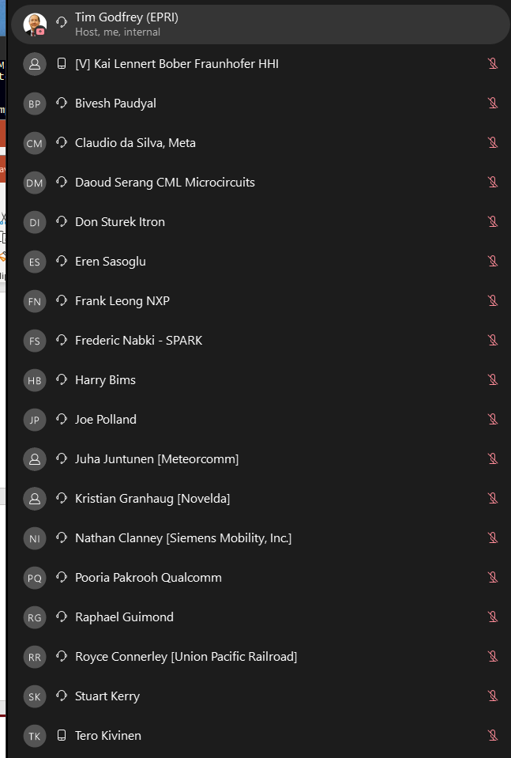

Attendees for Meeting on November 16, 2021
