**IEEE P802.15**

**Wireless Personal Area Networks**

|  |  |
| --- | --- |
| Project | IEEE P802.15 Working Group for Wireless Personal Area Networks (WPANs) |
| Title | **Draft D1-Optical Non-orthogonal Multiple Access (O-NOMA) Scheme for Indoor OCC System** |
| Date Submitted | November, 2021 |
| Source | Md. Shahjalal and Yeong Min Jang Voice: [ ]  Fax: [ ]  E-mail: [yjang@kookmin.ac.kr] |
| Re: | Draft D1 Comment Resolution |
| Abstract | We develop an optical non-orthogonal multiple access (O-NOMA) scheme for OCC system where each LED can transmit two separate signal of two different power levels. An image sensor based receiver system have been designed to capture both the transmitted signal.. |
| Purpose | D1 Comments Resolutions |
| Notice | This document has been prepared to assist the IEEE P802.15. It is offered as a basis for discussion and is not binding on the contributing individual(s) or organization(s). The material in this document is subject to change in form and content after further study. The contributor(s) reserve(s) the right to add, amend or withdraw material contained herein. |
| Release | The contributor acknowledges and accepts that this contribution becomes the property of IEEE and may be made publicly available by P802.15. |

# **Introduction**

Optical wireless communication (OWC) is an emerging technology which can provide ubiquitous connectivity by complementing radio frequency communication for the fifth generation wireless communication and beyond [1]. However, low range modulation bandwidth of light emitting diodes (LED) limits the achievable data rate for camera and LED based OWC. Hence, densely deployed OCC networks, multiple access control is an important issue while supporting massive users. Several MA schemes have been proposed VLC systems to improve maximum throughput and an increasing number of connected channels [2].

# **O-NOMA concept**

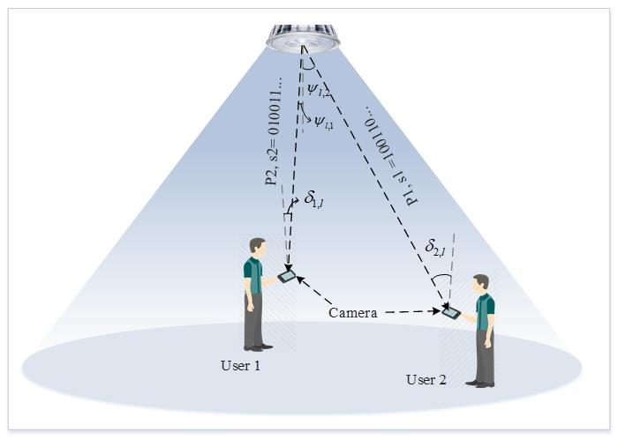

Figure 1: The scenario of proposed non-orthogonal multiple access (NOMA) scheme for OCC

In a conventional OCC system, data is transmitted by modulating the light at its full and zero voltage level. Unlike this approach, this study proposes a two-level power transmission through an LED transmitter to support non-orthogonal multiple access in the OCC system (NOMA-OCC). Let’s consider an LED to transmit two separate digital data  and  by superimposition as illustrated in Figure 1. The  and  are transmitted through a higher power level   and a lower power level  respectively. In this case, flickering of the LED light within its varied power level is not an issue because under-sampled FSOOK was used at a frequency level between 2~4 kHz. Whereas, human eye can perceive visual flickering up to 200 Hz. The modulation frequency for both signal remains the same and does not affect each other. The details of the NOMA-OCC superposition concept are discussed in the following sections. Assuming user 1,  & user 2,  wants to receive information from the same LED at the same time using a smartphone camera with located at a distance closer to LED than . As a result, will experience higher channel gain than  and receive the data  which conveying lower power level of the LED. Alternatively,  will receive the information from  containing higher power level. In this case, smartphone application should utilize the channel selection algorithm by applying intensity threshold between the received data streams.

Total transmitted signal given by:

 (1)

Where,  and  are the high and low power level of the LED respectively. And,  and  are the two signals modulated at each power level respectively. The received signal at the receiver can be written as:

 (2)

Where,  is the dc channel gain to the receiver from the target LED,  is the optical to electrical conversion efficiency per pixel,  is the area of projected image in the IS,is defined as the image distortion factor and  is the white Gaussian noise matrix with zero-mean. can be expressed as  where, is the noise variance.

Visible light channel response can be written as:

  (3)

Where, represents optical concentrator gain of the image sensor and  is the direct distance between LED and the receiver camera. Where, *F* is the camera focal length and  is the LED area. represents the Lambertian radiant intensity of the transmitter with order *m* and is the angle of irradiance with respect to LED axis.  represents the angle of incidence with respect to camera axis and is camera field-of-view (FoV).

# **LED Data encoding scheme**

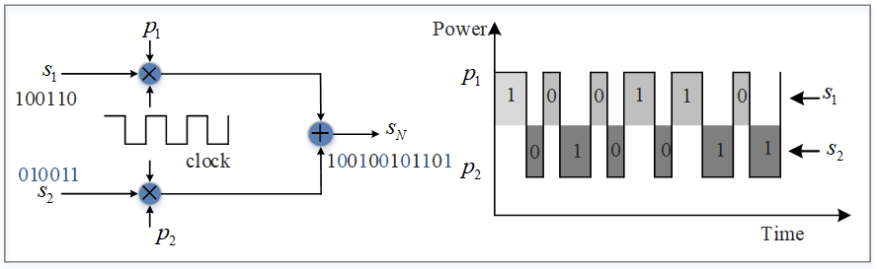

Figure 2: Data encoding scheme of 2-stage power allocation based NOMA-OCC system

In order to use FSOOK as the technique to modulate LED light according to input bits, two frequencies (mark and space) have to be chosen, mark frequency for bit “1” and space frequency for bit “0”. Both channels are modulated using the same frequencies, however, they will not create any interference in the receiver side as the channels are non-orthogonally superimposed by a power difference of the LED. In this study, the proposed NOMA-OCC scheme utilizes two different bit streams in order to support multiple access. The bit encoding scheme is illustrated in Figure 2. In this system, mark is defined for lower frequency (2 kHz) and space is defined for higher frequency (4 kHz). Consequently, while bit “1” is transmitted through LED, the camera will capture longer state and vice versa as shown in Figure 2. The input data sequences are encoded according to the clock state which has to be synchronous with the modulation speed. Sequence  transmits with power  only with the clock at its ON-state and sequence  is transmitted with power  with the clock at its OFF state. For example, if  and  have bit sequences “100110” and “010011” respectively, after encoding the actual input to the LED will be 100100101101 and consequently, each consecutive bit will convey different power levels  and ****. This means two signals are transmitted in consecutive LED flickering stripes. Also, synchronization between the LED flickering speed and the FR of the receiver in important to avoid any bit loss.

# **SIC principle at the receiver**

The image sensor in the smartphone camera or other high-speed cameras comprises a number of unit pixels that capture the light intensity coming into it. In the proposed OCC system, as the transmitter is designed to transmit signals through light modulation at the speed of carrier frequency, the camera has the capability of capturing every lighting state by controlling its shutter speed. The camera’s rolling shutter mechanism helps to capture LED state as horizontal stripes. In this system, LED flickers according to the transmitted bits using two power levels in one-bit duration. The upper half of a bit contains power , and the lower half of a bit contains power level . When a camera records the LED signal in its consecutive frames, it will capture strip patterns according to the power level of the upper portion and lower portion of that signal such that each frame will contain both the signals of different intensity as shown in Figure 4.

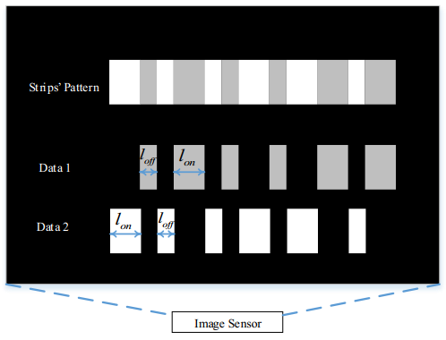

Figure 3: Two signal separation and data decoding from a captured LED image using intensity threshold in the image sensor.

The strips pattern shown in this figure is vertical due to the rotation of image view about . This strip patterns can be separated by applying an intensity threshold value. A smartphone can be a suitable device to implement such an application supporting RoI detection and to apply image processing to separate the two received data pattern. Smartphones can support multiple data reception simultaneously from multiple LEDs. However, due to the limitation of the current smartphone camera FR and data rate, one can use high-speed camera (FR up to 1000 fps) integrated device to achieve higher data rate and mobility support. Although, the necessary image processing libraries such as openCV have to be integrated with the software. This library helps to carry out necessary pixel intensity measurement, change its format, pixel grouping, edge selection and classification by pixel matrix operation.

# **Experimental Setup**

In Fig. 4, the captured image of the transmitter is also depicted. As the LED flickers at two power levels, its recorded image contains ON-OFF strips of both power levels. Because of the rolling shutter effect of the camera, the strips of two different intensity levels lay sequentially one after another. These two different types of strips resemble the two signals transmitted using the NOMA-OCC scheme. To extract the signals, the intensity threshold could be applied and depending on the users’ locations, the unnecessary signal  
could be discarded.

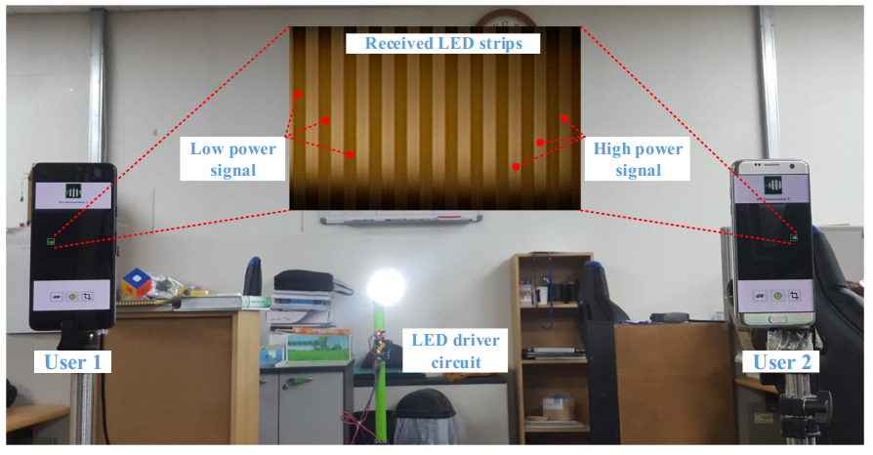

Figure 4. Experimental setup for analyzing NOMA-OCC transmitter image

# **Channel capacity analysis**

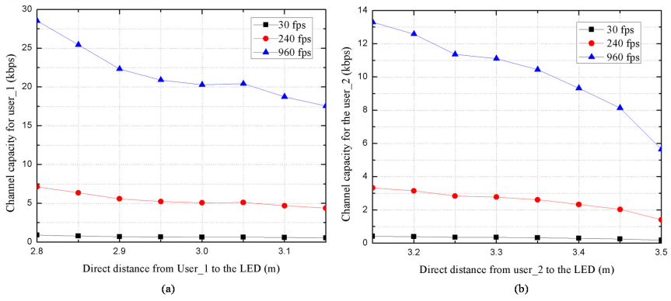

Figure 5. The channel capacity experienced at different camera frame rate by the (a) User 1 in the inner region and (b) User 2 in the outer region.

Fig. 5(a) and (b) depict the relationship between the achievable channel capacity with the change of communication distance for both U1 and U2, respectively. Even though higher power is allocated to U2, the U1 achieved a relatively high data rate because it is located closer to the floor position of the LED. This is due to the number of bits per frame increase with the increase of the LED size in the IS. The simulation results show that the data rate up to 28 kbps can be achieved by using a camera of 960 fps at a communication distance of 2.8 m and it decreases with the increase of communication distance from the LED as shown in Fig. 5(a) and (b).