IEEE P802.15
Wireless Personal Area Networks

Project | IEEE P802.15 Working Group for Wireless Personal Area Networks (WPANs)
Title | Draft D0 of Accurate Data Transmitting LED Detection Scheme.
Date Submitted | [September 2021]
Source | Md. Habibur Rahman and Yeong Min Jang | Voice: [ ]  Fax: [ ]  E-mail: [yjang@kookmin.ac.kr]
Re: | Efficient OCC data communication in Multi User System.
Abstract | Deploying optical camera communication (OCC) commercially as a favorable complement of radio-frequency technology has led to the desire for an intelligent receiver system that is eligible to communicate with an accurate Light emitting diode (LED) transmitter.
Purpose | A novel scheme for detecting and recognizing multi user data transmitting light-emitting diode (LED) has been proposed for efficient OCC.
Notice | This document has been prepared to assist the IEEE P802.15. It is offered as a basis for discussion and is not binding on the contributing individual(s) or organization(s). The material in this document is subject to change in form and content after further study. The contributor(s) reserve(s) the right to add, amend or withdraw material contained herein.
Release | The contributor acknowledges and accepts that this contribution becomes the property of IEEE and may be made publicly available by P802.15.

Introduction
Embedding optical camera communication (OCC) commercially as a favorable complement of radio-frequency technology has led to the desire for an intelligent receiver system that is eligible to different light-emitting diode (LED) transmitters in multi user system. To shed light on this issue, a novel scheme for detecting and recognizing data transmitting LEDs has been elucidated in this proposal. Since the optically modulated signal is captured wirelessly by a camera that plays the role of the receiver for the OCC technology, the process to detect LED region and retrieval of exact information from the image sensor is required to be intelligent enough to achieve a low bit error rate (BER) and high data rate to ensure reliable optical communication within limited computational abilities of the most used commercial cameras such as those in smartphones, vehicles, and mobile robots. In the proposed scheme, we have designed an intelligent camera receiver system that is capable of recognizing multiple data transmitting LED regions in multi user communication system employing a support vector machine (SVM) classifier along with a convolutional neural network (CNN) in the camera receiver. CNN is used to detect every LED region from the image frame and then essential features are extracted to feed into an SVM classifier for further accurate classification.

System Architecture

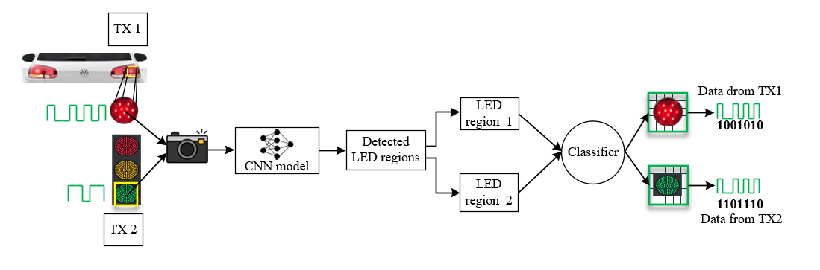
Fig. 1: Architecture of the accurate data transmitting LED detection scheme
In Fig. 1, the block diagram delineates the overall architecture the accurate data transmitting LED detection scheme. On the transmitter side, numerous LED regions were present. The LED optical signal was modulated by modulation at a frequency level between 2–4 kHz before sending to the receiver to attenuate the flickering issue in a significant margin. With regard to the transmitting LEDs and other sources of interference, they are not modulated in that particular frequency. The projection of all these light-emitting sources was captured by the image sensor. Interference sources were dispelled when a trained CNN model is used. All the possible LED sources were detected and segmented using image processing techniques. Due to the rolling shutter effect of the CMOS based image sensor, each image frame gets striated of white and black shade. Afterwards, necessary geometrical features have been extracted to classify and recognize accurate data transmitting regions from the range of all possible regions.

Classifier structure:
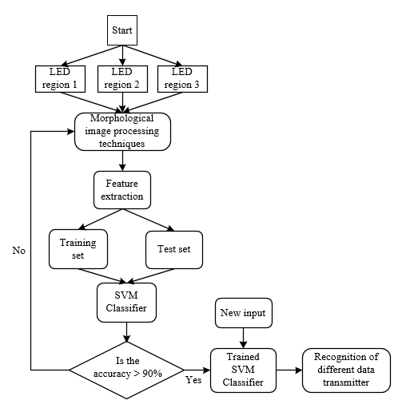

Fig. 2: Classifier structure
In Fig. 2, the detected LED regions with bounding boxes are the output of the CNN. The bounding box LED objects are then processed employing several image processing techniques. At first, each LED image is converted into a grayscale format to specify the distinct pixel intensity values of the stripes generated in the image sensor. Next, a kernel full of ones is used to reduce the shape of the projected stripes by removing small anomalies near the stripe boundaries. To make the receiver an intelligent and robust retrieval system, the system needs to recognize accurate LEDs separately as quickly as possible. Therefore, the selection of features is very important. The extraction of appropriate features is very challenging since the objects are almost the same. LED objects of the same type can have a different shape, stripe pattern based on the communication distance, camera frame rate, and mark and space frequency. To analyze the different geometrical shapes, computation of the features from the contour line has been considered significant distinguishable features. Contours are the outline that is designed using the edges of the object to represent the shape. They contain some geometrical attributes that are effective to recognize and segment objects. However, before performing feature extraction, a closing operation is applied on the selected regions to combine all the neighboring stripes, and the contour is drawn on the shape by combined stripes.

Description of feature set:
A feature set formed that includes zero order moments or area of LED region, no. of stripes per LED region, perimeter of combined stripes contour, and no. of line segment of combined stripes contour. Fig. 3 depicts the processed image for differnt transmitter from where features have been extracted. All the features are described below:

Fig. 3: An example of a processed image for 2 different transmitter

Zero Order Moments or Area of LED Region:
The moment is a unique feature that defines the relationship between pixels of the corresponding objects with their surroundings. For many years, this feature is being used to recognize objects from image frames. Fundamentally, it computes the weighted average intensity of the pixels, and, therefore, it cannot be applied on a single pixel except a definite area of the projected object.

No. of Stripes per LED Region :
Since LED modulated data results in dark and bright stripes in the captured image, the number of stripes and the width plays an important role in recovering the data stream from the image frame. The number of stripes is varied proportionally with the size of LED, mark, and space frequency of LED, and also the distance between the camera and LED. It is noticed that high-speed cameras with high read-out capability outperform in terms of communication speed.

Perimeter of Combined Stripes Contour :
A contour is drawn considering all the stripes generated by the LED blinking and rolling shutter effect of the camera. Hence, the arc length of the enclosed contour varies according to the number of stripes. Thus, the perimeter is also considered a significant feature.

No. of Line Segment of Combined Stripes Contour :
In 1973, the Douglas–Peucker algorithm developed by D. Douglas and T. Peucker splits a curve into line segments depending upon the specified precision (e). It determines the dominant point on the curve by digitizing the original curve and generates a similar curve of fewer points. We have used this algorithm to relate the number of line segments with the no. of stripes. It is noticeable that, with the variation of LED on-off frequency and distance, getting accurate contour of the object is difficult. Thus, errors maybe present in determining the number of stripes. Combining all stripes, we segmented combined contour using the Douglas–Peucker algorithm based on the corner point of each stripe.

