**IEEE P802.15**

**Wireless Personal Area Networks**

|  |  |  |
| --- | --- | --- |
| Project | IEEE P802.15 Working Group for Wireless Personal Area Networks (WPANs) | |
| Title | **Draft D1-PHY Layer Operating Modes and Specifications of Hybrid S2-PSK OFDM scheme** | |
| Date Submitted | November, 2021 | |
| Source | Huy Nguyen, Yeong Min Jang | Voice: [ ] Fax: [ ] E-mail: [yjang@kookmin.ac.kr] |
| Re: | Draft D1 Comment Resolution for Hybrid S2-PSK OFDM scheme | |
| Abstract | Details of Resolutions regarding to the submitted Comments on D1 are suggested Hybrid S2-PSK OFDM PHY Layer Operating Modes and PHY Specifications. | |
| Purpose | D1 Comments Resolutions | |
| Notice | This document has been prepared to assist the IEEE P802.15. It is offered as a basis for discussion and is not binding on the contributing individual(s) or organization(s). The material in this document is subject to change in form and content after further study. The contributor(s) reserve(s) the right to add, amend or withdraw material contained herein. | |
| Release | The contributor acknowledges and accepts that this contribution becomes the property of IEEE and may be made publicly available by P802.15. | |

# **PHY Layer Operating Modes**

The Hybrid Orthogonal Frequency Division Multiplexing- Spatial-2 Phase Shift Keying (HS2-PSK-OFDM) Modulation for high-speed OCC system uses the PHY VIII – Multiple Point Source. The output waveforms are a hybrid modulation of S2-PSK and OFDM.

The PHY VIII Operating Modes system specifications are given in Table xx. The additional PHY Operating Modes by HS2PSK-OFDM for Smart Device is presented the Table xx – PHY VIII Operating Modes.

|  |  |  |  |  |  |  |  |
| --- | --- | --- | --- | --- | --- | --- | --- |
| **PHY Operating Modes** | | | | | | |  |
| **Modulation** | **Mode** | **Optical Clock rate** | **Modulation** | **RLL Code** | **FEC**  **(Convolution code)** | **Packet length** | **Total data rate** |
| HOOK-OFDM | Mode 1 | 16 kHz | OFDM | None | CC (3/4) | 32 | 20.16 kbps |
| S2-PSK | Manchester | CC (3/4) | 20 | 20 bps |
| ~~Mode 2~~ | ~~32 kHz~~ | ~~OFDM~~ | ~~None~~ | ~~CC (3/4)~~ | ~~32~~ | ~~38.40 kbps~~ |
| ~~S2-PSK~~ | ~~Manchester~~ | ~~CC (3/4)~~ | ~~30~~ | ~~30 bps~~ |
| ~~Mode 3~~ | ~~16 kHz~~ | ~~OFDM~~ | ~~None~~ | ~~CC (3/4)~~ | ~~64~~ | ~~48.00 kbps~~ |
| ~~S2-PSK~~ | ~~4B6B~~ | ~~CC (3/4)~~ | ~~12~~ | ~~12 bps~~ |
| Mode 4 | 32 kHz | OFDM | None | CC (3/4) | 64 | 94.08 kbps |
| S2-PSK | 4B6B | CC (3/4) | 24 | 24 bps |

# **HS2PSK-OFDM**

The PHY VIII with supported data rates and operating conditions is shown in Table 153 – PHY VIII Operating Modes for HS2PSK-OFDM scheme with high-speed OCC system uses the PHY VIII

* 1. Reference architecture

A reference architecture to implement HS2PSK-OFDM is shown in Figure xxx



Figure xx. HS2PSK-OFDM block diagram

* 1. HS2PSK-OFDM encoder

A packet of data is modulated using OFDM modulation. The optical clock rate is at 16 kHz or 32 kHz. The configuration of the mode of HS2PSK-OFDM scheme shall be implemented via the PHY PIB attribute *phyHs2pskOfdmMode*



Figure xx. Hybrid S2PSK OFDM waveform

2.2.2. Sequence Number inserting

The data sub-packet payload shall consist of two subparts: SN data, payload. The SN Data consists of asynchronous information, which helps the receiver side decode data.

SN shall be implemented over the PHY PIB attribute *phyHs2pskOfdmSn*

2.2.3. Forward error correction (FEC)

The data sub-packet payload may be coded by FEC to protect the payload from error. Convolution code (CC) may be used as an FEC.

The configuration of error correction for HS2PSK-OFDM, including FEC for S2-PSK scheme and FEC for OFDM scheme, shall be implemented via the PHY PIB attribute *phyHs2pskOfdmFec*

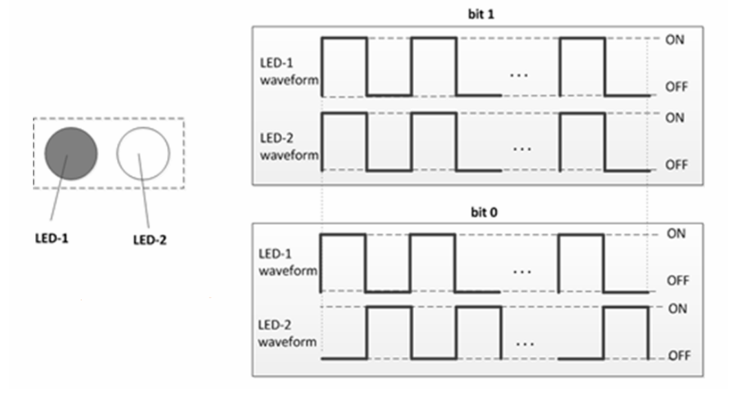

S2-PSK waveform

In each ‘high’ and ‘low’ period of S2-PSK waveform, we can embed the high-frequency OFDM waveform to increase data rate of the system.

In the low data rate stream, we apply the S2-PSK frame as the above figure. With high data rate stream, each period of S2-PSK waveform will be put one OFDM frame to generate hybrid waveform.



Data frame structure for Rolling-OFDM system in high speed stream

The SN represents the serial number of packets. In reality, we can divide two cases depending on the packet rate of the transmitter and the frame rate of the camera:

Case 1: Oversampling: the frame rate of camera is many times greater than the packet rate of the transmitter

Case 2: Undersampling: the frame rate of camera is less than the packet rate of the transmitter (LED)

|  |  |  |  |
| --- | --- | --- | --- |
| **Attribute** | **Type** | **Range** | **Description** |
| *phyHs2pskOfdmMode* | Integer | 0-7 | The mode applied for HS2PSK-OFDM. 0: Mode 1 1: Mode 2  2: Mode 3  3: Mode 4 Others: Reserved |
| *phy**Hs2pskOfdmSn* | Integer | 0-3 | This attribute specifies the length of Sequence Number per packet of HS2PSK -OFDM  0: 2 bits  1: 3 bits  2-3: reserved |
| *phyHs2pskOfdmFec* | Integer | 0-7 | This attribute specifies FEC for HS2PSK-OFDM modulation. 0: None 1: Hamming (8/4) 2: Hamming (15/11) 3: RS(15,11) Other values: Reserved |