**IEEE P802.15**

**Wireless Personal Area Networks**

|  |  |  |
| --- | --- | --- |
| Project | IEEE P802.15 Working Group for Wireless Personal Area Networks (WPANs) | |
| Title | **Draft D1- PHY Layer Operating Modes of Rolling Shutter OFDM scheme** | |
| Date Submitted | November, 2021 | |
| Source | Huy Nguyen, Yeong Min Jang | Voice: [ ] Fax: [ ] E-mail: [yjang@kookmin.ac.kr] |
| Re: | Draft D1-PHY Layer Operating Modes of Rolling Shutter OFDM scheme | |
| Abstract | Details of Resolutions regarding to the submitted Comments on D1 are suggested Rolling Shutter OFDM PHY Layer Operating Modes and PHY Specifications. | |
| Purpose | D1 Comments Resolutions | |
| Notice | This document has been prepared to assist the IEEE P802.15. It is offered as a basis for discussion and is not binding on the contributing individual(s) or organization(s). The material in this document is subject to change in form and content after further study. The contributor(s) reserve(s) the right to add, amend or withdraw material contained herein. | |
| Release | The contributor acknowledges and accepts that this contribution becomes the property of IEEE and may be made publicly available by P802.15. | |

# **PHY Layer Operating Modes**

The Rolling Shutter Orthogonal Frequency Division Multiplexing (RS-OFDM) Modulation for high-speed OCC system uses the PHY VII – Singular Point Source.

The PHY VII Operating Modes system specifications are given in Table xxx. The additional PHY Operating Modes by RS-OFDM for Smart Device is presented the Table xxx – PHY VII Operating Modes.

**Table xxx – PHY VII Operating Modes**

|  |  |  |  |  |  |
| --- | --- | --- | --- | --- | --- |
| **PHY Operating Modes** | | | | |  |
| **Modulation** | **RLL Code** | **Optical Clock Rate** | **FEC** | **OFDM symbol length** | **Data rate** |
| RS-OFDM | None | 20 kHz | Hamming (15,11) | 64 | 1.92 kbps |
| 40 kHz | RS (15,11) | 128 | 7.68 kbps |

# **RS-OFDM**

The PHY VII with supported data rates and operating conditions is shown in Table xxx – PHY VII Operating Modes for Rolling Shutter OFDM scheme with high-speed OCC system uses the PHY VII

* 1. Reference architecture

A reference architecture to implement RS-OFDM is shown in Figure xxx



Figure xxx. Rolling Shutter OFDM block diagram

* 1. RS-OFDM encoder

2.1.1. Encoder configuration

A packet of data is modulated using OFDM modulation. The optical clock rate is at 20 kHz or 40 kHz. The optical clock rate at which RS-OFDM symbols are clocked out is configurable over PHY PIB attribute *phyOfdmOpticalClockRate*.



Figure xx. RS-OFDM data packet structure

The data packet structure is as shown in Figure xx. A packet consists of multiple similar data sub-packets to avoid missing data between adjacent images' gap time. The number of repetitions depends on the communication mode specified later.

2.2.2. Hermitian mapping

Unlike the conventional OFDM in Radio Frequency, instead of feeding the data symbol directly into the IDFT block, each symbol must pass through the Hermitian block. The signal is then fed into the IFFT. The special purpose of the Hermitian block is that it ensures the output of the IDFT is entirely real. The modes of RS-OFDM shall be configured via the PHY PIB attribute *phyOfdmMode.* And the length of RS-OFDM symbol shall be configured via the PHY PIB attribute *phyOfdmFrame.*

1. DCO-OFDM

Before coming to the IDFT block, the data signal, , must be constrained to have Hermitian symmetry:

for  and 

After the IDFT block, the signal *x* is a real signal in the time domain. The  time domain sample of *x* is shown:



1. ACO-OFDM

Only the odd subcarriers carry data symbols in ADO-OFDM to ensure that the signal after the IDFT is real and non-negative. The input signal to the IDFT, **X**, just comprises odd components such as . After the IDFT block, the resulting real signal is shown as:

for 

2.2.3. Sequence Number inserting

The data sub-packet payload shall consist of two subparts: SN data, payload. The SN Data consists of asynchronous information, which helps the receiver side decode data. SN shall be implemented over the PHY PIB attribute *phyOfdmSn*

2.2.4. Forward error correction (FEC)

The data sub-packet payload may be coded by FEC to protect the payload from error. Hamming (8,4) or Reed Solomon (15,11) code may be used as an FEC. FEC shall be configured via the PHY PIB attribute *phyOfdmFEC*

Table xx shows PHY PIB attributes.

|  |  |  |  |
| --- | --- | --- | --- |
| **Attribute** | **Type** | **Range** | **Description** |
| *phyOfdmOpticalClockRate* | Integer | 0-7 | The optical clock rate (or symbol rate) applied for OFDM. 0: 8 kHz 1: 10 kHz Others: Reserved |
| *phyOfdmMode* | Integer | 0-3 | This specifies the mode of OFDM modulation. 0: DCO-OFDM 1: ACO-OFDM Other values: Reserved |
| *phyOfdmFec* | Integer | 0-7 | This attribute specifies FEC for OFDM modulation. 0: None 1: FEC: Hamming (8/4) 2: FEC: Hamming (15/11) 3: FEC: RS(15,11) Other values: Reserved |
| *phyOfdmFrame* | Integer | 0-3 | This attribute specifies the  symbol length of OFDM frame.  0: 32 1: 64  Other values: Reserved |
| *phyOfdmSn* | Integer | 0-3 | This attribute specifies the length of Sequence Number per packet of OFDM  0: 2 bits  1: 3 bits  Other values: reserved |

* 1. RS-OFDM decoder (annex )



* *Oversampling:*

The Oversampling caused by the frame rate variation of the rolling shutter camera when the frame rate of a rolling-shutter camera becomes many times greater (at least double) than the packet rate of the transmitter, every data packet is sampled at least twice (i.e., two images). At the receiver, we receive the same packet causing confusions of packet merger. To assist the receiver in reducing the effect of the frame rate variation of the camera, the SN is added to DS. Each packet contains DSs with the same SN, which helps the receiver remove redundant data. When the receiver receives a DS, it will choose which has a compatible SN. The receiver will eliminate consecutive packets with the same SN and choose packets with consecutive SN (n-1, n, n+1) to the merger.



Merging packet method in Oversampling case

* *Undersampling:*

Undersampling occurs if the frame rate drops to below the packet rate of the transmitter. In this case, the payload will be lost. The detection of a missed payload using the SN is shown in figure. If the SN length is long enough, the missed payload can be detected by SN. The data frame achieved from the payload n–1 represents the SN as n–1. The next data frame indicates that the SN is n, but the actual data frame carries SN n+1. This demonstrates that the payload n is missed and the loss is detected by comparing the SN of the two adjacent data sub-packets. However, depending on the length of the SN, a number of different states are generated. For example, if the SN length is 3 bits, seven missing payloads of transmitted packets can be detected by the Sequence Number. The error correction becomes easy if the errors are detected. If two consecutive packets have two non-consecutive SN (n-1 and n+1), respectively.



Detecting missed packets in Undersampling case

* Equalization: we applied Linear Equalizer

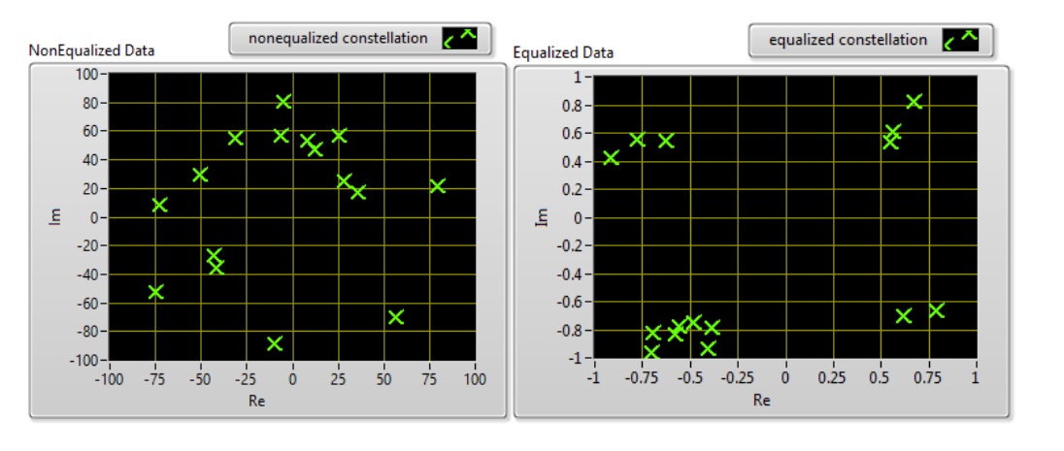

The signal before and after Equalizer Block