IEEE P802.15
Wireless Personal Area Networks

Project | IEEE P802.15 Working Group for Wireless Personal Area Networks (WPANs)
Title | Design of a Power-domain Optical Non-orthogonal Multiple Access (PDO-NOMA) Mechanism with Ultra-massive-link Setup for the vehicular OCC System
Date Submitted | September, 2021
Source | Md. Shahjalal and Yeong Min Jang Voice: [ ]  Fax: [ ]  E-mail: [yjang@kookmin.ac.kr]
Re: | Draft D0 Comment Resolution
Abstract | We propose the power-domain optical non-orthogonal multiple access (PDO-NOMA) technique in the vehicular OCC system
Purpose | D0 Comments Resolutions
Notice | This document has been prepared to assist the IEEE P802.15. It is offered as a basis for discussion and is not binding on the contributing individual(s) or organization(s). The material in this document is subject to change in form and content after further study. The contributor(s) reserve(s) the right to add, amend or withdraw material contained herein.
Release | The contributor acknowledges and accepts that this contribution becomes the property of IEEE and may be made publicly available by P802.15.

- Introduction

PDO-NOMA allows sharing the same time and frequency slots by different users by changing the transmission power. The transmitter sends the signals of different power levels by applying superposition coding. More power is allocated to the receiver at longer distance and vice versa. To apply this PDO-NOMA technique in vehicular OCC system, the vehicle LEDs are set to flicker at different power levels in accordance with the signals.

- PDO-NOMA Concept

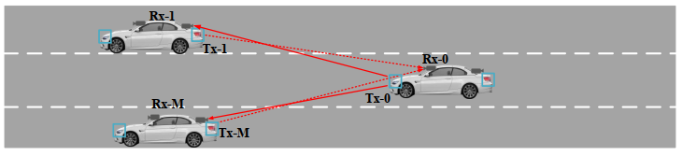
Figure 1: Scenario of applying NOMA in Vehicular OCC

To increase the capacity of such networks, non-orthogonal multiple access (NOMA) modulation technique can be implemented as a promising candidate. Power domain NOMA allows sharing the same time and frequency slots with different users by changing the transmission power. The transmitter sends the different power level signals by applying superposition coding. More power is allocated to users of lower channel gain and vice versa. To apply this NOMA technique for VLC, the LED is set to flicker at different power levels according to the signals. And to avoid the problem of visual flickering, the transmitted signals are modulated at a higher frequency that is not visible to human eye. In recent times, NOMA has been proposed for several VLC based network architectures to improve user throughput and reduce bit error rate (BER) probability

- Block diagram of the process

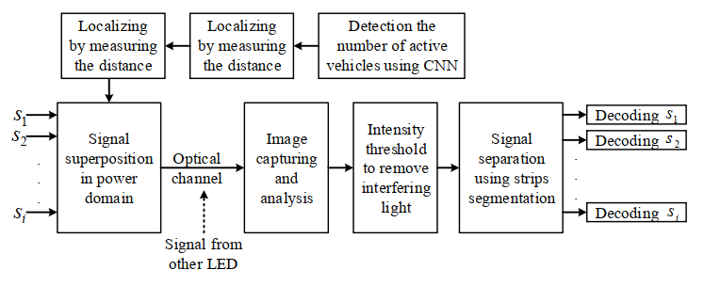
Figure 2: Data encoding scheme of 2-stage power allocation based NOMA-OCC system

The NOMA-OCC principle is illustrated in Fig. 2. According to the principle of NOMA, bipolar signals for different users are superimposed in the power domain. In this NOMA-OCC system, these superimposed signal is sent through an optical channel at a very high carrier frequency beyond the perceivable range of the human eye. As OCC systems use IS as a receiver, it initially receives LED ON–OFF strips image of various intensity levels. Thus to receive the desired signal, successive interference cancellation is performed by intensity threshold over the received strips.
- Two level PDO-NOMA OCC transmitter design
In order to use FSOOK as the technique to modulate LED light according to input bits, two frequencies (mark and space) have to be chosen in such a manner that the mark frequency represents bit “1” and the space frequency represents bit “0”. Both channels are modulated using the same frequencies. However, they will not create any interference in the receiver side as the channels are non-orthogonally superimposed by a power difference of the LED. In this study, the proposed PDO-NOMA OCC scheme utilizes two different payloads in order to support multiple access. Consequently, while bit “1” is transmitted through the LED, the camera will capture a longer state and vice versa, as shown in Fig. 3. The input data sequences are encoded according to the clock state which has to be synchronous with the modulation speed. Sequence s1 transmits with power P1 only with the clock at its ON- state and sequence s2 is transmitted with power P2 with the clock at its OFF state. For example, if s1 and s2 have bit sequences “100110” and “010011”, respectively, after encoding the actual input to the LED will be “100100101101” and consequently, each consecutive bit will convey different power levels P1 and P2. This means that the two signals are transmitted in consecutive LED flickering strips.
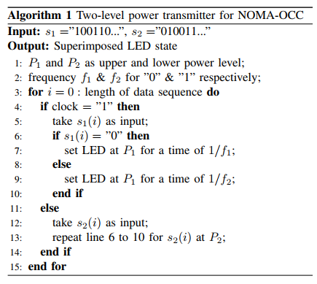
- Localizing by measuring distance
Because of the superimposed transmission of the two signals of two different power levels P1 and P2 , the strips in the LED-ROI are of two types, with one group of strip brighter than the other. The next step involves separating the two groups of LED strips of power level P1 and P2 as shown in Fig. 5. After that, the measured area of LED-ROI is used to determine the direct distance D_{r,LED} from the receiver to the LED. If d_{lens} is the distance of the IS from the camera lens and F is the focal length, then we can write from the general lens equation as:
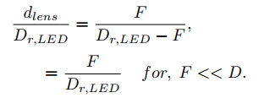 (1)
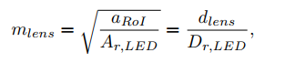 (2)
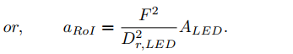 (3)
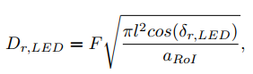 (4)
where l is the radius of the circular LED. Users located at a distance greater than d_{max} ( D_{r;LED} > d_{max} ) will experience lower channel gain than the users located close to the vertical LED point ( D_{r;LED} < d_{max} ). Hence, if D_{r;LED} > d_{max}, the user will select the channel of the higher power level P1. Otherwise, the user can switch to the channel of lower power level P2.

- Technology Advantages
Advantage of the novel PDO-NOMA technique for bi-directional hybrid vehicular OCC system using dual camera.
• Data transmission considering massive-link setup on the basis of PDO-NOMA in OCC.
• Development of a new localization mechanism based on counting vehicles and their relative positions and accuracy improvement
• Development of a highly efficient and real-time power allocation scheme based on the number of active cars inside the field of view of the camera.

