**IEEE P802.15**

**Wireless Personal Area Networks**

|  |  |  |
| --- | --- | --- |
| Project | IEEE P802.15 Working Group for Wireless Personal Area Networks (WPANs) | |
| Title | **PHY Layer Operating Modes and Specifications of** **Hybrid Rolling Shutter OFDM-OOK - Draft D0** | |
| Date Submitted | September, 2021 | |
| Source | Huy Nguyen, Yeong Min Jang | Voice: [ ] Fax: [ ] E-mail: [yjang@kookmin.ac.kr] |
| Re: | Draft D0 Comment Resolution for Hybrid OOK-OFDM scheme | |
| Abstract | Details of Resolutions regarding to the submitted Comments on D0 are suggested Hybrid OOK-OFDM PHY Layer Operating Modes and PHY Specifications. | |
| Purpose | D0 Comments Resolutions | |
| Notice | This document has been prepared to assist the IEEE P802.15. It is offered as a basis for discussion and is not binding on the contributing individual(s) or organization(s). The material in this document is subject to change in form and content after further study. The contributor(s) reserve(s) the right to add, amend or withdraw material contained herein. | |
| Release | The contributor acknowledges and accepts that this contribution becomes the property of IEEE and may be made publicly available by P802.15. | |

# **PHY Layer Operating Modes**

The Hybrid Orthogonal Frequency Division Multiplexing- On-Off Keying (HOOK-OFDM) Modulation for high-speed OCC system uses the PHY VIII – Singular Point Source.

The PHY VIII Operating Modes system specifications are given in Table xx. The additional PHY Operating Modes by HOOK-OFDM for Smart Device is presented the Table xx – PHY VIII Operating Modes.

**Table xx – PHY VIII Operating Modes**

|  |  |  |  |  |  |  |  |
| --- | --- | --- | --- | --- | --- | --- | --- |
| **PHY Operating Modes** | | | | | | |  |
| **Modulation** | **Mode** | **Optical Clock rate** | **Modulation** | **RLL Code** | **FEC**  **(Convolution code)** | **Packet length** | **Total data rate** |
| HOOK-OFDM | Mode 1 | 16 kHz | ACO-OFDM | None | CC (3/4) | 32 | 20.16 kbps |
| OOK | Manchester | CC (3/4) | 20 |
| Mode 2 | 32 kHz | DCO-OFDM | None | CC (3/4) | 32 | 38.40 kbps |
| OOK | Manchester | CC (3/4) | 40 |
| Mode 3 | 16 kHz | ACO-OFDM | None | CC (3/4) | 64 | 48.00 kbps |
| OOK | 4B6B | CC (3/4) | 24 |
| Mode 4 | 32 kHz | DCO-OFDM | None | CC (3/4) | 64 | 94.08 kbps |
| OOK | 4B6B | CC (3/4) | 48 |

# **HOOK-OFDM**

The PHY VIII with supported data rates and operating conditions is shown in Table 153 – PHY VIII Operating Modes for HOOK-OFDM scheme with high-speed OCC system uses the PHY VIII

* 1. Reference architecture

A reference architecture to implement HOOK-OFDM is shown in Figure xx.



Figure xx. HOOK-OFDM block diagram

* 1. HOOK-OFDM encoder

2.2.1. Encoder configuration

A packet of data is modulated using OFDM modulation. The optical clock rate is at 16 kHz or 32 kHz. The configuration of the mode of HOOK-OFDM scheme shall be implemented via the PHY PIB attribute *phyHookOfdmMode*



Figure xx. Data frame structure of hybrid OFDM-OOK scheme. (a) OOK packet. (b) OOK data (c) hybrid signal (d) OFDM signal.

In each ‘high’ and ‘low’ period of C-OOK waveform, we can embed the high-frequency OFDM waveform to increase data rate of the system.

In the low data rate stream, we apply the C-OOK frame as the above figure. With high data rate stream, each period of C-OOK waveform will be put one OFDM frame to generate hybrid waveform.

2.2.2. Hermitian mapping

Unlike the conventional OFDM in Radio Frequency, instead of feeding the data symbol directly into the IDFT block, each symbol must pass through the Hermitian block. The signal is then fed into the IFFT. The special purpose of the Hermitian block is that it ensures the output of the IDFT is entirely real.

1. DCO-OFDM

Before coming to the IDFT block, the data signal, , must be constrained to have Hermitian symmetry:

for  and 

After the IDFT block, the signal *x* is a real signal in the time domain. The  time domain sample of *x* is shown:



1. ACO-OFDM

Only the odd subcarriers carry data symbols in ADO-OFDM to ensure that the signal after the IDFT is real and non-negative. The input signal to the IDFT, **X**, just comprises odd components such as . After the IDFT block, the resulting real signal is shown as:

for 

2.2.3. Sequence Number inserting

The data sub-packet payload shall consist of two subparts: SN data, payload. The SN Data consists of asynchronous information, which helps the receiver side decode data.

SN shall be implemented over the PHY PIB attribute *phyHookOfdmSn*

2.2.4. Forward error correction (FEC)

The data sub-packet payload may be coded by FEC to protect the payload from error. Convolution code (CC) may be used as an FEC.

The configuration of error correction for HOOK-OFDM, including FEC for OOK scheme and FEC for OFDM scheme, shall be implemented via the PHY PIB attribute *phyHookOfdmFec*

|  |  |  |  |
| --- | --- | --- | --- |
| **Attribute** | **Type** | **Range** | **Description** |
| *phyHookOfdmMode* | Integer | 0-7 | The mode applied for HOOK-OFDM. 0: Mode 1 1: Mode 2  2: Mode 3  3: Mode 4 Others: Reserved |
| *phy**HookOfdmSn* | Integer | 0-3 | This attribute specifies the length of Sequence Number per packet of HOOK-OFDM  0: 2 bits  1: 3 bits  2-3: reserved |
| *phyHookOfdmFec* | Integer | 0-7 | This attribute specifies FEC for HOOK-OFDM modulation. 0: None 1: Hamming (8/4) 2: Hamming (15/11) 3: RS(15,11) Other values: Reserved |

* 1. HOOK-OFDM decoder

HOOK decoder architecture

1. C-OOK decoder

* *Oversampling:*

When the frame rate of a rolling shutter camera is at least two times larger than the packet rate of the transmitter, the data packet is sampled multiple times causing the oversampling effect. When the packet is sampled more than once, errors of packet merger are created at the receiver’s end. The SN is added to the DS to deal with this problem because it improves the receiver’s ability to decrease the effect of the frame rate variation of the camera. The redundant data will be removed in the receiver when the same SN value is recognized in the DS of different packets. The receiver will eliminate consecutive packets with the same SN and choose packets with consecutive SN values (n − 1, n, n + 1) for the merger.

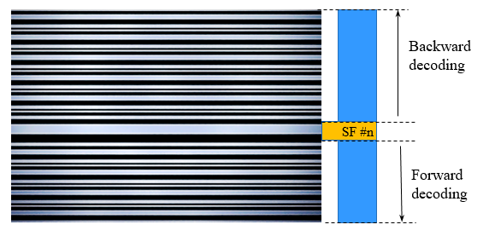

Merge Forward and Backward parts in each image (One SF in each image)



Full payload in each image (Multiple SF in each image)

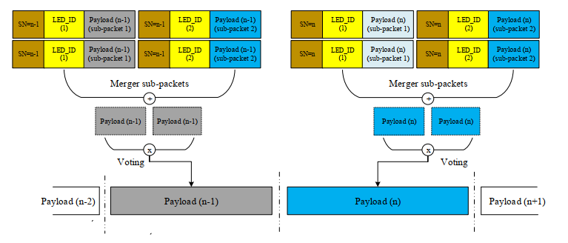

Merging packet of MIMO C-OOK scheme in multiple images

* *Undersampling:*

When the frame rate decreases below the packet rate of the transmitter, undersampling occurs. The payload will be lost in undersampling unlike in the case for oversampling. Figure below shows the scenario in which the missing payload is created and detected using the SN. In this case, the SN is long enough for the receiver to detect the missing payload. The SN of the data frame is increased depending on the sequences of the payload. If one payload is missing, the error can be detected by comparing the SN of the two adjacent DSs. The number of SNs in different states depends on the length of each sub-packet.

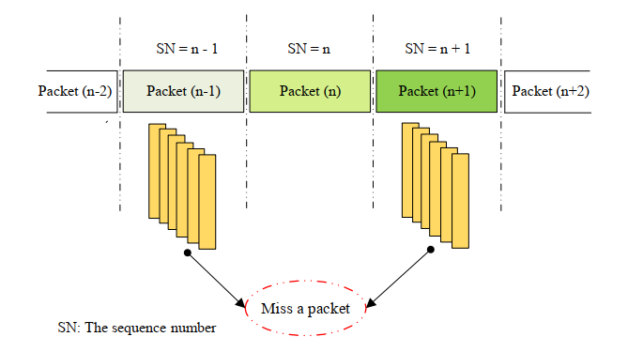

Error detection in grouping image during undersampling case

1. OFDM decoder

Based on the SN value from OOK decoder part, we can merger OFDM packets easily