IEEE P802.15
Wireless Personal Area Networks

Project | IEEE P802.15 Working Group for Wireless Personal Area Networks (WPANs)
Title | Design of a Power-domain Optical Non-orthogonal Multiple Access (PDONOMA) Mechanism with Ultra-massive-link Setup for the OCC System
Date Submitted | [July 2021]
Source | Md. Shahjalal and Yeong Min Jang  (Kookmin University)
Re:
Abstract | We propose the power-domain optical non-orthogonal multiple access (PDO-NOMA) technique in the vehicular OCC system
Purpose | The main goal of this contribution is to increase the capacity of OCC networks, PDO-NOMA technique can be implemented as a promising candidate.
Notice | This document has been prepared to assist the IEEE P802.15. It is offered as a basis for discussion and is not binding on the contributing individual(s) or organization(s). The material in this document is subject to change in form and content after further study. The contributor(s) reserve(s) the right to add, amend or withdraw material contained herein.
Release | The contributor acknowledges and accepts that this contribution becomes the property of IEEE and may be made publicly available by P802.15.

Introduction
PDO-NOMA allows sharing the same time and frequency slots by different users by changing the transmission power. The transmitter sends the signals of different power levels by applying superposition coding. More power is allocated to the receiver at longer distance and vice versa. To apply this PDO-NOMA technique in vehicular OCC system, the vehicle LEDs are set to flicker at different power levels in accordance with the signals.

PDO-NOMA Concept

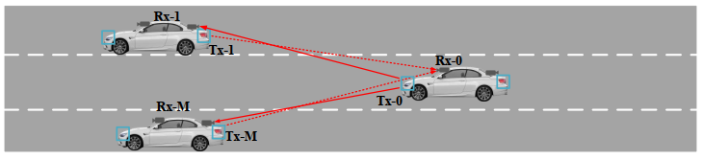
Figure 1: Scenario of applying NOMA in Vehicular OCC

To increase the capacity of such networks, non-orthogonal multiple access (NOMA) modulation technique can be implemented as a promising candidate. Power domain NOMA allows sharing the same time and frequency slots with different users by changing the transmission power. The transmitter sends the different power level signals by applying superposition coding. More power is allocated to users of lower channel gain and vice versa. To apply this NOMA technique for VLC, the LED is set to flicker at different power levels according to the signals. And to avoid the problem of visual flickering, the transmitted signals are modulated at a higher frequency that is not visible to human eye. In recent times, NOMA has been proposed for several VLC based network architectures to improve user throughput and reduce bit error rate (BER) probability

Block diagram of the process

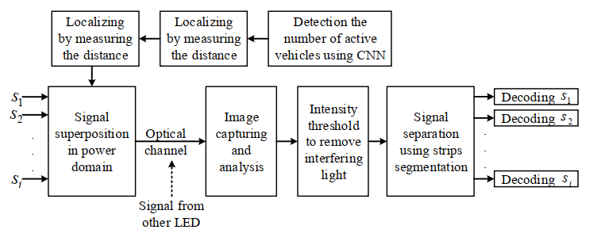
Figure 2: Data encoding scheme of 2-stage power allocation based NOMA-OCC system

The NOMA-OCC principle is illustrated in Fig. 2. According to the principle of NOMA, bipolar signals for different users are superimposed in the power domain. In this NOMA-OCC system, these superimposed signal is sent through an optical channel at a very high carrier frequency beyond the perceivable range of the human eye. As OCC systems use IS as a receiver, it initially receives LED ON–OFF strips image of various intensity levels. Thus to receive the desired signal, successive interference cancellation is performed by intensity threshold over the received strips.

Technology Advantages

Advantage of the novel PDO-NOMA technique for bi-directional hybrid vehicular OCC system using dual camera.
• Data transmission considering massive-link setup on the basis of PDO-NOMA in OCC.
• Development of a new localization mechanism based on counting vehicles and their relative positions and accuracy improvement
• Development of a highly efficient and real-time power allocation scheme based on the number of active cars inside the field of view of the camera.

