**IEEE P802.15**

**Wireless Personal Area Networks**

|  |  |
| --- | --- |
| Project | IEEE P802.15 Working Group for Wireless Personal Area Networks (WPANs) |
| Title | **Kookmin Suggested MIMO On-Off Keying for Optical IoT system** |
| Date Submitted | [July 2021] |
| Source | Huy Nguyen and Yeong Min Jang  (Kookmin University) |
| Re: |  |
| Abstract | Suggested the MIMO On-Off Keying for Optical IoT system |
| Purpose | Suggested the MIMO On-Off Keying for Optical IoT system |
| Notice | This document has been prepared to assist the IEEE P802.15. It is offered as a basis for discussion and is not binding on the contributing individual(s) or organization(s). The material in this document is subject to change in form and content after further study. The contributor(s) reserve(s) the right to add, amend or withdraw material contained herein. |
| Release | The contributor acknowledges and accepts that this contribution becomes the property of IEEE and may be made publicly available by P802.15. |

# **Introduction**

On-off keying (OOK) denotes the simplest form of amplitude-shift keying (ASK) modulation that represents digital data as the presence or absence of a carrier wave. The presence of a carrier for a specific duration represents a binary one, while its absence for the same duration represents a binary zero. Some more sophisticated schemes vary these durations to convey additional information. It is analogous to unipolar encoding line code.

In this study, we proposed MIMO OOK scheme which use RoI algorithm to detect and decode data. Even though RoI-signaling mode has a very low data rate, it is indispensable to the OCC system operating with long-range communication.

# **System Architecture**



Reference architecture of MIMO-OOK based RoI signaling for Optical IoT system

We provide details of the MIMO C-OOK scheme. Unlike the conventional OOK scheme, we used RoI algorithms to detect light sources and OCC signal. And MIMO technique was applied to increase data rate. Another, to detect preambles and decode data, we used a matched filter instead of the zero-crossing filter

# **Data packet structure**



Proposed data frame structure for MIMO-OOK scheme

The below figure illustrates the proposed data frame structure for the MIMO-OOK scheme. To access many users, we have added the node ID part to each frame. Each user will be defined by a unique ID, so that the receiver can categorize the signal from different users. Defining users by ID nodes helps the system accept dozens of users, up to hundreds of users. Furthermore, when module devices have many sensors, the amount of data is large. As such, we propose the use of multiple LEDs to increase the data rate. Additionally, we propose the addition of LED-ID to the data frame structure to support the receiver’s detection and collection of data.

# **Asynchronous Decoding**



Intensity of expected signal via RoI signaling



Intensity of noise signal via RoI signaling

As previously discussed, we added a preamble into each packet to detect the start frame. This is a special bit sequence, whose definition is based on the RLL code that has been used, and which both the transmitter and receiver know in advance. A preamble has two tasks. Firstly, the receiver can classify the signal light source and unexpected light sources (such as background light and noise light). By using the expected signal, payload data is inputted between two preambles. However, there is no significant change in the intensity of unexpected signals or noise signals.

After categorizing the expected noise, the signal is passed through the matched filter to detect the start frame. The desired data is in the middle part, between two adjacent preambles. Then, we can decode and categorize data packets from any user, based on the LED-ID and Node ID.

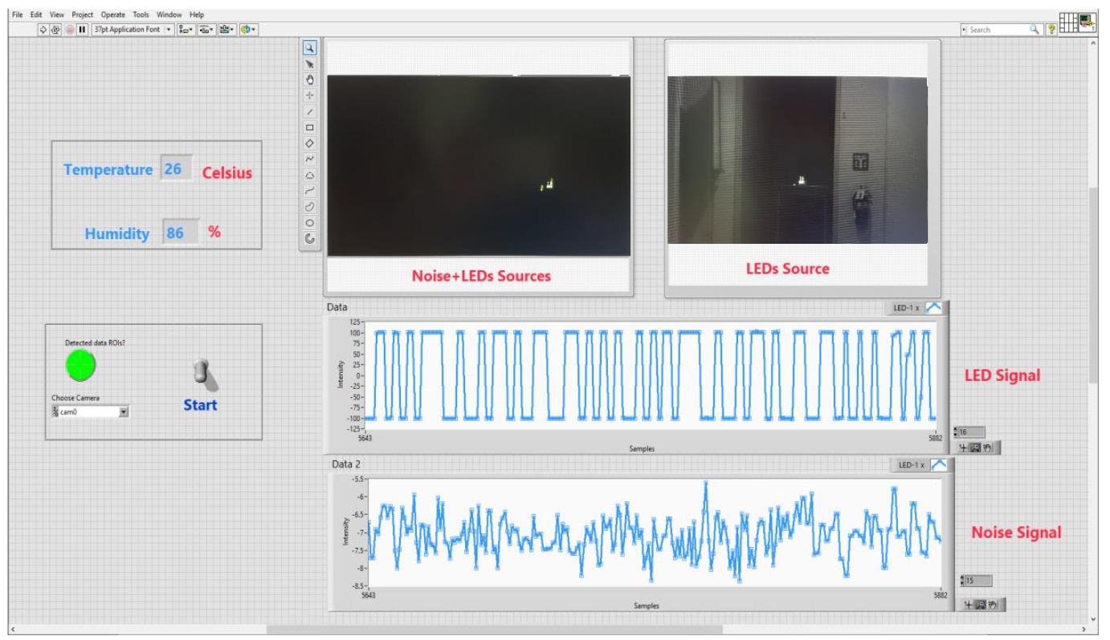

**Rx Interface**