**IEEE P802.15**

**Wireless Personal Area Networks**

|  |  |
| --- | --- |
| Project | IEEE P802.15 Working Group for Wireless Personal Area Networks (WPANs) |
| Title | **Kookmin Suggested** **Hybrid RoI signaling for Vehicle OCC system** |
| Date Submitted | [July 2021] |
| Source | Huy Nguyen and Yeong Min Jang  (Kookmin University) |
| Re: |  |
| Abstract | Suggested the Hybrid RoI signaling for Vehicle OCC system |
| Purpose | Suggested the Hybrid RoI signaling for Vehicle OCC system |
| Notice | This document has been prepared to assist the IEEE P802.15. It is offered as a basis for discussion and is not binding on the contributing individual(s) or organization(s). The material in this document is subject to change in form and content after further study. The contributor(s) reserve(s) the right to add, amend or withdraw material contained herein. |
| Release | The contributor acknowledges and accepts that this contribution becomes the property of IEEE and may be made publicly available by P802.15. |

# **Introduction**

S2-PSK is an operating mode being standardized at IEEE 802.15.7-2018. This scheme was proposed to be more suitable with vehicular applications with light pairs in cars. Pairs of lights transmit data by controlling the phase of two waveforms, which are created by a couple of lights.

Orthogonal Frequency-Division Multiplexing (OFDM) is a digital multi-carrier modulation scheme that is employed in broadband wired and wireless communication as an effective solution with Inter-Symbol Interference (ISI) caused by a multipath channel. Rolling Shutter OFDM scheme was proposed to take advantage of OFDM waveform for OCC system.

In this study, we proposed the hybrid waveform, which was combined two waveforms: S2-PSK and OFDM for Vehicular applications.

# **System Architecture**



System architecture of proposed hybrid OCC system for Vehicular Application

The S2-PSK and OFDM streams are transmit via the two LED backlight in vehicles. The S2-PSK scheme was shown as a candidate for the low-rate stream using RoI signaling when rolling shutter OFDM was applied for the high-rate stream. The high-rate data stream, based on the OFDM waveform, was embedded into the low-rate RoI stream in both the high period and the low period of the S2-PSK signal. Two data streams with identification signaling and high-rate data were deployed as the hybrid OCC scheme as figure.

# **Data packet structure**

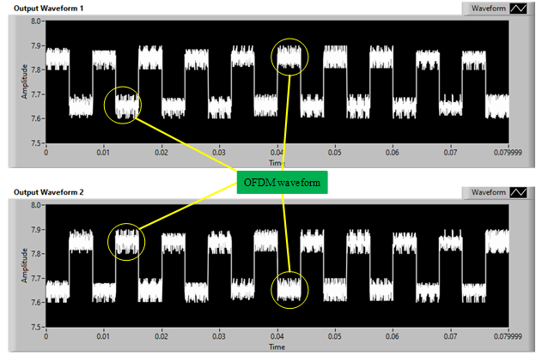

Hybrid waveform

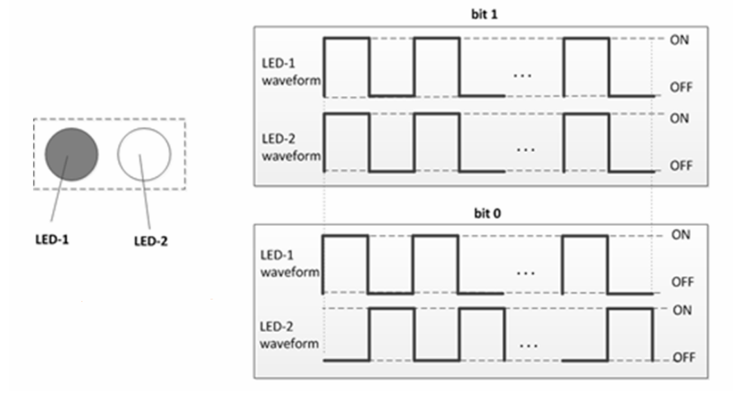

S2-PSK waveform

s

Data frame structure for Rolling-OFDM system in high speed stream

The SN represents the serial number of packets. In reality, we can divide two cases depending on the packet rate of the transmitter and the frame rate of the camera:

Case 1: Oversampling: the frame rate of camera is many times greater than the packet rate of the transmitter

Case 2: Undersampling: the frame rate of camera is less than the packet rate of the transmitter (LED)