**IEEE P802.15**

**Wireless Personal Area Networks**

|  |  |
| --- | --- |
| Project | IEEE P802.15 Working Group for Wireless Personal Area Networks (WPANs) |
| Title | **Kookmin Suggested MIMO Camera On-Off Keying scheme** |
| Date Submitted | [July 2021] |
| Source | Huy Nguyen and Yeong Min Jang  (Kookmin University) |
| Re: |  |
| Abstract | Suggested the MIMO C-OOK scheme for Optical Camera Communication system. |
| Purpose | Suggested the MIMO C-OOK scheme for Optical Camera Communication system. |
| Notice | This document has been prepared to assist the IEEE P802.15. It is offered as a basis for discussion and is not binding on the contributing individual(s) or organization(s). The material in this document is subject to change in form and content after further study. The contributor(s) reserve(s) the right to add, amend or withdraw material contained herein. |
| Release | The contributor acknowledges and accepts that this contribution becomes the property of IEEE and may be made publicly available by P802.15. |

# **Introduction**

On-off keying (OOK) denotes the simplest form of amplitude-shift keying (ASK) modulation that represents digital data as the presence or absence of a carrier wave. The presence of a carrier for a specific duration represents a binary one, while its absence for the same duration represents a binary zero. Some more sophisticated schemes vary these durations to convey additional information. It is analogous to unipolar encoding line code. In this study, we propose MIMO C-OOK scheme, which updated the conventional C-OOK scheme, used MIMO, region of interest, and matched filter techniques.

# **System Architecture**

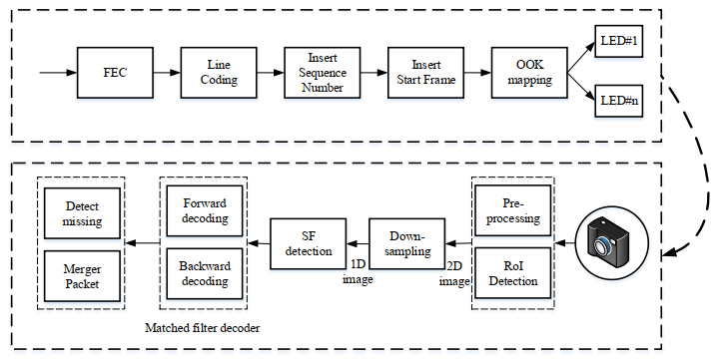

Reference architecture of the MIMO C-OOK scheme

We provide details of the MIMO C-OOK scheme. Unlike the conventional OOK scheme, we used RoI algorithms to detect light sources, MIMO technique to increase data rate. Another, to detect preambles and decode data, we used a matched filter instead of the zero-crossing filter.

# **Data packet structure**

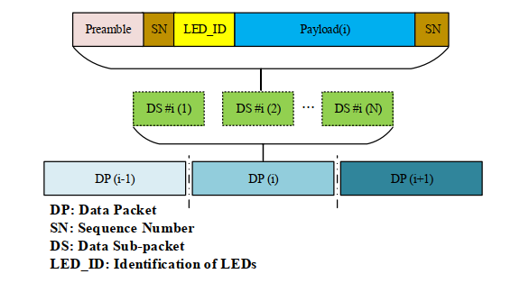

MIMO C-OOK data packet structure

The sequence number will be put in the head and tail of packet as above figure. To support the compatibility of frame rate variation, every packet can contain many sub-packets, and each sub-packet in the same packet has the same data payload with a Sequence Number (SN). The SN represents the serial number of packets. In reality, we can divide two cases depending on the packet rate of the transmitter and the frame rate of the camera:

Case 1: Oversampling: the frame rate of camera is many times greater than the packet rate of the transmitter  
Case 2: Undersampling: the frame rate of camera is less than the packet rate of the transmitter (LED)

# **Asynchronous Decoding**

* *Oversampling:*

When the frame rate of a rolling shutter camera is at least two times larger than the packet rate of the transmitter, the data packet is sampled multiple times causing the oversampling effect. When the packet is sampled more than once, errors of packet merger are created at the receiver’s end. The SN is added to the DS to deal with this problem because it improves the receiver’s ability to decrease the effect of the frame rate variation of the camera. The redundant data will be removed in the receiver when the same SN value is recognized in the DS of different packets. The receiver will eliminate consecutive packets with the same SN and choose packets with consecutive SN values (n − 1, n, n + 1) for the merger.

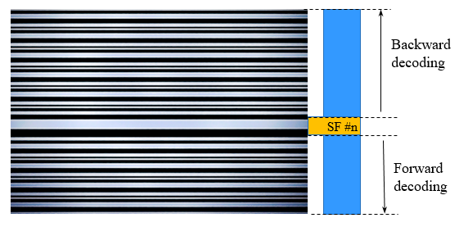

Merge Forward and Backward parts in each image (One SF in each image)



Full payload in each image (Multiple SF in each image)

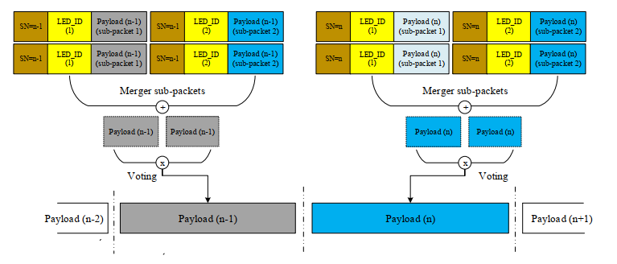

Merging packet of MIMO C-OOK scheme in multiple images

* *Undersampling:*

When the frame rate decreases below the packet rate of the transmitter, undersampling occurs. The payload will be lost in undersampling unlike in the case for oversampling. Figure below shows the scenario in which the missing payload is created and detected using the SN. In this case, the SN is long enough for the receiver to detect the missing payload. The SN of the data frame is increased depending on the sequences of the payload. If one payload is missing, the error can be detected by comparing the SN of the two adjacent DSs. The number of SNs in different states depends on the length of each sub-packet.

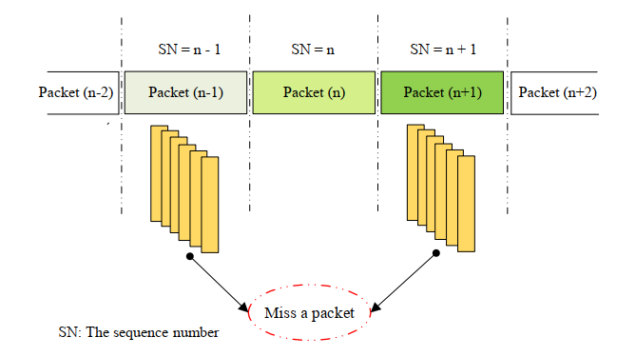

Error detection in grouping image during undersampling case

* *Matched filter*

The matched filter is a filter technology achieved by comparing a template signal with the real signal to determine the template signal in the real signal. The matched filter, which is one of the linear filter technologies, optimizes the SNR in the appearance of additive random noise. Matched filters are widely used in almost all wireless communication systems, such as mobile communications and radar systems to maximize the SNR of the system; these filters increase the system performance. To detect preamble positions, the received signal is multiplied with the known preamble signal via the convolution algorithm as Equation (1):

$(f*g)(t)≜\int_{-∞}^{+∞}{f\left(τ\right)g\left(t-τ\right)dτ}$ (1)

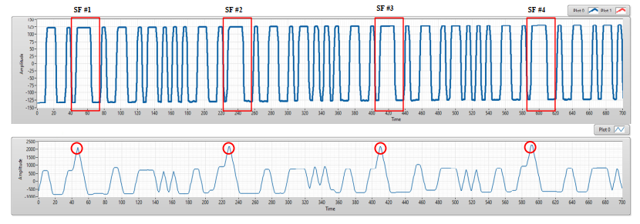

(a) An experimental result of COOK within a rolling image. (b) The results of preamble position detection based on matched filter

After the detect preamble, to decode data, we also used the matched filter to decode data to improve the system performance. By create known patterns as Figure below, the received signal is multiplied with the known preamble signal via the convolution algorithm. From convolution results, we can know that: which patterns are the most like the received signal? From that, it is easy to verify the value of signals (0 or 1). Same with the Manchester code, we can create 16 patterns of 4B6B code to decode data.

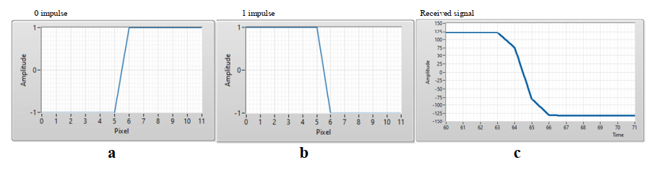

Manchester code signal patterns and COOK received signal. (a) 0 impulse, (b) 1 impulse, (c) COOK received signal.