**IEEE P802.15**

**Wireless Personal Area Networks**

|  |  |
| --- | --- |
| Project | IEEE P802.15 Working Group for Wireless Personal Area Networks (WPANs) |
| Title | **Kookmin Suggested Rolling Shutter OFDM scheme** |
| Date Submitted | [July 2021] |
| Source | Huy Nguyen and Yeong Min Jang  (Kookmin University) |
| Re: |  |
| Abstract | Suggested the Rolling Shutter OFDM scheme for Optical Camera Communication system. |
| Purpose | Suggested the Rolling Shutter OFDM scheme for Optical Camera Communication system. |
| Notice | This document has been prepared to assist the IEEE P802.15. It is offered as a basis for discussion and is not binding on the contributing individual(s) or organization(s). The material in this document is subject to change in form and content after further study. The contributor(s) reserve(s) the right to add, amend or withdraw material contained herein. |
| Release | The contributor acknowledges and accepts that this contribution becomes the property of IEEE and may be made publicly available by P802.15. |

# **Introduction**

Orthogonal Frequency-Division Multiplexing (OFDM) was introduced by Bell Lab in 1966 but only reached sufficient maturity for standardization and employment in the 1990s. By using multi-carriers, the OFDM scheme has many advantages compared to a single-carrier modulation scheme. The OFDM system is a special form of Frequency-Division Multiplexing (FDM), dividing the high bit rate stream into lower bit rate streams and simultaneously transmitting all streams through orthogonal subcarriers. By splitting the bandwidth, the OFDM system can mitigate the ISI by adding a Cyclic Prefix (CP) to the OFDM symbol, augmenting it enough to completely mitigate the negative impact of ISI. However, the CP interval does not carry a signal; therefore, the length of the CP must be carefully selected to balance ISI reduction effective performance. Throughout this study, we proposed the new scheme applying OFDM in OCC system based on rolling effect.

The definition of Discrete-Fourier Transform (DFT) is well-known and represented as a periodic transform:

 with k=0,1,2,…,N-1

Meanwhile, the Inverse-Discrete Fourier Transform (IDFT) is defined as follows:

 with n=0,1,2,…,N-1

The orthogonality between the subcarriers can be described as follows:



# **System Architecture**

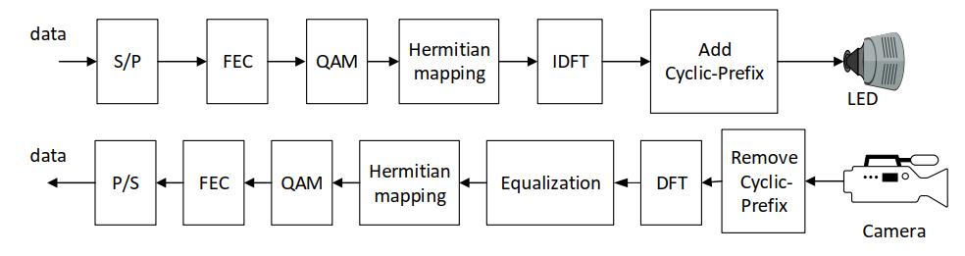

Block diagram of Architecture of Rolling Shutter-OFDM system

In this study, we present the technical details of a rolling-OFDM system. Unlike the conventional OFDM in Radio Frequency, instead of feeding the data symbol directly into the IDFT block, each symbol must pass through the Hermitian block. The signal is then fed into the IFFT. The special purpose of the Hermitian block is that it ensures the output of the IDFT is entirely real.

The following equation illustrates the Hermitian mapping process:

 for  and  (4)

 (5)

# **Data packet structure**

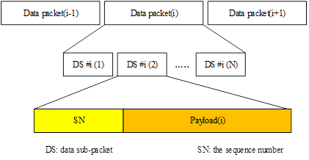

Proposed data frame structure for Rolling-OFDM system

To support the compatibility of frame rate variation, every packet can contain many sub-packets, and each sub-packet in the same packet has the same data payload with a Sequence Number (SN). The SN represents the serial number of packets. In reality, we can divide two cases depending on the packet rate of the transmitter and the frame rate of the camera:

Case 1: Oversampling: the frame rate of camera is many times greater than the packet rate of the transmitter  
Case 2: Undersampling: the frame rate of camera is less than the packet rate of the transmitter (LED)

# **Asynchronous Decoding**

* *Oversampling:*

The Oversampling caused by the frame rate variation of the rolling shutter camera when the frame rate of a rolling-shutter camera becomes many times greater (at least double) than the packet rate of the transmitter, every data packet is sampled at least twice (i.e., two images). At the receiver, we receive the same packet causing confusions of packet merger. To assist the receiver in reducing the effect of the frame rate variation of the camera, the SN is added to DS. Each packet contains DSs with the same SN, which helps the receiver remove redundant data. When the receiver receives a DS, it will choose which has a compatible SN. The receiver will eliminate consecutive packets with the same SN and choose packets with consecutive SN (n-1, n, n+1) to the merger.

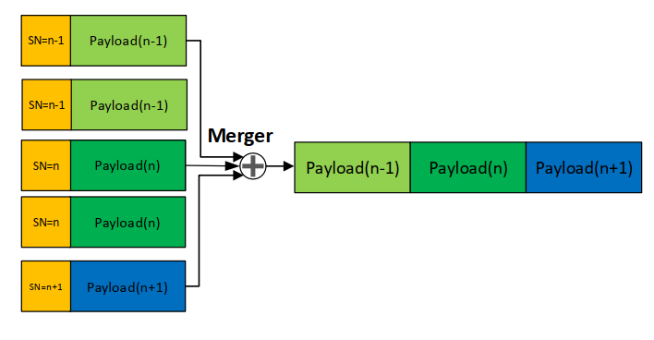

Merging packet method in Oversampling case

* *Undersampling:*

Undersampling occurs if the frame rate drops to below the packet rate of the transmitter. In this case, the payload will be lost. The detection of a missed payload using the SN is shown in figure. If the SN length is long enough, the missed payload can be detected by SN. The data frame achieved from the payload n–1 represents the SN as n–1. The next data frame indicates that the SN is n, but the actual data frame carries SN n+1. This demonstrates that the payload n is missed and the loss is detected by comparing the SN of the two adjacent data sub-packets. However, depending on the length of the SN, a number of different states are generated. For example, if the SN length is 3 bits, seven missing payloads of transmitted packets can be detected by the Sequence Number. The error correction becomes easy if the errors are detected. If two consecutive packets have two non-consecutive SN (n-1 and n+1), respectively.

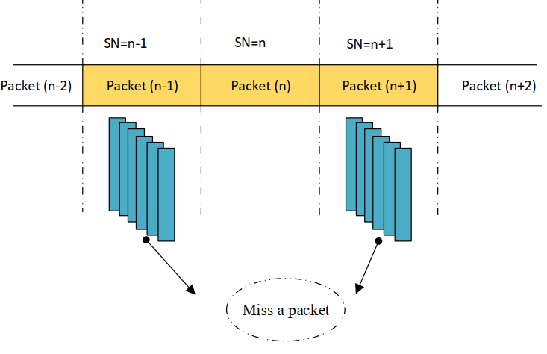

detecting missed packets in Undersampling case