IEEE P802.15
Wireless Personal Area Networks

Project | IEEE P802.15 Working Group for Wireless Personal Area Networks (WPANs)
Title | Relaying Comment Resolution Text
Date Submitted
Source | Refik Çağlar Kızılırmak, Nazarbayev University  Kai Lennert Bober, Fraunhofer HHI  Tunçer Baykaş, Kadir Has University  Murat Uysal, Özyeğin University | Voice: [ ]  Fax: [ ]  E-mail: [ ]
Re:
Abstract
Purpose | Comment resolution
Notice | This document has been prepared to assist the IEEE P802.15. It is offered as a basis for discussion and is not binding on the contributing individual(s) or organization(s). The material in this document is subject to change in form and content after further study. The contributor(s) reserve(s) the right to add, amend or withdraw material contained herein.
Release | The contributor acknowledges and accepts that this contribution becomes the property of IEEE and may be made publicly available by P802.15.

Legend:
- Arial size 13 indicates subsections for individual comments
- Red underlined text needs to be adapted during the comment implementation (e.g. because it is a reference).
- Bold italic text is an instruction to the editor to implement the text

REVISION HISTORY:

New Relayed Device Configuration Request and Relayed Device Configuration Response elements are added.

MCS ID information to be used for relayed frames is included in the Relay Configuration Response, Relayed Device Configuration Request and Relayed Device Configuration Response elements.

Relay Control field is added in Data Frame and Control Frame formats.

DESCRIPTION:

Step by step relaying mechanism is summarized below as reference.

STEP 1: Relay sends Association Request element and receives Association Response element.

STEP 2: Relay obtains GTS (GTS Descriptor elements or GTS Descriptor List element.)
This allocation is required for relay to transmit Reachable Address element to coordinator.

STEP 3: Relay sends Reachable Address element to coordinator

STEP 4: Coordinator sends Relay Device Configuration Request to relay device
This is required for relay device to know which devices it will serve

STEP 5: Relay device sends Relay Device Configuration Response to coordinator
Relay device confirms the list of devices that it will serve
It will only forward the frames that are destined to those devices

STEP 6: Coordinator sends Relay Device Configuration Request to device
This is required for devices to use relay. They will set Relayed Frame bit to 1.

STEP 7: Device sends Relay Device Configuration Response to coordinator
Device confirms that it will use relaying by setting Relayed Frame bit to 1.

STEP 8: Relay device request additional GTS.
GTSs for the relay link in the superframe after the ones allocated for the direct link by macRelayingOffset.
Device does not request additional GTS since its receiver is enabled all the time.

DRAFT-AMENDING TEXT:

Add the following definitions under 3.1:

relay device: A non-coordinator device that is used to forward data from a coordinator to a device and from a device to a coordinator.”

relayed device: A non-coordinator device whose frames are being relayed by a relay device.

relay link: A relay link is an indirect connection between a device and the coordinator through a relay device.

Remove the following sentence in P30L9:

“Relay device is a non-coordinator device and is used to forward data from a coordinator to a device and from a device to a coordinator.”

Add the following paragraph after P30L16:

Relaying functionality is supported only for beacon enabled multiple access mode. When multiple OFEs are used by the coordinator, relaying functionality is not supported.

Insert the following sentence after P38L37:

GTS for relay devices shall not overlap with GTS allocated to other devices.

Insert the following subclauses and update references therein:

5.10 Relaying

5.10.1 Determining potential relay configurations

A relay device shall indicate capRelay during the association as described in 5.3.4.3. After receiving an Association Response element indicating successful association and confirming the use of capRelay, the relay device starts listening to its environment and collecting the transmitter addresses of observed MPDUs.

NOTE--Due to the nature of wireless communications, a device in the OWPAN will be able to receive and decode transmissions from all other devices complying with this standard that are in the same coverage area.

The relay device shall periodically transmit a Reachable Address element to the coordinator. The periodicity is implementation-specific. Fig. x shows the exchange of the Reachable Address element between the potential relay device and the coordinator.

Upon receiving a Reachable Address element, the coordinator shall decide whether to use relaying for communication with the devices in the Reachable Address element. The coordinator may activate the relaying for a certain device as described in 5.10.2. The coordinator may deactivate the relaying for a certain device at any time as described in 5.10.3. The coordinator should deactivate the relaying for a certain device when it was previously reachable by the relay device and determined permanently not reachable anymore.

In the presence of multiple relay devices in the environment, coordinator may choose more than one relay for a device.
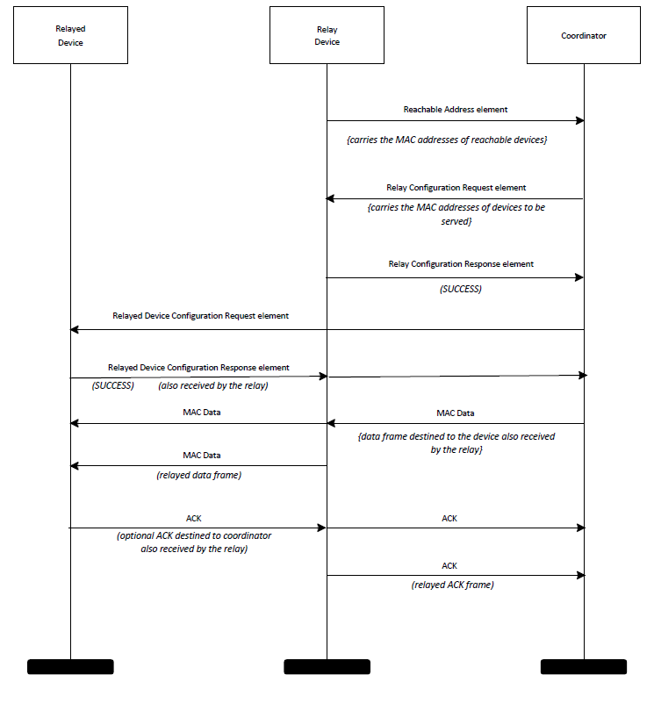
Fig. X Relay activation chart for relaying operation

5.10.2 Activating a relay link

To configure a relay device and activate a relay link, the coordinator shall send Relay Device Configuration Request element, as described in 6.6.29, to the intended relay device with the Relay Active field set to one and the Relay Link Address field set to the address of the device intended to have the relay link.

Upon receiving the Relay Configuration Request element from the coordinator, the intended relay device shall answer with a Relay Configuration Response element. It shall set the Status field to SUCCESS if the request was accepted and DENIED otherwise. The intended relay device shall include the usable MCS ID for transmissions from the intended relayed device to the relay device in the Relay Configuration Response element.

Upon receiving a Relay Configuration Response element with Status set to SUCCESS from the intended relay device, the coordinator shall transmit Relayed Device Configuration Request element to the intended relayed device.

Upon receiving the Relayed Device Configuration Request from the coordinator, the intended relayed device shall answer with a Relayed Device Configuration Response. It shall set the Status field to SUCCESS if the request was accepted and DENIED otherwise. The intended relayed device shall include the usable MCS ID for transmissions from the intended relay device to the relayed device in the Relayed Configuration Response element. The frame containing the Relayed Device Configuration Response element shall have the Relayed Frame field set to one. The intended relay device shall thus decode the frame and if the Status field is SUCCESS, shall store the MCS to use for future relayed transmissions to the intended relayed device.

If the coordinator receives a Relayed Device Configuration Response element with Status other than SUCCESS from the intended relayed device, the coordinator shall undo the configuration of the relay device as described in 5.10.3.

5.10.3 Deactivating a relay link

To deactivate a relay link, the coordinator shall transmit the same Relay Device Configuration Request and Relayed Device Configuration Request elements to the active relay device and the relayed device. Those elements shall have the Relay Active field set to zero and the Relay Link Address set to the device that had a relay link.

If the relay device or a device for which relaying is active leaves the OWPAN as described in 5.5.7, the coordinator shall deactivate the relaying in the remaining relay device or relayed device only.

A relayed device should deactivate a relay link when it notices that an active relay device is not reachable by the configured MCS anymore. A relay device should deactivate a relay link when it notices that a relayed device is not reachable by the configured MCS anymore.

5.10.4 Relaying frames

The relay device obtains GTS for relayed transmissions like any other device as described in 5.3.4.

The frames that will be relayed shall be sent with Relayed Frame field set to one as described in 6.2.2. The frames, either sent from coordinator to device or from device to coordinator, are also received by the relay device. The relay device accepts and stores the frames with Relayed Frame field set to one. If the frame is valid, its MAC sublayer then relays the frame as it is. The MCS to use for relayed frames shall be the one configured at relay link activation as described in 5.10.2.

ACK frames are relayed like any other frame. A relay device does not acknowledge any frame sent to it.

A frame with a destination address equal to the broadcast address shall be relayed like any other frame.

If the capFullDuplex was agreed during association with the device, the relay device may perform relaying simultaneously to both directions.

NOTE – This is possible without self-interference due to the directive nature of light propagation.

Add the following two rows to the Table 37 MAC Capabilities

Name | ID | Description | Required Capabilities
capRelayedDevice | X | The device supports relaying procedure
capRelayDevice | X | The device supports acting as a relay.

Add the new subclause under 6.6:

6.6.28 Reachable Address element

The format of the Reachable Address element is shown in Fig X2

1 Octet | 6 Octets | … | 6 Octets
Address Count  (N) | Reachable  Address 1 |  | Reachable  Address N

Fig X2 – Reachable Address element

Address Count: The Address Count field is an integer representing the number of addresses in the Reachable Addresses field.

Reachable Addresses 1 … N: These fields contain one or more MAC addresses of reachable, i.e. observed, devices.

Insert the following new subclause:

6.6.29 Relay Device Configuration Request element

The format Relay Device Configuration Request element is depicted in Figure X3.

Bit 0 | Bits 1-7 | 6 Octets
Relay Active | reserved | Device Address
Figure X3 – Relay Device Configuration Request Element

Relay Active: The Relay Active field is set to one to indicate that relaying is active. The Relay Active field is set to zero to indicate that relaying is not active.

Device Address: The Device Address field contains the address of the intended relayed device.

6.6.30 Relay Configuration Response element

The format Relay Configuration Response element is depicted in Figure X4.

1 Octet | 6 Octets | 1 Octet
Status  Code | Device  Address | MCS ID
Figure X4 – Relay Configuration Response Element

Status Code: The status code indicates the result of the preceding relay configuration request. Status codes are listed in Table Y1.

Table Y1 Status codes of the Relay Configuration Response element

Value | Description
0 | reserved
1 | DENIED
2 | SUCCESS
3-255 | reserved

MCS ID: The MCS ID indicates the MCS ID to use for relayed frames.

Device Address: This field shall contain the value from the Device Address field from the corresponding Relay Device Configuration Request element.

6.6.31 Relayed Device Configuration Request element

The format Relayed Device Configuration Request element is depicted in Figure X5.

Bit 0 | Bits 1-7 | 6 Octets | 1 Octet
Relay Active | reserved | Device Address | MCS  ID
Figure X5 – Relayed Device Configuration Request Element

Relay Active: The Relay Active field is set to one to indicate that relaying is active. The Relay Active field is set to zero to indicate that relaying is not active.

Device Address: The Device Address field contains the address of the devices that may become a relayed device. In case the element is sent to the intended relayed device, the field shall contain the address of the intended relay device.

MCS ID: The MCS ID field contains the MCS to be used for relayed frames.

6.6.32 Relayed Device Configuration Response element

The format Relayed Device Configuration Response element is depicted in Figure X6.

1 Octet | 6 Octets | 1 Octet
Status  Code | Device  Address | MCS ID
Figure X6 – Relayed Device Configuration Response Element

Status Code: The status code indicates the result of the preceding relay configuration request. Status codes are listed in Table Y2.

Table Y2 Status codes of the Relay Configuration Response element

Value | Description
0 | reserved
1 | DENIED
2 | SUCCESS
3-255 | reserved

Device Address: This field shall contain the value from the Device Address field from the corresponding Relay Device Configuration Request element.

MCS ID: The MCS ID indicates the MCS ID to use for relayed frames.

Append the following rows to Table 12

ID | Element | Subclause
17 | Reachable Address element | 6.6.28
18 | Relay Device Configuration Request element | 6.6.29
19 | Relay Configuration Response element | 6.6.30
20 | Relayed Device Configuration  Request element | 6.6.31
21 | Relayed Device Configuration  Response element | 6.6.32

In Figure 31, change Bit 10 Field name from “reserved” to “Relayed Frame”

Add the following paragraph after P63L10:

Relayed Frame: This field shall be set to one if the frame is relayed. It shall be set to zero otherwise. If the bit is set to one, the Relay Control field is present in the MPDU.

Add the Relay Control Field in figure 30, general frame format, as follows:

2 Octets | 0/2 Octets | 2/6 Octets | 2/6 Octets | 0/6 Octets | 0/6  Octets | 2  Octet | variable | 4 Octets
Frame  Control | Poll  ACK | Receiver  Address | Transmitter  Address | Auxiliary  Address | Relay  Control | Sequence  Control | Payload | FCS
MAC Frame Header (MHR)

Add the following description for the Relay Control field.

X.X.X Relay Control field

This field contains the MAC address of the relay device if the data frame is exchanged through a relay link between coordinator and relayed device. It is only present if the Relayed Frame field in of the Frame Control field is one. Otherwise, the field does not exist

Add the Relay Control field to the data, control and management frames in Figure 34, 35, and 36 respectively.

