IEEE P802.15
Wireless Personal Area Networks

Project | IEEE P802.15 Working Group for Wireless Personal Area Networks (WPANs)
Title | Relaying Comment Resolution Text
Date Submitted
Source | Refik Çağlar Kızılırmak  Nazarbayev University  Tunçer Baykaş  Kadir Has University  Murat Uysal  Özyeğin University | Voice: [ ]  Fax: [ ]  E-mail: [ ]
Re:
Abstract
Purpose | Comment resolution
Notice | This document has been prepared to assist the IEEE P802.15. It is offered as a basis for discussion and is not binding on the contributing individual(s) or organization(s). The material in this document is subject to change in form and content after further study. The contributor(s) reserve(s) the right to add, amend or withdraw material contained herein.
Release | The contributor acknowledges and accepts that this contribution becomes the property of IEEE and may be made publicly available by P802.15.

Legend:
- Arial size 13 indicates subsections for individual comments
- Red underlined text needs to be adapted during the comment implementation (e.g. because it is a reference).
- Bold italic text is an instruction to the editor to implement the text
Add the following definitions under 3.1:

relay device: A non-coordinator device that is used to forward data from a coordinator to a device and from a device to a coordinator.”

relay link: A relay link is an indirect connection between a device and the coordinator through a relay device.

Remove the following sentence in P30L9:

“Relay device is a non-coordinator device and is used to forward data from a coordinator to a device and from a device to a coordinator.”

Insert the following sentence after P38L37:

GTS for relay devices shall not overlap with GTS allocated to other devices.

Insert the following subclauses:

5.10 Relay Operations

A relay device shall indicate capRelay during the association as described in 5.3.4.3. After receiving an Association Response element indicating successful association and confirming the use of capRelay, the relay device starts listening to its environment and collecting the transmitter addresses of observed MPDUs.

Due to the nature of wireless communications, a device in the OWPAN will be able to receive and decode transmissions from all other devices complying with this standard that are in the same coverage area.

DME of the relay device shall periodically issue a request to listen the reachable devices in its environment. Fig. x shows the periodic message exchange between the relay device and coordinator.

In beacon enabled mode, relay device obtains GTS as described in 5.3.4 then sends the Reachable Address element to the coordinator in its allocated GTS. In non-beacon-enabled mode, relay device sends the Reachable Address element to the coordinator after it is polled.

Upon receiving Reachable Address element, the coordinator shall decide whether to use relaying for communication with the devices in the Reachable Address element. The decision algorithm is out scope of this standard.

Once the coordinator decides which devices will be served by the relay device, it sends control frames containing Relay Activation element with Relay Activation Mode set to 1 (request), as described in 6.6.29, to both relay device and the devices that will have a relay link. The Relay Activation elements convey the address information of the device(s) to be served to the relay device and of the relay device to the devices. On the receipt of Relay Activation element with Relay Activation Mode set to 1 (request), both device and relay device shall send Relay Activation element with Relay Activation Mode set to 0 (response) to the coordinator.

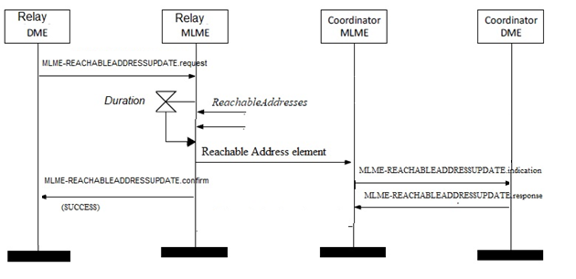
Fig. x Relay activation chart for relaying operation

In the presence of multiple relay devices in the environment, coordinator can choose more than one relay for a device.

The frames that will be relayed shall be sent with Relayed Frame field set to 1 as described in 6.2.2. The frames, either sent from coordinator to device or from device to coordinator, are also received by the relay device. The relay device accepts and stores the frames with Relayed Frame field set to 1. If the frame is valid, its MAC sublayer then relays the frame as it is.

In beacon-enabled mode, both the device and the relay device request additional GTS, as described in 5.3.4.4, to perform relaying and shall await updated GTS allocations from the coordinator. The coordinator shall position the GTSs for the relay link in the superframe after the ones allocated for the direct link by macRelayingOffset. The algorithm for defining macRelayingOffset is out of scope of this standard.

In non-beacon-enabled mode, the relay device relays the frames after it is polled. Coordinator shall poll relay devices after it polls the links without relay.

A frame with a destination address equal to the broadcast address shall be handled and shall also be relayed.

If the capFullDuplex was agreed during association with the device, the relay device can perform relaying simultaneously to both directions without self-interference due to the directive nature of light propagation.

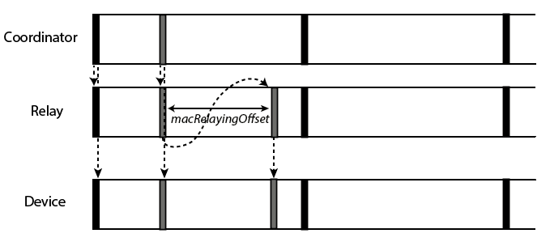
- From coordinator to a device

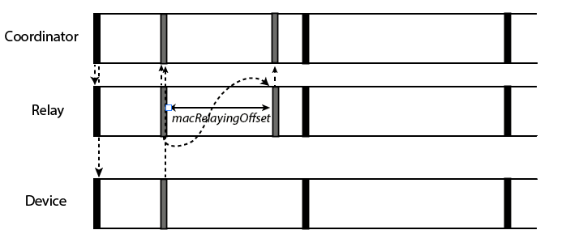

- From device to the coordinator
Fig. X Relaying frames for the beacon enabled OWPAN coordinator and a device
This figure is optional

If the relay device wants to leave the OWPAN, it initiates disassociation as in 5.5.7.

7.5 Capabilities
Add the row to the Table 37 MAC Capabilities
Name | ID | Description | Required Capabilities
CapRelay | 7 | The device supports relaying procedure

6.6.28 Reachable Address element
The format of the Reachable Address element is shown in

2 Octets | 1 Octet | Variable
Initiator Address | Address Count | Reachable  Addresses

Fig X – Reachable Address element
The Initiator Address: The initiator Address field indicates the short address of the Relay Device that transmits the Reachable Address element.

The Address Count: The Address Count field is an integer representing the number of addresses in the Reachable Addresses field.

The Reachable Addresses: The Reachable Addresses field contains one or more Reachable Address subfields.

The Reachable Address subfields indicate the short addresses that can be reached through the Relay Device. The format of the Reachable Address subfield is shown in Figure X.

Bit 0 | Bit 1-7 | Bit 8-15
Add/Remove | Reserved | Address

Fig X – Reachable Addresses subfield

Add/Remove: The Add/Remove subfield is set to 1 if the short address is the address of a new Device detected by the Relay Device. Add/Remove subfield is set to 0 if the short address is the address of a Device has left the relay’s coverage.

6.6.29 Relay Activation Element

The format Relay Activation element is depicted in Figure X.

Bit 0 | Bit 1-2 | Bit 3-7 | 1 Octet | Variable
Relay Activation  Mode | Direction | Reserved | Address Count | Relay link Addresses
Figure X – Relay Activation Element

Relay Activation Mode: The Relay Activation Mode field is set to 1 to indicate that this element is a Relay Activation Request. The relay activation request is initiated by coordinator. The Relay Activation Mode field is set to 0 to indicate the Relay Activation Response.

Direction: The Direction field set to 11 indicates that the Relay Activation element is exchanged between coordinator and device. When it is 01, the Relay Activation element is exchanged between coordinator and relay device. Values 00 and 10 are reserved.

Address Count: The address count field is an integer representing the number of addresses in the Relay Link Addresses field.

Relay Link Addresses: The Relay Link Addresses field contains one or more short address fields. If the Relay Activation element is exchanged between the relay device and coordinator, the Relay Link Addresses are the addresses of the devices to be served by that relay. Similarly, if it is exchanged between the device and coordinator, the Relay Link Addresses are addresses of the relay device(s) that will serve that particular device.

2 Octet | 2 Octet | …
Address 1 | Address 2 | …

Fig X – Relay Link Addresses field

If the Relay Activation Mode is set to 0 (response), the Address Count and Relay Link Addresses fields shall be empty.

Table 12 Element IDs

Append the following rows to Table 12

ID | Element | Subclause
17 | Reachable Address element | 6.6.28
18 | Relay Activation Element | 6.6.29

6.2.2 Frame Control Field

Change Bit10 Field name from “reserved” to “Relayed Frame”

Add the following paragraph:

Relayed Frame: This field shall be set to 1 if relayed link is used and set to 0 otherwise.

4.7.2.4 Data transfer through a relay device

Add the following paragraph at the end.

When multiple OFEs are used by the coordinator, relaying functionality is not supported.

7.3.9 MLME-REACHABLEADDRESSUPDATE

7.3.9.1 General Description

The MLME-REACHABLEADDRESSUPDATE primitive is invoked by a relay in order to scan and obtain the addresses of other devices in its environment as described in 5.10.

7.3.9.2 MLME-REACHABLEADDRESSUPDATE.request

The MLME-REACHABLEADDRESSUPDATE.request is issued by the DME of a relay device to the MLME in order to scan the addresses of other devices in its environment.

The semantics of the primitive are as follows:

MLME-REACHABLEADDRESSUPDATE.request (
Duration
MaxNumberAddresses
)

Table X MLME-REACHABLEADDRESSUPDATE.request primitive

Name | Type | Valid Range | Description
Duration | integer milliseconds | [1, 65535] | The time after which the scanning reachable address shall be stopped. If the given time has passes since invocation of the primitive, the MLME shall respond with the corresponding MLME-REACHABLEADDRESSUPDATE.confirm primitive, indicating success or failure.
MaxNumberAddresses | integer | [1,65535] | If the number of reachable addresses found exceeds MaxNumberAddresses, scanning is stopped. The MLME shall respond with the corresponding MLME-REACHABLEADDRESSUPDATE.confirm primitive

7.3.9.3 MLME-REACHABLEADDRESSUPDATE.confirm

The MLME-REACHABLEADDRESSUPDATE.confirm primitive is issued by the MAC sublayer of a relay device to report the result of the previously requested association attempt to the DME.

The semantics of the primitive are as follows:

MLME-REACHABLEADDRESSUPDATE.confirm (
AddressCount
ReachableAddresses
Status
)

Name | Type | Valid Range | Description
AddressCount | integer | [1,65535] | Number of reachable addresses found.
ReachableAddresses | List of 48-bit MAC addresses | Device addresses | The full 48-bit address of the reachable devices
Status | enumeration | SUCCESS, FAIL_READ_ONLY, FAIL_NON_EXISTENT, FAIL_OTHER | The result of REACHABLEADDRESSUPDATE process.

7.3.9.4 MLME-REACHABLEADDRESSUPDATE.indication

The MLME-REACHABLEADDRESSUPDATE.indication primitive is issued by the MAC sublayer of a coordinator to inform the DME about the reachable addresses of a relay device from which it received Reachable Address element.

The semantics of the primitive are as follows:

MLME-REACHABLEADDRESSUPDATE.indication (
Relay Address
Address Count
ReachableAddresses
)

Name | Type | Valid Range | Description
Relay Address | 48-bit MAC address | The full 48-bit address of the relay device | MAC address of the relay device from which Reachable Address element was received.
AddressCount | integer | [1,65535] | Number of reachable addresses found.
ReachableAddresses | List of 48-bit MAC addresses | Device addresses | The full 48-bit address of the reachable devices

7.3.9.5 MLME-REACHABLEADDRESSUPDATE.response

The MLME-REACHABLEADDRESSUPDATE.response primitive is used by a coordinator DME to respond to a MLME-REACHABLEADDRESSUPDATE.indication after deciding how to respond to relay device with Relay Activation element.

The semantics of the primitive are as follows:

MLME-REACHABLEADDRESSUPDATE.response (
Relay Address
Address Count
Served Addresses
Status
)

Name | Type | Valid Range | Description
Relay Address | 48-bit MAC address | The full 48-bit address of the relay device | MAC address of the relay device from which Reachable Address element was received.
AddressCount | integer | [1,65535] | Number of addresses that the relay is decided to serve
Served Addresses | List of 48-bit MAC addresses | Device addresses | The full 48-bit address of the devices that are going to be served by the relay
Status | integer | Status Ids according to Table 5. | The result of the decision about using the relay

P88L1 Update Table 16 Parameters of the MCPS-DATA.indication primitive

MLME-SAP primitive | Request | Confirm | Indication | Response
MLME-REACHABLEADDRESSUPDATE | 7.3.9.2 | 7.3.9.3 | 7.3.9.4 | 7.3.9.5

