IEEE P802.15
Wireless Personal Area Networks

Project | IEEE P802.15 Working Group for Wireless Personal Area Networks (WPANs)
Title | Relaying Comment Resolution
Date Submitted
Source | Refik Çağlar Kızılırmak  Nazarbayev University  Tunçer Baykaş  Kadir Has University | Voice: [ ]  Fax: [ ]  E-mail: [ ]
Re:
Abstract
Purpose | Comment resolution
Notice | This document has been prepared to assist the IEEE P802.15. It is offered as a basis for discussion and is not binding on the contributing individual(s) or organization(s). The material in this document is subject to change in form and content after further study. The contributor(s) reserve(s) the right to add, amend or withdraw material contained herein.
Release | The contributor acknowledges and accepts that this contribution becomes the property of IEEE and may be made publicly available by P802.15.

Insert the following subclauses.

5.10 Relay Operation
5.10.1 Relaying in Beacon Enabled Mode
5.10.2 Relaying in Non-Beacon Enabled Mode
6.6.28 Reachable Address element
6.6.29 Relay Activation Element

Update the relevant parts of the subclauses
6.2.2 Frame Control Field
7.5 Capabilities
Table 12 Elements ID

5.10 Relay Operations

A direct link is a link between a Device and the Coordinator.
A relay link is a multi-hop link between a Device and the Coordinator through a Relay Device.

5.10.1 Relaying in Beacon Enabled Mode

Relay device associates as in 5.3.4.3 with capRelay in Table 37 set to TRUE and requests GTS as described in 5.3.4.4.

Due to the nature of wireless communications, a device in the OWPAN will be able to receive and decode transmissions from all other devices complying with this standard that are on the same channel and are in its coverage area. After receiving Association Response, Relay Device listens to its environment and generates Reachable Address element as in 6.6.28 that contains the current list of reachable addresses of devices.

The Relay Device sends the control frame containing to Reachable Address element to the Coordinator in its allocated GTS.

Upon receiving Reachable Address element, the Coordinator shall decide whether to use relay for communicating the devices in Reachable Address element. The decision algorithm is out scope of this standard. Once the coordinator decides which devices will be served by the Relay Device, it sends control frames containing Relay Activation element with Relay Activation Mode set to 1 (request), as described in 6.6.29, to both Relay Device and the devices that will have a relay link. The Relay Activation elements convey the address information of the device(s) to be served to the Relay Device and of the Relay Device to the devices. On the receipt of Relay Activation element with Relay Activation Mode set to 1 (request), both device and Relay Device shall send Relay Activation element with Relay Activation Mode set to 0 (response) to Coordinator.

In the presence of multiple relay devices in the environment, Coordinator can choose more than one relay for a device.

Both the device and the Relay Device request additional GTS, as described in 5.3.4.4, to perform relaying and shall await updated GTS allocations from the coordinator. The Coordinator shall position the GTSs for the relay link in the superframe after the ones allocated for the direct link by macRelayingOffset. The algorithm for defining macRelayingOffset is out of scope of this standard.

The relaying procedure is shown in Fig. X. The frames that will be relayed shall be sent with ToBackHaul and FromBackHaul fields set to 1 as described in 6.6.2. The frames, either sent from Coordinator to device or from device to coordinator, are also received by the Relay device. The Relay Device accepts only the frames whose Auxiliary Address field is set to its address. If the frame is valid, its MAC sublayer relays the frames as it is.

A frame with a destination address equal to the broadcast address shall be handled and shall also be relayed.

If the capFullDuplex was agreed during association with the device, the Relay Device can perform relaying simultaneously to both directions without self-interference due to the directive nature of light propagation.

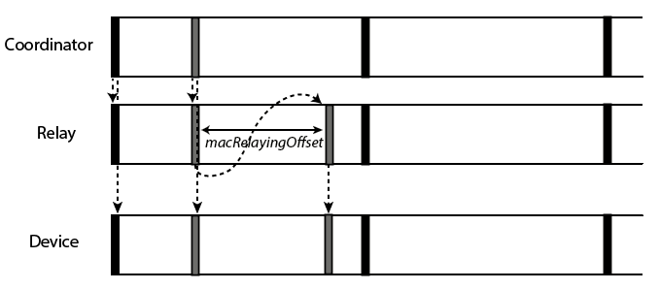
- From coordinator to a device

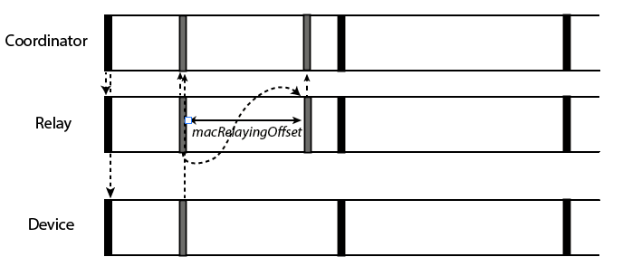

- From device to the coordinator
Fig. X Relaying frames for the beacon enabled OWPAN coordinator and a device

If the Relay Device wants to leave the OWPAN, it initiates disassociation as in 5.5.7.

6.2.2 Frame Control Field
Add the following row to Table 1, To Backhaul and From Backhaul field description

To Backhaul | From Backhaul | Description | Receiver address | Transmitter address | Auxiliary address
1 | 1 | The frame originates from a different device and is destined to another device and used for relaying. | Address of the designated receiver. (= MSDU destination address) | Address of the original transmitter device. (= MSDU source address) | Address of the relaying device

7.5 Capabilities
Add the row to the Table 37 MAC Capabilities
Name | ID | Description | Required Capabilities
CapRelay | 7 | The device supports relaying procedure

6.6.28 Reachable Address element
The format of the Reachable Address element is shown in
2 Octets | 1 Octet | Variable
Initiator Address | Address Count | Reachable  Addresses

Fig X – Reachable Address element
The Initiator Address: The initiator Address field indicates the short address of the Relay Device that transmits the Reachable Address element.

The Address Count: The Address Count field is an integer representing the number of addresses in the Reachable Addresses field.

The Reachable Addresses: The Reachable Addresses field contains one or more Reachable Address subfields.

The Reachable Address subfields indicate the short addresses that can be reached through the Relay Device. The format of the Reachable Address subfield is shown in Figure X.

Bit 0 | Bit 1-7 | Bit 8-15
Add/Remove | Reserved | Address

Fig X – Reachable Addresses subfield

Add/Remove: The Add/Remove subfield is set to 1 if the short address is the address of a new Device detected by the Relay Device. Add/Remove subfield is set to 0 if the short address is the address of a Device has left the relay’s coverage.

6.6.29 Relay Activation Element

The format Relay Activation element is depicted in Figure X.

Bit 0 | Bit 1-2 | Bit 3-7 | 1 Octet | Variable
Relay Activation  Mode | Direction | Reserved | Address Count | Relay link Addresses
Figure X – Relay Activation Element

Relay Activation Mode: The Relay Activation Mode field is set to 1 to indicate that this element is a Relay Activation Request. The Relay Activation Mode field is set to 0 to indicate the Relay Activation Response.

Direction: The Direction field set to 11 indicates that the Relay Activation element is exchanged between coordinator and device. When it is 01, the Relay Activation element is exchanged between coordinator and Relay Device. Values 00 and 10 are reserved.

Address Count: The address count field is an integer representing the number of addresses in the Relay Link Addresses field.

Relay Link Addresses: The Relay Link Addresses field contains one or more short address fields depicted in Figure X. If the Relay Activation element is exchanged between the Relay Device and coordinator, the Relay Link Addresses are the addresses of the devices to be served by that relay. Similarly, if it is exchanged between the device and coordinator, the Relay Link Addresses are addresses of the Relay Device(s) that will serve that particular device.

2 Octet | 2 Octet | …
Address 1 | Address 2 | …

Fig X – Relay Link Addresses field

If the Relay Activation Mode is set to 0 (response), the Address Count and Relay Link Addresses fields shall be empty.

Table 12 Element IDs

Append the following rows to Table 12

ID | Element | Subclause
17 | Reachable Address element | 6.6.28
18 | Relay Activation Element | 6.6.29

