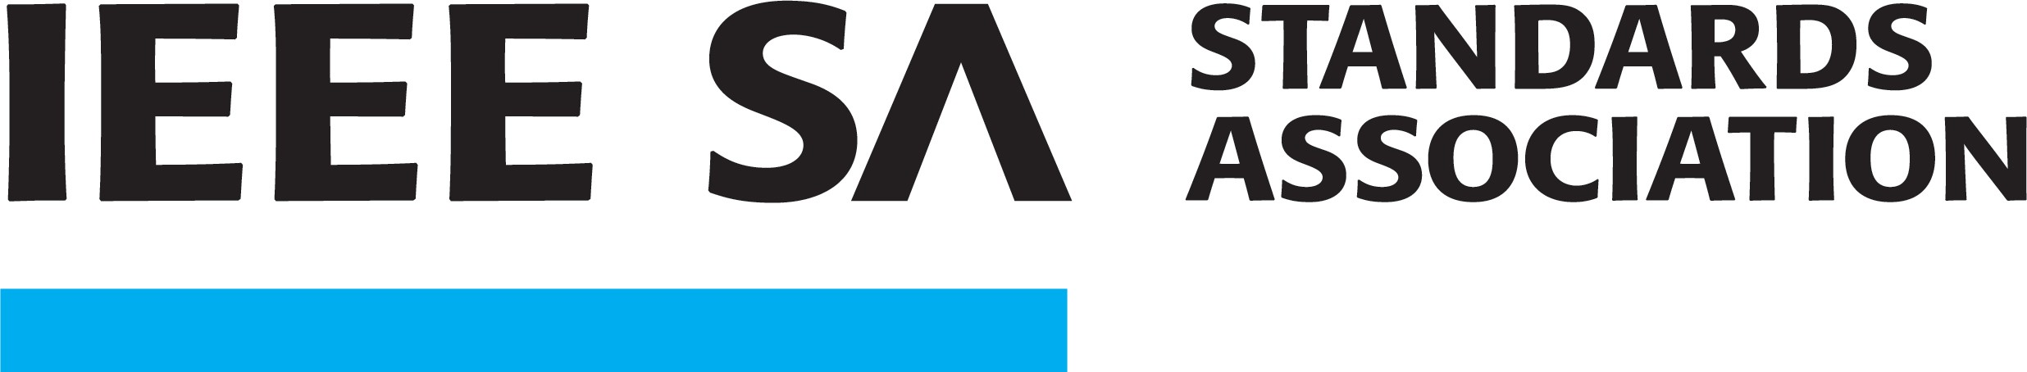

P802.15.13

This PAR is valid until 31-Dec-2021. The original PAR was approved on 23-Mar-2017. It was modified on 03- Jun-2020.
PAR Extension Request Date:
PAR Extension Approval Date:
Extension Request Submitter Email:
Number of Previous Extensions Requested: 0
- Number of years that the extension is being requested: 1
- Why an Extension is Required (include actions to complete): An extension is needed to complete IEEE-SA balloting of the draft amendment. P802.15.13 D4.0 completed initial IEEE-SA ballot on January 13, 2021, with 95% approval and 314 technical and editorial comments. Comment resolution is underway. The plan is to have the draft standard approved by the end of 2021. This extension request is a precautionary measure to account for any unforeseen circumstances and delays.
  - What date did you begin writing the first draft: 11 Feb 2019
  - How many people are actively working on the project:10
  - How many times a year does the working group meet? In person: 6
Via teleconference: 6
  - How many times a year is a draft circulated to the working group: 6
  - What percentage of the Draft is stable: 85%
  - How many significant work revisions has the Draft been through: 4
4. When will/did initial Standards Association Balloting begin: Dec 2020
When do you expect to submit the proposed standard to RevCom: Oct 2021
Has this document already been adopted by another source? (if so please identify) No
For an extension request, the information on the original PAR is not open to modification.

