|  |  |  |
| --- | --- | --- |
| Project | **IEEE 802.15 Wireless Specialty Networks Working Group <**<http://ieee802.org/15>**>** | |
| Title | **IEEE 802.15.16t Proposed Elements of the Air Interface Protocol** | |
| Date Submitted | **2021-04-20** | |
| Source(s) | 16t Task Group | Voice:  E-mail: menashe.shahar@ondas.com |
| Re: | 16t Task Group: Licensed Narrowband Amendment | |
| Abstract | Proposed Elements of the Air Interface Protocol | |
| Purpose | To consider elements of the Air Interface Protocol for 802.16t | |
| Notice | *This document does not represent the agreed views of the IEEE 802.16 Working Group or any of its subgroups*. It represents only the views of the participants listed in the “Source(s)” field above. It is offered as a basis for discussion. It is not binding on the contributor(s), who reserve(s) the right to add, amend or withdraw material contained herein. | |
| Copyright Policy | The contributor is familiar with the IEEE-SA Copyright Policy <http://standards.ieee.org/IPR/copyrightpolicy.html>. | |
| Patent Policy | The contributor is familiar with the IEEE-SA Patent Policy and Procedures:  <<http://standards.ieee.org/guides/bylaws/sect6-7.html#6>> and <rmation is located at <<http://standards.ieee.org/board/pat/pat-material.html>> and <<http://standards.ieee.org/board/pat>>. | |

Proposed Elements of Air Interface Protocol for ieee802.16t

April 20th, 2021

Menashe Shahar

# Introduction:

This document describes a proposed air interface protocol for ieee802.16t in response to the ieee802.16t System Requirement Document (SRD).

# Contents:

Contents

1 Introduction: 3

2 Contents: 3

3 List of Figures 3

4 Terminology: 5

5 Proposed Physical Layer: 6

5.1 Channels, their partitioning into sub-channel and subchannel groups 6

5.2 Channel span 8

5.3 Self sufficiency 8

5.4 Waveform 8

5.5 Frame structure 10

5.5.1 **TDD Frame Structure**: 10

5.5.2 FDD Frame structure 12

5.6 DL/UL Air Interface Resource Allocation 12

5.7 Resolution of air interface resource allocation 13

5.7.1 Bins and slots 13

5.7.2 DL Modulation and FEC Rates: 13

5.7.3 Mapping of bins into slots & bytes vs MCS 14

5.8 DL Signal Processing Chain 14

5.9 UL TX Processing Chain: 15

5.10 Repetitions 15

# List of Figures

Figure 5‑1: An example of non-continuous channel partitioning 5

Figure 5‑2 Partitioning of a non-continuous channel with a non-adjacent subchannel group 6

Figure 5‑3: Partitioning of a continuous channel 6

Figure 5‑4: TDD Frame 8

Figure 5‑5 TDD Frame Example 1 8

Figure 5‑6 TDD Frame Example 2 9

Figure 5‑8: Bin Definition 11

Figure 5‑9: Slot Definition 11

Figure 5‑10: DL TX Chain 12

Figure 5‑14: UL Tx Chain 13

Figure 5‑18: Data Repetition Pattern 13

# Terminology:

* A continuous band: a continuous spectrum range allocated to an organization and under its exclusive control. Example: the IVDS band in the US consists of 1 MHz between 218 MHz to 219 MHz.
* Private Land Mobile Radio (PLMR) system: Traditional Push to Talk (PTT) conventional or trunked radio voice system.
* A PLMR channel: a channel allocated to PLMR system usage. This is typically a 6.25 kHz, a 12.5 kHz or a 25 kHz wide channel but other channel bandwidths are also used, e.g., 7.5 kHz, 15 kHz and 50 KHz.
* A PLMR band: a spectrum range containing a few adjacent or non-adjacent PLMR channels.
* A subchannel: a partition of a PLMR channel or a partition of a continuous band which serves as a minimal entity for allocation in the frequency domain. A PLMR channel may be considered a single subchannel or it may be partitioned into multiple subchannels. For example, in a PLMR band with a mix of 6.25 kHz, 12.5 kHz and 25 kHz wide PLMR channels, the subchannel bandwidth may be defined as 6.25 KHz. In this case, a 6.25 kHz PLMR channel will be considered a single subchannel, a 12.5 kHz PLMR channel will be considered as 2 sub-channels and a 25 kHz PLMR channels will be considered 4 sub-channels. The sub-channel bandwidth is configurable and can go as low as 3.75 kHz.
* A subchannel group: Any subset of sub-channels which is configured as such. The subchannels within the subchannel group may be adjacent or non-adjacent to each other. A subchannel group may consists of a single subchannel or all subchannels in the group.
* Channel: An aggregation of adjacent or non-adjacent subchannels used in one sector[1]. Two types of channels are supported by this standard:
  + Continuous channel: all subchannels within the channel are available.
  + Non continuous channel: One or more subchannels within the channel are not available.
* Channel span: the frequency range extending from the low edge of the lowest frequency sub-channel to the high edge of the highest frequency subchannel in the channel.

# Proposed Physical Layer:

## Channels, their partitioning into sub-channel and subchannel groups

Figures 5-1, 5-2 and 5-3 below shows 3 examples of non-continuous and continuous channels:

* Figure 5-1 shows the partitioning of a non-continuous channel into subchannels and subchannel groups. Subchannel group #1 consists of a single subchannel while subchannel group 3 consists of 8 subchannels. Certain subchannels, e.g., subchannel #2 are not available. All subchannel groups in this example consists of adjacent subchannels.
* Figure 5-2 shows an example of the partitioning a non-continuous channel into subchannel groups, some of which consist of adjacent subchannels and some of which consist of non-adjacent subchannels. Subchannel group #3 consist of non-adjacent subchannels. As in the previous case, some of the subchannels, e.g., subchannels 7 &8 are not available.
* Figure 5-3 shows the partitioning of a continuous channel into subchannels and subchannel groups.

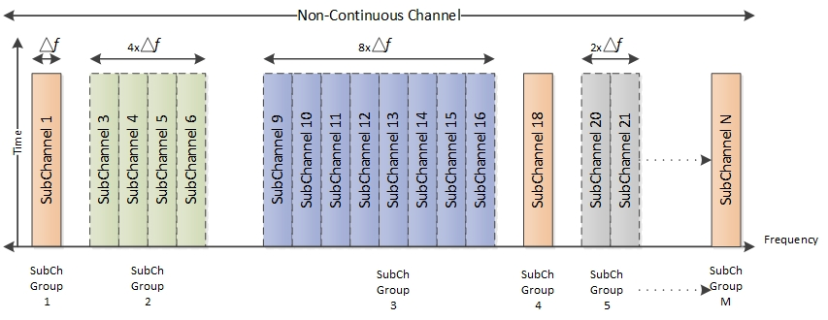

Figure 5‑1: An example of non-continuous channel partitioning

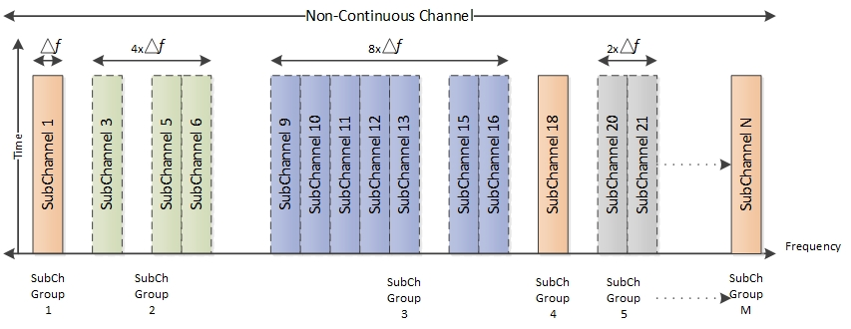

Figure 5‑2 Partitioning of a non-continuous channel with a non-adjacent subchannel group

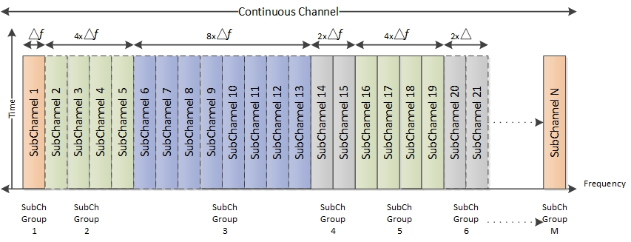

Figure 5‑3: Partitioning of a continuous channel

## Channel span

The channel span may be between the minimum bandwidth of a single subchannel (5 KHz) and up to 10 MHz. Aggregation of the two bands of a paired spectrum where the separation between the two bands exceeds 10 MHz can be implemented by means of frequency translation but such means are not part of this standard.

## Self sufficiency

* The sector base station controls the bandwidth of an entire channel:
  + All the downlink traffic to the remotes in the sector is transmitted by the base station.
  + All the uplink traffic in the sector from the remotes is received at the base station.
  + The base station allocates the air interface resources within the channel to the remotes in the sector.
* Each of the remotes in the sector operate over one subchannel group.
* Subchannel groups are self-sufficient in terms of supporting communication between the base station and remote stations including DL & UL synchronization, ranging, bandwidth allocation and network entry. The remotes send and receive the data over one subchannel group. The remote does not need to listen on any other subchannel outside the subchannel group to support its communication with the base station.
* Self-sufficiency advantages:
  + Multiple types of remotes can be developed depending on the application. For example, the system may employ a low-end remote designed to operate in a single subchannel and a high-end remote designed to operate at any number of subchannels.
  + A remote transmitting in one sub-channel does not need as much power as a remote operating in multiple subchannels.
  + A remote receiving over one subchannel is not subject to interference over the other sub-channels.

## Waveform

* Transmission in the downlink direction employs OFDM with single carrier per subchannel. 512 FFT is proposed to support up to 512 subchannels. A subchannel bit map is used to turn off any unused subchannel.
* Transmission in the uplink direction employs single carrier for remotes transmitting over a single subchannel and Single Carrier (SC) FDMA for remotes transmitting over multiple subchannels.
* The objective of the single carrier waveform is to reduce Peak to Average Ratio (PAPR) relative to OFDM.

## Frame structure

### **TDD Frame Structure**:

* The general TDD frame structure is shown in figure 5-4. It has a DL subframe followed by TTG and then UL subframe followed by RTG. Figures 5-5 & 5-5 shows the frame structure in more details. To maintain per frame overhead at an acceptable level, the per frame overhead components (preamble, FCH and MAPs) are decoupled from the frame, i.e., they are not present in every frame.



Figure 5‑4: TDD Frame

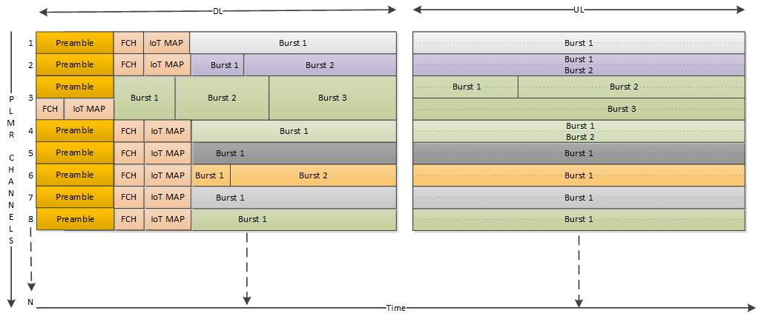

Figure 5‑5 TDD Frame Example 1

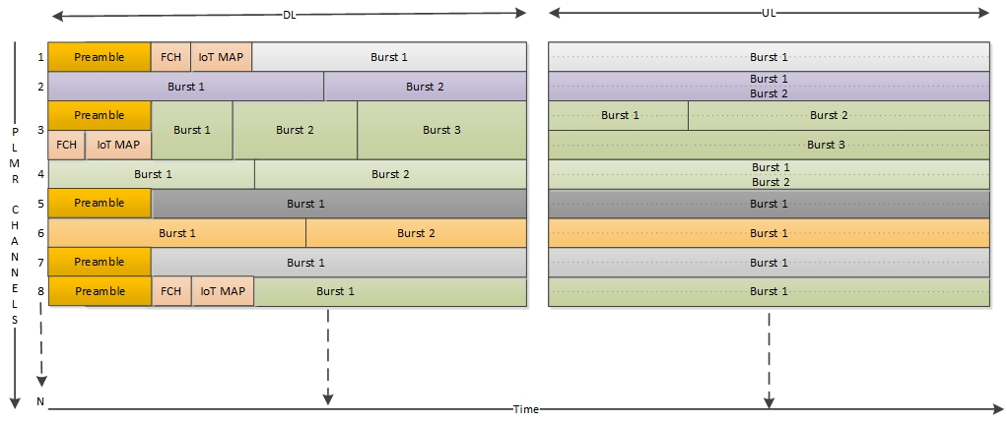

Figure 5‑6 TDD Frame Example 2

Each subchannel group can be shared by multiple remotes in the downlink and in the uplink direction. Each of the bursts in figure 5—5 & 5-6 above can be allocated to a distinct remote.

Preamble, FCH, pilots and MAPs are transmitted within every subchannel group. They are not required to be transmitted at every frame. Their periodicity is determined as follows:

* Preamble, FCH and pilot signal periodicity is determined by the channel dynamics as needed to maintain synchronization, e.g., static vs mobile application.
* MAPs periodicity is determined by the characteristics of the application and the need to support efficient air interface resource allocation.

Figure 5-5 shows an example of a frame containing Preamble, FCH and MAPs in every subchannel within the frame. Figure 5-6 shows subchannels 2,4,5,6 and 7 with no FCH and MAP, indicating the allocation is informed in previous frame whereas remaining subchannels are having the FCH and MAPs in the shown frame. In addition, subchannels 2, 3 and 6 do not have a preamble in this frame.

* Frame Duration

The TDD frame duration will be configured based on the application requirements, e.g., latency and throughput, considering the sub-channel bandwidth. Table 5-1 below shows the minimum frame duration vs subchannel bandwidth.

|  |  |
| --- | --- |
| Δ*f, kHz* | Frame Duration  in ms |
| 6.25 | 100 |
| 12.5 | 50 |
| 25 | 25 |
| 50 | 12.5 |

Table 5‑1: Minimum Frame Duration vs Subcarrier spacing

TTG and RTG configuration

* + TTG configuration is done based on the round-trip delay to be supported. The minimum amount that can be added is the bin duration, e.g., in case of 6.25 kHz subcarrier spacing, the bin duration is 900 µs. This will support a coverage area radius of about 135 km. 3 bins per gap are needed in this case to support a coverage area radius of 322 km (200 miles) as specified in the SRD.
  + RTG configuration will be based on the RF switching delay requirements.

### FDD Frame structure

TBD

## DL/UL Air Interface Resource Allocation

* Allocations of air interface resources in the DL and in the UL for the remotes in the sector is done by the BS. The allocations are communicated to the remotes via DL and UL MAP messages. MAPs are sent over each self-sufficient subchannel group for allocations to remotes present in that subchannel group.
* The BS may decide to move a remote from one subchannel group to another (e.g., for load balancing purposes), by indicating on the current subchannel group the required change and the new subchannel group for this remote.
* The DL/UL MAP messages will have the following information.
* Remote Identity – Identity of the remote for which is allocation is intended.
* Allocation – A definition of the allocation in terms of start symbol and number of opportunities.
* Validity – Validity of this allocation (Allocation can be valid for one or more frames)
* Periodicity – The same allocation can be considered as repeated for the validity period at the given periodicity.
* Indication to change and continue operation with some other subchannel group.

## Resolution of air interface resource allocation

### Bins and slots

* The minimum air interface resource allocation in the downlink and in the uplink is the slot. It is constructed using co0nfigurable bins.
* A bin spans over one subcarrier/tone across multiple symbols in time, e.g., 5 symbols.
* A slot contains two bins.
* Multiple slots form the various transport block sizes.



Figure 5‑8: Bin Definition

* The structure of a bin containing 5 symbols is shown in figure 5-8. This can be modified to improve the spectral efficiency by increasing the data symbols to pilot ratio.

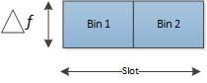

Figure 5‑9: Slot Definition

### DL Modulation and FEC Rates:

* Convolutional Coding (CC) is used with various rates as listed in table 5-2.

|  |  |
| --- | --- |
| Modulation | FEC rate |
| QPSK | 1/3 |
| QPSK | 1/2 |
| QPSK | 3/4 |
| QAM16 | 1/2 |
| QAM16 | 3/4 |
| QAM64 | 3/4 |
| QAM64 | 5/6 |
| QAM256 | 7/8 |

Table 5‑2: Modulation and FEC rate

### Mapping of bins into slots & bytes vs MCS

* The minimum number of bins needed to form the minimum bytes Based on the different modulation and coding schemes is as given in table below:

|  |  |  |  |  |  |  |
| --- | --- | --- | --- | --- | --- | --- |
| S No | Modulation | FEC Rate | Min Bins for Byte/s | Min Bytes | Min Slots allocation | Min Bytes for Min slots |
| 1 | QPSK | 1/3 | 3 | 1 | 3 | 2 |
| 2 | QPSK | 1/2 | 2 | 1 | 1 | 1 |
| 3 | QPSK | 3/4 | 4 | 3 | 2 | 3 |
| 4 | 16QAM | 1/2 | 1 | 1 | 1 | 2 |
| 5 | 16QAM | 3/4 | 2 | 3 | 1 | 3 |
| 6 | 64QAM | 3/4 | 4 | 9 | 2 | 9 |
| 7 | 64QAM | 5/6 | 2 | 5 | 1 | 5 |
| 8 | 256QAM | 7/8 | 2 | 7 | 1 | 7 |

Table 5‑3: Mapping of bins into bytes and slots

Table 5‑3: Min Bins for Min Bytes indicates that for QPSK 1/3 rate minimum 3 bins are needed to allocate 1 Byte, using this basic information based on the need number of bins can be allocated. For example, consider 24 bytes to be allocated:

* 24*3 = 72 bins 36 slots will be required for QPSK 1/3.
* 24*1 = 24 bins 12 slots will be required for 16QAM 1/2.
* In case of 64QAM 5/6 minimum byte allocation is 5 so we need to allocate 25 bytes with 1 padded byte and will require 10 bins 5 slots.

## DL Signal Processing Chain

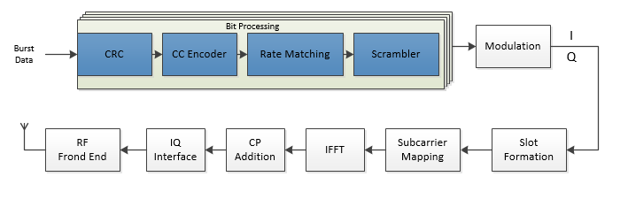

Figure 5‑10: DL TX Chain

## UL TX Processing Chain:

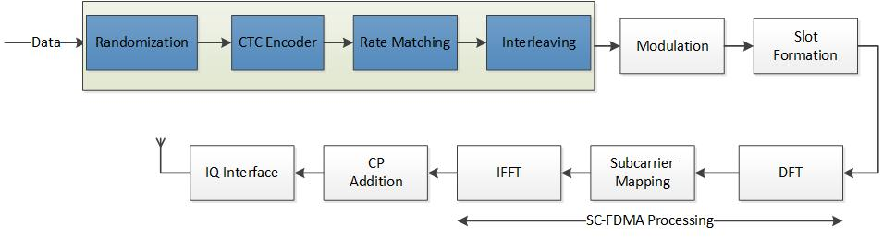

Figure 5‑14: UL Tx Chain

## Repetitions

Repetitions will be used to improve the receiver sensitivity in both DL and UL. Up to 128 repetitions will be supported.

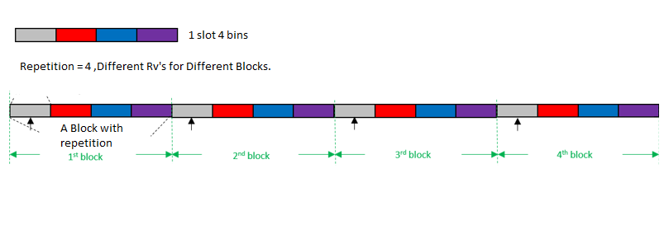

Figure 5‑18: Data Repetition Pattern

1. The terms “channel”, “subchannel” and “subchannel group” are common to both the PLMR band and the continuous band.