**IEEE P802.15**

**Wireless Personal Area Networks**

|  |  |  |
| --- | --- | --- |
| Project | IEEE P802.15 Working Group for Wireless Personal Area Networks (WPANs) | |
| Title | **D4 Comment resolution instructions** | |
| Date Submitted | 25 May 2021 | |
| Source | Bober, Kai Lennert Fraunhofer HHI | Voice: - Fax: - E-mail: bober@ieee.org |
| Re: | Comment resolution on D4 | |
| Abstract | This document contains proposed resolutions for CIDs A-19, I-20 | |
| Purpose | Aid comment resolution | |
| Notice | This document has been prepared to assist the IEEE P802.15. It is offered as a basis for discussion and is not binding on the contributing individual(s) or organization(s). The material in this document is subject to change in form and content after further study. The contributor(s) reserve(s) the right to add, amend or withdraw material contained herein. | |
| Release | The contributor acknowledges and accepts that this contribution becomes the property of IEEE and may be made publicly available by P802.15. | |

**Legend:**

* Arial size 13 indicates subsections for individual comments
* Red underlined text needs to be adapted during the comment implementation (e.g. because it is a reference).
* Bold italic text is an instruction to the editor to implement the text

CID A-19

***Remove the definition of HCM on page 20***

***Remove the following text from P27L28-31:***

, M-ary pulse amplitude modulation (PAM) with Hadamard-coded modulation (HCM) without the all-ones code

***Change P28L17-19 as follows:***

Binary pulse-amplitude modulation (2-PAM) with 8B10B line coding, as defined in 9.3.5 is supported. It is combined with Reed-Solomon (RS) forward error correction (FEC) to correct errors due to the noise.

***Remove HCM Allocation element from Table 4 Control frame subtypes.***

***Remove 6.6.17 HCM Allocation element and renumber the subsequent clauses.***

***Change 6.6.20 as follows:***

**6.6.20 PM-PHY MCS element**

The *PM-PHY MCS* element, shown in 0, holds a subset of supported MCS for the PM-PHY.

|  |
| --- |
| **1 Octet** |
| Clock Rates |

**PM-PHY MCS element**

**Clock Rates:** A bitmap indicating the set of supported clock rates. Reserved bits shall be set to 0. A 1 in the bitmap indicates that the given clock rate is supported. A 0 indicates that the clock rate is not supported. 0 shows the bitmap structure.

|  |  |  |  |  |  |  |  |  |  |
| --- | --- | --- | --- | --- | --- | --- | --- | --- | --- |
|  | processed first | | | | processed  last | | | | |
| 1. **Bit in the bitmap:** | 0 | 1 | 2 | 3 | | 4 | 5 | 6 | 7 |
| 1. **Clock rate:** | 12.5 MHz | 25 MHz | 50 MHz | 100 MHz | | 200 MHz | reserved | reserved | reserved |

**Clock rate bitmap**

***Remove entry 13 HCM Allocation from table 12***

***Remove capHcm from table 37***

***Replace the sentence “PM-PHY enables moderate data rates from 1 Mb/s to some 100 Mb/s.” with:***

PM-PHY enables moderate data up to around 100 Mb/s.

***Change the sentences on P103L7-11 as follows:***

2-PAM with 8B10B line coding and RS FEC is used. The PM-PHY includes means to adapt the data rate of the link to varying channel conditions by varying the clock rate on a per PPDU basis.

***Change table 39 as follows:***

* ***Modulation: 2-PAM***
* ***Line Coding: 8B10B***
* ***Replace “Data rates with 2-PAM and 8b10b” with “Data rates”***
* ***Remove the “Min” column”***

***Replace the text on P103L15-16 with***

The base MCS for the PM-PHY shall be Clock Rate ID = 0, i.e., use 2-PAM, 12.5 MHz clock rate.

***Change the sentence in P104L12 as follows:***

PPDU header fields that contain numbers shall be transmitted starting with the LSB of the number first to the MSB of the number last.

***Remove “independent of the clock rate” in P104L16.***

***Change P104L19 as follows:***

The second section is intended for channel estimation and synchronization. It enables both, cross- and autocorrelation with an appropriate window size.

NOTE – The general approach has been described by Schmidl and Cox [B12], Minn et al. [B3], Schellmann et al. [B10] and Goroshko et al. [B9].

For the preamble, the base sequence A8, a specific pseudo-noise sequence of length 8 is used, as defined in B.2. A8 is repeated six times yielding a total sequence length of $N=48$ Each base sequence of length 8 is multiplied with positive or negative sign as given below which is known to create a sharper peak after autocorrelation, compared to a double sequence of the same total length as described by Goroshko [B9]. The total preamble reads [A8 A8 A8 A8 A8 A8] where for elements of the sequence. The preamble is finally passed through the 2-PAM Modulator.

***Remove table 41.***

***Delete “data stream /” in P106L7***

***Remove “The MCS 12 ID is composed as depicted in Figure 75.” in P107L12-13***

***Remove figure 75***

***Change text in P107L15-L20 as follows:***

MCSs are defined by the applied clock rate. The Clock Rate ID describes the used clock rate as defined in Table 43. The data rate for each MCS can be derived based on the corresponding clock rate and cyclic prefix duration. For instance, using RS(256,248) with 2-PAM, 8B10B and clock rate 12.5 MHz yields 9.6 Mb/s.

Table X ***(TE: adapt number)*** defines the relationship between MCS ID and clock rate.

***Insert a new table X at the end of subclause 9.2.5 as follows:***

***Create two columns MCS ID, Clock rate***

***Insert a row: MCS ID 0, Clock rate 12.5 MHz***

***Insert a row: MCS ID 1, Clock rate 25 MHz***

***Insert a row: MCS ID 2, Clock rate 50 MHz***

***Insert a row: MCS ID 3, Clock rate 100 MHz***

***Insert a row: MCS ID 4, Clock rate 200 MHz***

***Change “Channel estimation sequence, defined in B.2” to “Payload Channel estimation sequence, defined in B.2” in table 43.***

***Remove “For specific MCS, only a subset of the blocks may be used.” in P107L25.***

***Replace figure 76 with the following figure:***



***Change the text in P108L3-14 as follows:***

Header or payload data enters the transmitter and is scrambled in order to randomize uncoordinated interference. 8B10B line coding is applied as the second step. For FEC, the payload uses RS(256, 248) and the header uses RS(36, 24).

NOTE - According to Ivry [B4] and Boada [B5], a particular order of line and channel coding shown in Figure 76 achieves lowest error rates. After FEC, only the systematic part of the binary output code word (248 bits) is well balanced.

For maintaining a constant average light output, also the redundant part of the binary code word (360 – 240 = 120 bits in case of header data and 2560-2480 = 80 bits in case of payload data) passes through 8B10B line encoder. Both parts are concatenated again in a multiplexer. Subsequently, 2-PAM bit-to-symbol mapping is applied for the header.

***Remove the column Clock Rate ID in table 43***

***Remove P109L17-19.***

***Change text in P109L21-P110L2 as follows:***

The bit-to-symbol mapper is using PAM with 2 levels. For 2 levels, each input bit is mapped in one symbol. The symbols are mapped to levels as {0, 1} to {0, 1}, respectively.

***Remove table 44***

***Remove 9.3.7.***

***Remove Annex B.4***

***Remove Annex C.1***

CID I-20

Modify sentence starting in P17L5 as follows:

It is designed for point to point and point to multi point communications in non-coordinated and coordinated topologies.

Modify the sentence starting in P30L10 as follows:

The coordinator should have connectivity to the relaying device and the end device.

Modify the sentence starting in P37L3 as follows:

The CAP and the CFP may shrink or grow dynamically on a superframe-by-superframe basis in order to allow more random access transmissions in the CAP or more scheduled ones in the CFP.

Modify the sentence starting in P45L6 as follows:

A newly connected device is made aware of its queue number with the first valid frame it receives from the coordinator. This frame contains the devices queue number and MAC address.

Modify the sentence starting in P47L5 as follows:

After the downlink and uplink transmissions are complete, the coordinator sends a data frame to Device 2.

Modify the sentence starting in P61L7 as follows:

Widths of fields are specified in numbers of bits or numbers of octets if the total number of bits is representable by an integer number of octets.

Modify the sentence starting in P104L19 as follows:

It enables cross- and autocorrelation with an appropriate window size as described by Schmidl and Cox [B12], Minn et al. [B3], Schellmann et al. [B10] and Goroshko et al. [B9].

Modify the sentence starting in P132L3 as follows:

Following this procedure, all negative samples in St1 and St2 are removed, and the two signals are summed.

Modify the sentence starting in P150L19 as follows:

Puncturing is applied to information and parity-check bits.

Modify the sentence starting in P153L11 as follows:

The LFSR is advanced by two bits for each supported subcarrier or masked subcarrier of each symbol of the payload.

Modify the sentence starting in P154L19 as follows:

Support for all even order constellations is mandatory at the transmitter and the receiver.

Modify the sentence starting in P167L14 as follows:

The control unit can set the bias and the modulation index to achieve the required dimming level and to avoid clipping.

CID I-13 / I-191 / I-9 / A-20

Discussion:

The referenced figure from the web looks differently:

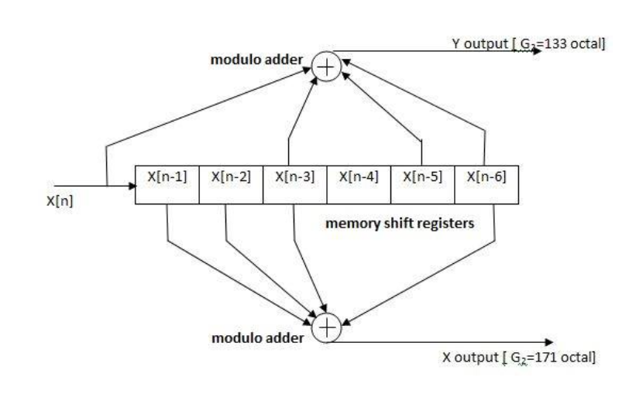

Proposed change:

Replace figure 85 with the following graphic:

