IEEE P802.15
Wireless Personal Area Networks

Project | IEEE P802.15 Working Group for Wireless Personal Area Networks (WPANs)
Title | TG4aa Coexistence Document
Date Submitted | 4 March, 2021
Source | [Kiyoshi Fukui, OKI, Japan] | E-mail: [fukui535@oki.com]
Abstract | Analysis on coexistence of 802.15.4aa with other 802 systems within the same spectrum bands.
Purpose | To address the coexistence capability of 802.15.4aa.
Notice | This document has been prepared to assist the IEEE P802.15. It is offered as a basis for discussion and is not binding on the contributing individual(s) or organization(s). The material in this document is subject to change in form and content after further study. The contributor(s) reserve(s) the right to add, amend or withdraw material contained herein.
Release | The contributor acknowledges and accepts that this contribution becomes the property of IEEE and may be made publicly available by P802.15.

Main contributors of the CA document are sorted by alphabetical order of last name:
- Phil Beecher(Wi-SUN Alliance)
- Takashi Kuramochi(TG4aa chair, LAPIS Technology)
- Benjamin Rolfe(BLIND CREEK ASSOCIATES)

1. Introduction 4
2. Bibliography 4
3. Overview 5
3.1 Overview of IEEE802.15.4aa 5
3.2 Regulatory Information 6
3.3 Overview of Coexistence Mechanism in 802.15.4aa 6
4. Dissimilar IEEE802 Systems Sharaing the Same Frequency Bands with 802.15.4aa 6
4.1 Coexisting 802 Systems in 920MHz Band 7
5. Coexsistence Scenarios and Analysis 7
5.1 802.15.4 Coexistence Performance 7
5.2 802.15.4aa Specific Coexistence 8
5.2.1 Victim 802.15.4aa 8
5.3 802.11ah Coexistence Performance 9
6. Interference Mitigation and Avoidance Techniques 10
7. Conclusions 11

Introduction

TG4aa introduces operating modes to 802.15.4 supporting higher data rates in the 920MHz band. These new operating modes use GFSK modulation, which is one of the existing modulation methods. The higher data rates have the effect of increasing the signal bandwidth from the GFSK operating modes specified in 802.15.4 for the 920MHz band. The regulation governing the 920MHz band[B1] specify stringent requirements on devices to ensure efficient and equitable shared usage of the band. The regulation specifies a channel plan which also allows aggregation of channels, hence permitting varying signal bandwidths. It additionally specifies parameters for listen before talk, maximum transmit power levels and transmit duty cycle limits. The TG4g coexistence assurance document[B2], and P802.19 draft[B3] already provide a comprehensive analysis for coexistence in all bands, including 920MHz band. TG4aa adds no functionality, channel access requirements, or modulations beyond those used in 802.15.4.

Bibliography

[B1] ARIB STD-T108, 920MHz-BAND TELEMETER, TELECONTROL AND DATA TRANSMISSION RADIO EQUIPMENT, (http://www.arib.or.jp/english/html/overview/doc/5-STD-T108v1_3-E1.pdf).
[B2] P802.15.4aa PAR, DCN 15-20-0202-04,2020
[B3] P802.19/D0.08,Draft Recommended Practice for Local and Metropolitan Area Networks – Part 19:Coexistence Methods for 802.11 and 802.15.4 based systems operating in the Sub-1GHz Frequency Bands
[B4] T. Kuramochi, Channel assignment for SUN FSK operating mode #5, #6, #7 and #8 in 920MHz band, DCN ( https://mentor.ieee.org/802.15/dcn/21/15-21-0081-02-04aa-channel-assignment-for-sun-fsk-operating-mode-5-6-7-and-8-in-920mhz-band.pdf)
[B5] TG4g coexistence assurance document, (https://mentor.ieee.org/802.15/dcn/10/15-10-0668-05-004g-tg4g-coexistence-assurance-document-first-draft.pdf).
[B6] IEEE Std 802.15.4-2020
[B7] IEEE Std 802.11ah
[B8] 802.15.4w Coexistence Document, DCN 15-19-0165-01
[B9] 802.15.4k Coexistence Document, DCN 15-12-0314-01
[B10] S. J. Shellhammer, Estimating Packet Error Rate Caused by Interference – A Coexistence Assurance Methodology, DCN IEEE 802.19-05/0029r0, September 14, 2005.

Overview
This clause gives on overview on IEEE 802.15.4aa which covers used frequency band and the changes compared to the existing IEEE Std 802.15.4 SUN FSK system. Finally, it introduces the coexistence mechanisms for improved performance and coexistence in license-exempt frequency bands.

P802.15.4aa extends the existing 802.15.4 SUN FSK PHY, specifically operating in the 920 MHz band for Japan. Coexistence characteristics of the SUN FSK PHYs operating in sub-1GHz bands has been previously presented in [B5], which describes the coexistence mechanisms available in 802.15.4 and identifies other 802 wireless services known to be defined for the bands at that time. This analysis builds upon the prior work by identifying changes significant to the coexistence situation since publication of [B5].

Notable changes since the publication of IEEE Std 802.15.4g-2012 addressed by the amendment include:
- The 950-958 band for Japan has been reallocated to 920-926 MHz.
- Rule changes in Japan that allow channel bonding up to 1000 kHz
- Completion of IEEE Std 802.11ah
- Completion of IEEE Std 802.15.4w-2020

The coexistence impacts with respect to the systems described in [B5] are unchanged by this amendment. This document builds on that analysis focusing on 802.11ah and 802.15.4w which were not available at the time that analysis was completed.

Overview of IEEE802.15.4aa
The IEEE 802.15 Task Group 4aa defines data rate extension of SUN FSK PHY to IEEE Std 802.15.4-2020. According to the 802.15.4aa PAR[B2], the requirements for higher data rates have come from Japanese utilities to allow the number of nodes to be increased per Personal Area Network (PAN), permitting the communication of various utility data for not only electricity but also gas and water, along with Over-the-Air (OTA) updates without an increase of the meter's energy consumption.

PHY amendments in 802.15.4aa are shown in Table 1.Operating modes #5,#6,#7, and #8 are added to IEEE Std802.15.4-2020 in 802.15.4aa. Compare to former operating modes, these new operating modes have 1MHz bandwidth, and utilize overlapping channel assignments[B4] in order to increase the number of available channels; the channel separation, which is narrower than the channel bandwidth, is permitted by Japanese regulation[B1].

Table 1 PHY amendments in 802.15.4aa
Frequency band  (MHz) | Parameter | Operating mode
 |  | #1 | #2 | #3 | #4 | #5 | #6 | #7 | #8
920-928  MHz | Data rate  (kb/s) | 50 | 100 | 200 | 400 | 400 | 600 | 600 | 800
 | Modulation | 2-FSK | 2-FSK | 2-FSK | 4-FSK | 2-FSK | 2-FSK | 4-FSK | 4-FSK
 | Modulation index | 1.0 | 1.0 | 1.0 | 0.33 | 0.5 | 0.4 | 0.5 | 0.33
 | Channel  bandwidth  (kHz) | 200 | 400 | 600 | 600 | 1000 | 1000 | 1000 | 1000
 | Channel separation  (kHz) | 200 | 400 | 600 | 600 | 200 * N  1≦N≦5 | 200 * N  1≦N≦5 | 200 * N  1≦N≦5 | 200 * N  1≦N≦5
 | Standard | SUN FSK PHY of IEEE Std 802.15.4-2020 |  |  |  | TG4aa amendment

Regulatory Information
The allocated frequency band for 802.15.4aa is 920.5-928.1 MHz (Japan) as defined in [B1].

Overview of Coexistence Mechanism in 802.15.4aa
The developed amendment follows the coexistence mechanisms defined in IEEE Std 802.15.4-2020 [B6], as described in the 802.15.4g Coexistence Assurance Document[B5]. These existing methods are applicable to both homogeneous (among systems using the SUN FSK PHY) and heterogeneous (across other 802 systems) coexistence. Use of the coexistence mechanisms available to achieve positive coexistence performance specifically between 802.15.4 SUN FSK based systems and 802.11ah based systems is discussed in detail in P802.19.3 [B3] clause 7.

Dissimilar IEEE802 Systems Sharing the Same Frequency Bands with 802.15.4aa
This clause presents an overview on other 802 systems which are specified to operate in the same frequency bands that are also specified for the 802.15.4aa. The table in the following section list the latest standard (or amendment) and the corresponding PHY specifications that share the same frequency band as 802.15.4aa.

Coexisting 802 Systems in 920MHz Band
The 802 wireless systems defining operation in the 920.5-928.1 MHz band are shown in Table 2.

Table 2: Dissimilar systems co-existing with the 802.15.4aa PHY within the 920.5-928.1MHz band.
System | PHY Specification
802.15.4-2020 | GFSK
 | SUN FSK
 | SUN OFDM
 | SUN O-QPSK
 | LECIM DSSS
 | LECIM FSK
 | TVWS-FSK
 | TVWS-OFDM
 | TVWS-NB-OFDM
802.15.4w-2020 | LPWAN
802.11ah | S1G OFDM

Coexsistence Scenarios and Analysis

Coexistence scenarios considered include combinations of systems based on 802.15.4aa in combination with other 802.15.4 sub-1 GHz systems as well as 802.15.4aa in the mutual presence of 802.11ah.

The additional modes to the SUN FSK operate using the same constant envelope FSK modulations (2-FSK and 4-FSK) as previously defined. The differences introduced are addition channelization options and higher data rates using 2-FSK and 4-FSK modulations. The coexistence performance as described in the referenced analysis remain valid for these additional operating modes.

The method used in this and the referenced documents uses the standard method of examining two-way impacts on each of the systems considered with each as interferer (assailant) and each as the interred (victim). The method (and nomenclature) used is presented in [B10].

802.15.4 Coexistence Performance
Impacts when the SUN FSK based system is the victim are characterized in references [B5], [B8] and [B9] which provide detailed simulation results for operation of SUN FSK (802.15.4g), LECIM (802.15.4k) and LPWAN (802.15.4w). The performance metrics used are Bit Error Rate (BER) and Packet Error Rate (PER). Each provides results for the SUN FSK based system as assailant transmitter and as victim receiver.

Coexistence performance for SUN FSK operating in the relevant bands is given in clauses 4.4 and 4.6 of [B5]. Detailed performance simulation results are provided.

Clause 4.8 of [B8] provides detailed simulation results for LECIM and SUN FSK systems. Note that at the time of writing, the SUN FSK was known as the MR-FSK PHY.

Clause 3.6 of [B9] provides detailed simulation based results for coexistence with LWPAN systems.

A general trend shown in all of the above is that SUN FSK systems tend to be tolerant of interference from wider bandwidth signals when separation distances of 35 to 40 meters can be maintained, with PER and BER typically better than 10⁻⁶ at greater distances. The simulation results also show that in some situations use of CSMA-CA, and selection of CSMA-CA parameters, can have a significant impact on performance. Other mitigation techniques, such as channel agility, are supported by the standard and are commonly used to improve performance in an interference limited environment. See the references for details.

802.15.4aa Specific Coexistence

Victim 802.15.4aa
Figure1 shows the relationship between the PER performance of the 802.15.4g FSK 50kbps and 802.15.4aa FSK 600kbps victim receivers corresponding to the distance between the victim receivers to the interferer.
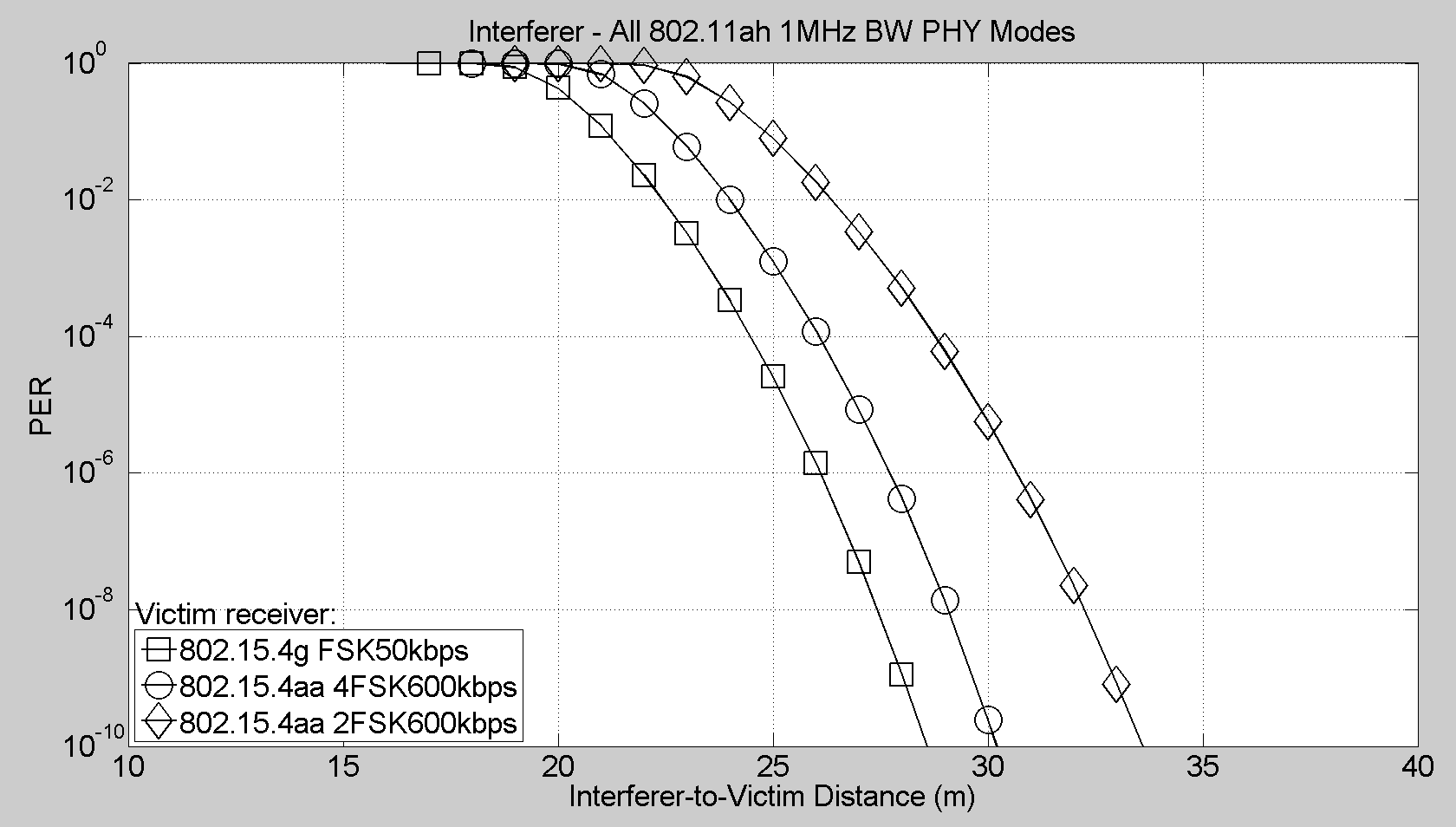
Figure 1 Victim PER vs. Distance between Interferer to 802.15.4aa Victim Receiver

802.11ah Coexistence Performance

A significant change since [B5] is the completion of IEEE Std 802.11ah and rule updates in Japan that provide for channel bonding to 1000 kHz, which enables the minimum 1000 kHz channel width required for operation of 802.11ah. A recommended practice for coexistence in sub-1 GHz bands has been developed [B3] that focuses on 802.15.4 and 802.11ah. [B3] contains extensive characterizations of uses in the band from measurement studies as well as simulation of coexistence performance in various scenarios.

The findings in 802.19.3 [B3] illustrate the potential for significant performance impacts of 802.15.4 FSK systems on 802.11ah systems, as well as impacts from the 802.11ah system on the 802.15.4 systems. As noted there, the 802.15.4 and 802.11 MACs provide a great deal of flexibility and configuration options that can be used to mitigate the impacts on performance. The optimal mitigations depend on the desired performance priorities. Scenario based recommendations are provided to minimize negative impact for a given set of performance priorities.

While focused on coexistence between 802.11ah and 802.15.4 FSK systems, much of the material in [B3] will be helpful for optimizing coexistence performance in the presence of other systems.

Clause 7 of P802.19.3 [B3] describes coexistence mechanisms and analysis of performance for some typical coexistence scenarios between 802.11 and 802.15.4 sub-1GHz systems. Also provided are measurement-based characterizations of the sub-1 GHz channel. Refer therein for details on the methods and detailed results. In summary, impacts were measured by data packet delivery rates and delivery latency with various combinations of network sizes and traffic load based on identified use case scenarios. Some notable observations include:

- 802.11ah performance degradation in the presence of 802.15.4 FSK interfering devices impacts delivery latency before packet deliver rate drops. Latency impact can be severe.
- 802.15.4 packet delivery rate will be impacted by 802.11ah interference before latency is notably impacted.
- In both cases adjustment of the various operating parameters such as channel width and channel access parameters provided can achieve trade-offs between packet delivery and packet latency.
- Each standard provides multiple mechanisms to improve coexistence performance both as in terms of impact from interference and generated interference foot impact.
- Optimal selection of operating parameters depends on the usage scenario and performance priorities (e.g. trade-off between PER and latency).

[B3] identifies methods, mechanisms and strategies that can be applied to improve coexistence performance. Clause 9 therein provides specific recommendations for techniques to improve significantly the performance achieved.

Interference Mitigation and Avoidance Techniques
In general, Interference Mitigation and Avoidance Techniques are the same as 802.15.4g.

Coexistence strategies can be divided into coordinated coexistence schemes and distributed coexistence schemes. A coordinated scheme depends upon cooperation between participating devices. Such schemes can be employed with similar and dissimilar systems. A coordinated scheme may be dynamic or passive. Examples of dynamic include exchanging of information between devices to optimize operating parameters in each device with scheduled channel access. An example of passive techniques would include channel allocation performed via provisioning.

Advantages of coordination include the ability to have greater relevant information available to participating devices. Such advantage is reduced when there are non-cooperating devices also operating in the area. Some methods, e.g. scheduled channel access, perform well when there are few non-participating devices and less well otherwise. Other techniques, such as dynamic channel selection, can be effective in mitigating interference from non-cooperating devices.

Distributed coexistence techniques are those in which each participating device independently mitigates interference. Distributed techniques tend to be easy to implement at low cost, flexible, and tend to scale well in large networks and in environments with many heterogeneous wireless devices. A limitation of distributed coexistence methods is that each device has a limited “view” of channel information and does not benefit from information that may be present in another device in the area.

Typically employing some degree of coordination will improve performance. Exchange of channel information may assist participating devices in better optimizing mitigations for non-participating devices as the “shared view” contains more usable information, for example.

The 802 wireless standards considered in this assessment provide mechanisms to support both coordinated, non-coordinated and combination techniques. In general, how these mechanisms are used for best result depends upon operating conditions and is not covered in the scope of 802.15.4 or 802.11.

Conclusions
The coexistence properties of the SUN FSK PHY operating in vicinity of other 802 standards has been extensively characterized previously. The references provided herein include simulation and measurement based analysis. The results show that both 802.15.4 and 802.11 standards provide the means to achieve positive coexistence when the features of each are used appropriately. The recommended practices in IEEE Std 802.19.3 provide useful guidance for using the available features to optimize performance. The additional PHY modes introduced in P802.15.4aa will not change the coexistence properties significantly.

This document presented the coexistence analysis of 802.15.4aa. The presented analyses show the excellent performance of 802.15.4aa as victim. It can be operated in close proximity to other 802 networks without a significant loss of performance.

As an interferer 802.15.4aa, techniques as Listen before Talk can be used very effectively, removing almost all relevant impairments on existing 802 systems.

