IEEE P802.15
Wireless Personal Area Networks

Project | IEEE P802.15 Working Group for Wireless Personal Area Networks (WPANs)
Title | Proposal of Annex A: Interfacing to IEEE 802.11 MAC
Date Submitted
Source | pureLiFi | Voice: [ ]  Fax: [ ]  E-mail: [ ]
Re:
Abstract
Purpose | Aid non-beacon-enabled MAC mode
Notice | This document has been prepared to assist the IEEE P802.15. It is offered as a basis for discussion and is not binding on the contributing individual(s) or organization(s). The material in this document is subject to change in form and content after further study. The contributor(s) reserve(s) the right to add, amend or withdraw material contained herein.
Release | The contributor acknowledges and accepts that this contribution becomes the property of IEEE and may be made publicly available by P802.15.

- Annex A: Interfacing to IEEE 802.11 MAC
- Interfacing concept
Taking into account the close targets of IEEE 802.11 standards (e.g., IEEE P802.11bb) against IEEE 802.15.13, and the widely accepted ready-to-go features in the IEEE 802.11 stack, it will benefit the IEEE 802.15 compliant equipment if an interface between the two standard families can be established. Benefits include reusing services available in IEEE 802.11 such as association, authentication, handover, and etc. This subclause describes one possible solution.

The left side of Figure 1 shows the lower layers of an IEEE 802.11 device. The right side of Figure 1 shows the two lowest layers of IEEE 802.15.13 devices, the 802.11 lower MAC and the 802.11 PHY are to be replaced by the Non-beacon-enabled channel access (See 5.4) and the LB-PHY (See 10).

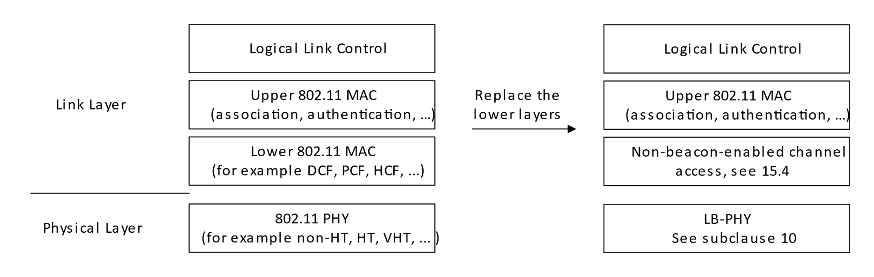
Figure 1 Protocol stack interfacing to IEEE 802.11 standard
The IEEE 802.11 MAC frames coming from/going to the upper MAC are passed through unmodified by the lower two layers on the right side in Figure 1 except the frame control field. The transmitter address and the receiver address of the 802.11 frames are used to identify stations and direct the frames to the correct destination. The PSDU of the LB-PHY are 802.11 MAC frames.
Referring to Fig. 15 in 5.4.1(Figure 2), the process remains the same as the default. However, the frame content and format are specified as follows.
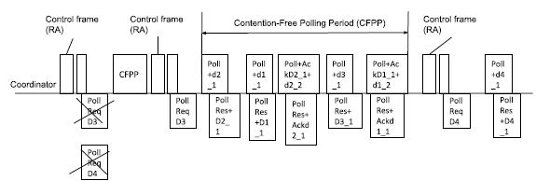
Figure 2 Non-beacon-enabled channel access

Poll frame: If an IEEE 802.11 MAC Management/Data frame from the higher layer is ready to be transmitted to the station, this frame is transmitted and serves as a Poll frame. If no such frame is ready, an 802.11 NULL frame is transmitted as a poll frame.
Poll response frame: If an IEEE 802.11 MAC Management/Data frame from the higher layer is ready to be transmitted to the coordinator, this frame is transmitted and serves as a poll response frame. If no such frame is ready, an 802.11 NULL frame is transmitted as a poll response frame.
Control frame (RA): Instead of the Control frame (RA) proposed in Clause 5, the Control frame (RA) used for the interfacing mode is sent by AP with similar frame body as beacons in IEEE 802.11. On the station side, received Control frames (RA) are forwarded to the higher layer.
Poll request frame: This frame is used by the stations to request connection with the coordinator. It has the header of the 802.11 NULL frame, but a four octets payload. The four octets are reserved for future use and set to zero.

- Frame formats comparison between IEEE 802.11 and 802.15.13
  - IEEE 802.11 MAC Management/Data frame
See 6.3 for Data frame format (Figure 4) or 6.4 for Management frame format (Figure 6).

The information in the Duration field in IEEE 802.11 will be transmitted in the field of Poll ACK in IEEE 802.15.13. The information in the Address 3 field in IEEE 802.11 will be transmitted in the field of Auxiliary Address in IEEE 802.15.13. The optional fields (Address 4, QoS Control and HT Control) are not relevant to the use case.
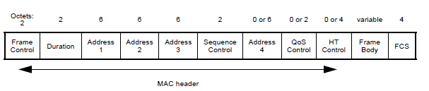
Figure 3 Data frame format in IEEE 802.11
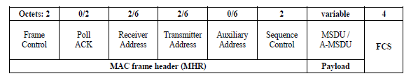
Figure 4 Data frame format in IEEE P802.15.13
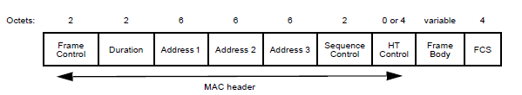
Figure 5 Management frame format in IEEE 802.11

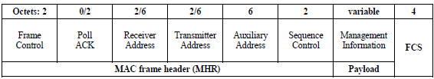
Figure 6 Management frame format in IEEE P802.15.13
  - IEEE 802.11 NULL frame
See 6.3 for Data frame format (Figure 4).

The information in the Duration field in IEEE 802.11 will be transmitted in the field of ACK information in IEEE 802.15.13. The information in the Address 3 field in IEEE 802.11 will be transmitted in the field of Auxiliary Address in IEEE 802.15.13.

  - IEEE 802.11 beacon frame

See 6.4 for Management frame format (Figure 6) for the header format. The information in the Duration field in IEEE 802.11 will be transmitted in the field of ACK information in IEEE 802.15.13. The information in the Address 3 field in IEEE 802.11 will be transmitted in the field of Auxiliary Address in IEEE 802.15.13.

See 9.3.3.3 in IEEE 802.11-2016 for the beacon body format.

  - Poll request frame
See 6.3 for Data frame format (Figure 4).

The information in the Duration field in IEEE 802.11 will be transmitted in the field of ACK information in IEEE 802.15.13. The information in the Address 3 field in IEEE 802.11 will be transmitted in the field of Auxiliary Address in IEEE 802.15.13.

The payload of the Poll request frames for this mode consists of a four octets payload. The four octets are set to 0 by default and reserved for future use.

  - Frame control field in all above-mentioned frames
See 6.2.2 for Frame Control field format (Figure 8).
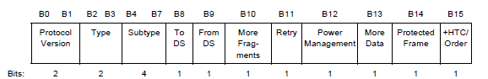
Figure 7 Frame Control field format in IEEE 802.11
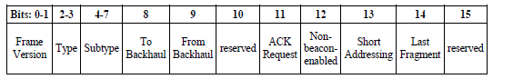
Figure 8 Frame Control field format in IEEE P802.15.13

The mapping of the subfields of IEEE 802.11 and IEEE 802.15.13 are listed as follows:

Table 1 Mapping subfileds in Frame control filed
Subfield in IEEE 802.11 | Subfield in IEEE 802.15.13
Protocol version | Frame version
To DS | To Backhaul
From DS | From Backhaul
More Fragments | Reserved
Retry | ACK Request
Power Management | Non-beacon-enabled
More Data | Short Addressing
Protected Frame | Last Fragment
+HTC/Order | Reserved
- Subtypes for the IEEE 802.11 frames
Use type 3 (the reserved 16 subtypes) for 14 Management frames and 2 Data frames in IEEE 802.11. The subtypes for Type 3 frames are listed in Table 2. When a device receives such type 3 frames, it uses a local entry table to map them to either type 0 or type 2 frames in order to decode and use them as usual in IEEE 802.11. The example local entry table is given in Table 3.

Table 2 Type 3 and subtype combinations
Type | Type  description | Subtype | Subtype  description
11 | Management | 0000 | Association Request
11 | Management | 0001 | Association Response
11 | Management | 0010 | Reassociation Request
11 | Management | 0011 | Reassociation Response
11 | Management | 0100 | Probe Request
11 | Management | 0101 | Probe Response
11 | Management | 0110 | Timing Advertisement
11 | Management | 0111 | Beacon
11 | Management | 1000 | ATIM
11 | Management | 1001 | Disassociation
11 | Management | 1010 | Authentication
11 | Management | 1011 | Deauthentication
11 | Management | 1100 | Action
11 | Management | 1101 | Action No Ack
11 | Data | 1110 | Data
11 | Data | 1111 | Null

Table 3 Local entry table for the mapping between IEEE 802.11 and 802.15.13
IEEE 802.11 |  |  | IEEE 802.15
Type | Subtype | Frame name | Type | Subtype | Frame name
00 | 0000 | Association Request | 11 | 0000 | Association Request
00 | 0001 | Association Response | 11 | 0001 | Association Response
00 | 0010 | Reassociation Request | 11 | 0010 | Reassociation Request
00 | 0011 | Reassociation Response | 11 | 0011 | Reassociation Response
00 | 0100 | Probe Request | 11 | 0100 | Probe Request
00 | 0101 | Probe Response | 11 | 0101 | Probe Response
00 | 0110 | Timing Advertisement | 11 | 0110 | Timing Advertisement
00 | 0111 | Reserved | Not mapped | Not mapped | Not mapped
00 | 1000 | Beacon | 11 | 0111 | Beacon
00 | 1001 | ATIM | 11 | 1000 | ATIM
00 | 1010 | Disassociation | 11 | 1001 | Disassociation
00 | 1011 | Authentication | 11 | 1010 | Authentication
00 | 1100 | Deauthentication | 11 | 1011 | Deauthentication
00 | 1101 | Action | 11 | 1100 | Action
00 | 1110 | Action No Ack | 11 | 1101 | Action No Ack
00 | 1111 | Reserved | Not mapped | Not mapped | Not mapped
01 | 0000 | Reserved | Not mapped | Not mapped | Not mapped
01 | 0001 | Reserved | Not mapped | Not mapped | Not mapped
01 | 0010 | Reserved | Not mapped | Not mapped | Not mapped
01 | 0011 | Reserved | Not mapped | Not mapped | Not mapped
01 | 0100 | Beamforming Report Poll | Not mapped | Not mapped | Not mapped
01 | 0101 | VHT NDP Announcement | Not mapped | Not mapped | Not mapped
01 | 0110 | Control Frame Extension | Not mapped | Not mapped | Not mapped
01 | 0111 | Control Wrapper | Not mapped | Not mapped | Not mapped
01 | 1000 | Block Ack Request (BlockAckReq) | Not mapped | Not mapped | Not mapped
01 | 1001 | Block Ack (BlockAck) | Not mapped | Not mapped | Not mapped
01 | 1010 | PS-Poll | Not mapped | Not mapped | Not mapped
01 | 1011 | RTS | Not mapped | Not mapped | Not mapped
01 | 1100 | CTS | Not mapped | Not mapped | Not mapped
01 | 1101 | Ack | Not mapped | Not mapped | Not mapped
01 | 1110 | CF-End | Not mapped | Not mapped | Not mapped
01 | 1111 | CF-End +CF-Ack | Not mapped | Not mapped | Not mapped
10 | 0000 | Data | 11 | 1110 | Data
10 | 0001 | Data +CF-Ack | Not mapped | Not mapped | Not mapped
10 | 0010 | Data +CF-Poll | Not mapped | Not mapped | Not mapped
10 | 0011 | Data +CF-Ack +CF-Poll | Not mapped | Not mapped | Not mapped
10 | 0100 | Null (no data) | 11 | 1111 | Null (no data)
10 | 0101 | CF-Ack (no data) | Not mapped | Not mapped | Not mapped
10 | 0110 | CF-Poll (no data) | Not mapped | Not mapped | Not mapped
10 | 0111 | CF-Ack +CF-Poll (no data) | Not mapped | Not mapped | Not mapped
10 | 1000 | QoS Data | Not mapped | Not mapped | Not mapped
10 | 1001 | QoS Data +CF-Ack | Not mapped | Not mapped | Not mapped
10 | 1010 | QoS Data +CF-Poll | Not mapped | Not mapped | Not mapped
10 | 1011 | QoS Data +CF-Ack +CF-Poll | Not mapped | Not mapped | Not mapped
10 | 1100 | QoS Null (no data) | Not mapped | Not mapped | Not mapped
10 | 1101 | Reserved | Not mapped | Not mapped | Not mapped
10 | 1110 | QoS CF-Poll (no data) | Not mapped | Not mapped | Not mapped
10 | 1111 | QoS CF-Ack +CF-Poll (no data) | Not mapped | Not mapped | Not mapped
11 | 0000 | DMG Beacon | Not mapped | Not mapped | Not mapped
11 | 0001 | S1G Beacon(11ah) | Not mapped | Not mapped | Not mapped
11 | 0010 | Reserved | Not mapped | Not mapped | Not mapped
11 | 0011 | Reserved | Not mapped | Not mapped | Not mapped
11 | 0100 | Reserved | Not mapped | Not mapped | Not mapped
11 | 0101 | Reserved | Not mapped | Not mapped | Not mapped
11 | 0110 | Reserved | Not mapped | Not mapped | Not mapped
11 | 0111 | Reserved | Not mapped | Not mapped | Not mapped
11 | 1000 | Reserved | Not mapped | Not mapped | Not mapped
11 | 1001 | Reserved | Not mapped | Not mapped | Not mapped
11 | 1010 | Reserved | Not mapped | Not mapped | Not mapped
11 | 1011 | Reserved | Not mapped | Not mapped | Not mapped
11 | 1100 | Reserved | Not mapped | Not mapped | Not mapped
11 | 1101 | Reserved | Not mapped | Not mapped | Not mapped
11 | 1110 | Reserved | Not mapped | Not mapped | Not mapped
11 | 1111 | Reserved | Not mapped | Not mapped | Not mapped

