IEEE P802.15
Wireless Personal Area Networks

Project | IEEE P802.15 Working Group for Wireless Personal Area Networks (WPANs)
Title | IEEE 802.15.4z
Date Submitted | 14-Jan-2020
Source | Boris Danev (3db Access)
Re: | Sponsor Ballot comment resolution of draft Standard document P802.15.4z-D5
Abstract | This contribution proposes updated text for the baseline draft P802.15.4z-D5
Purpose | Provision of the text to facilitate its incorporation into the draft text of the IEEE 802.15.4z standard currently under development in TG4z.
Notice | This document does not represent the agreed views of the IEEE 802.15 Working Group. It represents only the views of the participants listed in the “Source(s)” field above. It is offered as a basis for discussion and is not binding on the contributing individual(s) or organization(s). The material in this document is subject to change in form and content after further study. The contributor(s) reserve(s) the right to add, amend or withdraw material contained herein.
Release
Patent Policy | The contributor is familiar with the IEEE-SA Patent Policy and Procedures:  <http://standards.ieee.org/guides/bylaws/sect6-7.html#6> and  <http://standards.ieee.org/guides/opman/sect6.html#6.3>.  Further information is located at <http://standards.ieee.org/board/pat/pat-material.html> and  <http://standards.ieee.org/board/pat>.

Comments (in complement to Excel file’s “Resolution Detail”)

27634300023: 27634300023, 27634400023, 27633600023, 27633700023, 27633800023, 27634000023, 27634100023, 27634200023, 27634500023, 27634600023, 27634900023, 27635000023: Revise

Resolution Step 1:

Figures 40, 41, 42, 43, 44, 45 and 46 added the ranging counters, removed the duplicated .confirm primitives. Sent to Billy per email.

Resolution Step 2: Include the RangingReportDescriptor into the MCPS-RANGING-VERIFIER.confirm and MCPS-RANGING-PROVER.confirm

8.3.6.2: Change text and add RangingReportDescriptor as follows:

The MCPS-RANGING-VERIFIER.confirm primitive reports the result of a MCPS-RANGING-VERIFIER.request.

MCPS-RANGING-VERIFIER.confirm(
Status,
RangingReportDescriptor
)

Add the following row in Table 34:

RangingReportDescriptor | Structure | As defined in Table 32. | Reports ranging related results.

8.3.7.2: Change text and add RangingReportDescriptor as follows:

The MCPS-RANGING-PROVER.confirm primitive reports the result of a MCPS-RANGING-PROVER.request.

MCPS-RANGING-PROVER.confirm(
Status,
RangingReportDescriptor
)

Add the following row in Table 37:

RangingReportDescriptor | Structure | As defined in Table 32. | Reports ranging related results.

8.3.6.3: Remove RxRangingCounter from the Primitive and also from Table 35.
It is not needed anymore because RangingReportDescriptor was included in the .confirm primitives.

27638300023, 27638400023: Accept
Tero is right, that the ACCRR IE is created by the MAC when the upper layer sets a Boolean parameter in the request.

27640900023: Revise
Resolution: Change ChallengeResponseTransfer IE as follows:

Bits: 0 | 1-7 | Octets: 4 – 64
Type | Length | Data
Figure 75 - ChallengeResponseTransfer IE Content field format

The Type field selects the type in the Data field. If Type equals 0, Data field contains Challenge data. If Type equals 1, Data field contains the Response data.

The Length field contains the number of octets of the Data field

The Data field contains the Challenge or Response data

27641000023: Accept. Extend the Challenge field to 4/8/16/32/64
Now the ChallengeResponseTransfer IE can handle up to 64 bytes of challenge or response transfer.

27641100023: Accept. Extend the response field to 4/8/16/32/64
Now the ChallengeResponseTransfer IE can handle up to 64 bytes of challenge or response

27593100023: Revise
Resolution: Change Table 12 as follows:

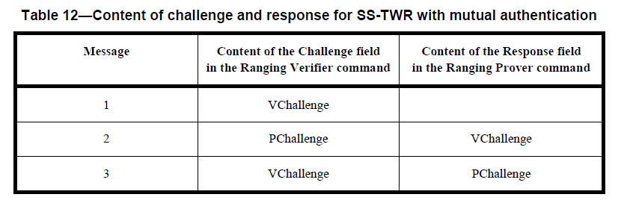
VChallenge, PChallenge
PChallenge, VChallenge

27635600023: Accept

27635800023, 27635900023: Revise
The revised text was provided above in “Resolution Step 2” for both .confirm primitives

27633100023: Accept
Remove phyLrpUwbSignaling. In addition also remove phyLrpUwbLeipEnabled, phyLrpUwbLeipLength.

27636000023: Revise

The MCPS-RANGING-PROVER.indication primitive indicates the reception of the Ranging Verifier command from a verifier device as part of a challenge-response ranging exchange.

